**Assign Teacher Access**

Staff members (Teacher/Non-Teaching) can be given access to the following options:

* Attendance – Enter Daily or Period Attendance
* Competency – Add/Modify Competencies or Add/Modify Narrative
* Future Student Schedules – View future student schedules (Guidance Counselors, School Admins)
* Future Teacher Schedules – View future teacher schedules (Guidance Counselors, School Admins)
* Grades – Add/Modify or Submit Course Grades
* Gradebook/Rankbook – Add/Modify Rankbook view or My Courses Gradebook view (teaching staff only)

Go to Security System > Assign Teacher Access

Search for the user you want to give access to another staff member’s Attendance, Competency, Grades or Gradebook/Rankbook or the user you want to give access to view Future Student Schedules or Future Teacher Schedules.

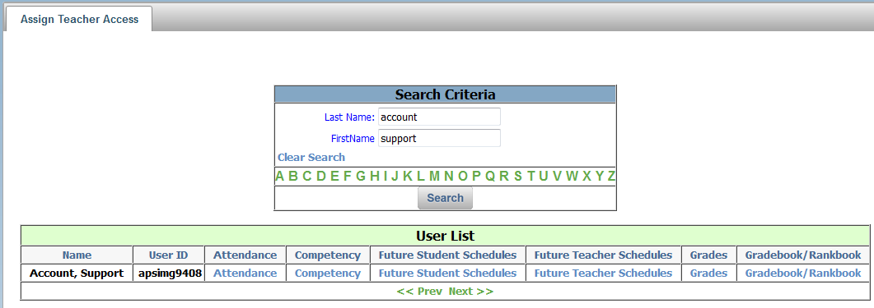

**Assign Teacher Access for Gradebook/Rankbook**

The new version of iPass provides users additional options for assigning teacher access to Gradebook view. Users can be given one or more of the following options:

* View Only – User can view the teacher’s Gradebook only.
* Edit Assignments – User can create and update assignment in the teacher’s Gradebook.
* Edit Weights & Types – User can create and update the Assignment Types and Weights in the teacher’s Gradebook.
* Allow Submit Grades – User can enter and update assignment grades in the teacher’s Gradebook.

**NOTE:** Assigning a user access to any of the above Gradebook options will give the user access to Edit Assignments and Allow Submit Grades in the original Add/Modify Rankbook view.

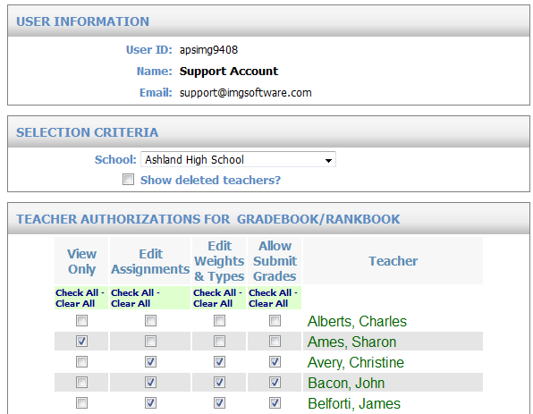

iPass High School

Smith, David

Fields, Karen

Ames, Richard

Mahoney, John

Gold, Mary

Assign Teacher Access to Attendance, Competency, Future Student Schedules, Future Teacher Schedules and Grades offer one check box for Assign. Check the box and the User ID has been given access to enter Attendance, Competency, Future Student Schedules, Future Teacher Schedules and/or Grades for the teacher checked off.

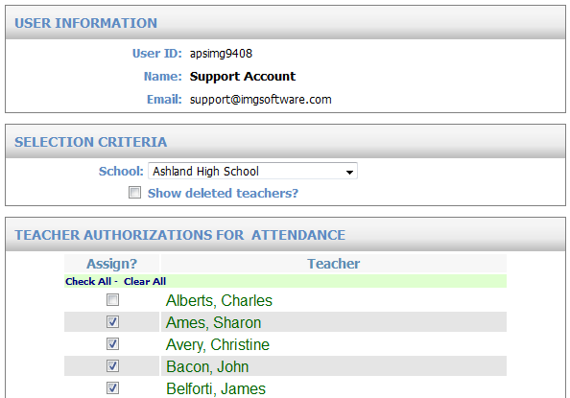

iPass High School

Smith, David

Fields, Karen

Ames, Richard

Mahoney, John

Gold, Mary

Check off the box for Show deleted teachers and you will see any teacher who has a deleted iStaff record.

Note: Teachers that have Exited will no longer appear on the Assign Teacher Access Assign list but may continue to show in your teacher selection drop down box.