**Liaison Field**

In addition to the SPED Liaison field, an optional alternate Liaison field may be activated for use. When activated, student can be assigned a Liaison and that Liaison will behave similar to the assigned Assistant Principal and Counselor fields on certain iPass screens and in certain reports.

**By default sites do NOT have this field activated.** Each iPass site can decide if they want this Liaison field activated.

**IMPORTANT NOTE:** When this Liaison field is activated the selected Liaison will be used in place of the SPED Liaison (text field) from the Confidential screen.

**To activate the Liaison field:**

Go to System Configuration > Parameter Maintenance > Application = TEAM, Parameters = System

Set Liaison Active = Yes

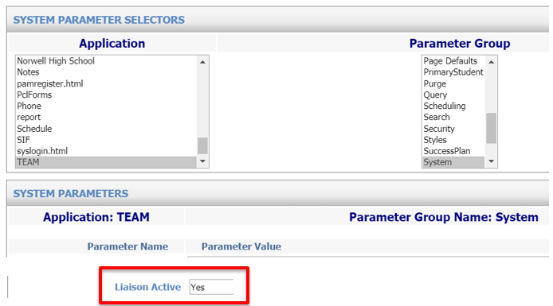

The Liaisons available for selection are based on HRS Job Types identified in the System Parameter for Liaison

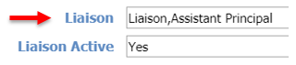

**Student Profile**

When the Liaison field is activated (system configuration parameter) the Liaison field will be available on the Student Profile screen.



**Biographical System – Mass Update Student**

When the Liaison field is activated, the Liaison field will be available on the Biographical system Mass Update Students screen. The Liaison can be selected and added to students based on the search criteria. The Liaisons listed are based on the HRS Job Types set up in system configuration parameter (refer to above section).

Biographical System > Mass Update Students > Liaison

Select the Liaison you want to assign from the drop down list.

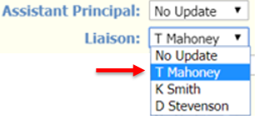

**Student Header Box**

When the Liaison field is activated, the Liaison will display under the Assistant Principal in the Student Header box.

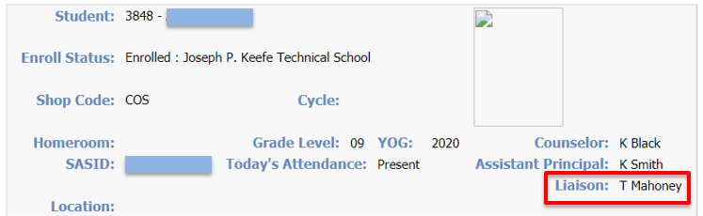

**View Only Access – Student Profile**

When the Liaison field is activated, the Liaison will display under the Assistant Principal in the Student Data section of the View Only Access Student Profile screen.

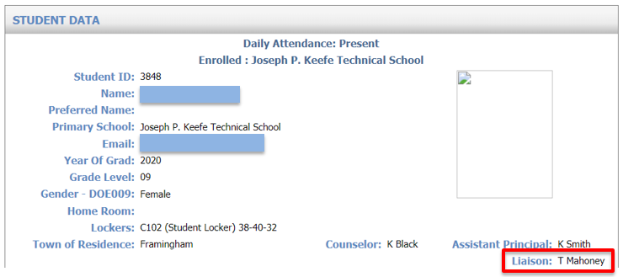

**Advanced Export Report**

When the new Liaison field is activated, the new Liaison field is available as a selection when running the Biographical System Advanced Export Report.

Biographical System > Reports – Biographical > Advanced Export Report

Click on the Data field down arrow to search for the Liaison field.

***Helpful Hint!*** You will find the Liaison field selection at the bottom of the field selection list.

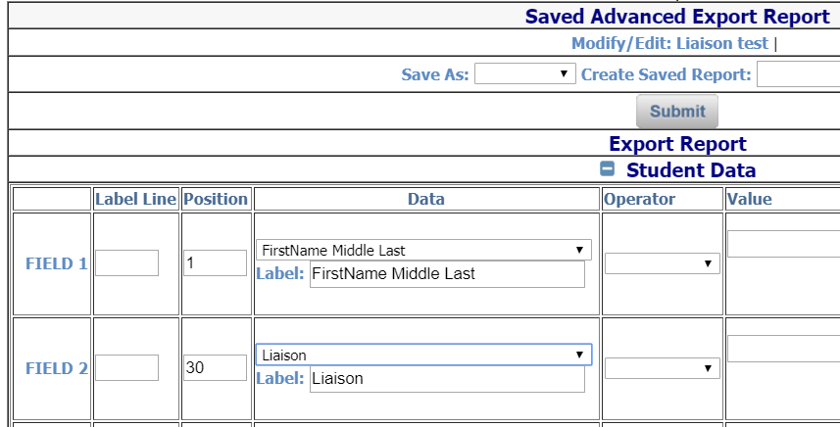

**Note:** When the new Liaison field is NOT activated, the Liaison option is not available for selection.

Example Report: You may select both the SPED Liaison and Liaison fields:

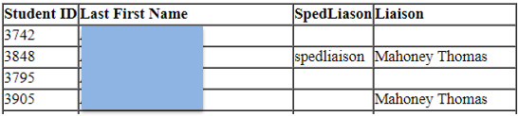

**Export Report**

When the new Liaison field is activated, the new Liaison field is available as a selection when running the Biographical System Export Report.

Biographical System > Reports – Biographical > Export Report

Click on the Data field down arrow to search for the Liaison field.

***Helpful Hint!*** You will find the Liaison field selection at the bottom of the field selection list.

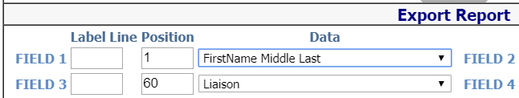

**Note:** When the new Liaison field is NOT activated, the Liaison option is not available for selection

**Navigational Toolbar – Send Email**

When the Liaison field is activated and a Liaison has been assigned to a student, the Navigational Toolbar Send Email will include the Liaison as an option.

Click on Send Email icon to get to the Email Form screen to create email and select recipients.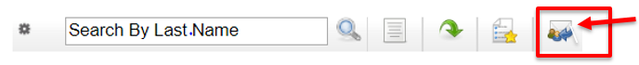

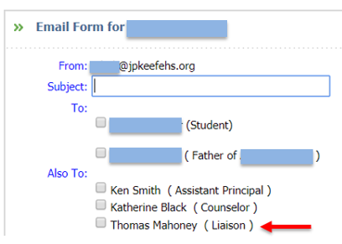

**Note:** To send email from iPass – Districts that use Google Mail or Office365 Outlook must have the email username and password configured. This is done in My Data > My Preferences > Mail Settings.

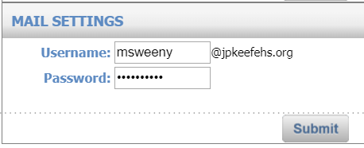

**Gradebook/Rankbook – Show Liaison**

When the Liaison field is activated and Show Liaison is checked off under Gradebook/Rankbook Student Data Options, the Gradebook/Rankbook class roster will show a Liaison column that will reference the Liaison selected for the student.

My Courses > **Gradebook** > Settings > Preferences > Student Data Options, or

iTeacher > **Add/Modify Rankbook** > Settings > Student Data Options

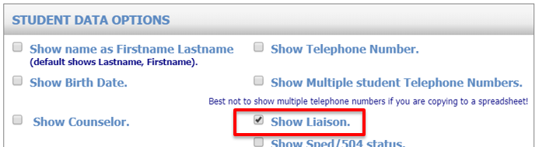

Gradebook Interface – Class Roster: Rankbook Interface – Class Roster:

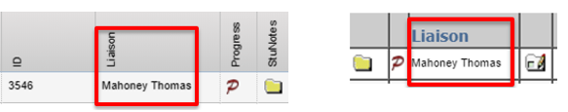

**NOTE:** When the Liaison field is NOT activated, the Liaison Column will display the SPED Liaison from the Confidential screen.

**Attention iPass Administrators:** If the checkbox for “Show Liaison” is NOT available under Student Data Options then the Teacher Rankbook Parameters Rankbook Student Data Visibility settings need to be updated to “Allow teacher to show Liaison.” The Parameters are set by Default School.

Administration > Teacher Rankbook Parameters > Rankbook Student Data Visibility

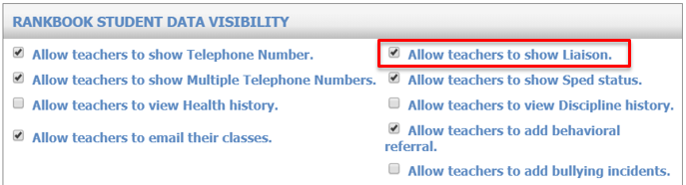

**Biographical Reports – SPED/Tech Ed Services**

When the Liaison field is activated, the Biographical Report for SPED/Tech Ed Services report will include the assigned Liaison in the Liaison column.

Biographical System > Reports – Biographical > SPED/Tech Ed Services Report

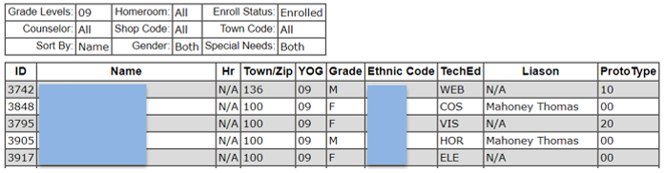

**NOTE:** When the Liaison field is NOT activated, the Liaison column will report the SPED Liaison from the Confidential screen.

