
iPass
End of Year
Procedures

i PASS PROCEDURES FOR ANOTHER SCHOOL YEAR
***CHECK LIST***

PHASE I: Preparation for a New School Year.

 I-1. DISTRICT - Define a New School Year – (Page 2)
 I-2. Enter/Access Incoming Students – (Page 3)
 I-2-A. DISTRICT Define a New Grade Level and/or YOG – (Page 3)
 I-2-B. Assign Next Year’s School, Homeroom & Grade Level – (Page 4)
I-2-B-i. Update Next Year’s School, HR, GL for a Student - (Page 5)
I-2-B-ii. Mass Update Next Year’s School or HR - (Page 6)
I-2-B-iii. Primary School Report – (Page 7)
I-2-B-iv. Next Year’s Homeroom Report – (Page 8)
 I-2-C. Registering a Single Student - (Page 9)
 I-3. Define School Year Scheduling Parameters – (Page 10)
 I-4. Define Next Year’s School Calendar - (Page 11)
 I-4-A. Define Next Year’s School Calendar - (Page 11)
 I-4-B. Enter your Holidays/No School Days – (Page 12)
 I-4-C. Verify your Cycle Days & A/B Weeks – (Page 14)
 I-4-D. Print & Verify your School Calendar – (Page 14)
 I-4-E. Correct Errors, if needed – (Page 15)
 I-5. Check Your School Term Dates - (Page 16)
i PASS PROCEDURES FOR ANOTHER SCHOOL YEAR - (cont.)
***CHECK LIST***
PHASE II: Ending the Current School Year.

 II-1. Verify/Update School Calendar - (Page 17)
 II-1-A. Print School Calendar - (Page 17)
 II-1-B. Update School Calendar - (Page 18)
 II-1-C. Update Calendar Holidays - (Page 19)
 II-2. Update School Term Dates - (Page 20)
 II-3. Complete Report Cards, Honor Rolls, etc. – (Page 21)
 Honor Rolls
 Horizontal Averages
 Report Cards
 GPA Calculations
 Transcripts
 Competency Report
 Current Year’s Homeroom Lists
 Current Year’s MCAS Mailing Labels
 Current Year’s Teams/Cycles/Clusters
 ___________________________

i PASS PROCEDURES FOR ANOTHER SCHOOL YEAR - (cont.)
***CHECK LIST***
PHASE II: Ending the Current School Year – (cont.)
 II-4. Print End-of-Year Reports - (Page 22)
 II-4-A. Biographical Reports - (Page 22)
 Student Directory
 Entry/Withdrawal Report
 _________________________
 _________________________
 _________________________

 II-4-B. Attendance Reports - (Page 23)
 State Register
 Attendance History
 Attendance Statistics
 Attendance Tally or Perfect Attendance
 Enrollment Report(s)
 _________________________
 _________________________
 _________________________

i PASS PROCEDURES FOR ANOTHER SCHOOL YEAR - (cont.)
***CHECK LIST***
PHASE II: Ending the Current School Year – (cont.)
 II-4-C. Other Reports - (Page 24)
 Student Discipline Records
 Earned Credits Report
 __________________________
 __________________________
 __________________________

 II-5. Graduate Your High School Seniors – Be sure to clear lockers first! (Page 25)

 II-6. Create MA DESE SIMS/CT. PSIS Year End file - (Page 29)

 II-7. Create MA DESE Discipline File – Submit School Safety & Discipline Report to DESE (Page 30)
i PASS PROCEDURES FOR ANOTHER SCHOOL YEAR
***CHECK LIST***

PHASE III: Starting a New School Year.

***MASSACHUSETTS IPASS USERS PLEASE NOTE***
You cannot move to Phase III and start a new school year until your End Of Year SIMS, SSDR, SIMS and EPIMS have been filed with the DESE and certified!!!
 III-1. DISTRICT - Change the Academic Year - (Page 31)
 III-2. DISTRICT - Promote Grade Level - (Page 32)
 III-2-A. DISTRICT – Redefine YOG’s for Grade Levels – (Page 33)
 III-3. Add/Modify Teachers/Staff - (Page 34)
 III-A. Add a new Teacher/Staff member - (Page 34)

 III-B. Modify a Teacher/Staff member – (Page 36)

 III-C. Remove a Teacher/Staff member – (Page 36)
 III-4. Add/Modify/Delete Rooms - (Page 37)
 III-5. Clear Existing Biographical Data - (Page 39)
 III-6. Enroll/Withdraw/Transfer Students - (Page 40)
 III-6-A. Mass Enroll/Re-enroll Students – (Page 41)
 III-6-B. Enroll/Withdraw/Transfer a Single Student (Page 44)
 III-6-B-i. Enroll a Single Student – (Page 45)
 III-6-B-ii. Withdraw a Single Student – (Page 46)
 III-6-B-iii. Transfer a Single Student – within District – (Page 47)

i PASS PROCEDURES FOR ANOTHER SCHOOL YEAR
***CHECK LIST***
PHASE III: Starting a New School Year – (cont.)

 III-7. Assign Homerooms - (Page 48)
III-7-A. Mass Update Homerooms – (Page 49)
III-7-B. Mass Load Homerooms by Grade Level – (Page 49)
III-7-C. Assign HRs based on Student Schedules – (Page 50)

III-7-D. Print Homeroom Assignment by GL Report – (Page 51)
 III-8. Rollover Various Tables & Values – (Page 52)
 III-8-A. Activity Rollover (Page 52)

 III-8-B. Attendance Rollover (Page 52)

 III-8-C. Grades Rollover (Page 52)

 III-9. Alerts – Check and re-set Expiration Dates (Page 53)

 III-10. Assign Horizontal Averaging Rules to Sections (Pg 53)
 III-11. Assign Free/Reduced Lunch Status – (Page 54)
 III-12. Counselors - (Page 55)
III-12-A. Mass Update Counselors – (Page 55)
III-12-B. Add/Modify Student Biographical – (Page 56)
 III-13. Assistant Principals - (Page 57)
III-13-A. Mass Update Assistant Principals – (Page 57)
III-13-B. Add/Modify Student Biographical – (Page 58)

i PASS PROCEDURES FOR ANOTHER SCHOOL YEAR
***CHECK LIST***
PHASE III: Starting a New School Year – (cont.)

 III-14. Lockers - (Page 59)
III-14-A. Mass Update Lockers – (Page 60)
III-14-B. Quick Add Lockers – (Page 61)
III-14-C. Add/Modify Student Biographical – (Page 62)
III-14-D. Change Locker Combination – (Page 62)

 III-15. Assign Bus Routes/Stops - (Page 63)
III-15-A. Mass Update Buses – (Page 63)
III-15-B. Quick Add Buses – (Page 64)
III-15-C. Add/Modify Student Biographical – (Page 64)

 III-16. Assign Shop Week/Cluster/Team - (Page 65)
III-16-A. Mass Update Shop Week/Team – (Page 65)

 III-17. Set up Narrative Parameters for Standards/Competency Based Report Cards (page 65-66)

III-17 Grading System- Narrative Parameters
PHASE I: Preparation for a New School Year

A New School Year can be started as early as you like. Most of the items in the first section of this documentation will already have been completed as part of the preparation for secondary school scheduling.

If the data is Academic Year specific, then an Academic Year pull-down box will be part of the filtering criteria. The current Academic Year, as defined by the District, will be the default. Other (past or future) Academic Years that have been defined will be available in the pull-down list.

If the data is School specific, then a Select School pull-down box will be part of the filtering criteria. Your default school will be displayed and other schools within your district can be accessed by selecting them in the pull-down list, if you have been given access to other schools. You can also change your default school using <My Data> <Set Default School>.
NOTE: If you change your default school, then it may be necessary to also logout and log back in to insure that you are accessing data which is specific to that school.

Because i PASS is District based, several procedures will be done at the district level. The timing of some of these procedures must be coordinated with the individual schools to at least notify them of the changes or to insure that the changes will not adversely affect what they need to accomplish, particularly end of year reports. These DISTRICT based procedures are clearly indicated in this document.

Menus are definable at the District level and may vary from those indicated in this documentation. IMG is working on modifying menus to make them consistent with programming changes and documentation. Please let us know if you prefer that IMG not make any modifications to your menu system without your specific approval.

NOTE: Screen shots have not been updated unless there was a significant change.

I-1. DISTRICT - Define a New School Year -
This is a DISTRICT function that can be done at any time. It is generally done early enough to allow scheduling procedures to begin for the new school year.
- Select <Attendance System> <Maintenance> <Calendar Years> or
- Select <Administration> <District Resources> <Calendar Years>.

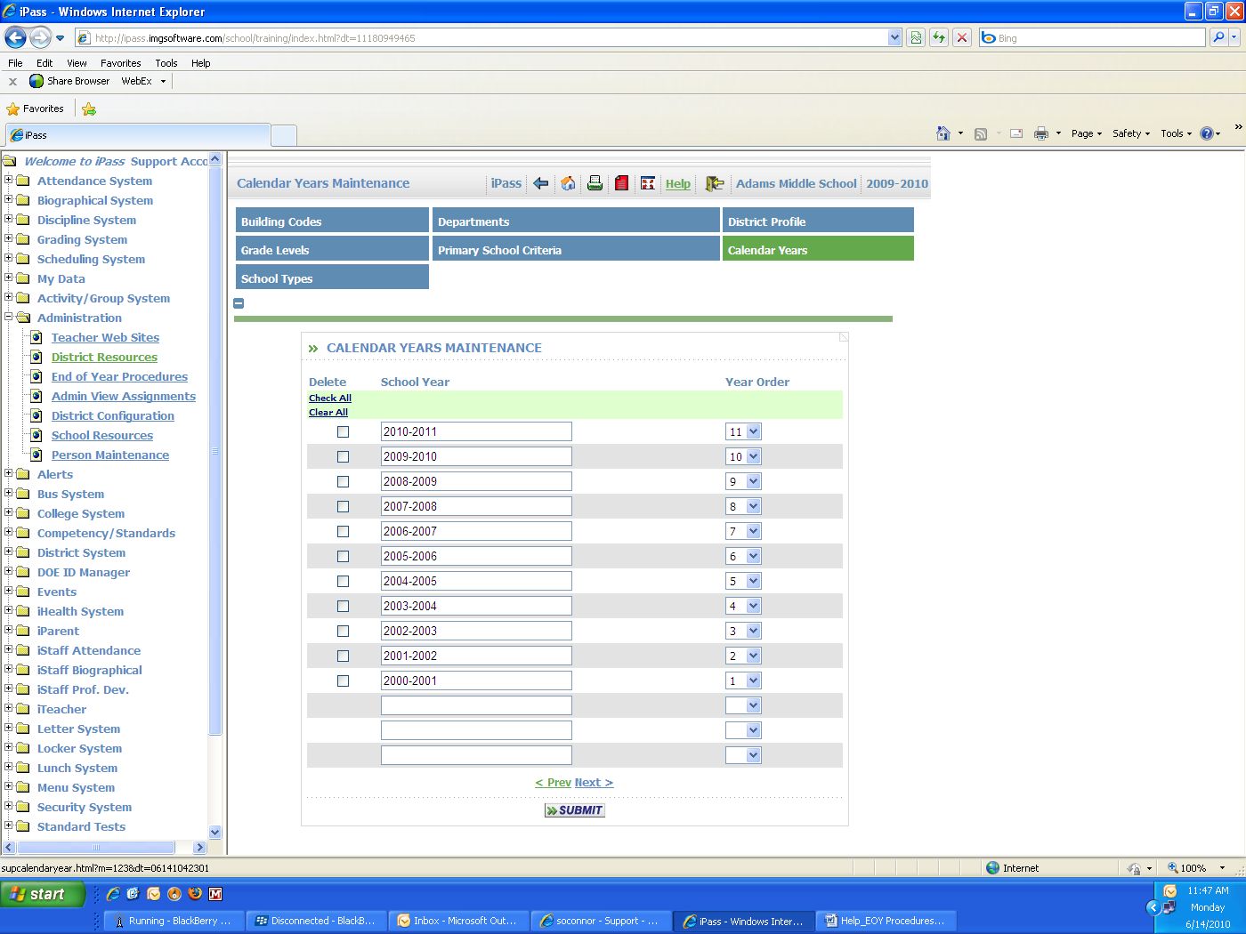

Add the new Academic Year
- Enter the new Academic Year (format yyyy-yyyy) into the first blank field at the bottom of the page.
- Select the next highest Year Order (display) from the pull-down list. The Year Order will dictate the display order (descending) of the Academic Years for the pull-down lists (highest order number on the top of the list). The current Academic Year as defined in <System Configuration> <Parameter Maintenance>, and is described later in this document (Section III-1), will be the default regardless of its Year Order (display).
- Click to save your changes.
I-2. Enter/Access Incoming Students -

I-2-A. DISTRICT - Define a New Grade Level and/or YOG (Year of Graduation) –
This is a DISTRICT function. A new Grade Level will need to be added before the HS senior class (Grade 12) is promoted. This is also the table that is read when all students are promoted. If you are adding a new Grade Level to your District, then you will also need to add a new YOG (Year of Graduation) for that Grade Level to your District.
- Select <Administration> <District Resources> <Grade Levels>

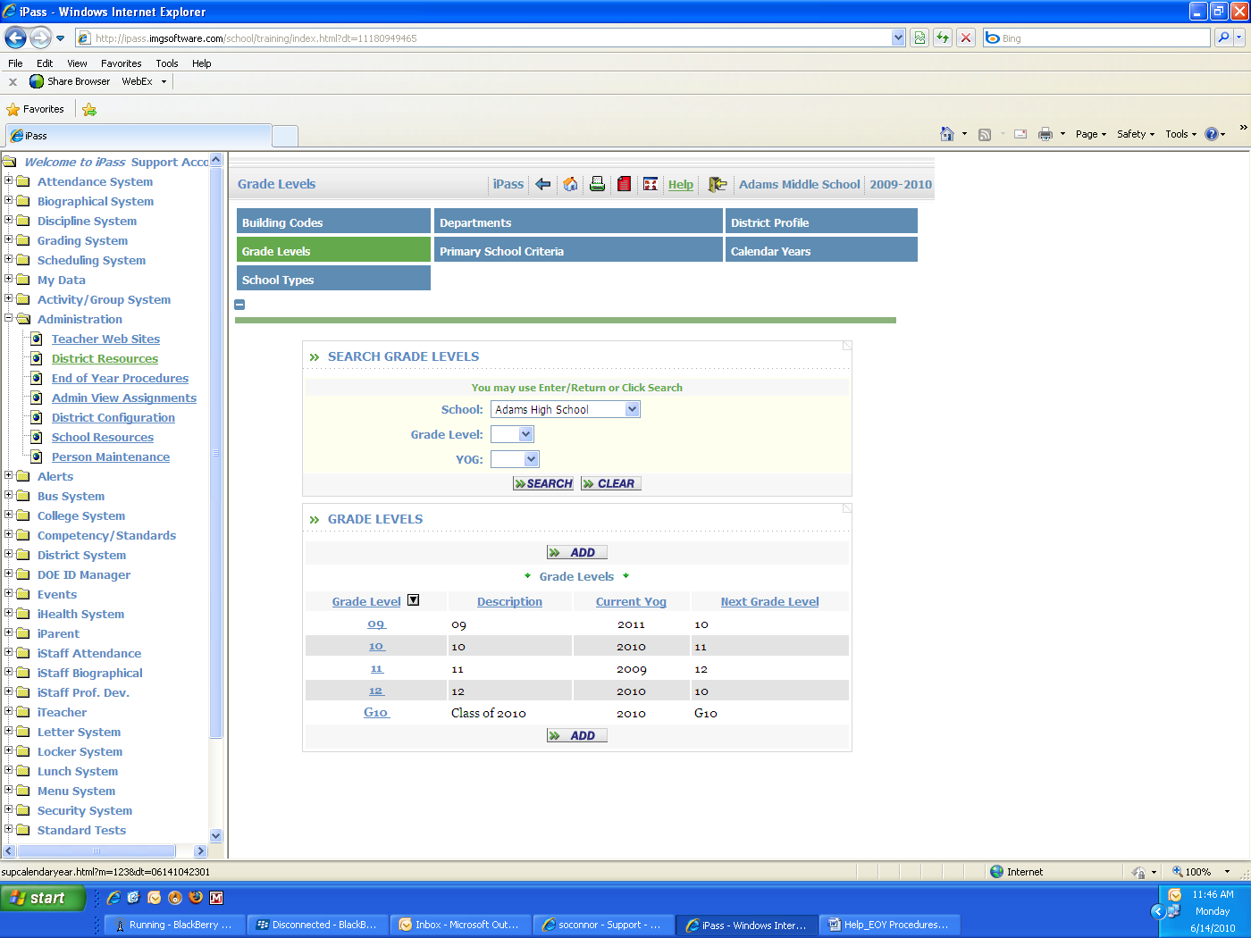

- Click to create a new record.

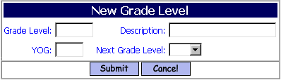

NOTE: Select the “blank” option for School Name to see all of the Grade Levels for the District. DO NOT Add a new Grade Level if it already exists in the District

Grade Level:
- Enter a Grade Level.
Suggestion: G11 for the Graduating Class of 2011.
Description:
- Enter a Description of the Grade Level.
Suggestion: Enter Class of 2011.
YOG:
- Enter the appropriate YOG (Year of Graduation).
In the suggested example, enter 2011.
Next Grade Level:
- Do not select a Next Grade Level. It will be G11, but until this entry is complete and an additional step is taken, the Grade Level G11 is not available.
I-2-A. DISTRICT - Define a New Grade Level and/or YOG (Year of Graduation) – (cont.)

The New Grade Level record has been created, but is not currently assigned to the school.
- Select <Administration> <School Resources> <School Profile>.
- Select your Default School from the list.
- Highlight the new Grade Level within the list of District Grade Levels.

You can now go back to the Grade Level table, Select Grade G11 and define the Next Grade Level for current Grade 12 students to be G11 since these students will never be promoted out of the Class of 2011. You may also want to assign the new Grade Level to you school in order to be able to produce reports in future years for previously graduated students. Select <Administration> <School Resources> <School Profile>.

I-2-B. Assign Next Year’s School, Homeroom and Grade Level -
There are fields in each student’s Biographical – Profile record to identify the school, within your District, that they will be attending during the next school year, their Homeroom and their Grade Level. It can be updated individually or collectively. All students who will remain in your District for the new school year MUST have the Next Year’s Primary School field filled, regardless of whether they are changing schools or remaining in your school. The Next Year’s Homeroom field is optional. The Next Year’s Grade Level, if not filled in manually, will be assigned as part of the Grade Level Promotion program.

The Next Year’s School field will:
- allow access to these students by the Next Year’s school for scheduling;
- determine which students are included in the scheduling process and on scheduling reports for either the receiving school or sending school;
- automatically replace the Primary School value when the Academic Year is changed;
- automatically be cleared when the academic year is changed.

The Next Year’s Homeroom field will:
- allow you or the receiving school to assign Homerooms;
- create lists without having to wait and without interfering with the data for the current academic.

The Next Year’s Grade Level field will allow you to easily identify retained students prior to the Promotion process. (For those students who are to be retained, change the Next Year’s Grade Level to be the same as the current year and it will not be changed during the Promotion process.)

I-2-B-i. Update Next Year’s School, Homeroom and Grade Level for an Individual Student -
- Select <Biographical System> <Add/Modify Student Biographical> <Select Student> <Profile>.

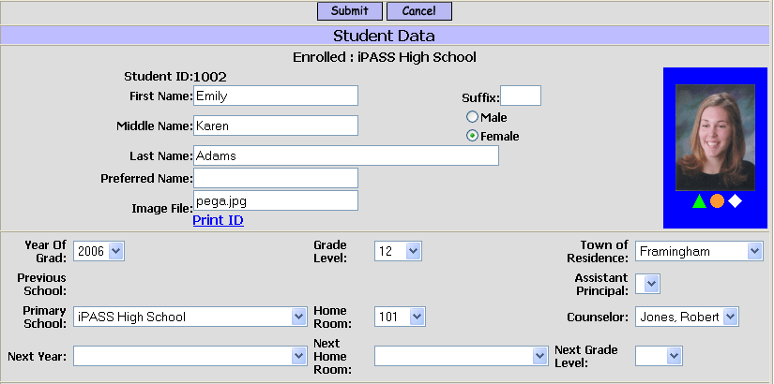

Next Year:
  - Select Next Year’s School from the pull-down list. This is the school, within your district, that the student will be attending for the next school year.
  - Select YOUR School if the student will still be attending your school next year.
  - Leave the field blank or select the blank option if you know that the student is leaving the district at the end of the school year and will not be in your school or in another school within your District for the next school year.

NOTE: For students who are being retained in your building or who have notified you that they will not be going to the assigned Next Year’s School:
1) Notify the receiving school that they will not be attending, so that the receiving school can remove the student’s next year’s requests/schedule and then they will reset the Next Year’s School to be their current/previous school. DO NOT set the field to “blank”.
2) If the Academic Year has already been changed, notify the receiving school so that they can select the student using the Enrollment = None option and change their Next Year’s School accordingly.
3) You also need to change their YOG and Grade Level. If they have not yet been promoted, then set the student’s Next Year’s Grade Level to be the same as their current Grade Level and the Promote Grade Level program will read that match and not promote the student.

Next Homeroom:
  - Select Next Year’s Homeroom from the pull-down list of all Homerooms in the District.
Next Grade Level:
  - Select Next Year’s Grade Level from the pull-down list of all Grade Levels in the District.

Helpful Hint: For Pre-school students who are not old enough to be promoted to KF or KP, set their Next Year’s Grade Level to “PK” so they will not get promoted with those students who are old enough.
- Click to save your changes.

NOTE: The Previous School field will be filled automatically and is a hyper-link to the student’s Enrollment Record. District schools will be displayed automatically, based on the student’s Primary School/Year record. Out of District schools are defined in <Administration> <School Resources> <School Profile> as “Out-of-District” schools and are available for selection in the pull-down list on the student’s enrollment record.
I-2-B-ii. Mass Update Next Year’s School or Homeroom -
- Select <Biographical System> <Mass Update Students>.

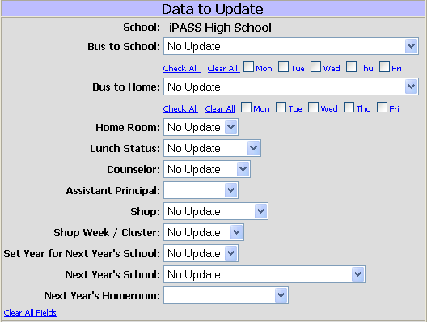

Data to Update

Set Year for Next Year’s School:
  - Select the Next Academic Year from the pull-down list. This setting is for Next Year’s School, Next Year’s Homeroom or both. The year could also be for the current year or for previous years to make corrections or adjustments.
Next Year’s School:
  - Select Next Year’s School from the pull-down list of schools within your District.
Next Year’s Homeroom:
  - Select Next Year’s Homeroom from the pull-down list of Homerooms within your District.

NOTE: When updating Next Year’s Homeroom or Next Year’s Grade Level, you must also select Next Year’s Year and Next Year’s School.

Student Search Criteria
Use the filtering criteria to select the students to be considered for assignment to the Next Year’s School as defined above.
- Click to list your selections.

Use the check-boxes to identify which students will be updated and which students will not be updated for their Next Year’s School and/or Next Year’s Homeroom for the appropriate the year.
Use the Check All, Clear All options to facilitate your selection/de-selection process.

NOTE: The Next Year’s School field needs to be filled for any students present in the district this year.

- Click to save your changes.
I-2-B-iii. Primary School Report -
- Select <Biographical System> <Reports> <Primary School Report>.
Use this report to list your students and where they have been assigned for next year or where they are coming from.

NOTE: The user must have access to the other sending or receiving schools in order to produce this report. They will need to be given temporary access to those schools, or created as a separate user with access to those schools and not have the same full access that they have for their default school, or the report will need to be produced for them by a District Super User.

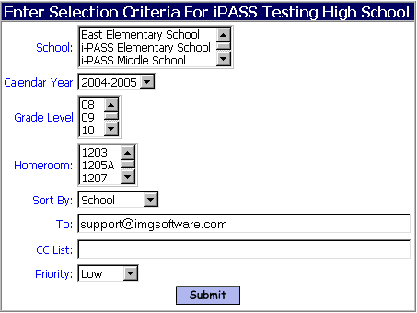
School:
  - Select one or more schools where your students have been assigned for the selected year, either the sending schools or the receiving schools depending on the report needed.
  - Do not select any School to include all Schools in the report.
Calendar Year:
  - Select the next Academic Year to list schools where students have been assigned.
  - Select the previous Academic Year to list schools where students came from.
Grade Level:
  - Select one or more Grade Levels.
  - Do not select any Grade Levels to include all Grade Levels in the report.
Homeroom:
  - Select one or more Homerooms.
  - Do not select any Homerooms to include all Homerooms in the report.
Sort:
  - Accept the default of School to report by school (send to) with page breaks.
  - Select Name, Grade Level or Homeroom to sort the data in that manner.

- Click to save your changes.

I-2-B-iv. Next Year’s Homeroom Reports -
An Academic Year pull-down list has been added, to enable you to print reports based on Next Year’s Homeroom, to both the <Biographical System> <Reports> <Homeroom Assignments> report and <Biographical System> <Reports> <Homeroom Assignments by Grade Level (GL)> report.

Use these reports to produce lists or summaries of Next Year’s Homeroom assignments.

Academic Year:
  - Select 2011-2012.
Enroll Status:
  - Select All.

I-2-C. Registering a Single Student -

New students can be entered/registered at any time. This will allow biographical data to be added and schedules to be produced. Students entering for the new school year (i.e. new Kindergarten students) will be enrolled in August/September with the other Grade Levels and if entered in the current school year, they will be promoted over the summer to their correct Grade Level for August/September.

Enter All new students in the Current Academic Year with their Current Grade Level and then define their Next Year’s School and Next Year’s Grade Level with the appropriate values.

Helpful Hint: Create bogus Grade Levels (NK=New Kindergarten or NPS=New Pre-School). As long as a Calendar has been defined, you can pre-enroll them for the next school year to get reports.

- Select <Biographical System> <Add/Modify Student Biographical> <Add>.
- Click to display the next page.

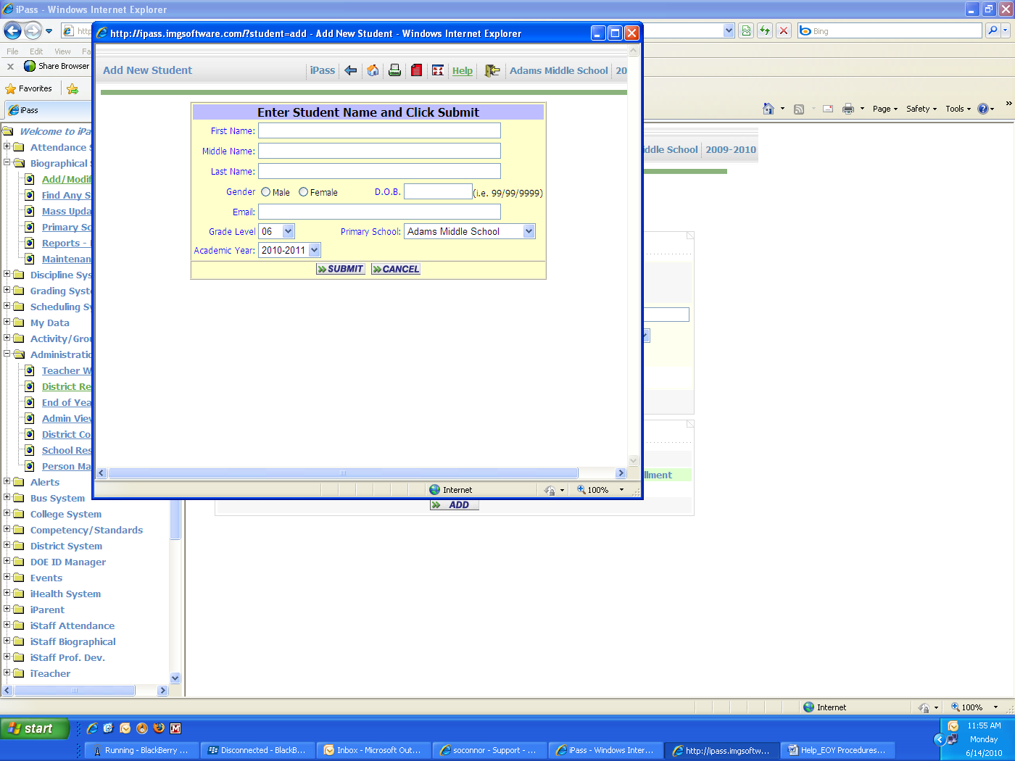

First Name:
  - Enter the First Name of the new student. This field is required in order to register a new student.

Middle Name:
  - Enter the Middle Name of the new student.

NOTE: Massachusetts Public School – Enter “NMN” is the student has no middle name. This is required for DOE reporting, but it will not print on Report Cards, Transcripts, etc.

I-2-C. Registering a Single Student – (cont.)

Last Name:
  - Enter the Last Name of the new student. This field is required in order to register a new student.

Gender:
  - Select Male if the student is Male
  - Select Female if the student is Female

Date of Birth (D.O.B.):
  - Enter the Date of Birth of the student. This is a required field if you wish the entry to be validated against students already existing in the District database.

Email:
  - Enter an E-mail address for the student or leave the field blank.

Grade Level:
  - Select the current Grade Level of the student from the pull-down list.
NOTE: You may need to re-assign this grade level to your school in <Administration> <School Resources> <School Profile> <Grade Levels>.

Primary School:
  - Select the Primary School of the student from the pull-down list.

Academic Year:
  - Select the Academic Year for the CURRENT School Year from the pull-down list.
You will also need to set the Next Year’s Primary School for the student on their profile page.

IMPORTANT: Be sure to select/highlight the Primary School and Academic Year.
Do not assume that it is pre-selected or defined as a default.

- Click to save your changes.

NOTE: With the entry of First Name, Last Name and Date of Birth, the system will check to determine if the student already exists in the system. If a duplicate is found, then the ID#, Name and Date of Birth of that existing student will be displayed and you will have the option to cancel the entry or submit the entry and create a record for this new and different student.

The system will assign the next ID number which is available within your District and will open the student’s Biographical Profile page for entry of additional information. A Massachusetts DOE LASID will also be automatically generated. The student will be available using the Enrollment = None option until they have been enrolled. Legally, they should not be enrolled until they are present in your building or you are certain that they will be attending, but for ease of reporting, as long as a school calendar has been defined, they can be enrolled at any time. For details on Enrolling a student, see Section III-6 of this documentation.

Entry should be as complete as possible.

Data should be consistent for all students and all schools within your District.
(For example: UPPER/lower case, format of names for Parents/Guardians/Contacts, entry of phone numbers, addresses, apartments, etc.)
I-3. Define School Year Scheduling Parameters -
- Select <Scheduling System> <Maintenance> <Academic Year Settings>.
Scheduling Parameters are both School and Academic Year specific to facilitate changes that may occur from year-to-year with the number of terms, the number of periods, the number of days in your cycle, etc.

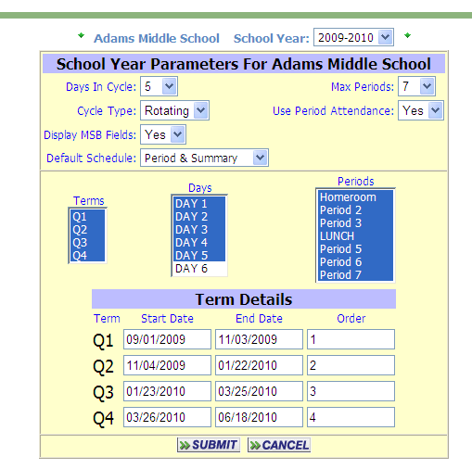
See the i PASS Scheduling Procedures document for details.

Helpful Hint: The system will automatically load dates which are exactly one year in advance of your current dates. Be sure to review and correct these dates once your school calendar has been set. Do not leave gaps in the dates from Term to Term. The Term Start/End dates are used to determine Attendance by Term and which Term’s Schedule to display (in Period or Rotation format).

NOTE: In order to correctly report the Massachusetts DOE elements #47-51(Advanced Placement courses, ALL schools, including Elementary Schools MUST have at least one (1) term defined and highlighted. This can be a single term with Start/End dates which match the school calendar.
In order to create a school Attendance Calendar, ALL schools, including Elementary Schools MUST have at least one (1) Day defined and highlighted.

I-4. Define Next Year’s School Calendar -
I-4-A. Define a New School Year Calendar -
- Select <Attendance System> <Maintenance> <Calendar Maintenance>.

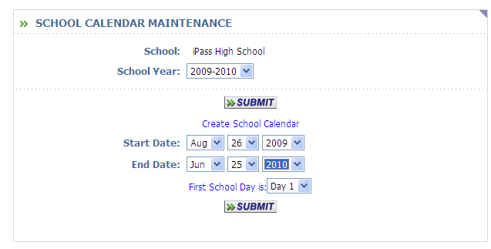
Calendar:
  - Select the correct Academic Year from the pull-down list.

- Click to display your selection.

Start Date:
  - Select the Start Date for the First day of school.

End Date:
  - Select the End Date for the Last day of school.

First School Day is:
- Select the Day Name that will be the Cycle day for the first day of school.
You must select the Day Name under First Day of School is.
It must be highlighted in order to create the calendar.

- Click to save your changes.

I-4-A. Define a New School Year Calendar – (cont.)

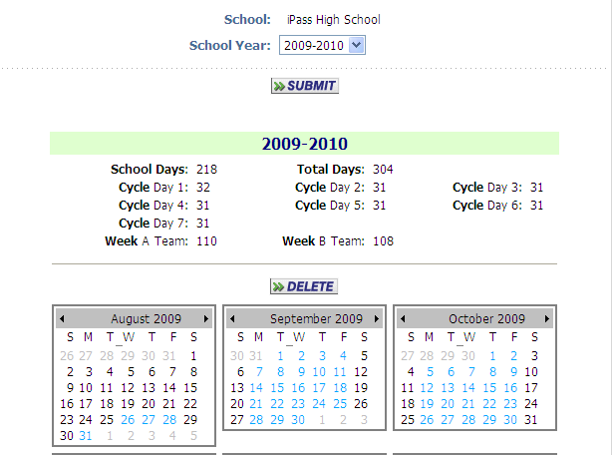

The calendar will display Light Blue to indicate school days and Red to indicate Holidays or Snow Days. Each day is a link. Click on the day to make any changes to Day Number, Cycle Day, or Holiday status. You can also “mouse-over” any date to see the information for that day.

Helpful Hint: It may be easier to define your extra “Snow Days” upfront and remove them if not needed at the end of the year, then to go through the extra work of adding a new day as each Snow Day occurs or forgetting to add them and not being able to enter attendance for the last days of school because the day was not yet defined in the calendar.

NOTE: There is now a “Delete” option which will delete the entire Calendar for the year. Student Attendance and Holidays are stored separately in the database and will re-appear when a new Calendar is created.

I-4-B. Enter Your Holidays/No School Days/ Snow Days –
Holidays can be entered or modified at any time and do not need to be entered when the calendar is created. This is also where Snow Days, etc. are defined as they occur.

I-4-B-i. Enter No School Days from the Months Calendar
- Select <Attendance System> <Maintenance> <Calendar Maintenance (Via List)>.

Calendar Year:
- Select the Calendar Year from the pull-down list.
- Click on the date you wish to change to a Holiday/Snow Day.
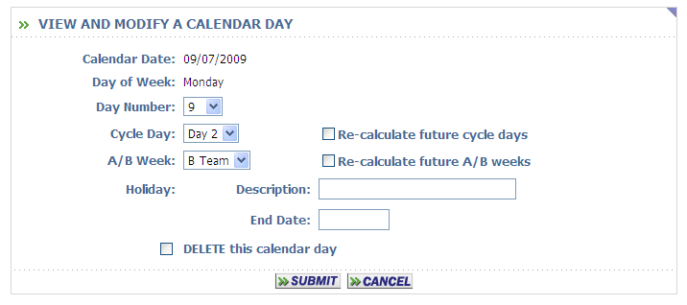

Holiday: Description:
- Enter the description of the No School day.

End Date:
- Enter the date selected for a single No School day.
- Enter the date of the last day of the No School days to set multiple days of No School, such as “Spring Break”.

- Click to save your changes.

NOTE: A day(s) entered here automatically assumes that the school is closed for the entire day and attendance will not and cannot be taken. Half days, Early Release days or Delayed Opening days CANNOT be entered into this School Attendance Calendar.
When entering new No School days, be sure to check the Cycle Days and A/B Weeks, if applicable.

I-4-B-ii. Enter No School Days from the Holidays List
- Select <Attendance System> <Maintenance> <Enter/Modify Holidays>.

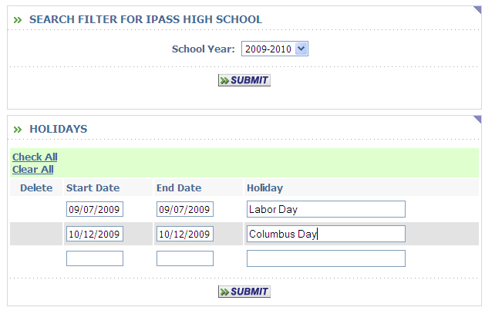

Calendar:
  - Select the Calendar Year from the pull-down list.
  - Enter the Start Date for the Holiday/No School Day.
  - Enter the End Date for the Holiday/No School Day.
  - Enter the Description for the Holiday/No School Day.

Add up to three (3) Holiday/No School Days in the blank fields and Submit, three (3) more blank fields will then appear.

Continue the process until all of your Holiday/No School Days have been defined.

- Click to save your changes.

NOTE: A day(s) entered here automatically assumes that the school is closed for the entire day and attendance will not and cannot be taken. Half days, Early Release days or Delayed Opening days CANNOT be entered into this School Attendance Calendar.
When entering new No School days, be sure to check the Cycle Days and A/B Weeks, if applicable.

I-4-C. Verify your Cycle Day(s) and A/B Weeks -
NOTE: For convenience, the previous list format of the Calendar is still available with a tab titled <Calendar Maintenance via List>. Please contact IMG if you would like access to this option and it is not current available.
- Select <Attendance System> <Maintenance> <Calendar> or <Calendar Maintenance via List> to review and edit.

The calendar will display Light Blue to indicate school days and Red to indicate Holidays or Snow Days. Each day is a link. Click on the day to make any changes to Day Number, Cycle Day, or Holiday status. You can also “mouse-over” any date to see the information for that day.

If your school uses a Schedule Rotation and Period Attendance, the Cycle Days MUST be reviewed and corrected, if necessary, to insure accurate data.

Day Number:
- Select the Day Number from the pull-down list.

Cycle Day:
- Select the Cycle Day from the pull-down list.
- Check the Re-Calculate future cycle days if you want to adjust the days based on your rotation.

A/B Week:
- Select the A/B Week from the pull-down list.
- Check the Re-Calculate future A/B Weeks if you want to adjust the Weeks based on you’re A/B Weeks set up in <Administration> <School Recourses> <School Profile>.

Cycle Days and A/B Weeks need to be checked and probably adjusted after any Holidays or Snow Days have been defined.

I-4-D. Print & Verify Your School Calendar -
Review on the screen or Print a report to check the school calendar. Look for the correct number of days.
- Select <Attendance System> <Maintenance> <Calendar> or <Calendar Maintenance via List> to review.
- Select <Attendance System> <Reports> <Calendar> to print.

Academic Year:
  - Select the Academic Year from the pull-down list.
- Click to save your changes.

I-4-E. Correcting School Calendar Errors, IF NEEDED -

ADD Days:
- Select <Attendance System> <Maintenance> <Calendar Maintenance via List>.

Calendar Year:
- Select the Calendar Year from the pull-down list.
- Enter the date(s) to be added in the first blank field(s) at the bottom of the page. You do not need to be at the bottom of the last page. Days can be added at the bottom of any page, as long as the dates are at the end of the existing calendar. If you are adding a day which spans a weekend, then you must enter Saturday and the Sunday.
- Click to save your changes.
------------------------------------------ OR -----------------------------------------------------
- Select <Attendance System> <Maintenance> <Calendar Maintenance (by Month)>.

Calendar Year:
- Select the Calendar Year from the pull-down list.
- Click on the date you wish to add. If you are adding a day which spans a weekend, then you must click on the Saturday and submit, then click on the Sunday and submit. Do not select or enter any other data for these days unless school will be open on those days.
Day Number:
- Select the correct Day Number form the pull-down list.
- Click to save your changes.

REMOVE Days:
- Select the Calendar Year from the pull-down list.
- Select the day (by clicking on the day)
- Check the Delete box next to the date(s) you wish to Remove.

NOTE: Only days at the beginning or end of the Calendar can be deleted.
- Click to save your changes.

Start Over:
<Attendance Maintenance> <Calendar Maintenance (by Month)>

- Select the Calendar Year from the pull-down list.
- Click the Delete box. Then redefine your calendar.
- Click to save your changes.

Start Over:
<Attendance Maintenance> <Calendar Maintenance via List>

- Select the Calendar Year from the pull-down list.
- Use the Check All option to check the Delete box for every day on a page. The Check All will need to be done on each page of the Calendar. Then redefine your calendar.
- Click to save your changes.

NOTE: Student attendance and Holidays are stored in the database independent of the calendar and will not be erased if errors are made in Calendar Maintenance.
I-5. Check Your School Term Dates -

The new school term dates can be entered/modified at any time once they are determined.
- Select <Scheduling System> <Maintenance> <School Terms> or <Academic Year Settings>.

Helpful Hint: It is easier and safer to define or edit the Term Start and End Dates in <Academic Year Settings>. See Section I-3 of this documentation for a sample.

When a new School Year is defined, Start Dates and End Dates will be filled automatically, with dates that are exactly one year later than those of the previous year. THEY NEED TO BE CHECKED AND MODIFIED.

Change the Start Dates and/or the End Dates to match the correct School Calendar.

- Click to save your changes.

PHASE II: Ending the Current School Year

II-1. Verify/Update School Calendar -
The accuracy of your School Calendar is key to your Attendance records, Enrollment records, related reports and DOE requirements.

II-1-A. Print School Calendar –
Print and check the school calendar. Look for the correct number of days.
- Select <Attendance System> <Reports> <Calendar>.
- Select the Academic Year from the pull-down list.
- Click to display your selection.

II-1-B. Update School Calendar, IF NEEDED -
If the closing date for the school year has CHANGED, EITHER because of extra days needed or extra days not needed, you MUST fix the School Calendar to insure correct end-of-year reports.
- Select <Attendance System> <Maintenance> <Calendar Maintenance>.

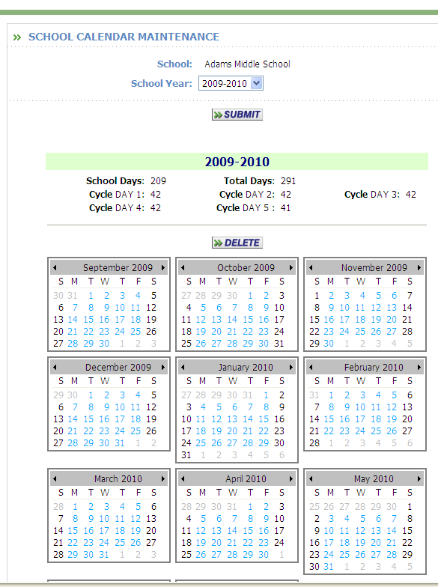

II-1-B. Update School Calendar, IF NEEDED – (cont.)

ADD Days:
- Select <Attendance System> <Maintenance> <Calendar Maintenance via List>.

Calendar Year:
- Select the Calendar Year from the pull-down list.
- Enter the date(s) to be added in the first blank field(s) at the bottom of the page. You do not need to be at the bottom of the last page. Days can be added at the bottom of any page, as long as the dates are at the end of the existing calendar.
- Click to save your changes.
OR
- Select <Attendance System> <Maintenance> <Calendar Maintenance>.

Calendar Year:
- Select the Calendar Year from the pull-down list.
- Click on the date you wish to add. If you are adding a day which spans a weekend, then you must click on the Saturday and submit, then click on the Sunday and submit. Do not select or enter any other data for these days unless school will be open on those days.

Day Number:
- Select the correct Day Number form the pull-down list.

- Click to save your changes.

NOTE: Only days at the end of the Calendar can be added. To add a Monday you must first select the Saturday (by clicking on the day) and click submit, then select the Sunday (by clicking on the day) and click submit. After that you can select the Monday to be added and define the necessary data.

II-1-B. Update School Calendar, IF NEEDED – (cont.)

REMOVE Days from List:
- Select the Calendar Year from the pull-down list.
- Check the Delete box next to the date(s) you wish to Remove.

NOTE: Only days at the beginning or end of the Calendar can be deleted.
- Click to save your changes.

REMOVE Days from Months:
- Select the Calendar Year from the pull-down list.
- Select the day (by clicking on the day)
- Check the “DELETE this calendar day” to Remove this day.

NOTE: Only days at the beginning or end of the Calendar can be deleted. Sundays and Saturdays must also be removed

- Click to save your changes.

Re-print the School Calendar for verification, if modifications were made.

II-1-C. Update Calendar Holidays -
If the Starting/Ending Dates are correct, but the number of days in the school year is incorrect, then review your calendar print-out for Holidays, Vacations, Professional Days, Snow Days, etc. and make any corrections.
- Select <Attendance System> <Maintenance> <Enter/Modify Holidays>.

Calendar:
  - Select the Calendar Year from the pull-down list.

ADD Holidays:
  - Enter the Holiday/No School Start Date, End Date and Description to be added in the first blank field at the bottom of the page.
- Click to save your changes.

CORRECT Holidays:
- Modify the Holiday/No School Date(s) to be correct.
- Click to save your changes.

REMOVE Holidays:
  - Check the Delete box next to the Holiday(s) you wish to Remove.
- Click to save your changes.
NOTE: If a Holiday is removed, they all students will be considered Present for that day.

Re-print the School Calendar for verification, if modification were made.
II-2. Update School Term Dates -
If the closing date for the school year has changed, then you will need to modify the School Term dates so that the correct student attendance data will appear on Report Cards.
- Select <Scheduling System> <Maintenance> <School Terms> or <Academic Year Settings>.

Helpful Hint: It is easier and safer to define or edit the Term Start and End Dates in <Scheduling System> <Maintenance> <Academic Year Settings>. See Section I-3 of this documentation for a sample.

NOTE: In order to correctly report the Massachusetts DOE elements #47-51(Advanced Placement courses, each Elementary School MUST have at least one (1) term defined. This can be a single term with Start/End dates which match the school calendar.

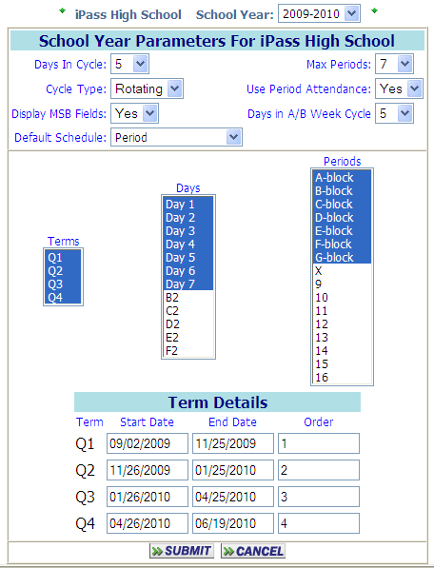

Change the Start Date and/or the End Date to match the correct School Calendar.
- Click to save your changes.

II-3. Complete Student Reports -
Certain reports and procedures need to be completed, particularly at the secondary level.

Calculate “Loss of Credit”

Honor Rolls

Horizontal Average calculations

Report Cards

GPA Calculations

Transcripts and/or Permanent Record Labels

Competency Reports

Update Post Graduate Plans

Helpful Hint: Space has been left intentionally here and on the Check List to allow you to list those additional reports which may be required by your school or district.

II-4. Print End-of-Year Reports -
You, your Principal and/or your District need to determine which reports are needed.

Helpful Hint: Save a copy of the reports for yourself. You could also save the reports to a file, diskette or CD for future reference. Reports should NOT be in your <My Data> <My Reports> list for any significant length of time. There have been several occasions where all reports in these lists for all users have had to be deleted because users were not clearing out stale reports or reports that they did not need causing the disk on the server to run out of space. PLEASE CLEAR YOUR REPORTS ON A REGULAR BASIS.

II-4-A. Biographical Reports -
It may be helpful and as a future resource, to print Biographical reports, such as the Student Directory and Entry/Withdrawal report. Select <Biographical System> <Reports>.

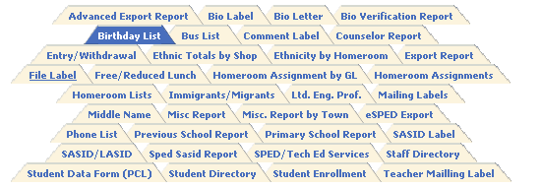

Student Directory

Entry/Withdrawal Report

Helpful Hint: Space has been left intentionally here and on the Check List to allow you to list those additional reports which may be required by your school or district. Also keep in mind those reports that you may have been asked for during the year that were based on the previous year’s data. If may be easier for you to print those reports now and save them, rather than trying to re-create them at some point in the distant future.

II-4-B. Attendance Reports -
Print samples of each of the Attendance reports listed to determine which are important to you and/or to your Attendance Office. Be sure to keep a copy for yourself.
- Select <Attendance System> <Reports>.

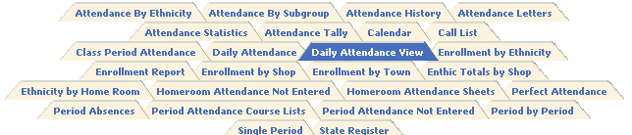

The State Register is a very important and detailed report which should be printed for both yourself and the district attendance office. The report shows the detailed record for each student for the year. It includes Entry and Withdrawal information as well as the dates of all Absences, Tardies and Dismissals.

The Attendance History report is a detailed report for each student. Some schools have decided to print this record at the end of the school year for each student and file the copies for future reference. Others have printed this report on a regular basis and sent it home with the Report Card and/or Mid-Term Progress Report.

The Attendance Statistics report is a very important and detailed report which should be printed for both yourself and the district attendance office. This report is also used by some schools to check the Attendance records by Grade Level so that recognition can be given to the “Class” with the best Attendance record.

Attendance Tally and/or Perfect Attendance report.

NOTE: The Perfect Attendance report is based on the Attendance Codes defined by the District.

Helpful Hint: Space has been left intentionally here and on the Check List to allow you to list those additional reports which may be required by your school or district. Also keep in mind those reports that you may have been asked for during the year that were based on the previous year’s data. If may be easier for you to print those reports now and save them, rather than trying to re-create them at some point in the distant future.

II-4-C. Other Reports -
There may be additional reports that you may need to or want to print at the end of the Year in other areas.

<Discipline System> Student Disciple records

<Grading System> Earned Credits Reports

Helpful Hint: Space has been left intentionally here and on the Check List to allow you to list those additional reports which may be required by your school or district. Also keep in mind those reports that you may have been asked for during the year that were based on the previous year’s data. If may be easier for you to print those reports now and save them, rather than trying to re-create them at some point in the distant future.

II-5. Graduate Your High School Seniors – Grade 12 – YOG 2011 -

Seniors need to be Graduated in i PASS with a date that is on or before the last day of school. You can wait until the school year ends and back date the withdrawal if there are reports that you need to produce for the end of the year. They must be Graduated with an Entry/Withdrawal code of “Graduated” prior to reports being filed with the state.

NOTE: For Massachusetts Public Schools they MUST have a valid Post Graduate Plan. Update all 12th grade students’ Post Graduate Plans.

DO NOT GRADUATE STUDENTS WHO ARE LEAVING YOUR BUILDING TO ATTEND ANOTHER BUILDING IN YOUR DISTRICT NEXT YEAR.
DO NOT GRADUATE STUDENTS WHO HAVE NOT COMPLETED GRADE 12.

Helpful Hint: You should also clear their Locker Assignments for these graduates.
II-5. Graduate Your High School Seniors – Grade 12 – YOG 2011 – (cont.)
*Please note: you must clear your senior lockers prior to graduating them!

Select <Biographical System> <Mass Update Students> <Mass Enroll>.

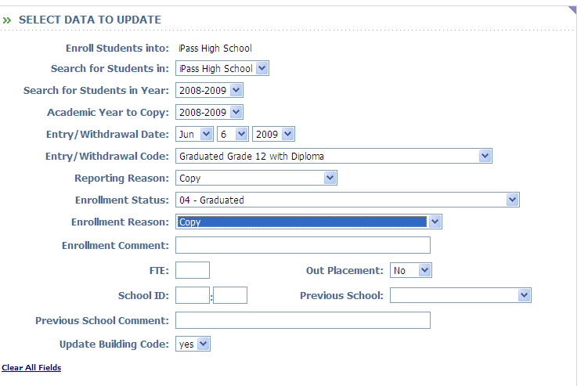
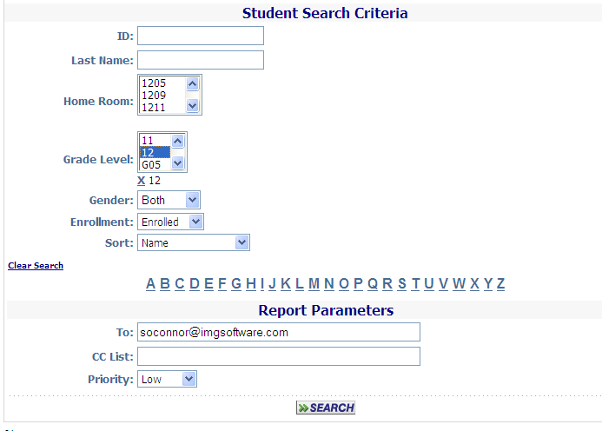
The Mass Enroll program will allow you to graduate your Seniors. You can also copy certain information from their most recent Enrollment record to insure that exceptions to DOE fields 11 & 13 are retained.
II-5. Graduate Your High School Seniors – Grade 12 – YOG 2011 – (cont.)

Data to Update

Search for Students in:
  - Select your school from the pull-down list.

Academic Year to Copy:
  - Select the current Academic Year.

Entry/Withdrawal Date:
  - Select a Date On or Before the Last day of School from the pull-down list, so that they will properly be reported to the DOE.

Entry/Withdrawal Code:
  - Select C1 - Graduated Grade 12 with Diploma from the pull-down list.
  - Select C2 – Completed a terminal program – completed the 12th grade but received no diploma for students who will be assigned Enrollment Status Mass. DOE code 10 – Certificate of Attainment either as a group or individually.

Enrollment Reason:
  - Select Copy. The Enrollment Reason from the student’s most recent Enrollment record will be copied into this new Withdrawn/Graduated record.

Enrollment Status:
  - Select 04 – Graduated from this District.
  - Select 10 – Certificate of Attainment if the student has completed Grade 12, but did not meet MCAS requirements.

Reporting Reason:
  - Select Copy. The Reporting Reason from the student’s most recent Enrollment record will be copied into this new Withdrawn/Graduated record.
NOTE:
- Students graduating from a Massachusetts Public School (State “Enrollment Reason” = 04 - Graduated from this District or 10 - Certificate of Attainment) MUST have a Post-Graduate Plans code other than the default value of 500. The DOE validation program will reject Graduated students who are reported as 500 – Does not apply at this time and will also reject your file if a large percentage of students are reported as 09 – Plans Unknown.
- The Enrollment Status is the only DOE element that changes from those originally used for their Enrollment when a student is Withdrawn, Graduated, or Transferred.
- The Copy feature of this program insures that those students with Enrollment Reasons and/or Reporting Reasons which are different from those of the majority of students will be copied and do not need to be processed separately.
- Exceptions can be processed as a new group using this Mass Enroll program or they can be Withdrawn/Graduated individually in <Biographical Systems> <Add/Modify Student Biographical> <Enrollment>.
- Non-Graduates will remain Enrolled. They will be need to be enrolled for 2011-2012 as Grade 12 student and will repeat the year or they will be reported to the Massachusetts DOE on the October 1 Report as a Summer Graduate (Mass. DOE Code 04 – Graduated from this District or Mass. DOE Code 10 – Certificate of Attainment). or they will be reported as a Drop-Out if you have no evidence that they are continuing their education. If you know that they are continuing their education elsewhere to complete their graduation requirements, then they must be given an “EXIT” record.

II-5. Graduate Your High School Seniors – Grade 12 – YOG 2011 – (cont.)

Enrollment Comment:
  - Enter a Comment or leave the field blank.

FTE:
  - Leave the field blank.

Out Placement:
  - Select No from the pull-down list.

School ID:
  - Leave the field blank or enter your School and District code.
If left blank, your School ID will be filled in automatically in the DOE 52 or CT elements file from the your District and School Profiles.
  - Enter School and District codes of the school the student is attending, if the student is out placed.

Previous School:
  - Accept the default of Copy.

Previous School Comment:
  - Leave the field blank or Enter your school name.

Update Building Code:
  - Select No.

Student Search Criteria

Grade Level:
  - Select Grade Level 12.

Enrollment:
  - Select Enrolled to list only those Seniors currently enrolled.

- Click to display your selection.

Use the check-boxes to identify which students will be Graduated with these values and which students will not be Graduated with these values.
Use the Check All, Clear All options to facilitate your selection/de-selection process.
- Click to save your changes.
II-6. Create the Massachusetts DOE SIMS file
or the Connecticut PSIS file -
(Year End/all data elements).

AFTER ALL ENROLLMENT REPORTS HAVE BEEN PRINTED

AND AFTER THE HIGH SCHOOL CLASS OF 2011 HAS BEEN GRADUATED

AND YOUR Special Education DATA HAS BEEN UPDATED. ALL GRADE 12 STUDENTS MUST HAVE UPDATED POST GRADUATE PLANS PRIOR TO CREATION OF THE SIMS OR PSIS FILE EXPORT.

The file can be created any time after the close of school AND after your High School Seniors – Class of 2007 has been processed as Graduated.
The file will ONLY include data for those students who need to be reported.
- Select <DOE ID Manager> <Import/Export> <Export 52 Elements> or <Export CT Elements>.

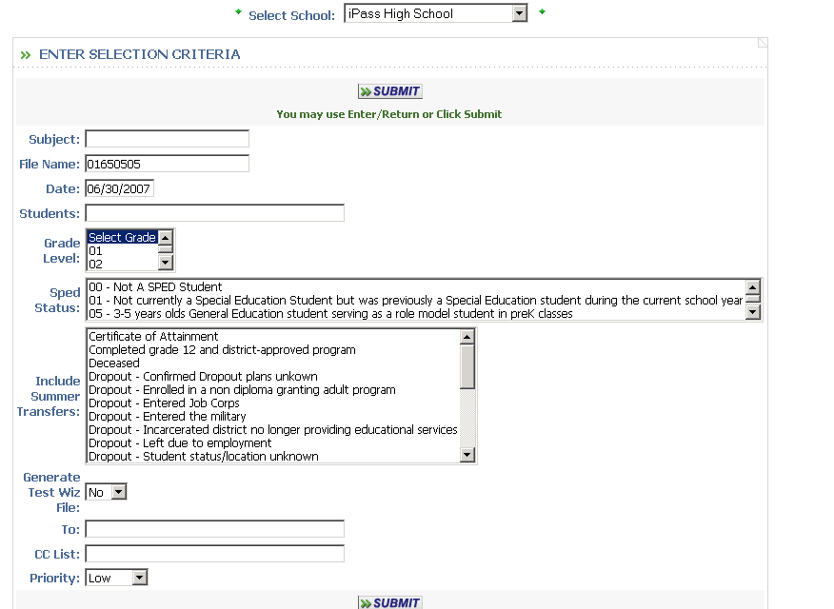

Subject:
  - Enter a Subject or leave blank. The Subject will appear in the Import/Export Viewer and may be helpful to identify the school and/or a particular Grade Level that you are checking.

Filename:
  - Accept the default of your School ID (District & School Code).

Date:
  - Enter the date of the Last Date of School.

Students:
  - Leave the field blank to include ALL students.

Grade Level:
  - Accept the default Select Grade and ALL grade levels will be included.
Sped Status:
  - Leave the field blank to include ALL students.
  - Highlight the specific Status codes that you want.

Include Summer Transfers:
  - Leave the field blank to include ALL summer transfers for the Oct 1 submission.
  - High all of the Dropout code for the March and June submissions.

Generate Test Wiz File:
  - Accept the default of NO to create a 52 element file.
  - Select Yes to create a File to import into Test Wiz which add course and teacher data to the Test Wiz MCAS statistics.

- Click to save your changes.

NOTE: You should review the file using the Import/Export Viewer. Blanks appear as red boxes. You can also open the file as an Excel spreadsheet and re-sort the file in various ways to look for exceptions.

Reminder: To open the file as an Excel spreadsheet:
1) <My Data> <My Report> right-click with the mouse on the CSV version of the report;
2) Click Save Target As;
3) Select the Save In folder where you want to place the file;
4) Enter a filename with as .csv extension;
5) Select Save As Type = All files;
6) Click on Save;
7) Open Excel, find the file and work with it to sort, view or print.

Helpful Hint: This file can be created at any time for select groups of students to verify data.

II-7. Create the Massachusetts DOE Discipline Records file
The file can be created any time after the close of school.
- Select <DOE ID Manager> <Import/Export> <Export MA DOE Discipline>.

PHASE III: Starting a New School Year

BE SURE THAT YOUR SUBMISSION OF THE Massachusetts DOE SIMS, SSDR (School Safety & Discipline Report) or Connecticut PSIS DATA ELEMENTS FILE HAS BEEN ACCEPTED BY THE DOE BEFORE DOING ANY OF THE FOLLOWING STEPS WHICH CHANGE EXISTING DATA!

III-1. DISTRICT - Change Academic Year -
This is a DISTRICT procedure. Be sure that all reports are completed and all schools are notified as soon as this step has been completed.
- Select <System Configuration> <Parameter Maintenance>.

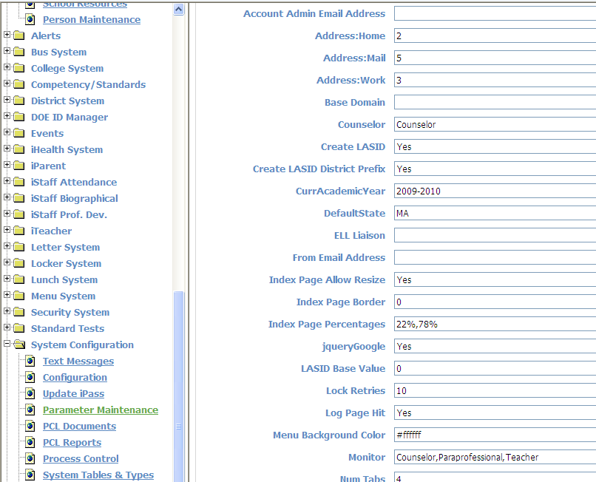

Application: TEAM Parameter Group: System

Current Academic Year (CurrAcademicYear):
- Set CurrAcademicYear to 2011-2012.
- Click to save your changes.

This step will:
1) Changes the default Academic Year for all appropriate programs to 2011-2012;
2) Move the Next Year’s School assignments to the Primary School field for each student;
3) Blank out the Next Year’s School field for each student, unless they have already been set for the next year (i.e. 2012-2013);
4) Display the correct Homeroom assignment for 2011-2012;
5) Set the Previous School to their 2010-2011 school, if they changed building, otherwise it will be the previous school/building that they attended.
6) Cancel the restriction for parents or staff to see schedules that are still being developed.
III-2. DISTRICT - Promote Grade Level -
This procedure MUST be completed at the DISTRICT level as all schools will be processed in a single step.

For each and every student with a Primary School/Year record in 2010-2011, this action will change their Grade Level to the Next Grade Level value as defined in the (District) Grade Level table <Administration> <District Resources> <Grade Levels> and increment the YOG associated with that Grade Level by one (1) year. The Grade Level table should have been checked and modified, if necessary, at the end of the previous year, or at least checked/modified in Step I-2-A of this document.

If a student’s “Next Grade Level” on their Biographical Profile screen was pre-defined, usually to indicate that they have been retained in grade, then the student will not be promoted and their Grade Level will be whatever was defined in the “Next Grade Level”.

- Select <Administration> <End of Year Procedures> <Promote Grade Level>.

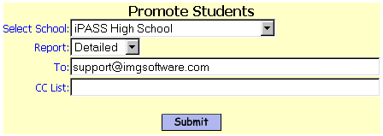

Promote Students’ Grade Level:

Report:
  - Select the default of “Detailed” to get a report which errors in the process and lists every student processed.
  - Select “Summary” to get a report which only shows errors in the process.

III-2A. DISTRICT Re-define YOG’s for Graduated Grade Levels –

This is a DISTRICT function. When students are promoted, the YOG for each Grade Level will have to be changed to reflect the YOG’s for the new school year. For example, grade 12 students will now have a YOG of 2012, and all grade levels will have to be set to one year higher than the previous year. Those Grade Levels defined for graduated students (G10,G09) should not be changed.
- Select <Administration> <District Resources> <Grade Levels>.

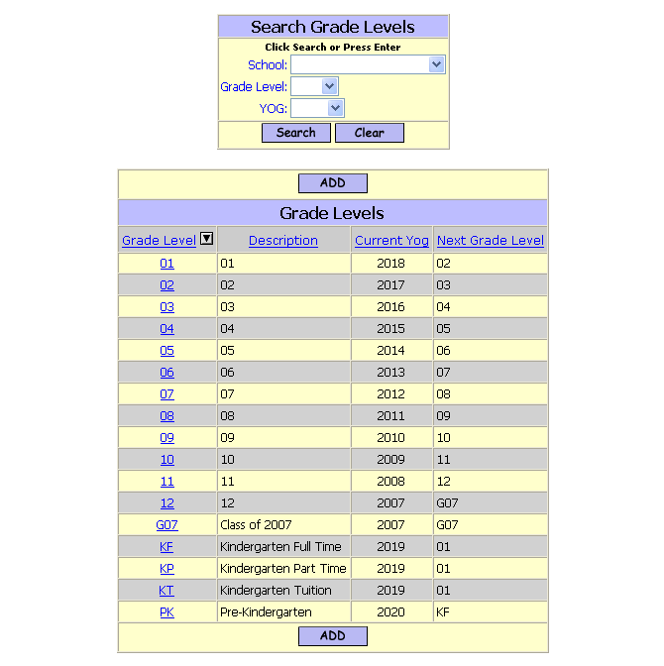

- Select the “Graduated” Grade Levels(s) which needs to be modified.
- Change the Current YOG to be the year the students graduated.
Suggestion: Grade Level G11 for the Graduating Class of 2011.

- Click to save your changes.
III-3. Add/Modify Teachers/Staff – iStaff Biographical

- Please note: Adding new staff or moving staff to new jobs/locations may be a district function and only be accessible by the Human Resources/Central Office staff.

III-3-A. iStaff Biographical>Add/Modify Staff

Click on to create a new teacher/staff member:

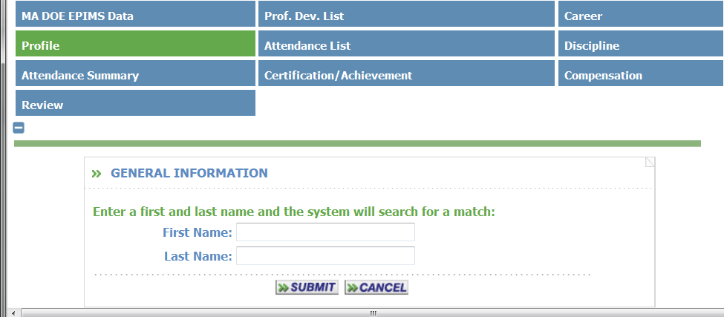

If a match is found, the match will be displayed and you may select the staff record that is in the database.

If no match is found, the following screen Staff Profile screen will be displayed:

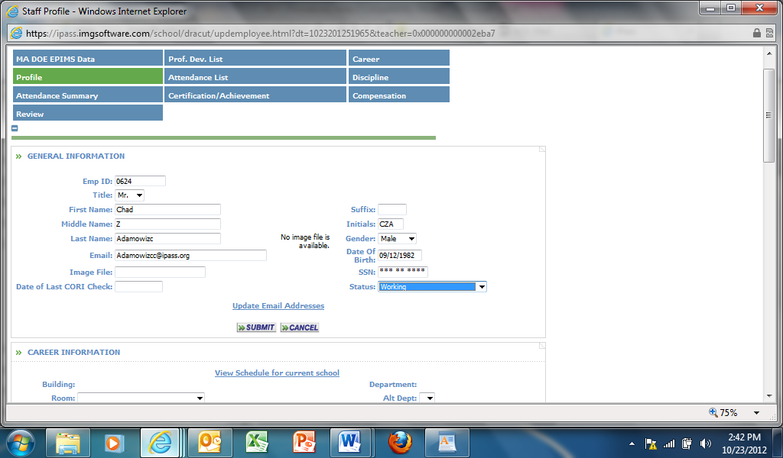

III-3. Add/Modify Teachers/Staff – (cont.)

Print Name:
  - Accept the default of the person’s Last Name, First Name.
  - Enter the Print Name that will appear on student schedules, report card, etc.
  - Modify the Print Name to the standard format determined by the school.

Room:
  - Enter the person’s Room or Homeroom assignment. This is a required field if the person is a teacher who will have student assigned to them in a homeroom.

NOTE: Additional Fields are optional. Some are related to Scheduling. These are explained in the Scheduling Procedures documentation. Others are related to the i Staff software module.

Add a Career Record

Click on the Career Tab at the top of the screen.

All careers for the employee are listed here. The most recent career will appear at the top.
⇒ Click on the Career Date to open the employee career screen.
⇒ Click Add to add another career.

⇒ You can also edit the Job on the Career Batch Entry Screen. (Refer to Page 30)
⇒ You can also edit the School on the Career Batch Entry Screen. (Refer to Page 30)

The Following information is for EPIMS
⇒ Enter Start Date used for Date of Hire
⇒ Select a Status
⇒ Select a Job used for Job Classification
⇒ Select a School use to generate School and District Numbers
⇒ Select an FTE used to generate the FTE by Section on the Work Assignment File
⇒ Use End Reason and End Date only when an employee leaves or ends a career

III-3-C. Remove a Teacher/Staff member -

Select School:
  - Select the school where the teacher/staff person is currently assigned.
  - Click on the teacher/staff person to access their record.

Check Delete this employee box in the bottom center of the basic profile section.
This makes the teacher/staff person inactive.
It will not purge their record.
If you uncheck this box, then the person will be re-activated.
You may also want to edit their (Employment) Status field to identify why the person is no longer active.

- Click to save your changes.

III-4. Add/Modify/Delete Rooms -
Use this program to add, modify or delete rooms which will be used as Homerooms, Classrooms or to identify locations for use within the <Discipline System>.
- Select <Administration> <School Resources> <Room Catalog>.

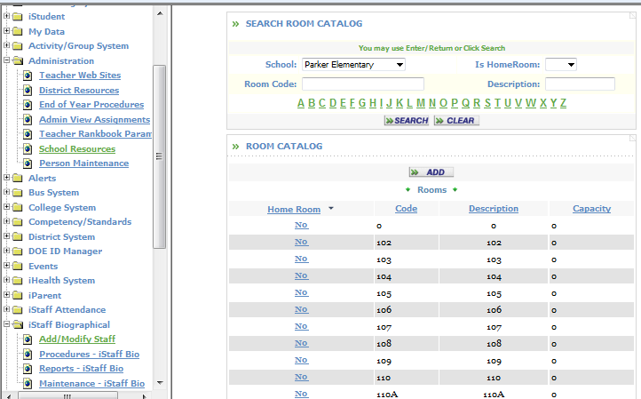

Add a room:
Click at the top or bottom of the default list of rooms.

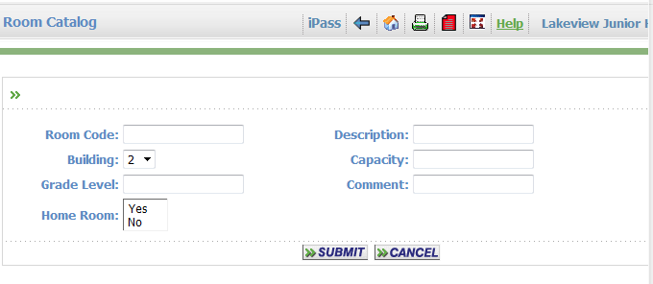

Room Code:
- Enter a room code or room number. This could also be the name or the abbreviation of the name of the Homeroom Teacher.

NOTE: If your Room Code or Room Description is a Teacher Name or other specific distinction that is not permanent, then those values need to be reviewed/modified. You may edit an existing Room Code and/or Room Description, but be aware that this will change that information anywhere that room has been assigned, including records in previous years.
Description:
- Enter a description of the room, e.g. Chemistry lab, or re-enter the room code/number.
Building:
- Enter the building code. This was designed for multi-building campuses. Most schools ignore this field. Schools with a multi-building campus will generally identify the building location within the room code/number.
Capacity:
- Enter the capacity of the room. Other than a reference, this value is only used when the <Mass Load Homerooms> program is run to automatically load Homerooms.
Grade Level:
- Enter the Grade Level to be assigned to this room when used as a Homeroom. Other than a reference, this value is only used when the <Mass Load Homerooms> program is run to automatically load Homerooms.
Comment:
- Enter a comment.
Homeroom:
- Enter Yes if this room will be used as a Homeroom and should appear on any pull-down list of Homerooms, included the update and load programs.
- Click to save your changes.

III-4. Add/Modify/Delete Rooms – (cont.)

Add a room:
Click at the top or bottom of the default list of rooms.

Room Code:
- Enter a room code or room number. This could also be the name or the abbreviation of the name of the Homeroom Teacher.

NOTE: If your Room Code or Room Description is a Teacher Name or other specific distinction that is not permanent, then those values need to be reviewed/modified. You may edit an existing Room Code and/or Room Description, but be aware that this will change that information anywhere that room has been assigned, including records in previous years.
Description:
- Enter a description of the room, e.g. Chemistry lab, or re-enter the room code/number.
Building:
- Enter the building code. This was designed for multi-building campuses. Most schools ignore this field. Schools with a multi-building campus will generally identify the building location within the room code/number.
Capacity:
- Enter the capacity of the room. Other than a reference, this value is only used when the <Mass Load Homerooms> program is run to automatically load Homerooms.
Grade Level:
- Enter the Grade Level to be assigned to this room when used as a Homeroom. Other than a reference, this value is only used when the <Mass Load Homerooms> program is run to automatically load Homerooms.
Comment:
- Enter a comment.
Homeroom:
- Enter Yes if this room will be used as a Homeroom and should appear on any pull-down list of Homerooms, included the update and load programs.
- Click to save your changes.

Modify a room:
- Click on the Homeroom Yes/No hyperlink for the room you wish to delete.
- Change the appropriate fields.

Delete a room:
You cannot remove a room that has been assigned to a student or course.
- Click on the Homeroom Yes/No hyperlink for the room you wish to delete.
- Click the Delete box at the bottom of the record.

III-5. Clear Existing Biographical Data -

The values of various Student Biographical fields change from year-to-year and need to be cleared and redefined. IMG suggests that you clear the existing old data before making new assignments. It is easier to identify students with blank records, then to identify students with incorrect values.
- Select <Administration> <End of Year Procedures> <Clear Student Data>.

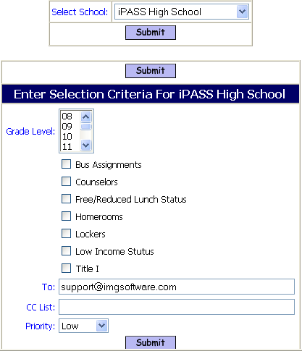

- Select one or more Grade Levels.
- Check one or more fields that you wish clear.

WARNING: This program will clear the selected data for ALL students in your school for the grade level(s) selected.

There is not currently an “Are you sure…” message in this program. BE SURE YOU WANT TO DELETE THE DATA FOR THE STUDENTS SELECTED BEFORE YOU CLICK SUBMIT!

- Click to save your changes.

Helpful Hint: Most schools will not remove Free/Reduced Lunch Status and Low Income Status until a report is printed, <Biographical System> <Reports> <Free/Reduced> in order to maintain services until the new application process is completed for October 1st.

Use the “Title I” option if students are moving from a school which is “school-wide” Title I to a school which is has Title I on an individual student basis, or no Title I program at all.

III-6. Enroll/Withdraw/Transfer Students –

III-6-A. Mass Enroll/Re-enroll Students -
The Mass Enroll program will allow you to enroll/withdraw/graduate one or more students. You can copy information from their most recent Enrollment record to insure that exceptions to the DOE fields 11 & 13 are retained.

You will not be able to use the Copy option for students who are new to your District.

ALL students MUST have a new Enrollment/Entry Record for a new Academic Year.

Massachusetts Public Schools – All students enrolled at the end of 2010-2011 MUST BE ENROLLED FOR 2011-2012 unless they have a summer withdrawal record!

NOTE: It is recommended that you only use the “Copy” option for Reporting Reason (Mass. DOE field #011 and Connecticut PSIS field “Enrolled at Local Expense”) and Enrollment Reason (Mass. DOE field #013), otherwise you may be copying incorrect data, such as enrollment data for students who entered in the middle of the previous school year.

Withdrawals are required if the student is leaving the district and or transferring to another school within the district during the school year.

NOTE: The Comment field within the student’s Withdrawal record can be used to indicate specific dates of notification and records being sent.

Any student may be Enrolled/Withdrawn individually in <Biographical System> <Add/Modify Student Biographical> <Enrollment>.

III-6-A. Mass Enroll/Re-enroll Students – (cont.)
  - Select <Biographical System> <Mass Update Students> <Mass Enroll>.

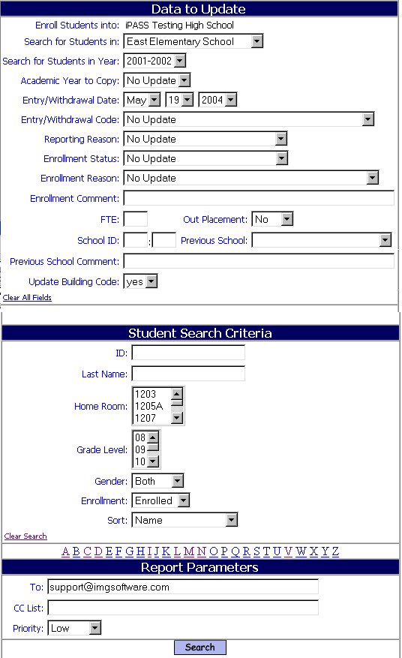

Data to Update

Search for Students in:
  - Select your school from the pull-down list.

Academic Year to Copy:
  - Select the previous Academic Year. This field MUST be defined if you intend to use the Copy option for any of the applicable fields.
  - Select No Update and the Copy option will be disabled for ALL fields.

Entry/Withdrawal Date:
  - Select the first day of school for 2011-2012 from the pull-down list, so that they will properly be reported to the Mass.DOE/CT.PSIS.

III-6-A. Mass Enroll/Re-enroll Students – (cont.)

Entry/Withdrawal Code:
The data in this field will automatically populate the Mass. DOE field 12 or the CT.PSIS record of the student.
It is also used by i PASS to determine Enrolled/Withdrawn/Graduated status. It is also included in the State Register report and in summary format in both the State Register report and Entry/Withdrawal report.
  - Select Re-enrolled Same School from the pull-down list for students who are returning to your school.
  - Select Re-enrolled Same District from the pull-down list for students who are entering your school from another school within the district.
  - Select the appropriate code from the pull-down list for students who are new to the district.
NOTE: You may use the Copy option, however, this may copy data that was accurate for last year’s entry, but may not be applicable for this year.

Enrollment Reason:
  - Select Copy. The Enrollment Reason from the student’s most recent Enrollment record will be copied into this new Enrollment record.
  - Select the appropriate code from the pull-down list for students you are enrolling.

Enrollment Status:
This field will automatically be populated from the student’s Entry/Withdrawal code defined above.

Reporting Reason:
  - Select Copy. The Reporting Reason from the student’s most recent Enrollment record will be copied into this new Enrollment record.
  - Select the appropriate code from the pull-down list for students you are enrolling.

Enrollment Comment:
  - Enter a Comment or leave the field blank.

FTE:
  - Leave the field blank.

Out Placement:
  - Select No from the pull-down list.

School ID:
  - Enter your District and School codes or leave the field blank.
If left blank, your School ID will be filled in automatically in the DOE 52 elements file from your District and School Profiles.
NOTE: It is strongly recommended that this field be left blank for all students, except those who are Special Education – Out Placement students. Otherwise the ID will need to be changed for each student when they move to a different building within your District.
  - Enter the (Mass. DOE 8-digit code) District and School codes of the school the student is attending, if the student is out placed.

Previous School:
  - Accept the default of Copy.
Previous School Comment:
  - Leave the field blank for mass update purposes.

III-6-A. Mass Enroll/Re-enroll Students – (cont.)

Update Building Code:
  - Select No for grade levels of students who were in your building last year.
  - Select Yes for grade levels of students who are new to your building. A new Entry Date in Building record will be created.

Student Search Criteria

Grade Level:
  - Select a single Grade Level. You may select more than one Grade Level, however, it will produce a very long list to deal with.

NOTE: If you do select more than one Grade Level, then do not include the grade level of students new to your school. These students need to have their Building entry redefined and must be processed as a single group.

- Click to display your selection.

Use the Check All option to identify which students will be re-enrolled for the new year. Uncheck those students who are exceptions to the majority selected for the field values selected.

- Click to save your changes.

IMPORTANT: Massachusetts Public Schools - If the student met their Graduation requirements during the summer, then ADD an Enrollment record with an Enrollment - Withdrawal Status of Mass. DOE Code 04 – Graduated with Competency Determination or Mass. DOE Code 10 – Certificate of Attainment and modify their YOG and Grade Level.

III-6-B. Enroll/Withdraw/Transfer a Single Student -
  - Select <Biographical System> <Add/Modify Student Biographical> Select the Student, then select <Enrollment>.

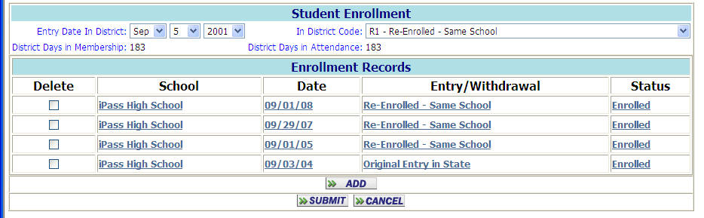

Click to create a new Entry/Withdrawal record.

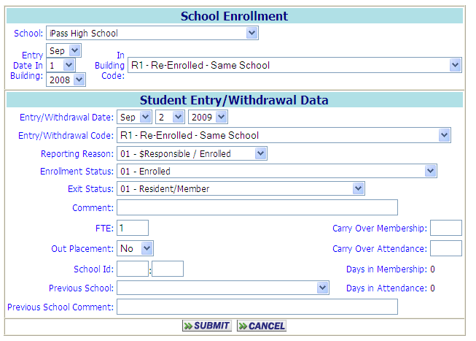

NOTE: Please note the Check Box which appears at the bottom of any Enrollment Record, after it has been submitted, to allow you to remove a Withdrawn or Transferred student from:
- The Course Seat count. It will not remove them from the course, or affect their schedule or grades, but only free up their seat to allow another student to be assign, particularly if the course was full.
- Their Locker assignment, making the locker available to be re-assigned.
- Their Homeroom.
- Their Bus Assignments.

Follow the directions below for the particular record type that you wish to create.
III-6-B-i. Enroll a single Student -

School:
  - Accept the default value of your school.
  - Select a school from the pull-down list.
Entry Date in Building:
  - Accept the default date of <Today> if today is the first day that the student is in or expected to be in your school.
  - Select the date of the student’s first day of school.
In Building Code:
  - Select the appropriate code to identify the student’s enrollment.
Entry/Withdrawal Date:
  - Accept the default date of <Today> if today is the first day that the student is in or expected to be in your school.
  - Select the date of the student’s first day of school.
Entry/Withdrawal Code:
  - Select the appropriate code to identify the student’s enrollment.
Enrollment Reason:
  - Select the appropriate code from the pull-down list for student you are enrolling.
Enrollment Status:
This field will automatically be populated from the student’s Entry/Withdrawal code defined above.
Reporting Reason:
  - Select the appropriate code from the pull-down list for students you are enrolling.
Enrollment Comment:
  - Enter a Comment such as the date paperwork was first completed or the name of the student’s Previous School if it is has not been defined in the database for the pull-down list below.
  - Leave the field blank.
FTE:
  - Leave the field blank.
Out Placement:
  - Select No from the pull-down list.
School ID:
  - Enter your District and School codes or leave the field blank.
If left blank, your School ID will be filled in automatically in the DOE 52 elements file from your District and School Profiles.
NOTE: It is strongly recommended that this field be left blank for all students, except those who are Special Education – Out Placement students. Otherwise the ID will need to be changed for each student when they move to a different building within your District.
  - Enter the (Mass. DOE 8-digit code) District and School codes of the school the student is attending, if the student is out placed.
Previous School:
  - Select the Previous School from the pull-down list of “Out of District” school, if available.
Previous School Comment:
  - Enter a Comment, such as the name of the school, city, state, country, contact information, etc.
  - Leave the field blank.
Carry Over Membership:
  - Leave the field blank when enrolling a new student.
Carry Over Membership:
  - Leave the field blank when enrolling a new student.

- Click to save your data.
III-6-B-ii Withdraw a single Student -
The Mass Enroll program will allow you to enroll/withdraw/graduate one or more students. You can

Massachusett Public Schools – All students who do not return to your school or another school within the District MUST be given an additional Enrollment record with the appropriate Withdrawal “Exit” code.

School:
  - Accept the default value of your school.
  - Select a school from the pull-down list.
Entry Date in Building:
Do Not Change this record.
In Building Code:
Do Not Change this record.
Entry/Withdrawal Date:
  - Accept the default date of <Today> if today is the first day that the student is NOT in your school.
  - Select the date of the student’s first day of NOT in your school.
NOTE: You cannot withdraw a student in advance. They must remain enrolled in order to record attendance.
Entry/Withdrawal Code:
  - Select the appropriate code to identify this student’s withdrawal.
Enrollment Reason:
  - Select the appropriate code from the pull-down list which matches their previous enrollment record.
Enrollment Status:
This field will automatically be populated from the student’s Entry/Withdrawal record.
Reporting Reason:
  - Select the appropriate code from the pull-down list which matches their previous enrollment record.
Enrollment Comment:
  - Enter a Comment such as the date paperwork was first completed or the name of the school the student is moving to.
  - Leave the field blank.
FTE:
  - Leave the field blank.
Out Placement:
  - Select No from the pull-down list.
School ID:
  - Leave the field blank for a student who is withdrawing
Previous School:
  - Leave the field blank for a student who is withdrawing
Previous School Comment:
  - Leave the field blank for a student who is withdrawing
Carry Over Membership:
  - Leave the field blank for a student who is withdrawing
Carry Over Membership:
  - Leave the field blank for a student who is withdrawing

- Click to save your data.

Helpful Hint: After Withdrawing a student, open the newly created record and use the Check box option at the bottom of the record to remove the student from “Seat count, Locker, Homeroom and Bus assignment”.
III-6-B-iii. Transfer a single Student to another School within District

NOTE: For a student who is transferring to another school within the same school district:
- A Withdrawal record must be entered by the sending school for the first day the student will not be in their school.
- The student’s “Primary School” record on their Biographical – Profile page must be changed to indicate the new receiving school.
- An Entry record must be entered by the receiving school with a date of the first day the student will be or should be in the new school. This date would be the same date as their withdrawal in order to maintain a continuous record.

School:
  - Accept the default value of your school.
  - Select a school from the pull-down list.
Entry Date in Building:
Do Not Change this record.
In Building Code:
Do Not Change this record.
Entry/Withdrawal Code:
  - Select TRF – Transfer within District to identify this student’s transfer. This will also insure that the student is only reported to the DOE from one school.
Enrollment Reason:
  - Select the appropriate code from the pull-down list which matches their previous enrollment record.
Enrollment Status:
This field will automatically be populated from the student’s Entry/Withdrawal record.
Reporting Reason:
  - Select the appropriate code from the pull-down list which matches their previous enrollment record.
Enrollment Comment:
  - Enter a Comment such as the reason for the transfer.
  - Leave the field blank.
FTE:
  - Leave the field blank.
Out Placement:
  - Select No from the pull-down list.
School ID:
  - Leave the field blank.
Previous School:
  - Leave the field blank.
Previous School Comment:
  - Leave the field blank.
Carry Over Membership:
  - Leave the field blank when transferring a student.
Carry Over Membership:
  - Leave the field blank when transferring a student.

- Click to save your data.

Helpful Hint: After Transferring a student, open the newly created record and use the Check box option at the bottom of the record to remove the student from “Seat count, Locker, Homeroom and Bus assignment”.

III-7. Assign Homerooms -
There are several program options for assigning students to Homerooms, other than editing their Biographical Profile record one student at a time.

Helpful Hint: Use the <Administration> <End of Year Procedures> <Clear Student Data> program to remove last year’s homerooms. It will be easier and with fewer errors to load new homerooms into blank fields, then to keep track on which assignments are new and which are old.

III-7-A. Mass Update Homerooms -
- Select <Biographical System> <Mass Update Students> <Mass Update Students>.

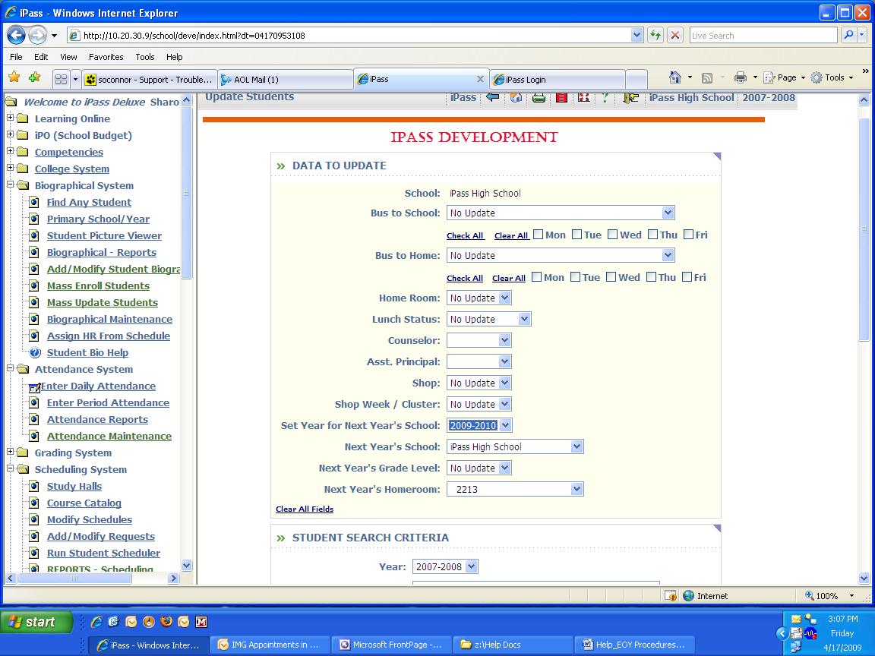

Data to Update

Homeroom:
  - Select the Homeroom to load from the pull-down list.

Student Search Criteria
Use the filtering criteria to select the students to be considered for assignment to the Homeroom selected above.

Helpful Hint: A last name range may be appropriate (Enter a Last Name range, i.e. A-G) to identify the students or to narrow down your selection list.

- Click to list your selections.

Use the check-boxes to identify which students will be assigned to the selected Homeroom.
Use the Check All, Clear All options to facilitate your selection/de-selection process.
- Click to save your changes.
III-7-B. Mass Load Homerooms (by Grade Level in Last Name Order) -
This program will read the data in the Room Catalog to load students into Homerooms based on the Room Capacity and Grade Level assigned to the Room. It is a “bucket-load” process, where the first room will be filled to its defined capacity before moving to the second room. It will not balance, automatically. To balance the room counts, modify the capacities of reach room in <Administration> <School Resources> <Room Catalog>. The room capacity is only used for this program. You will not have to redefine the capacity to allow for new students to be individually assigned to Homerooms.
- Select <Biographical System> <Mass Update Students> <Mass Load Homerooms>.

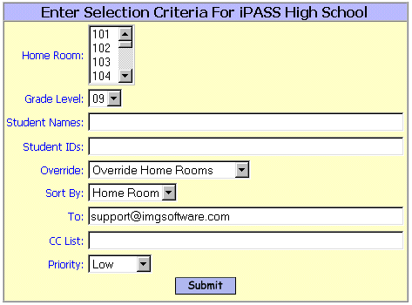
Select School:
  - Select the School from the pull-down list.
Homeroom:
  - Select one or more Homerooms that you wish to load from the pull-down list.
If you select more than one Homeroom, then students will be assigned in alphabetical order in homerooms based on room code order up to the maximum capacity of each room as defined in the Room Catalog.
Grade Level:
  - Select the Grade Level that you wish to assign from the pull-down list.
Student Names:
  - Enter a last name or part of a last name or a range of last names of the students that you wish to assign.
  - Leave the field blank to load students based on other criteria.
Student IDs:
  - Enter an ID# or a string of ID#s, separated by commas, of the students that you wish to assign.
  - Leave the field blank to load students based on other criteria.
Override:
  - Select Yes to override their existing Homeroom.
  - Select No to only fill blank assignments and not override existing assignments.
Sort By:
A report will list the students who have been assigned.
  - Select the default sort of Homeroom.
  - Select Name to sort by student last name.
- Click to save your changes.
III-7-C. Assign Homerooms based on Student Schedules -
This program will assign a homeroom to each student based on their Course Schedule room location, based on the Term, Period and Day that you select.
This program could be helpful for modifying Homerooms for distribution of materials. For example: Change Homerooms to the students’ last period location; print Report Cards in Homeroom sort order and distribute them to the last period locations without re-sorting or sending students back to a regular Homeroom or back to their first period class.
- Select <Biographical System> <Mass Update Students> <Assign Homeroom from Schedules>.

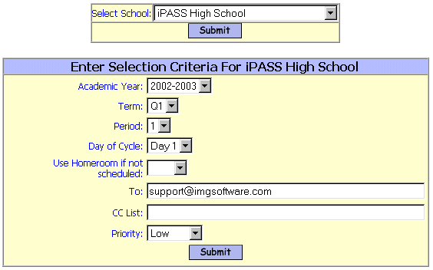

Academic Year:
  - Select the Academic Year from the pull-down list.
Grade Level:
  - Select the Grade Level that you wish to assign from the pull-down list.
  - Do not highlight any Grade Level to assign Homerooms for all Grade Levels.
Term:
  - Select the Term from the pull-down list.
Period:
  - Select the Period from the pull-down list.
Day in Cycle:
  - Select the Day in Cycle from the pull-down list.
Use Homeroom if not Scheduled:
  - Select a Homeroom from the pull-down list which you would like to assign students to who do not have a course assignment for the Term, Period or Day of Cycle as defined above.

Helpful Hint: The “Use Homeroom if not Scheduled” could be selected and designed “Guidance” to easily get a list of students missing a course for the Term, Period or Day of Cycle as defined.

  - Click to save your changes.

III-7-D. Print Homerooms Assignments by GL Report -
This report will list each homeroom with the Room Number, Teacher, name of the first and last student assigned, alphabetically, M/F count and total assigned. Also included are gender subtotals and totals by Grade Level and the entire school. This is a very valuable report for distribution of materials, particularly to selected groups of students, i.e. all senior boys.
- Select <Biographical System> <Reports> <Homeroom Assignment by GL>.

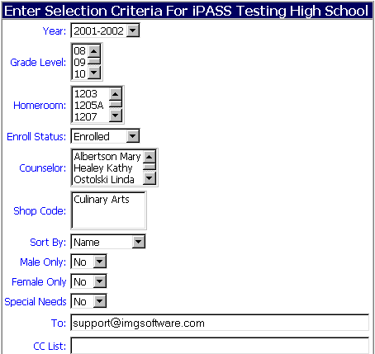
Year:
  - Select the Academic Year of the Homeroom assignments.
Grade Level:
  - Select one or more Grade Levels.
  - Do not select any Grade Levels to include all Grade Levels in the report.
Homeroom:
  - Select one or more Homerooms.
  - Do not select any Homerooms to include all Homerooms in the report.
Enrollment Status:
  - Select the default Enrolled to include only enrolled students.
  - Select Withdrawn to include only withdrawn students.
  - Select All to include both enrolled and withdrawn students.
Counselor:
  - Select one or more Counselors.
  - Do not select any Counselors to include all Counselors in the report.
Shop Code:
  - Select one or more Shop Codes.
  - Do not select any Shop Codes to include all Shop Codes in the report.
Male Only:
  - Select the default No to not list only Males.
Female Only:
  - Select the default No to not list only Females.
Special Needs:
  - Select the default No to not list only Special Needs students.
  - Click to save your changes.

III-8. Roll Over Various Tables and Values -
- Select <Administration> <End of Year Procedures>.

III-8-A. Activity Rollover
Copies your Activities and Personnel assigned to those activities to the next year.

III-8-B. Attendance Rollover
This program copies your <Attendance Configuration> data to the next year.
NOTE: Your <School Attendance Parameters> are not Academic Year specific and do not need to be rolled over.

III-8-C. Grades Rollover
Copies your <Grade Maintenance> (1-100, A’s, B’s C’s, etc.), <Scale Codes> (GPA) and <Grade Scales> (GPA) tables to next year.

NOTE: Competencies are not Academic Year specific and do not need a roll-over procedure.

The screen is the same for each of these procedures.

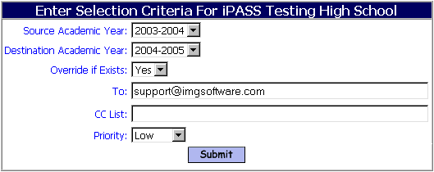

Source Academic Year:
  - Select the current Academic Year.
  - Select the Academic Year with the correct data that you wish to copy.

Destination Academic Year:
  - Select the Academic Year where the data will be copied to.
NOTE: Generally this is the next Academic Year, however, data can also be copied back to previous Academic Year if that that data were missing or incorrect.

Override if Exists:
  - Select Yes if you wish to override existing data.
  - Select No if you wish to only create records that did not previously exist.

III-9. Alerts - Check and re-set Expirations Dates
- Select <Alerts System> <Add/Modify Alerts>.
Use the filtering options to select a listing by single grade or single alert type to review expiration dates and re-set those which should remain active or set to expired those of students who have left the District.
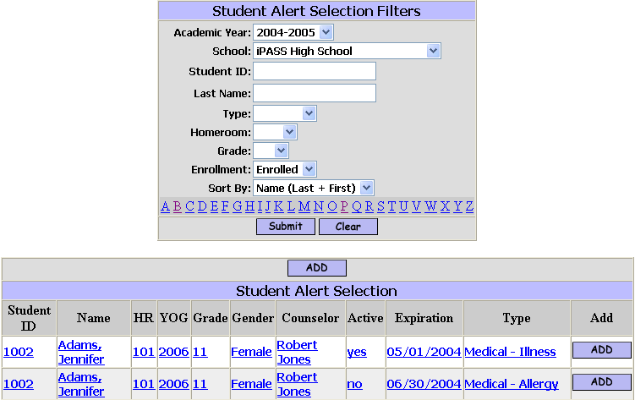

III-10. Assign Horizontal Averaging Rules to Sections -
- Select <Scheduling System> <Course Catalog> <Assign Horizontal Averaging Rules to Sections>.
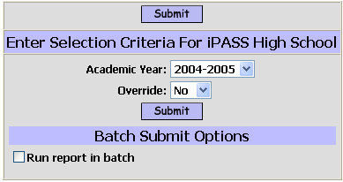

Academic Year:
  - Select the current Academic Year.

Override:
  - Select Yes to be sure that all values are the most up to date.
III-11. Assign Free/Reduced Lunch Status -
- Select <Biographical System> <Mass Update Students> <Mass Update Students>.

NOTE: This program will update the <Biographical System> <Add/Modify Student Biographical> <Confidential> <Free Lunch> field in the students’ record. It will NOT update the <Confidential> <Low Income Status> field at this time.

Data to Update

Lunch Status:
  - Select the appropriate status (Not Eligible, Reduced Lunch, Free Lunch) that you wish to assign from the pull-down list.

Student Search Criteria
Use the filtering criteria to select the students to be assigned the Lunch Status defined above.
- Click to save your changes.

Use the check-boxes to identify which student will be updated and which students will not be updated for Free/Reduced Lunch status.
Use the Check All, Clear All options to facilitate your selection/de-selection process.
- Click to save your changes.

NOTE: Build 5.3 will include an enhancement such that the update of Lunch Status will automatically update or populate the DOE – Low Income Status for each student.
III-12. Assign Counselors -

III-12-A. Mass Update Counselors -
- Select <Biographical System> <Mass Update Students> <Mass Update Students>.

Data to Update

Counselor:
  - Select the Counselor to load from the pull-down list. Counselors must be defined in <Administration> <School Resources> <Teachers/Staff> with a Job Type = Counselor in order to be available on the pull-down list.

Student Search Criteria
Use the filtering criteria to select the students to be considered for assignment to the Homeroom selected above.

Helpful Hint: A last name range may be appropriate (Enter a Last Name range, i.e. A-G) to identify the students or to narrow down your selection list.

- Click to list your selections.

Use the check-boxes to identify which student will be assigned to the selected Homeroom.
Use the Check All, Clear All options to facilitate your selection/de-selection process.

- Click to save your changes.

III-12-B. Add/Modify Counselor Assignments in Student Biographical -
- Select <Biographical System> <Add/Modify Student Biographical> <Profile>.

Student Data

Counselor:
  - Select the Name of the Counselor to assign to this student for the pull-down list.

- Click to save your changes.

III-13. Assign Assistant Principals -
III-13-A. Mass Update Assistant Principals -
- Select <Biographical System> <Mass Update Students> <Mass Update Students>.

Data to Update

Assistant Principal:
  - Select the Assistant Principal to load from the pull-down list. Assistant Principals must be defined in <Administration> <School Resources> <Teachers/Staff> with a Job Type = Assistance Principal in order to be available on the pull-down list.

NOTE: This title can be changed to “Dean” or “Housemaster” or “Vice Principal”, etc. for the District in <System Configuration> <Parameter Maintenance> <Application = TEAM> <Parameter Group = System> <Vice Principal = enter your choice>. Contact IMG Support if you need assistance.

Student Search Criteria
Use the filtering criteria to select the students to be considered for assignment to the Homeroom selected above.

Helpful Hint: A last name range may be appropriate (Enter a Last Name range, i.e. A-G) to identify the students or to narrow down your selection list.

- Click to list your selections.

Use the check-boxes to identify which students will be assigned to the selected Homeroom.
Use the Check All, Clear All options to facilitate your selection/de-selection process.

- Click to save your changes.
III-13 B. Add/Modify Assistant Principal Assignments in Student Biographical -
- Select <Biographical System> <Add/Modify Student Biographical> <Profile>.

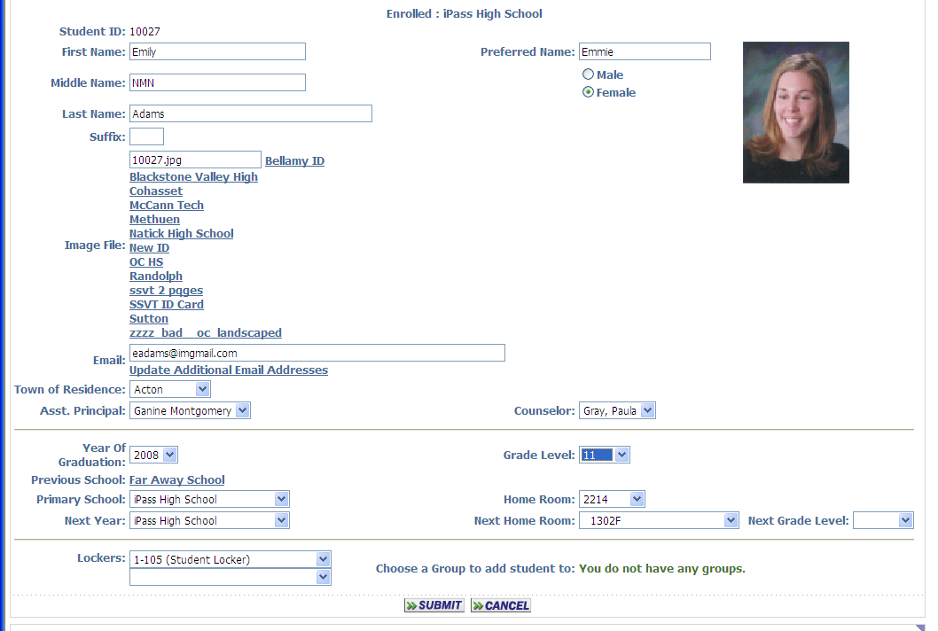

Student Data

Assistant Principal:
  - Select the Name of the Assistant Principal to assign to this student for the pull-down list.

- Click to save your changes.

III-14. Lockers -
Multiple types of Lockers can be assigned to students (Academic, Gym, Shop, Science, etc.). Contact IMG Support for assistance in defining and maintaining your Locker System.

III-14-A. Mass Update Lockers -
- Select <Locker System> <Mass Update Lockers>.

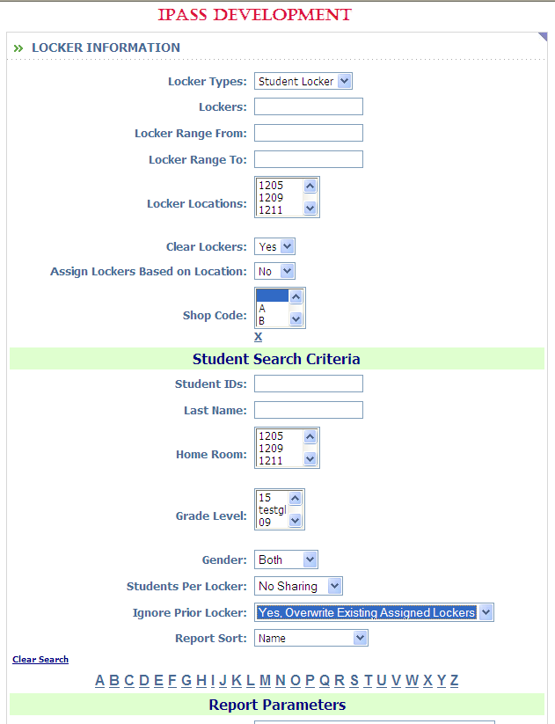

Locker Selection

Locker Types:
  - Select the Locker Type to load from the pull-down list.

Lockers:
  - Enter one or more Locker numbers, separated by commas, to be assigned.

Locker Range From:
  - Enter the first Locker number in a range of numbers to assigned.

Locker Range To
  - Enter the last Locker number in a range of numbers to assigned.

Locker Locations:
  - Select one or more Locker locations to assign.

Shop Code:
  - Select one of more Shop Codes the Locker to load from the pull-down list.
III-14-A. Mass Update Lockers – (cont.)

Student Search Criteria
Use the filtering criteria to select the students to be considered for assignment to the Homeroom selected above. A last name range may be appropriate to identify the students or to narrow down your selection list.
Student IDs:
  - Enter an ID# or a string of ID#s, separated by commas, of the students that you wish to assign.
  - Leave the field blank to load students based on other criteria.
Last Name:
  - Enter a last name or part of a last name or a range of last names of the students that you wish to assign.
  - Leave the field blank to load students based on other criteria.
Homeroom:
  - Select one or more Homerooms.
  - Do not select any Homerooms to include all Homerooms in this process.
Grade Level:
  - Select one or more Grade Levels.
  - Do not select any Grade Levels to include all Grade Levels in this process.
Gender:
  - Select Both to include all students.
  - Select Male to include only the Male students.
  - Select Female to include only the Female students.
Students Per Locker:
  - Select the default of No Sharing to assign only one student per locker.
  - Select 2 per Locker to allow 2 students to be assigned to the same locker.
  - Select 3 per Locker to allow 3 students to be assigned to the same locker.
Ignore Prior Locker:
  - Accept the default of No, Only Assign New Lockers to the selected students.
  - Select Yes, Overwrite Existing Assigned Lockers to assign a new locker to the selected students.
Report Sort:
  - Accept the default of Name to sort the report by student last, first name.
  - Select Homeroom to sort the report by Homeroom.
  - Select Grade Level to sort the report by Grade Level.
  - Click to list your selections.

Use the check-boxes to identify which student will be assigned to the selected Homeroom.
Use the Check All, Clear All options to facilitate your selection/de-selection process.
- Click to save your changes.
III-14-B. Quick Add Lockers -
- Select <Locker System> <Quick Add Lockers>.

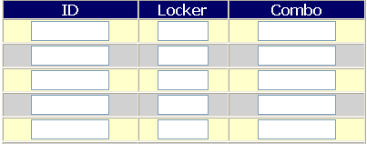

ID:
  - Enter the ID# of the student to be assigned.

Locker:
  - Enter the Locker Number for this student.
  - Blank out the Locker Number to remove the assignment for this student.
Repeat this process for each student you wish to assign or remove.

Combination:
  - Enter the Combination of a padlock which has been given to the student for this locker.
NOTE: The display of an entry field for combination is controlled for the District in <System Configuration> <Parameter Maintenance> <Application = Locker> <Parameter Group = Configuration> <Quick Add Update Combo = Yes/No>. Contact IMG Support if you need assistance.

- Click to save your changes.

III-14-C. Add/Modify Locker Assignments in Student Biographical -
Multiple Lockers can be assigned to a student (Academic & Vocational, Academic & Gym, etc.).
NOTE: There is also an option in the Security System to define individual users to be able to see the student’s locker combination on the student’s Profile page and on the View Only Profile page.
- Select <Biographical System> <Add/Modify Student Biographical> <Profile>.

Student Data

Lockers:
  - Select the Locker to assign to this student.
- Click to save your changes.

Define and submit a single locker and second locker field will be displayed to allow the assignment of an additional locker.

III-14-D. Change Locker Combo –
This program allows you to change the default combination which is in use for ALL lockers in your school.
- Select <Locker System> <Maintenance> <Change Locker Combination>.

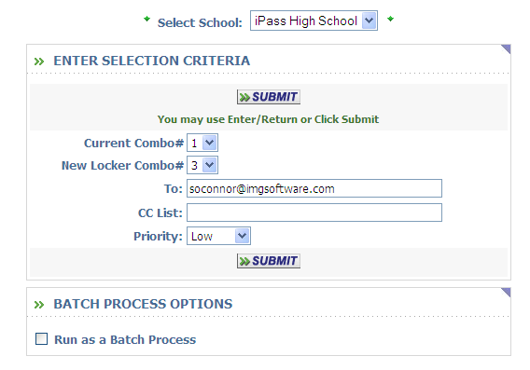

III-15. Assign Bus Routes/Stops -
There are several options for assigned buses to students. There is separate documentation available for defining your DISTRICT buses. Contact IMG Support if you need this documentation or assistance in defining your District buses.
If students ride the same bus everyday to and from school, then you may want to assign that bus for Monday, Bus - To School only and leave the other fields blank.
Bus assignment can be made by Bus Route in general or by Bus Route: Stop.
It is also possible to define a Bus Route or Bus Route: Stop to indicate Walkers or exceptions to the student taking a Bus on certain days, such as Pick-Up, for certain days. These exceptions need to be defined on the individual student’s Profile page.

III-15-A. Mass Update Buses -
- Select <Biographical System> <Mass Update Students> <Mass Update Students>.

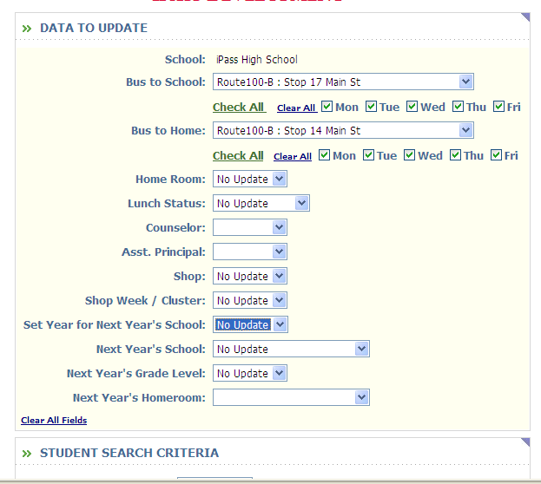

Data to Update
Bus to School:
  - Select the Bus to School that you wish to assign from the pull-down list.
  - Click on Check All to have that Bus assign every day of the week.
  - Check the days that you wish to assign this bus.
Bus to Home:
  - Select the Bus to Home that you wish to assign from the pull-down list.
  - Click on Check All to have that Bus assign every day of the week.
  - Check the days that you wish to assign this bus.

Student Search Criteria
Use the filtering criteria to select the students to be assigned to Buses as defined above.
- Click to save your changes.

Use the check-boxes to identify which student will be updated and which students will not be updated for these Bus assignments.
Use the Check All, Clear All options to facilitate your selection/de-selection process.
- Click to save your changes.
III-15-B. Quick Add Buses -
This program will add the Bus assignments to the student for everyday, both To and From school.
- Select <Bus System> <Quick Add Buses>.

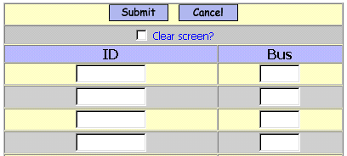

ID:
  - Enter the ID# of the student to be assigned.
Bus:
  - Enter the Bus Route Code for this student.
  - Blank out the Bus Route Code to remove the bus assignment for this student or enter a new bus assignment to replace an existing assignment.
Repeat this process for each student you which to assign or remove or change.
- Click at either the top of the list or the bottom of the list to save your changes.

III-15-C. Add/Modify Bus Assignments in Student Biographical -
- Select <Biographical System> <Add/Modify Student Biographical> <Transportation>.

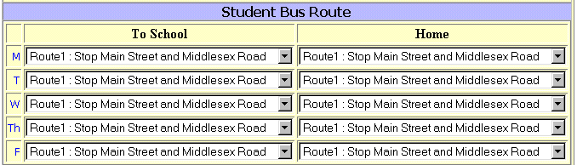

Student Bus Route
To School:
  - Select the Bus Route or Bus Route: Stop that the student takes To School each day.
Home:
  - Select the Bus Route or Bus Route: Stop that the student takes Home each day.
- Click to save your changes.
III – 16. Assign Shop Week/Cycle/Cluster/Team -

III-16-A. Mass Update Shop Week/Cluster -
Use this program to assign Voc/Tech students to a Week Cycle or to assign students to Teams.
- Select <Biographical System> <Mass Update Students> <Mass Update Students>.

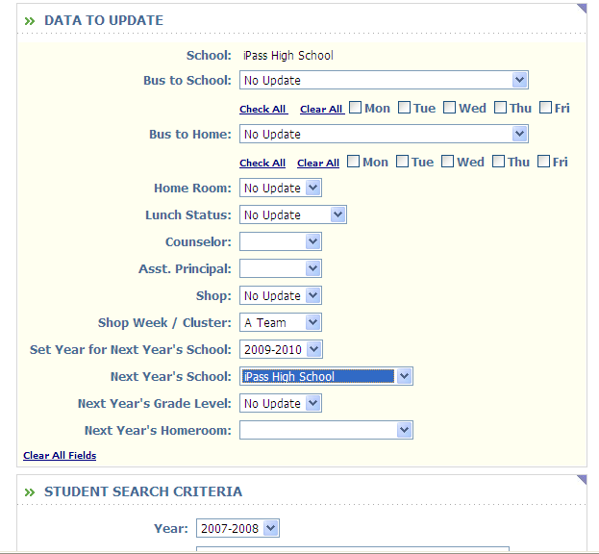

Data to Update

Shop Week/Cluster:
  - Select the Shop Week/Cluster to load from the pull-down list.

Student Search Criteria
Use the filtering criteria to select the students to be considered for assignment to the Shop Week/Team selected above. A last name range may be appropriate to identify the students or to narrow down your selection list.
- Click to list your selections.

Use the check-boxes to identify which student will be assigned to the selected Shop Week/Team.
Use the Check All, Clear All options to facilitate your selection/de-selection process.
- Click to save your changes.

III-17. Set up Narrative Parameters for Standards/Competency Based Report Cards

Each year the narrative parameters have to be set up. You can do this by going to: Grading System Grading Maintenance - Narrative Parameters tab - select School year for Previous Academic Year and click on . Write down/copy the settings from the previous academic year.
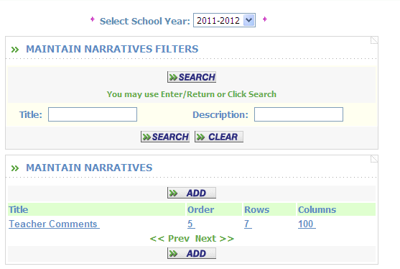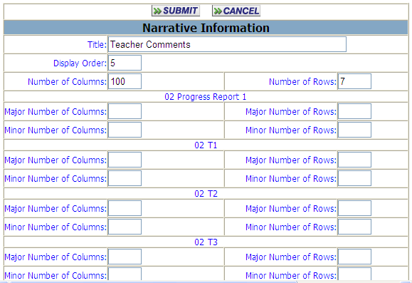

Go back to the top and select school year and change it back to current academic year.

Click on the button. Enter the title, display order, number of columns and number of rows based on the data that you copied from the previous year.

Click on . Go back to the previous screen and click on and the narrative parameters that were just created will appear.

