Procedures for Using iFIPS Requisition/PO
Information Marketing Group's, (IMG’s)
Internet Financial Information Processing System

1. Log on to the Network -
Enter Login Name:
Enter Password:

Your Login Name & Password for the Network is the first level of Security in protecting your system and your data. Be sure to logout whenever your workstation is left unattended.

2. Double click on the "iFIPS" Icon (May be customized for your site) -
Enter User ID:
Enter Password:

Your Login Name & Password for the Financial Information Processing System (iFIPS) is an additional level of Security in protecting your system and your data. Be sure to logout, at least to this level, whenever your workstation is left unattended. While the system is equipped with a time out feature it is good habit not to leave a workstation logged in.

The identity of your Passwords is also very important to the Security of your system. Your Passwords should be easy for you to remember, but difficult for someone to guess. A common practice is to use a name or word that you can easily remember and then to replace certain letters with numbers. ( Example: PASSWORD becomes PA55W0RD with a five in place of the letter S and a zero in place of each letter O.)
Your iFIPS Login Name & Password also identifies a set of access parameters which have been determined by your System Administrator. These parameters are established to control unauthorized access to restricted areas of the software and are in place for your protection and the security of the data.
These parameters include:
- Which menu options you have access to: If your access is restricted for any particular menu option, then that menu option will not appear on your screen. If you find that you do not have access to an area that is needed to carry out your required tasks please contact the system administrator for corrective action.

- Which Accounts you have access to for Lookup, Creating Requisitions, or Processing Transactions.

- Certain Monetary Limits: Maximum amount of a Requisition and whether or not an account can be overdrawn.

- Supervisor and Subordinate designations

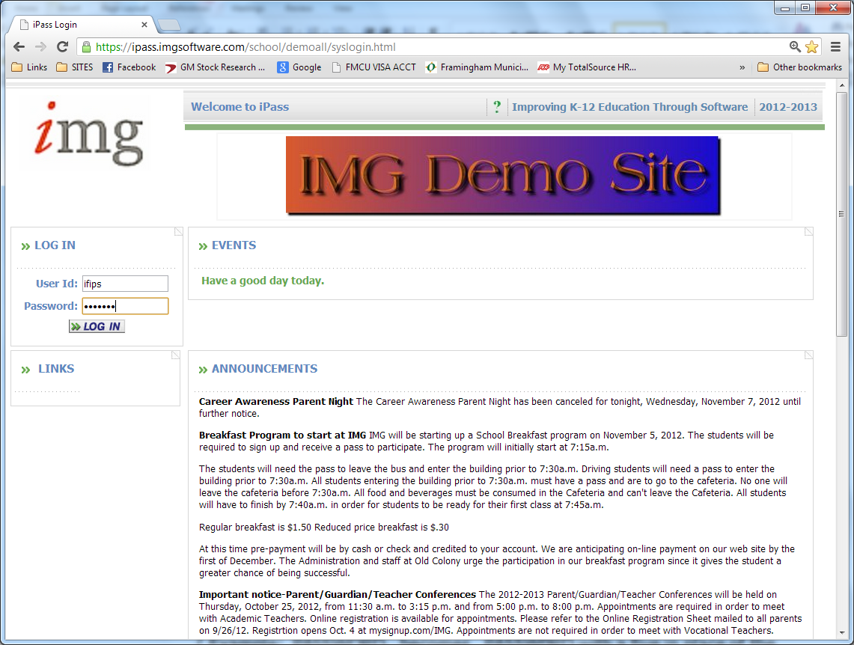

3. Entering a Requisition -

Within the Main Menu (down the left side of the Home Page (with your mouse) right click on the “+” next to Purchase Order/Requisition System

The above action will open a list of menu options for this function:
Left-click the mouse on the desired option. (Purchase Orders/Requisition)

Depending on your security level and the option selected you will then be displaying a search screen with add/modify features and/or a tab menu across the top of the page.

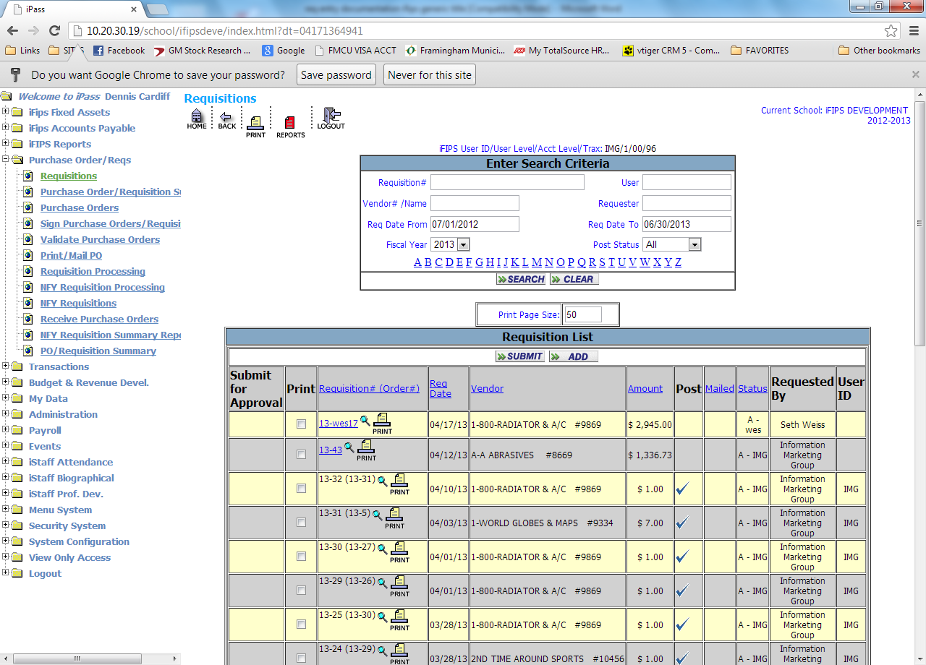

PLEASE CHOOSE THE REQUISITION OPTION

This will populate the above screen. The top section of the screen is a selection criteria for finding requisitions that have been previously entered.

The bottom section of the screen will populate the list of requisitions based on the selection criteria entered in the top section.

If you are merely adding a new requisition you need only to proceed directly to the button in the middle of the Requisition List screen.

This will open the requisition entry template: (see below)

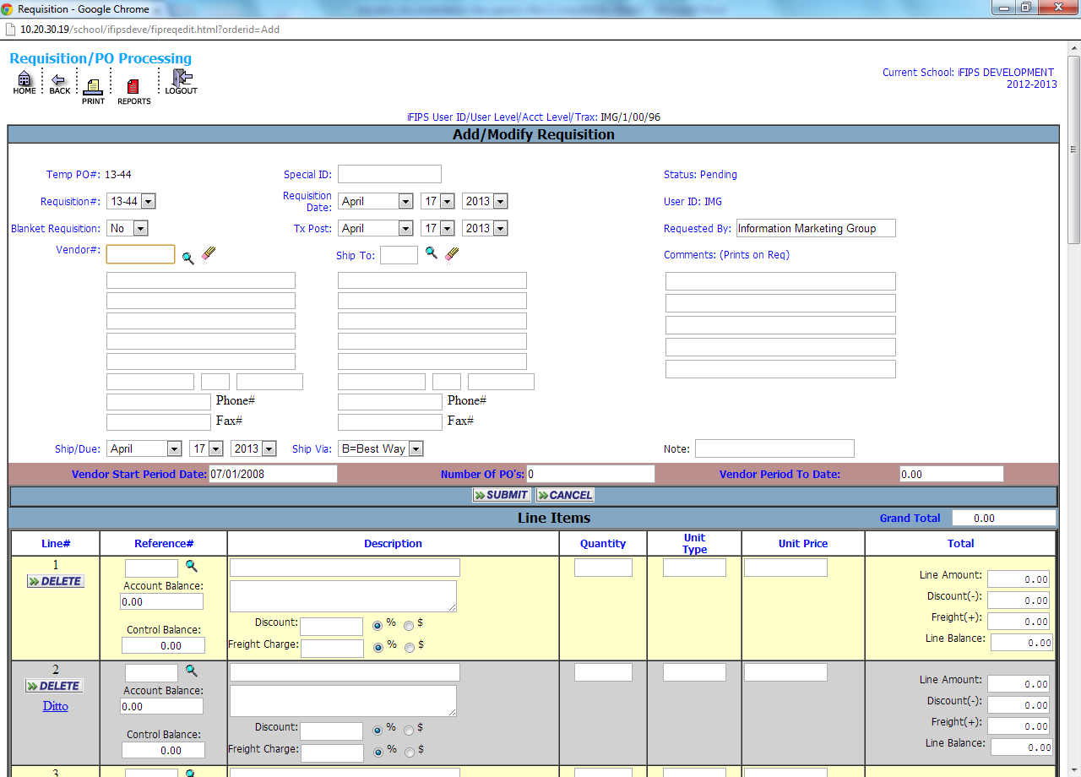

iFIPS uses the same functions as any internet connection.
On any non-menu screen:
Use the <Tab> Key
to move forward to the next field.
Use the <Shift><Tab> Keys
to move back to the previous field.
OR
Left-click with your mouse on the field you want.

<F5> is your "Refresh Screen" Key and refreshes your screen to the home page should you get hung up etc.

is utilized on all screens labeled Enter Search Criteria where you are looking to display certain data, based on the criteria entered.

is utilized to update your data entry and move on.

<> This magnifying glass symbol is utilized as tool to look-up lists such as accounts, vendors, etc.

The TOP portion or Heading of the Requisition contains the basic information about the Requisition as a whole. When this portion is complete, the options in the lower portion, the detail, are the area in which you will enter the actual accounts and items you will be requisitioning.

Req#:
Press <Tab> to accept the default value (Example 13-DWC1).
The system will assign a Requisition "Number", prefaced with the fiscal year and then the initials of the user plus a numbering unique to that user.

iFIPS will not allow the creation a duplicate Requisition number.

Vendor#:
Enter the Vendor Code (alpha/numeric) for the Vendor who will receive the Purchase Order.
If the Vendor does not exist with the code entered, then a message will appear on the screen indicating that the code is invalid.
If you need to look up a vendor number, left-click on the magnifying glass to get a listing of Vendors (Code, Name & Address) At the top of the display will be a search box. You can enter a vendor name or portion of the name and clicking on the search button will display a list starting with the Vendor whose name is, or is closest to, the name or characters you entered
When you have selected a valid Vendor, the Name and Address of the Vendor will appear in the vendor information space on the Requisition.
The default "Ship To" Name and Address will appear on the right side or you may enter the code for your building or view via the .

Vendor Sub-Address:
Press <Tab> to accept the default "00" which displays the Vendor's primary address.
Or enter the number of the secondary address you wish to use which will be 01, 02 and so on.
A colored asterisk * to the left of the Vendors Data will indicate that there are sub addresses available for this vendor which may be the requisition/order address.
Click on the to get a list of sub addresses in the Vendor’s file and choose the appropriate address.
NOTE:
The new address will be displayed.
If the address that you need is NOT listed, then an additional address must be added by the FINANCE Office staff.

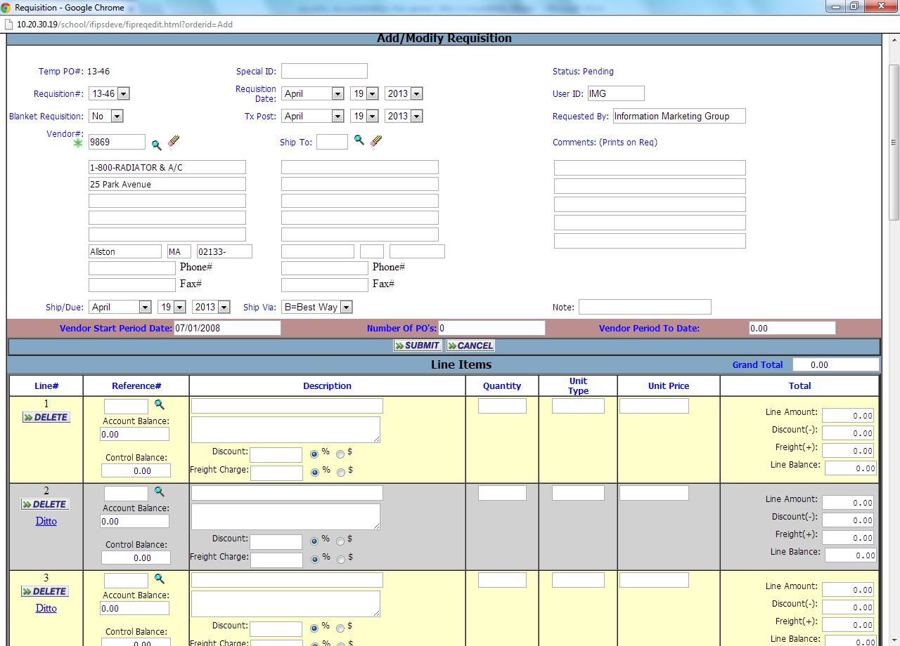

Ship To-Address:
Press <Tab> to accept the default "00" which displays the primary "Ship To" address.
Enter the number of the ship-to address you wish to use. (Example 01, 02 etc.)
Click on the for a help list of additional ship to addresses for the district and select the desired address for this Req. The new address will be displayed.

New ship to addresses will need to be adde by the FINANCE office staff.

Date:
Press <Tab> to accept the default date <Today> or utilize the pull down arrows to adjust the dates. The “Requisition Date” is the date that will print on the hard copy document. The Tx Post date is the Posting date or the effective date of the encumbrance.

Status:
If your requisition requires approval and signing by your department head the requisition will automatically be assigned “pending” until approved by your authorized department head.

TX Post:
Press <Tab> to accept the default Transaction/Posting date <Today>or
enter the desired Posting Date for the Req. You cannot post to a future
date.

Req By:
Press <Tab> to accept the default of your name, as the log-on person.
Or enter the name of the person actually requesting the Goods/Services.

Blanket PO:
Press <Tab> to accept the default NO unless this order is to remain open
should the balance reach zero.

Ship:
Press <Tab> to accept the default date <Today>.
Or enter the Date you wish to have the Goods/Services delivered.

Ship Via:
Press <Tab> to leave the default or use pull down

Note:
Enter any notation of up to seventeen (17) characters that will appear on the display of the Requisition. It will not print on the PO.

Comments: Comments: (Prints on Req)
You may enter a comment of up to five (5) lines of seventy-two
(72)characters per line. The comment will appear on and print-out on the Requisition and whenever you look-up or modify the Req.

NOTE: At any time you have completed your information entry on the top portion of the screen you can proceed directly to the lower portion of the Requisition and enter the details of the first and subsequent lines of the Requisition.

The Items Section (lower portion) of the Requisition:

The LOWER portion of the Requisition contains one or more entries of detail about the Goods/Services being purchased. The program will display the basic information about one entry at a time with a running total for the entire Requisition.

Ref#:
Enter the Reference Number of the Account you wish to charge.
If you do not know the Reference # of the account you are charging, then Click on the to get a list of Accounts that you are authorized to encumber.

When you have selected a valid account:
The Unencumbered Balance for the Account will appear directly below the reference number entered on this line.

If your organization is using the Control Balance functionality then you will also see an amount in the Control Balance field just below the Account Balance. This functionality allows user to expend from the total appropriation within their restricted account access for a particular department.

Note: You may be restricted from creating a Requisition, if there are insufficient funds. You should be sure to check the Unencumbered Balance before entering detail that will be erased because of this restriction.

Description:
The account title or account # will appear in line one by default for verification. Begin entering the detailed description of the goods/services being ordered on the second line.
You have the option of entering an unlimited number of lines of description of up to thirty (30) characters per line.

Qty:
Enter any Quantity. This field accepts decimals and will round penny calculations

Units:
Press <Tab> to leave the Units description blank.
Enter any Units description ( Examples: Cases, Cartons, Pkgs., and Liters etc.).

Unit Price:
Enter any dollar amount in unit price up to 4 decimal places

Total:
iFIPS will automatically calculate the Total cost of the item(s) ordered.

Discount:
If you know the vendors discount amount you may take a discount on each line of the Req. This entry may be a fixed amount or a percentage amount by entering the amount and then clicking the radio button for amt or % next to the field.

Freight:
If you know the freight amount or are allowed to add a specific amount or percentage you may apply a freight charge in a similar manner as discount. This entry may be a fixed amount or a percentage amount by entering the amount and then clicking the radio button for amt or % next to the field.
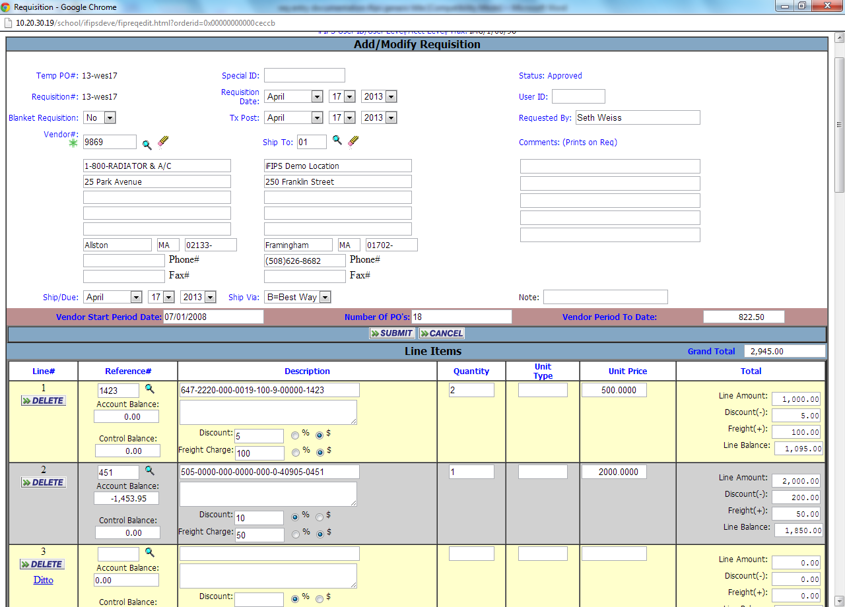

NOTE: If the net amount of this entry exceeds the Unencumbered Balance of the Account being charged, then a message will be displayed and you must adjust the Quantity and/or Price if you are restricted from over-encumbering accounts. OR exit the processing without <submit>.
\
A "Grand Total" for the entire Requisition will be displayed in the lower right
corner of the Requisition as well as in a designated total box in the top
portion of the Req. If this total exceeds the limit set by your system
administrator the entire Requisition will be aborted (erased) upon your
submit .

Additional Items Entry:

Ref#:
Enter the Reference Number of the Account you wish to charge.
If this is the same Account charged in the first entry simply click Ditto

OR enter a new and different Account.

Follow the same instructions and prompts for each additional entry.

Continue to process entries until you have entered all accounts and items for this requisition.

The FINANCE Office will set policy regarding Discounts and Freight
assignments. Please check with them before utilizing this feature.

Although a user can enter unlimited charge accounts and items it is preferable that a single Requisition contain no more that 10-15 entries.

Once you have completed the entry of all accounts and line items you must scroll up or down to display the button. Click on the submit button and your Requisition has been entered in the system. Keep in mind that you are working over an internet connection and unless you submit your entries your data will be lost.

In the event that you truly want to abort a process simply click on the x in the upper right hand corner of your web display or use the in the middle of the screen and you will exit the entry screen and return to your previous window.

Enter another Requisition OR exit the entry process and return to the previous window or home page.

View/Print UnPosted Requisitions -
You will be able to view the requisitions you have entered by going to the add/modify requisition screen. You may click on the to view the Req or you may print the list by clicking on the print icon at the top of the requisition window

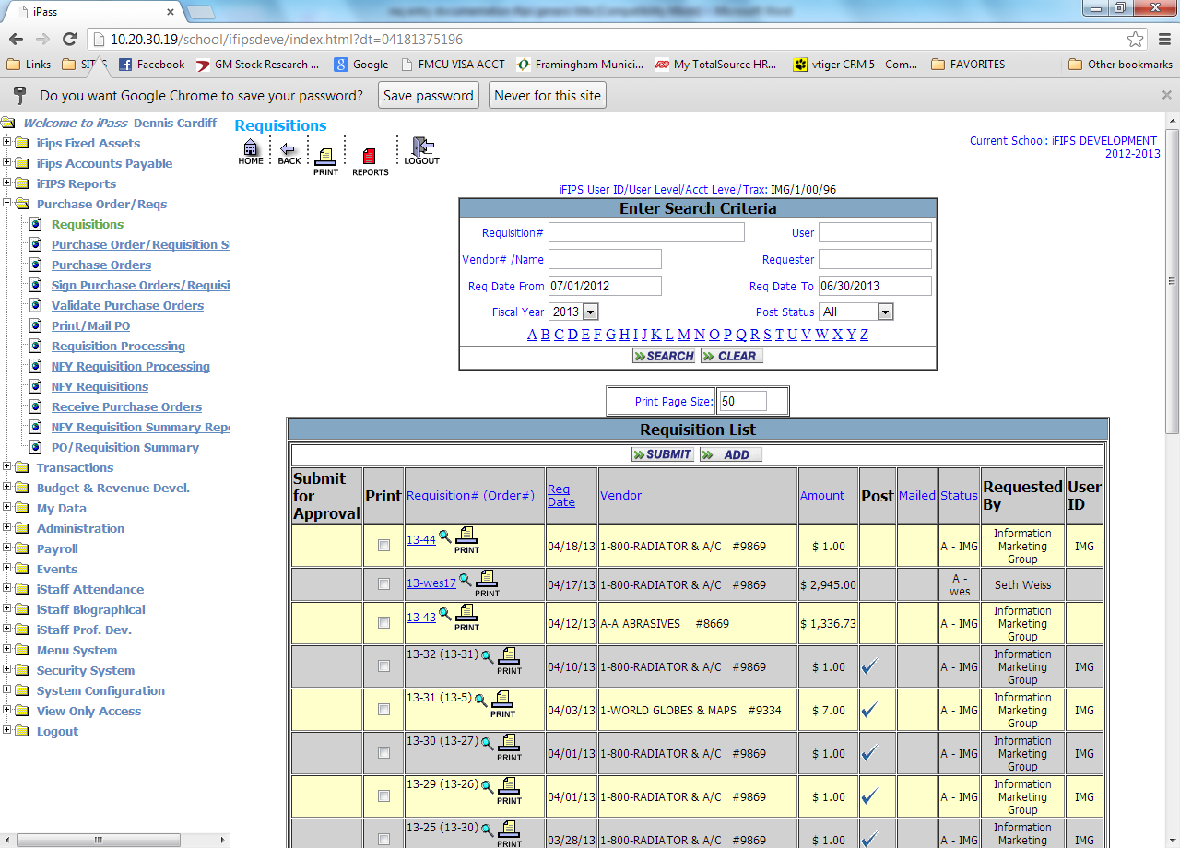

Printing Requisitions to paper:
Click on the print icon just below the Requisition number in the list of Reqs. This will display the printer default and where the item will be printed. Requisitions can be viewed or printed to paper at any time.

Approval of Requisitions:
Although you have entered a requisition at this stage the requisition is neither approved nor posted. Your requisition must be approved by an authorized supervisor prior to posting. If you have completed the entry and any edit or modification of this requisition then you will need to check the box to submit for approval and click the at the top of the list of requisitions being submitted for approval.

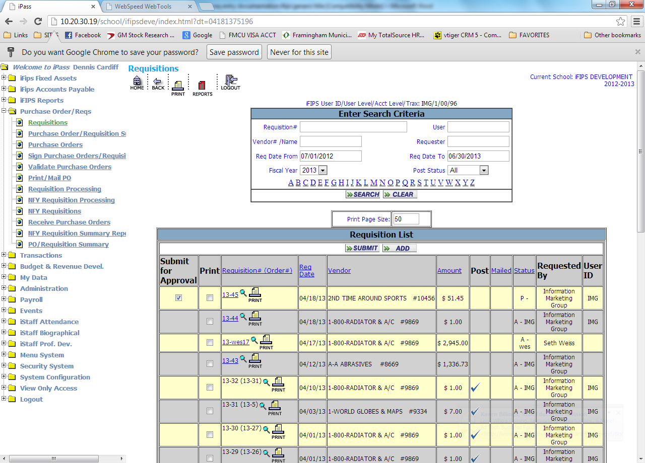

The supervisors log on screen’s yellow dashboard will appear notifying them that they have requisition to approve. Once approved the requisition will be electronically signed and converted to a purchase order for validation. The approver will also receive an email indicating they have a requisition to approve if the email system is being utilized.

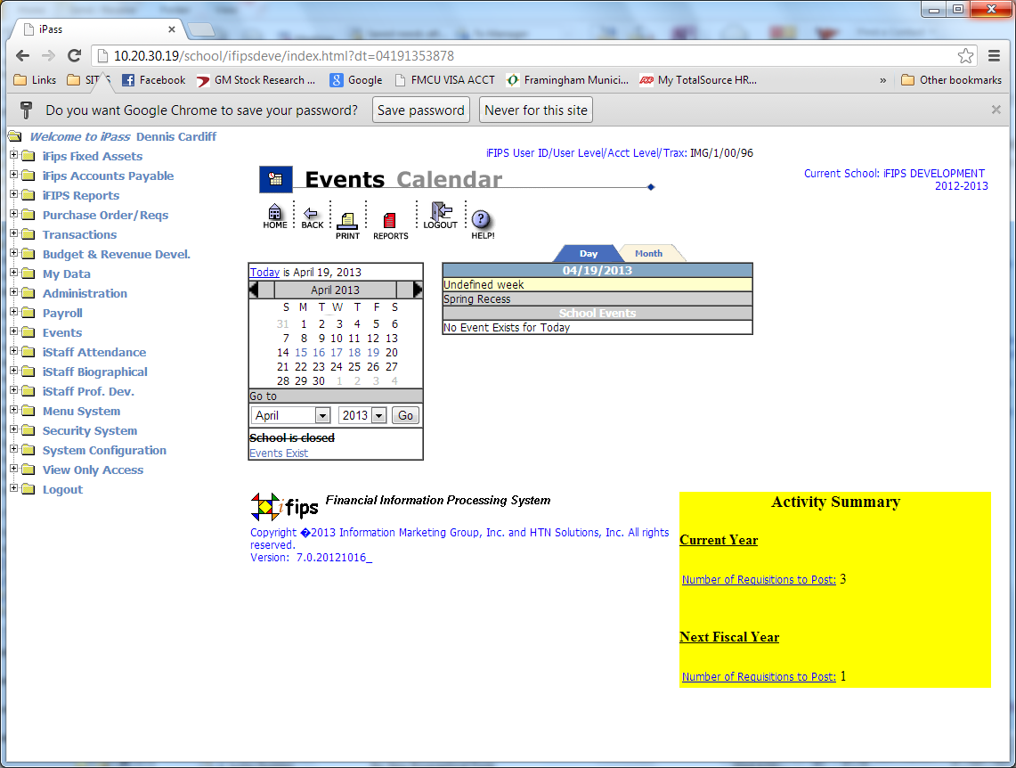

The supervisor must select the “approve requisitions” option from the main menu and a list will appear for their review and approval or alternately this function may be processed from the yellow dashboard (see above) by clicking on the item needing action.

Much in the same manner as above, the supervisor may view the requisition by clicking on the or simply click the requisition to be approved and click the button. Utilizing the check all feature at the top of the screen will allow the supervisor to select all the reqs and simultaneously approve all that have been selected. This “check all” feature is only applicable to the window you have open and not subsequent windows containing additional requisitions for approval.

It is important to note that that if your organization is using the “express process” option for requisitions/PO’s then the supervisor approver step has been combined with the posting and conversion process. This express option allows for the approval, electronic signing, and conversion from requisition to PO in one step.

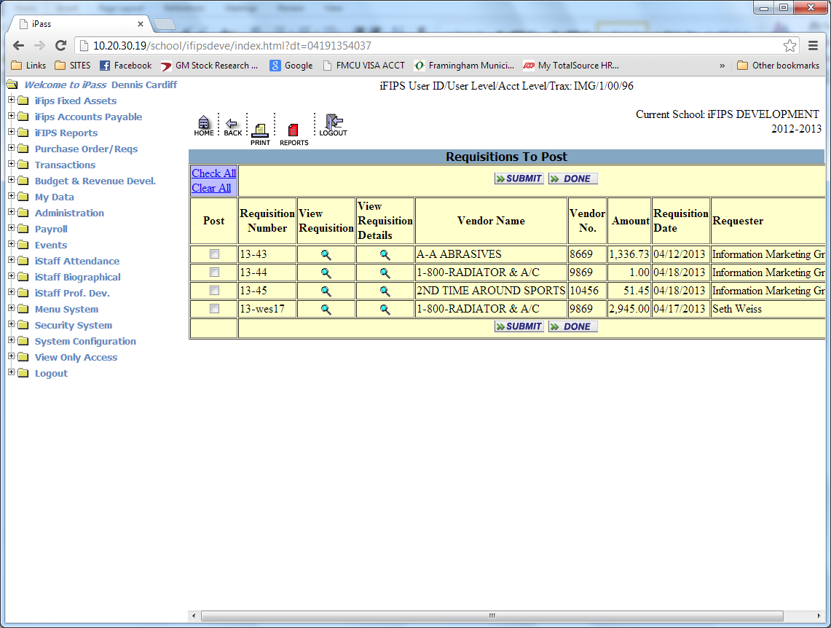

Modify / Delete Unposted Requisitions:
Any requisition may be modified or deleted prior to for approval.

Posting of Requisitions:
The posting of the requisition will be the next step in the process. Once the requisition has been approved it may be posted by selecting the “Requisitons Process” option from the Tabs at the top of the screen. This again will populate a list of Requisitions. Much in the same manner as above, the supervisor may view the requisition by clicking on the .

The Requisition search box at the top of the window is where the user will identify the action that they wish to take on the requisition. The pull down menu will offer the user a posting option that, when chosen, will populate a list of requisitions to be posted.

Much in the same manner as the “Approval” , simply click the requisition to be posted and click the button. Utilizing the check all feature at the top of the screen will allow the supervisor to select all the reqs and simultaneously post all that have been selected. This “check all” feature is only applicable to the window you have open and not subsequent windows containing additional reqs for posting.

The Posting Process completes the entry of the Requisition
AND
Pre-encumbers the Account(s) charged
(separately from the encumbrances of a Purchase Order).

Administrative Lookup :

F.I.P.S. provides a Menu Option whereby you can view the data posted to the system in a "Lookup ONLY" mode.
Data cannot be entered, modified or deleted using this option.

Click on “Administrative Look-up”

This will populate a screen with a list of accounts that you are authorized to encumber. The top of the screen is an accounts search criteria. Entering the applicable data will allow for the display of data in accordance with your choices.

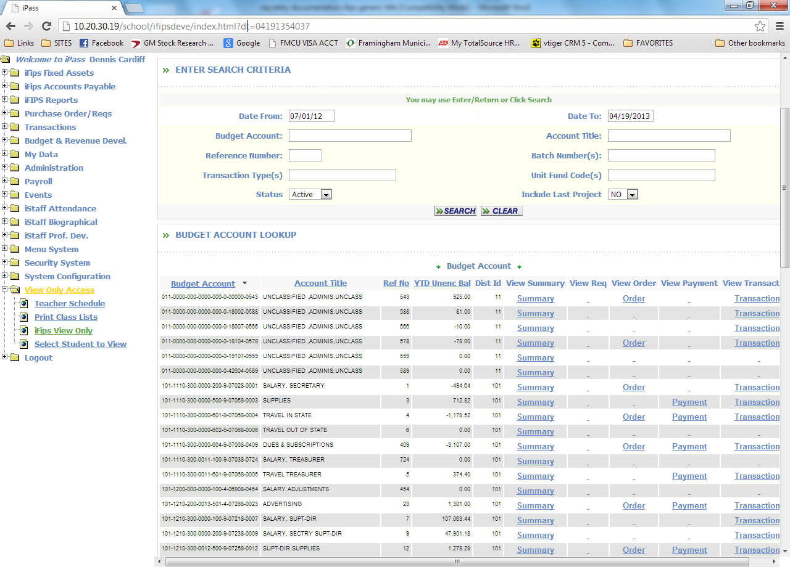

From/To Date:
Press <Tab> to accept the default dates of the current fiscal year to date.
Enter From / To Dates to view/print records for a specific date or a range
of Dates, including prior fiscal years.
The list displays accounts. Any account with a blue item under any column is
indication that there is additional data to be displayed in detail. Clicking on any
of the items in blue will display the underlying detail for that item.

Utilizing the Budget, Revenue or GL Level look-up allows the user to view specific
data within a designated segment code of the account, such as location.

This option is quite useful for a building principal to see a snapshot of his/her
fiscal position at any given time or date range.

Once the posting and conversion process is complete your order has arrived at
the FINANCE office for validation, official signature, and posting to encumber the
accounts designated on the order lines.

When the order is posted by the FINANCE office your requisition search screen will display a list of requisitions that now contain the original requisition number and the newly assigned purchase order number.

