
iPASS toGo

Mobile Browser Setup Document

Mobile Browser Setup Document

Table of Contents

Blackberry 3
Windows Mobile 5
iPhone 6
Blackberry Opera Mini 4.2 8
Browser Compatibility Chart…………………………..………………………………….7

Setup/Configuration requirements for running the iPASS toGO application in different mobile devices.

Blackberry –
- Support Style Sheet should be checked (Browser OPTION>BROWSER CONFIGURATION)
- Support JavaScript should be checked (Browser OPTION>BROWSER CONFIGURATION)
- View Mode : Desktop
To do the above setup/Configuration Please go to below mention path
- Go to browser>> Options>> Browser Configuration >> 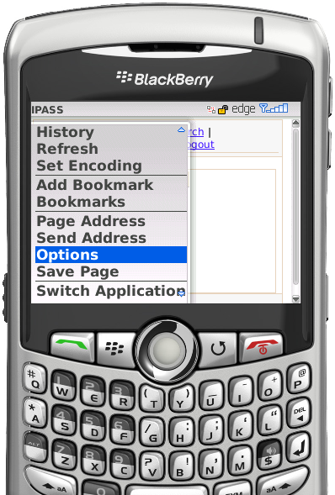 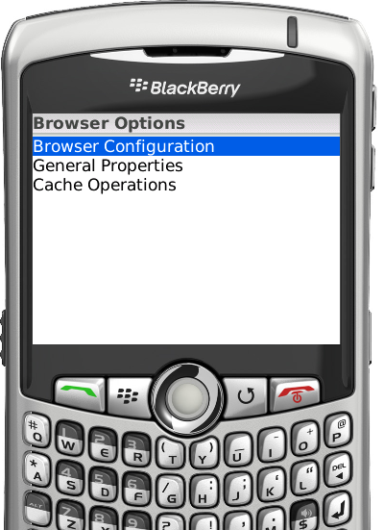

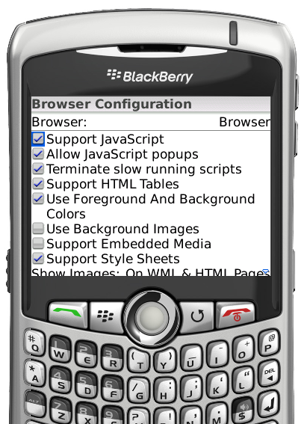

*Note: Make View mode: Page

Windows Mobile –

- Support Style Sheet should be checked
- Support JavaScript should be checked
- View Mode : Desktop
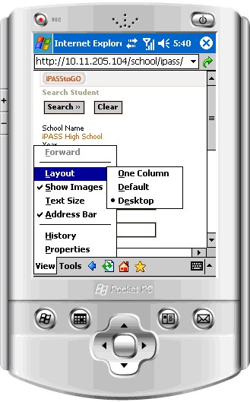

iPhone –

How to enable JavaScript on the iPhone
To enable JavaScript on your iPhone:
- Go to the Home screen by pressing the Home button or by unlocking your phone.
- Press the settings button.
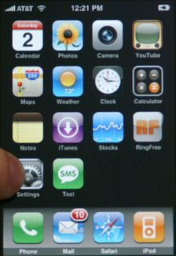
- Select Safari from the Settings menu.
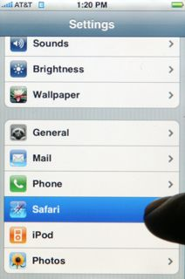
- Turn on JavaScript by touching the JavaScript toggle.
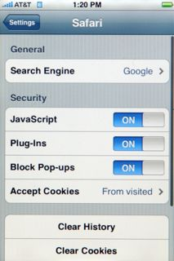
- Press the Home button to return the the iPhone home screen.
- Select the Safari icon to return to Safari.

Blackberry Opera Mini 4.2 –

Double Press on Opera Icon
Now the Opera Mini 4.2 appears

Press on the button  to the left of Trackball

From the Menu select the “Settings” menu

The Settings page appears

Set settings as shown below

WebPages
Load images (checked)
Image quality (low)
Font size (medium)
Mobile view (checked)
Appearance:
Visual effects (checked)
fullscreen mode (checked)
Show overview (checked)

Compatibility Chart
 | Mobile Browser/Firmware Version
 | Blackberry Firmware 4.2- 4.5 mobiles (8120/8310) | Blackberry Firmware 4.6 - 4.6+ mobiles | Windows Mobile 5 | Windows Mobile 6 | iPhone
JavaScript
CSS
HTML
Alignment
Fully
Partial
No support

