Google Translate

iPass utilizes the Google Translate technology for parents and students in school districts to translate view only screens into a variety of languages. Districts may select desired languages from those available in Google Translate which then reduces the menu in Google Translate to only those languages required to accommodate the district demographic.

Select Languages
Go to System Configuration>District Configuration

At the bottom of the screen, select languages from the list. CTRL+Click to select multiple languages.

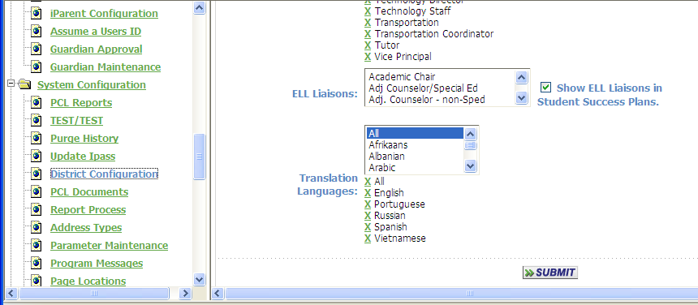

Click on to record your language selections.

View Translated Screens
iParent will now contain the Google Tranlsate Language selector at the top of each screen. Only selected languages will appear on the drop-down menu.

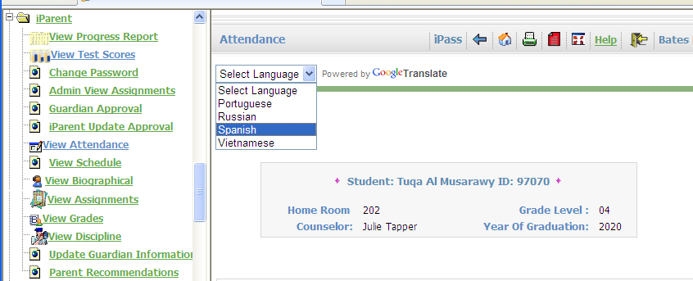
Screens will translate automatically based on language selection.

