i pass Grading System

There are many segments within the i pass Grading System. It is hoped that this document will assist you with the procedures that your school uses.

The i pass Grading System allows you to enter and track students grades, generate progress reports, transcripts, report cards, honor roll, GPA, averaging, setup and control Grade Headings, Terms, Teacher entry of Grades, and produce a variety of administrative reports.

Menus are definable at the District Level and may vary from those indicated in this documentation.

I. CHECK YOUR DATA -
All Grading System tables are school specific and should be reviewed.
Academic Year specific tables have a year pull-down list option.

Important Note: i pass is a relational database. Any changes to codes or descriptions will affect data previously entered or posted elsewhere in the database. For example, if you change a comment from “Good student” to “Poor effort”, then every student who was assigned the “Good student” comment will have the “Poor effort” comment appear then next time a record is reviewed or a report card is printed for that student.
Codes & descriptions can be changed in academic year specific tables prior to data being entered or posted elsewhere in the database.

A. Define Grades -
<Grading System> <Maintenance> <Maintain Grades>
This table is academic year specific and can be copied from a previous year using <Administration> <End of Year Procedures> <Grades Rollover>. The <Grades Rollover> program also copies GPA tables.
This table can also be copied by teachers into their Rankbooks to insure consistency.

Review the grades listed. Click on any piece of data for the grade code that you wish to modify or Click to define a new grade code.

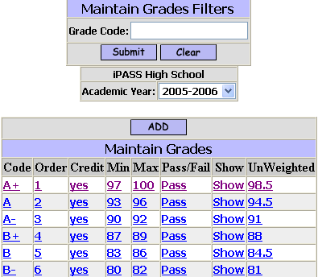

Grade Code:
- Enter the Grade Code you wish to modify.
- Click to list all codes which meet your filtering criteria.
- Click on any piece of data to access the values defined for the selected code.

Academic Year:
- Enter the Academic Year you wish to access.

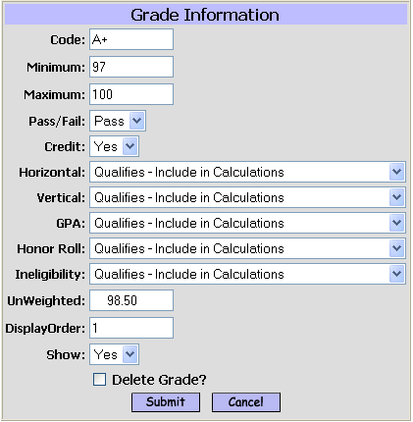

Note: Directions for filling fields throughout this document are written from the perspective of adding new data and will also serve as a guild for modifying data.

Code:
- Enter a grade code. This is a case-sensitive, alpha-numeric (character) field. The length of the code is unlimited, however, keep in mind that the code needs to be of convenient length for understanding, data entry and displaying on a report. Teachers may enter grade codes in either upper or lower case. If lower case alpha grades are entered, then they will be converter to the upper-case code, unless a lower case code has also been defined.

Helpful Hint!
If your school uses alpha grades, then define a grade of “F+” or “F-“ to distinguish a failing final grade that may or may not be made up in Summer School.

Minimum:
- Enter the minimum numeric value for this grade code.

Maximum:
- Enter the maximum numeric value for this grade code.

If your school has defined within <Report Card Parameters> to convert numeric grades to alpha grades for printing on Report Cards and Transcripts, then i PASS will read the minimum and maximum values defined for each grade code, in Display Order, to determine the alpha grade to be displayed.

Pass/Fail:
- Select Pass if this grade is considered as passing.
- Select Fail if this grade is considered as failing. The <Pass/Fail> report has an option to list only failing grades and this field determines which grades are passing and which grades are failing.

Credit:
- Select Yes if a student who receives this grade as a Final Grade will earn the attempted credits for the course.
- Select No if a student who receives this grade as a Final Grade will not earn the attempted credits for the course.

Horizontal:
- Select “Qualifies – Include in Calculations” to include this grade when using i pass to calculate a horizontal average.
- Select “Not Consider – Ignore this value & Calculate others” to not include this grade when using i pass to calculate a horizontal average.
- Select “Disqualifier – Do Not Do Any Calculations” to show no average using i pass to calculate a horizontal average.

Vertical:
- Select “Qualifies – Include in Calculations” to include this grade when using i pass to calculate a vertical average.
- Select “Not Consider – Ignore this value & Calculate others” to not include this grade when using i pass to calculate a vertical average.
- Select “Disqualifier – Do Not Do Any Calculations” to show no average using i pass to calculate a vertical average.

GPA:
- Select “Qualifies – Include in Calculations” to include this grade when using i pass to calculate a GPA.
- Select “Not Consider – Ignore this value & Calculate others” to not include this grade when using i pass to calculate a GPA.
- Select “Disqualifier – Do Not Do Any Calculations” to show no average using i pass to calculate a GPA.

Honor Roll:
- Select “Qualifies – Include in Calculations” to include this grade when using i pass to calculate an Honor Roll.
- Select “Not Consider – Ignore this value & Calculate others” to not include this grade when using i pass to calculate an Honor Roll.
- Select “Disqualifier – Do Not Do Any Calculations” to show no average using i pass to calculate a Honor Roll.

Ineligibility:
- Select “Qualifies – Include in Calculations” to include this grade when using i pass to calculate ineligibility.
- Select “Not Consider – Ignore this value & Calculate others” to not include this grade when using i pass to calculate ineligibility.
- Select “Disqualifier – Do Not Do Any Calculations” to show no average using i pass to calculate ineligibility.

Unweighted:
- Enter a numeric value for this grade code. Since grade codes are characters, they all MUST have a numeric value assigned to them for averaging purposes.

Display Order:
- Enter a display order number for this grade code. The display order is helpful for viewing and selecting codes. It is vital for conversion of numeric grades to alpha grades for printing on Report Cards and Transcripts. Using the Minimum and Maximum values defined above, i pass will find the first possible code by Display Order to make the conversion to an alpha grade. List alpha grades first if you use the conversion option.
Helpful Hint!
The display order numbering does not need to be consecutive. List your alpha grades first, then list your numeric grades starting at 100 with a display order of 100, then 99 with a display order of 101 and so on.

Show:
- Select Yes to show this grade code on Report Cards, Progress Reports & Transcript.
- Select No to NOT display this grade code on grading reports.

Delete Grade:
- Check this box to delete this grade code. You will not be able to delete the grade code if it has already been assigned to a student. Grades can be deleted only when copied to a new academic year and not yet assigned.

      - Click to save your changes.

B. Define Progress Report & Report Card Comments, Conduct Codes & Effort Codes -

1. Comments for Progress Reports & Report Cards:
<Grading System> <Maintenance> <Comments>
This table is not academic year specific. Care should be taken when changing comments. It will change the comments assigned in the previous years.

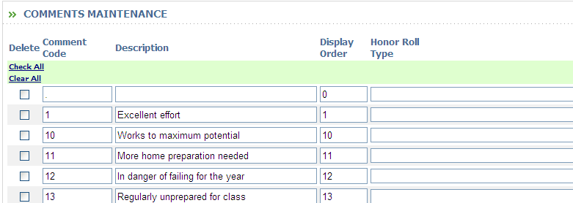

Comment Code:
- Enter the Comment Code that will be used by teachers. The code is alpha-numeric.

Description:
- Enter the Comment Description as you want it to appear on Progress Reports and Report Cards.

Display Order:
- Enter the Display Order number for the Comment Code. The Display Order is used when referencing the Codes list by clicking on the magnifying glass icon on a grades entry screen

Honor Roll Type:
- Select “Qualifies – Include in Calculations” to include this grade when using i pass to calculate an Honor Roll.
- Select “Not Consider” – Ignore this value & Calculate other” to not include this grade when using i pass to calculate an Honor Roll.
- Select “Disqualifier – Do Not Do Any Calculations” to show no average using i pass to calculate an Honor Roll.
- Leave the field blank, if Honor Roll is not based on Comments.

Ineligibility Type:
- Select “Qualifies – Include in Calculations” to include this grade when using i pass to calculate ineligibility.
- Select “Not Consider” – Ignore this value & Calculate other” to not include this grade when using i pass to calculate ineligibility.
- Select “Disqualifier – Do Not Do Any Calculations” to show no average using i pass to calculate ineligibility.
- Leave the field blank is Ineligibility is not based on Comments.

      - Click to save your changes.

Helpful Hint!
While alpha codes are acceptable, it is suggested that numeric codes be used to provide for quicker data entry from the number pad.
Numbered codes do not need to be consecutive.
You may want to cluster Positive comments together (e.g. numbers 1-50) and Negative comments together (e.g. number 51-99).
Be aware that your Report Card and/or Progress Report form has limited space. Care needs to be taken in defining Comments so that they fit on your form.

2. Conduct Codes for Progress Reports & Report Cards –
<Grading System> <Maintenance> <Conduct Codes>
This table is not academic year specific. Care should be taken when changing comments. It will change the comments assigned in the previous years.

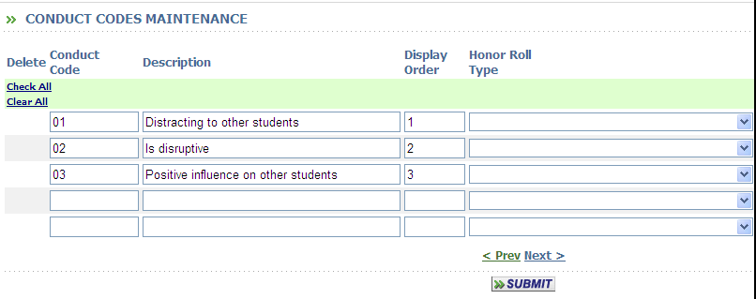

Conduct Code:
- Enter the Conduct Code that will be used by teachers. The code is alpha-numeric.

Description:
- Enter the Conduct Description that will print on Progress Reports and/or Report Cards.

Display Order:
- Enter the Display Order number for the Conduct Code. The Display Order is used when referencing the Codes list by clicking on the magnifying glass icon on a grades entry screen

Honor Roll Type:
- Select “Qualifies – Include in Calculations” to include this grade when using i pass to calculate an Honor Roll.
- Select “Not Consider – Ignore this value & Calculate others” to not include this grade when using i pass to calculate an Honor Roll.
- Select “Disqualifier – Do Not Do Any Calculations” to show no average using i pass to calculate an Honor Roll.
- Leave the field blank, if Honor Roll is not based on Conduct Codes.

Ineligibility Type:
- Select “Qualifies – Include in Calculations” to include this grade when using i pass to calculate ineligibility.
- Select “Not Consider – Ignore this value & Calculate others” to not include this grade when using i pass to calculate ineligibility.
- Select “Disqualifier – Do Not Do Any Calculations” to show no average using i pass to calculate ineligibility.
- Leave the field blank is Ineligibility is not based on Conduct Codes.

      - Click to save your changes.
3. Effort Codes for Progress Reports & Report Cards –
<Grading System> <Maintenance> <Effort Codes>
This table is not academic year specific. Care should be taken when changing comments. It will change the comments assigned in the previous years.

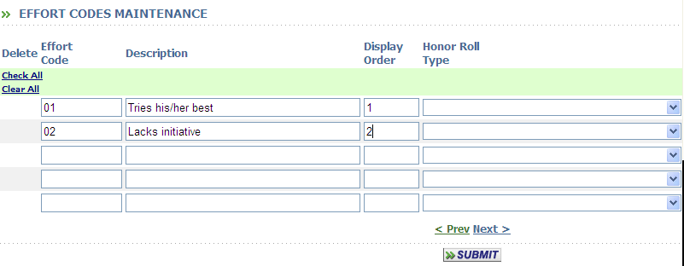

Effort Code:
- Enter the Effort Code that will be used by teachers. The code is alpha-numeric.

Description:
- Enter the Effort Description that will print on Progress Reports and/or Report Cards.

Display Order:
- Enter the Display Order number for the Effort Code. The Display Order is used when referencing the Codes list by clicking on the magnifying glass icon on a grades entry screen

Honor Roll Type:
- Select “Qualifies – Include in Calculations” to include this grade when using i pass to calculate an Honor Roll.
- Select “Not Consider – Ignore this value & Calculate others” to not include this grade when using i pass to calculate an Honor Roll.
- Select “Disqualifier – Do Not Do Any Calculations” to show no average using i pass to calculate an Honor Roll.
- Leave the field blank, if Honor Roll is not based on Effort Codes.

Ineligibility Type:
- Select “Qualifies – Include in Calculations” to include this grade when using i pass to calculate ineligibility.
- Select “Not Consider – Ignore this value & Calculate others” to not include this grade when using i pass to calculate ineligibility.
- Select “Disqualifier – Do Not Do Any Calculations” to show no average using i pass to calculate ineligibility.
- Leave the field blank is Ineligibility is not based on Effort Codes.

      - Click to save your changes.

Helpful Hint!
Report Cards and Progress Reports can be defined to print either the Conduct/Effort Codes or the Conduct/Effort Code Descriptions. They can also be printed for the current term only or for each term.
If you plan on printing the Descriptions, then be aware of the length of your descriptions and the available space on your form(s).
Using Conduct and Effort Codes provides additional information without strictly limiting the number of Teacher Comments.

Note: There is a <System Configuration> setting to indicate if Teacher Comments and Conduct Codes and Effort Codes and to be considered for Honor Roll and/or Ineligibility.
Please refer to the “System Configuration” section of this document for details.

C. Define Grade Parameters, Grade Headings and Grade Headings & Terms -
These tables are dependent on each other and need to be defined in this order.

1. Grade Parameters:
<Grading System> <Maintenance> <Grade Parameters>
This table is not academic year specific. Care should be taken when changing parameters. It will change the parameters assigned in the previous years.

After Grade Parameters are defined, they are assigned to each Grade Heading from a pull-down list. A Grade Parameter need only to be defined based on the unique combination of values for the parameter and can be assigned to multiple Grade Headings.

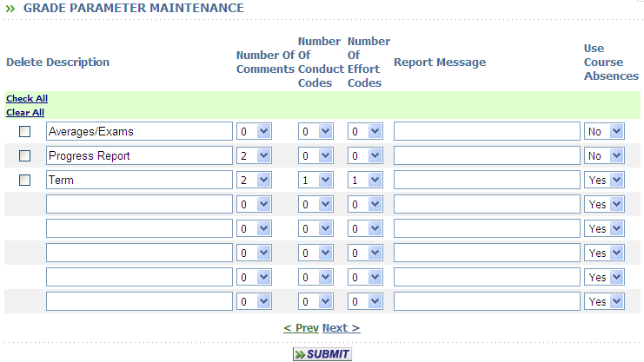

Description:
- Enter the Grade Parameter description.

Number of Comments:
- Enter the maximum number of Comments that can be entered for Grade Headings defined with this Grade Parameter.

Number of Conduct Codes:
- Enter the maximum number of Conduct Codes that can be entered for Grade Headings defined with this Grade Parameter.

Number of Effort Codes:
- Enter the maximum number of Effort Codes that can be entered for Grade Headings defined with this Grade Parameter.

Report Message:
- Enter a message that will be displayed on the generic Progress Report.

Use Course Absences:
- Accept the default of Yes if you want Course Absences to be available as an entry column for Grade Headings defined with this Grade Parameter. If the school is using Period Attendance and this Parameter is set to Yes, then the number of course absences will be shown, but cannot be edited by the teacher, otherwise, they can enter a number of course absences from their own records.

      - Click to save your changes.

2. Grade Headings:
<Grading System> <Maintenance> <Grade Headings>
This table is not academic year specific. Care should be taken when changing headings. It will change the headings assigned in the previous years.

Grade Headings that are defined will be displayed on the <View Only Access> <Grades> page and are defined to be used with Progress Reports and/or Report Cards.

Note: Grade Headings must be defined for Standards-based Report Cards even if only Competency scores or only Narrative Comments are being entered

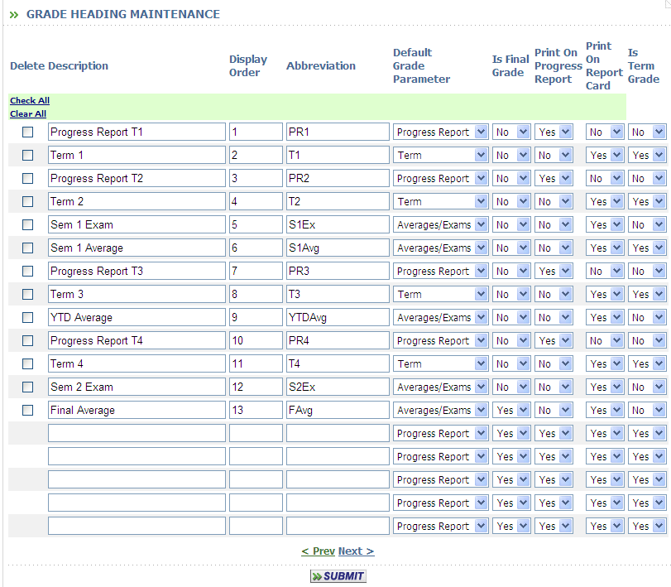

Use the “Search Grade Heading” options to define the list of existing grade headings to be reviewed or modified.

      - Click or Press Enter to submit your Search criteria.
      - Click to create additional Grade Headings.
      - Click on the Grade Heading Display Order to modify an existing heading.
      - Click on the column heading to sort the list in either ascending or descending order. The up/down arrow icon will indicate your sort selection.

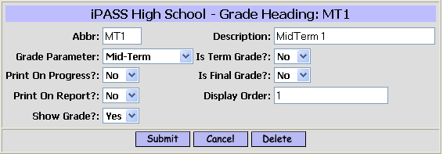

Abbreviation (Abbr):
  - Enter an abbreviation for the grade heading that you are defining. This is the abbreviation teachers/users will see on the various grade column headings.

Description:
  - Enter a Description of the grade heading. The description will only appear in this table.

Grade Parameter:
  - Select the Grade Parameter that defines this Grade Heading.

Is Term Grade:
  - Select the default value of Yes, if a grade with this grade heading should appear on a transcript that includes term grades.
  - Select No, if a grade with this grade heading should not appear on a transcript that includes term grades

Print on Progress Report:
  - Select the default value of Yes, if a grade with this grade heading should appear on a transcript that includes term grades.
  - Select No, if a grade with this grade heading should not appear on a transcript that includes term grades

Is Final Grade:
  - Select the default value of No, if a grade with this grade heading should not appear on a transcript that includes term grades.
  - Select Yes, if a grade with this grade heading should appear on a transcript that includes term grades.

Print on Report (Cards):
  - Select the default value of Yes, if a grade with this grade heading should appear on a transcript that includes term grades.
  - Select No, if a grade with this grade heading should not appear on a transcript that includes term grades.

Display Order:
- Enter the Display Order of the grade heading column. The display order is important for correct view of grades in <View Only Access> <Grades> and for defining Report Card forms.

Show Grade:
  - Select No, if a grade in this grade heading should not appear on a transcript that includes term grades.
  - Select Yes if a grade in this grade heading should appear on a transcript that includes term grades.

      - Click to save your changes.

3. Define Grade Headings & Terms:
<Grading System> <Maintenance> <Grade Headings & Terms>
This table is academic year and term specific. Care should be taken when assigning Grade Headings, opening and closing them and defining the Grade Parameters.

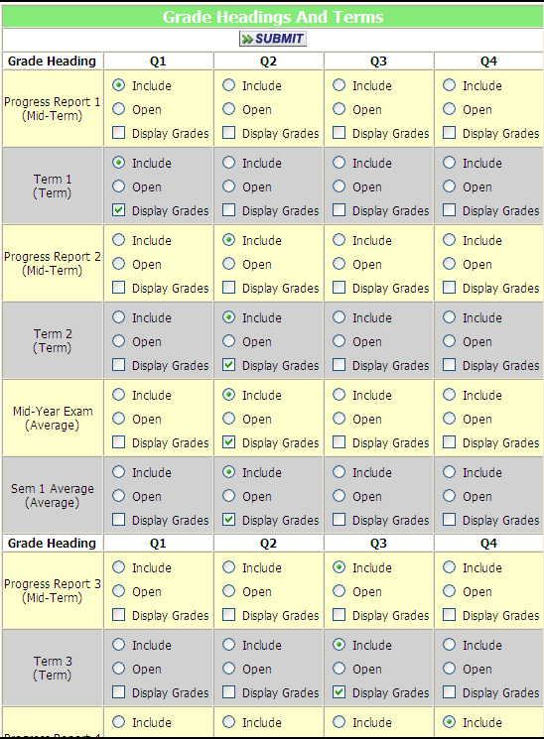

School:
  - The school is set by default value of your “Default School”.

Year:
  - Select the default of the current Academic Year.
  - Select a different academic year from the pull-down list.

Note: Be sure that you have selected the correct Search criteria.

Assigned:
  - Click and place a check-mark on the Grade Headings that would be made available (Open) for data entry for the Term Selected.

Note: “Final Grade” and “Final Exam” are generally the only Grade Headings that should be Assigned to more than one Term. This would be the case when teachers would be entering data for semester courses.
Do not assign “Mid-Term” or “Term” or any other Grade Heading that may have comments, conduct codes or effort codes associated with it.

Open/Closed:
  - Select Open for the appropriate Grade Heading(s) to allow grade entry by teachers/users to enter grades by clicking on the radio button “Open” under the appropriate term column.

Note: The “Extra Security Options”, “Can enter grades for closed terms” in <Security System> <Manage Users> only allows access to <Add/Modify Student Grades> if the Grade Heading is closed. It does not allow access to <Add/Modify Course Grades if the Grade Heading is closed.

      - Click to save your changes.

Important Note: Assignments of Grade Headings and Grade Parameters should be defined once at the beginning of the school year for each Term. Then your only requirement is to open and closed the appropriate Grade Headings as needed during the school year.

D. Define Grade Entry Parameters -
<Grading System> <Maintenance> <Grade Entry Parameters>
This table is not academic year specific. Care should be taken when changing headings. It will change the headings assigned in the previous years.

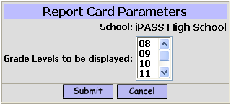

Grade Levels to be displayed:
  - Select and highlight the grade levels that are appropriate for your school. Students in the selected grade levels will be listed on class lists for teacher/user grade entry when Grade Headings are Open.

      - Click to save your changes.

Helpful Hint!
For a High School, in late May, change the parameter to Grade 12 Only so that grades are being entered for Seniors only. Change it to 9-11 after Senior grade entry is complete, for entry of grades for underclassmen. Don’t forget to reset the parameter for all grades at the beginning of the school year.

E. Define GPA Scale Codes & GPA Grade Scales -

1. Scale Codes:
<Grading System> <Maintenance> <Scales Codes>
This table is not academic year specific. Care should be taken when changing headings. It will change the headings assigned in the previous years. Additional Scale Codes can be added. Existing Scales Codes that were used to calculate GPA should never be removed, in case you need to go back and re-calculate a GPA for a previous year.

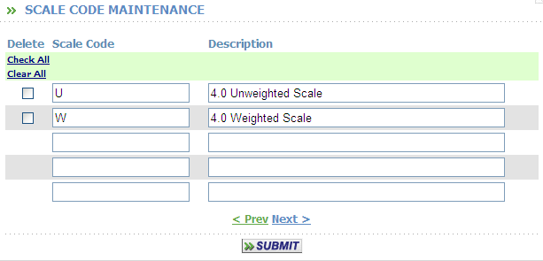

Scale Code:
  - Define as many types of Grade Scales (GPA tables) as necessary for your school.

      - Click to save your changes.

2. Grade Scales
<Grading System> <Maintenance> <Grade Scales>
Define the values that will be used for GPA calculations for each grade, Curriculum Level and Scale.

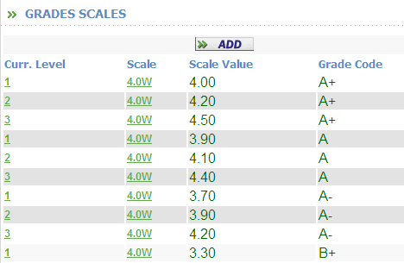

Grade:
  - Accept the default value of Select Grade to get a list, with a Next page option to view all assigned grades and scales values.
  - Select a specific grade to view or modify.

Scale:
  - Accept the default value of first Scale listed to view the list of all grades or the grade selected above.
  - Select a scale from the pull-down list.

      - Click to process your selections.

Academic Year:
  - Accept the default value of the current Academic Year.
  - Select another Academic Year from the pull-down list.

      - Click to process your selection.

      - Click to create additional Grade Scale values.
      - Click on any piece of data to modify an existing Grade.

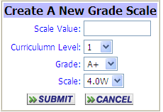
Scale Value:
  - Define the value that will be used for GPA calculations for selected Curriculum Level, Grade and Scale.

Curriculum Level:
  - Select the Curriculum Level (1-5) for the grade you are defining.

Grade:
  - Select the Grade from the pull-down list of grades defined for the Academic Year selected.

Scale:
  - Select the Scale for the grade scale that you are defining.

      - Click to save your changes.

F. Define Report Card Parameters & Transcript Parameters

1. Report Card Parameters
<Grading System> <Maintenance> <Report Card Parameters>
This table is not academic year specific.

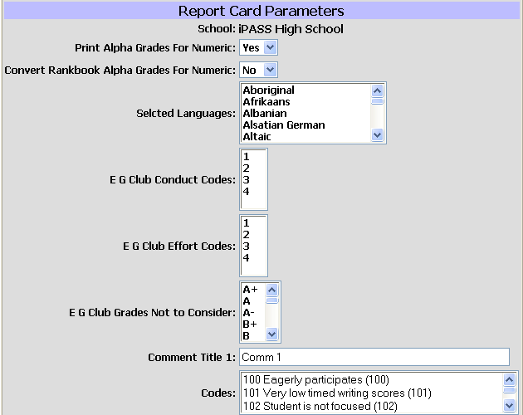

Print Alpha Grades for Numeric:
  - Select the default value of No to have whatever alpha or numeric grades entered by teachers print on students’ Report Cards and Transcripts.
  - Select Yes to have all numeric grades converted to alpha grades when printing students’ Report Cards and Transcripts. Numeric grades will be converted based on the Minimum and Maximum values defined for each alpha grade code defined in the <Maintain Grades> table.
NOTE: The display order of the alpha grades in the <Maintain Grades> table is important. The first alpha grade, by display order in the table, where the numeric grade assigned by the teacher falls within the minimum and maximum range defined will be the alpha grade which prints.

Convert Rankbook Alpha Grades for Numeric:
  - Select the default value of No to have the teachers’ iPASS Rankbook numeric average with 2 decimal places rounded to a whole number and pre-filled for posting to Report Cards.
  - Select Yes to have the teachers’ iPASS Rankbook numeric average with 2 decimal places rounded to a whole number and converted to an alpha grade and pre-filled for posting to Report Cards. The conversion will be based on the school’s Grades table, not that of the teacher.

Select Language:
  - Select one or more Languages to exclude when printing the majority of student Report Cards or to be printed as separate batches.
When Report Cards are printing, you will have the option to print:
- All Report Cards regardless of Language;
- Only Report Cards for the selected Languages, or
- All other Report Cards except those of selected Languages.
The correct Report Card will print based on the language selected and the Primary/First Native Language defined for the student.

Foreign Language Report Cards
i pass currently has the following three (3) option for producing Report Cards and/or Progress Reports in languages other than English.

- Create a single PCL Report Card form and have the teachers select from the defined list of comments either the English comment or the Spanish comment (numbered or coded differently) from the list of available comments that would be appropriate for the student and their parents.
- Create one or more separate Report Cards with the headings, labels, legends and school-wide comments in the appropriate language(s). Use the <Select Language> option and the appropriate form to print the correct Report Card.

Other Report Card Parameter Options
These are specific fields for very unique custom programs. Please ignore these fields.
E G Club E G Club Conduct Codes:
E G Club Effort Codes: E G Club Grades Not to Consider:
Comment Title & Codes 1-5

      - Click to save your changes.
2. Transcript Parameters
<Grading System> <Maintenance> <Transcript Parameters>
This table is not academic year specific.

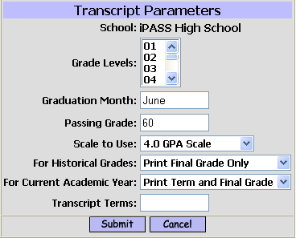

Grade Levels:
  - Select/Highlight the Grade Levels that you want to include when printing Transcripts.
  - Accept the default of no Grade Levels highlighted and all Transcript History records will print regardless of the Grade Level assigned to the record. Because iPASS is a K-12 database, if no Grade Levels are selected, then in a K-12 district, history records from grade 7 and 8, for example, will also print on the Transcript.

Graduation Month:
This is a field that is available for inclusion on the PCL Transcript form.
  - Enter a Month, Month and Year or a complete date that you want to appear on ALL transcripts that include this field in the form definition.
  - Leave the field blank or do not include the field in the form definition if your do not want this information on the Transcript.
This field may be obsolete since a data field is now available to print the date of graduation directly from the student’s Entry/Withdrawal record.

Passing Grade:
This is a field that is available for inclusion on the PCL Transcript form.
  - Enter lowest Passing Grade that you want to appear.

Scale to Use:
  - Select a GPA scale from the pull-down list. The GPA or GPA/Rank calculated for this scale will the values that will print on the Transcript. This option also determines which scale results will be displayed at the bottom of the students’ <View Only Access> <Grades> tab.

For Historic Grades:
  - Select Print Final Grade Only to have only final grades print on the students’ Transcript for years prior to the current academic year.
  - Select Print Term and Final Grade to have all term grades and a final grade print on the students’ Transcript for years prior to the current academic year.

For Current Academic Year:
  - Select Print Final Grade Only to have only final grades print on the students’ Transcript document for the current academic year.
  - Select Print Term and Final Grade to have all term grades and a final grade print on the students’ Transcript for the current academic year.

Transcript Terms:
This is a Custom field – Please ignore this field.

      - Click to save your changes.

G. Honor Roll /Ineligibility Levels -
<Grading System> <Maintenance> <Honor Roll Levels>
This table is not academic year specific.

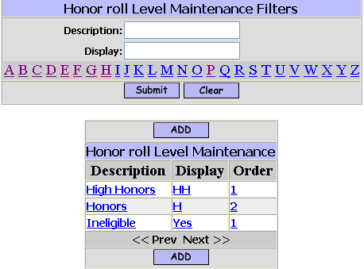

Use the “Honor Roll Levels Maintenance Filters” to define the list of existing rules to be reviewed or modified.

      - Click or Press Enter to submit your Search criteria.
      - Click to create additional Rules.
      - Click on the Description, Display or Order to modify an existing rule.

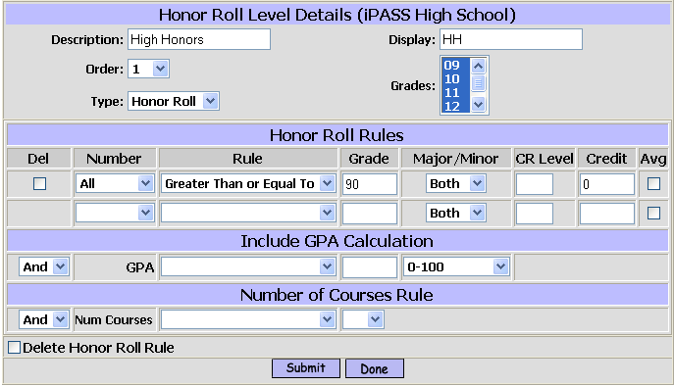

Description:
  - Enter the description that will appear in pull-down lists for calculations and reports.

Display:
  - Enter the abbreviated description of the rule which will appear in the Honor Roll or Ineligibility Status field for each term at the bottom of the students’ <View Only Access> <Grades> tab and could also be printed on the students’ Report Card.

Order:
  - Select the order in which multiple rules of the same type will be calculated.
When an Honor Roll or Ineligibility Type has multiple rules, all rules of that type will be calculated according to the display order, so the students who meet the criteria for the first rule will not be calculated or included on the list for the second rule even though they also meet the criteria for the second rule, as so on.

Grades:
  - Select the grade level(s) that the rule applies to.

Type:
  - Accept the default value of Honor Roll to create an honor roll rule.
  - Select Ineligibility to create an ineligibility rule.

Honor Roll Rules
Define the specific rules for this Honor Roll Level. The order in which they are defined will determine the order in which the student is tested to determine eligibility.

Number:
  - Accept the default value of All as the number of grades a student must have to meet the criteria for this rule or this portion of the rule.
  - Select another number (No/None, All But 1, All But 2, All But 3, All But 4, 1, 2, 3, 4, 5, 6, 7, 8, 9 or 10) from the pull-down list to define this rule.

Rule:
  - Select the rule (Equal, Greater Than, Greater Than or Equal To, Less Than, Less Than or Equal To) as the operator for this rule.

Grade:
  - Select the Grade what will be tested for this rule.
The Grade must be a valid grade defined for your school.

Major/Minor:
  - Select the default value of Both if both “Major” and “Minor” course, as defined in the <Course Catalog> <Course Details> are considered for this rule.
  - Select Major if only major should be considered for this rule.
  - Select Minor if only minor should be considered for this rule.

CR (Curriculum Level):
  - Leave the field blank if the curriculum level of the course is not a factor for this rule.
  - Enter the curriculum level that courses must have to be considered for this rule.

Credits:
  - Accept the default value of zero if the number of (attempted) credits is not a factor for this rule.
  - Enter the number of (attempted) credits that are need to meet the criteria for this level.

Avg:
  - Check the box if you want the average of all grades which meet the criteria to determine eligibility for this rule.

Define as many additional rules for this level as you wish.

Include GPA Calculation
Any one of your GPA tables could be use as criteria for this Honor Roll Level, either alone or in combination with options.

And/Or:
  - Accept the default value of And to require that the student must meet both the Rules criteria and the GPA calculations criteria for this Honor Roll Level.
  - Select Or from the pull-list if the student must meet either the Rule criteria or the GPA criteria for this Honor Roll Level.

Rule:
  - Select the rule (Equal, Greater Than, Greater Than or Equal To, Less Than, Less Than or Equal To) as the operator for the GPA calculation.

Grade:
  - Select the GPA calculation value that will be tested for the GPA calculation.

Scale:
  - Select GPA scale that will be used for the calculation. You may select an existing scale or create a new scale, such as an unweighted scale, specifically for this calculation.

Number of Courses Rule
The number of course to be considered can be determined as an addition factor in combination with your Honor Roll Rules and/or your GPA Calculation Rules.

And/Or:
  - Accept the default value of And to require that the student must meet both the previous required criteria and the Number of Courses Rule to be eligible for this Honor Roll Level.
  - Select Or from the pull-list if this criteria by itself will identify the student as Ineligible.

Rule:
  - Select the rule (Equal, Greater Than, Greater Than or Equal To, Less Than, Less Than or Equal To) as the operator for the GPA calculation.

Grade:
  - Select the GPA calculation value that will be tested for the GPA calculation.

Note: Ineligibility rules are the reverse of Honor Roll rules. You are defining the rules which would put the student on the Ineligibility List. For Example: 3 grades less than 60 or less that 4 courses.

      - Click to save your changes.

I. Horizontal Averaging Rules -
<Grading System> <Maintenance> <Horizontal Average Rules>.
This table is not academic year specific.

The rules are used to determine the weight of each grade based on the Grade Heading it is in when you use i pass to calculate mid-year, YTD of Final averages or to calculate the GPA Quality Points and GPA Attempted Credits for each course to accumulate toward a YTD and Career GPA.

You need to define a code that will be applied to each course-section that will be averaged or used in the GPA calculation based on the criteria of the terms that the section meets.

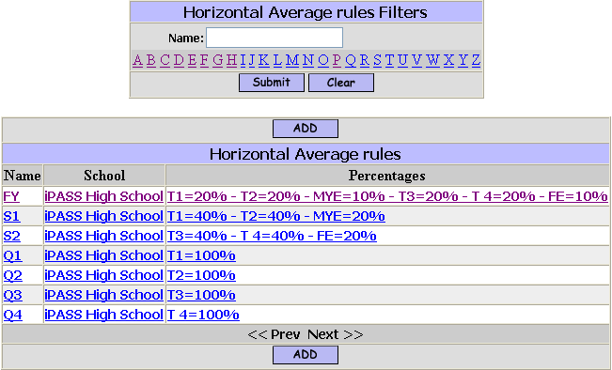

Use the “Horizontal Average Rules Filters” option to find the specific rules to be reviewed or modified.

      - Click or Press Enter to submit your Search criteria.
      - Click to create additional Rules.
      - Click on the Name, School or Percentages to modify an existing rule.

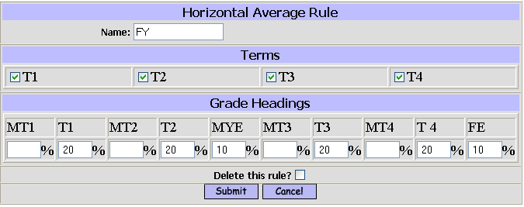

Name:
  - Enter a name for this rule. The name will appear in a pull-down list in <Course Details> for each section of a course. Examples: FY = Full Year Courses, S1 = Semester 1 Courses, T2 = Sections that meet Term 2.
NOTE: A Rule must be defined for each possible combination of term in your Master Schedule.

Terms:
  - Check all boxes that match required combination of terms.

Grade Headings:
  - Assign a whole number percentage to each grade heading that you wish to use in the calculation. The total of all percentages must equal 100.

      - Click to save your changes.

Helpful Hints!
You may change the values in this table before processing either an Average calculation or a GPA calculation if you want different weighting.
Horizontal Averages/Percentage (%) Rules need to be assigned to the course sections. This can be done individually in the Course Details or globally using <Scheduling System> <Course Catalog> <Assign Average Rules to Sections>.

J. Competencies–
<Competencies> <Maintenance>
These tables are not academic year specific. This is very much intentional so that the same competency can be evaluated and scored over multiple years.

Competencies can be defined and used by:
Technical Schools to track proficiency levels of tasks for each shop;
High Schools to track learning skills as a whole or specific achievement levels that need to be maintained for NEASC Accreditation;
Elementary & Middle Schools to track achievement levels for each subject and grade level based on local or state learning standards.

There are 3 layers in the definition of competencies. The most basic are the Tasks which can be scored or rated which can be averaged to provide an overall score/rating for the Competency. A Competency is a related set of tasks that can be scored/rated or given its own score/rating. A Competency Group is a related set of Competencies which would be assigned to a Course. (Courses need to be defined for Elementary Schools who want to produce standards-based report cards. This aspect of the procedure is covered later in the documentation.)

Example – Technical School -
For Health Services course/shop
Competency Group = Health and Safety -
Competency #1 = Define health and safety regulations . . .
Task#1 = Identify and apply OSHA regulations . . .
Task #2 = Identity and apply EPA regulations . . .
Competency #2 = Demonstrate health & safety practices . . .
Task #1 = Read chemical, product & equipment labels . . .
Task #2 = Demonstrate safe dress & relevant safety gear . . .
(Generally scored as Introduced, Semi-proficient, Proficient and Mastered)

Example - High School –
For an English course or a class that uses writing skills -
Competency Group = Writing Effectively
Competency #1 = Structure
Competency #2 = Content
Tasks do not need to be defined
(Generally scored on a Rubric of clearly defined achievement levels)

Example – Middle School –
For a Mathematics course –
Competency Group = Mathematics
Competency #1 = Problem Solving
Competency # 2 = Computation
Tasks do not need to be defined
Other Competencies could be defined to score Effort, Conduct, Class Participation, etc.
(Generally scored with ABCs or Exceeds/Meets/Does not meet expectations)

Example – Elementary School –
For a Grade 1 Mathematics course –
Competency Group = Mathematics
Competency #1 = Number Sense & Operations
Task #1 = Count, name & write numbers, identify place values . . .
Task #2 = Know addition facts
Competency #2 = Measurement
Task #1 = Tell time to the hour and half-hour
Task #2 = Identify parts of the day, days of the week, months . . .
Note: Competency Groups need to be identified for each subject, even if the same teacher is teaching the multiple subject.
(Generally scored with Not Yet Understanding, Developing an Understanding, Consistently Understanding and Applying, Extensively Understanding beyond Standards, Not evaluated at this time or similar development type statements.)

1. Competency Groups, Competencies, Tasks –
<Competencies> <Maintenance> <Competency Groups>

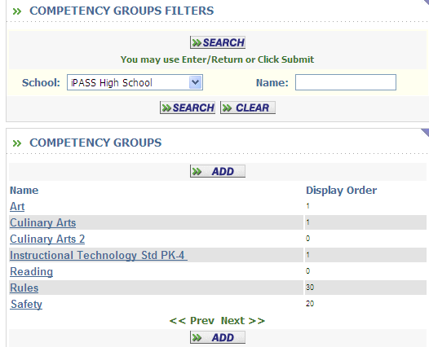

      - Click or Press Enter to submit your Search criteria.
      - Click to create additional Competency Groups.
      - Click on the Name or Display Order to modify an existing Group.

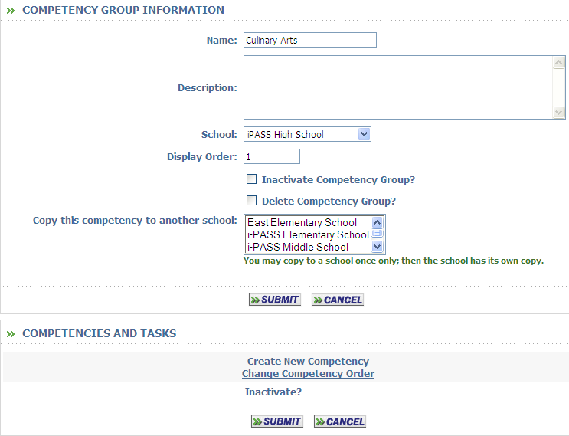
Name:
  - Enter the name of the Competency Group. The name could be printed on the Report Cards as an identifier, but it cannot be scored.

Description:
  - Enter the description of the Competency Group. The description can be the same as the name.

School:
  - Select the School that this Competency Group will apply to.

Display Order:
  - Enter the order in which this Competency Group will be listed for assigning to courses and selected for grading.

      - Click to save your changes.

The following option will be displayed after the Group has been defined.

Inactivate Competency Group:
  - Check the box to make this group inactive. Previous records and scores will be retained, but new records cannot be entered.

Delete Competency Group:
  - Check to box to delete this group. The group cannot be deleted if scores have been assigned to students for any competencies or tasks within this group.

Create New Competency:
  - Click on this hyperlink to create or add a new competency.

Code:
  - Enter a Code, Name or Title for this competency.

Description:
  - Enter the Description of this competency. The Description is displayed as the column heading when entering scores from a class list.

Display Order:
  - Select the order in which this competency should be displayed on entry lists. It does not define the order for placement in a report card.

      - Click to save your changes.

      - Click to add a task or click on the hyperlink “Add Task”.

Add Task:
This option is available on the same screen where you define the competency and on the main screen to allow you to add additional tasks to a competency.

Task:
  - Enter a Code, Name or Title for this task.

Description:
  - Enter the Description of this task. The Description is displayed as the column heading when entering scores from a class list.

Display Order:
  - Select the order in which this task should be displayed on entry lists and on the report card.

      - Click to save your changes.

Change Task Order:
  - Click on this hyperlink to open a new screen which will allow you change the order of the tasks within this competency. If you have defined the Task with numbers, they will not change when you change the order. You may re-define the task to be a different number, either before or after you change the order.

Move to different Group:
  - Click on this hyperlink to open a new screen which will allow you to move this competency and all of its tasks to another group. This is a MOVE function, NOY a COPY function.

      - Click to save your changes.

2. Competency Grades –
<Competencies> <Maintenance> <Competency Grades>
This table is not academic year specific.

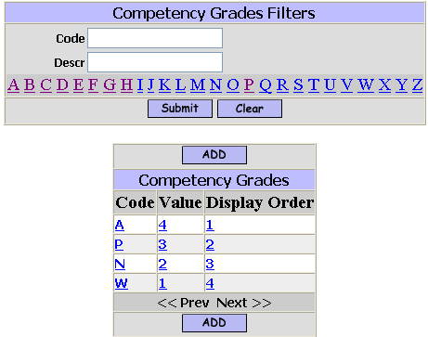

Use the “Competency Grades Filters” to find the specific grade to be reviewed or modified.

      - Click or Press Enter to submit your Search criteria.
      - Click to create additional Grades.
      - Click on the Code, Value or Display Order to modify an existing grade.

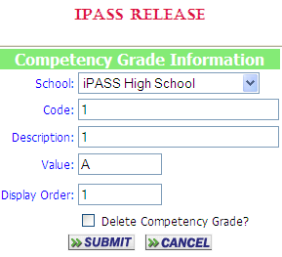

School:
  - Select the School that will have access to these grades.

Code:
  - Enter the Code that the teachers will enter and will be displayed on the report card for competencies or tasks.

Description:
  - Enter a description of the code. This description will not automatically be printed in a legend box on the report. It can be defined as text on the report card form and is only here for clarification.

Value:
  - Enter the numeric value for this code if you will be averaging grades.

Display Order:
  - Enter the Display Order for this grade.

      - Click to save your changes.

Delete Competency Grade?:
This option will appear after you create a new grade and submit or when you open an existing grade.
  - Check the box to delete this grade. A grade cannot be deleted if it has been assigned to a student.

      - Click to save your changes.

K. PCL Grading Documents -
<System Configuration> <PCL Documents>
Additional Tabs <PCL Fields>, <PCL Commands>, <Command Mnem> and <Document Types> should not be modified. These options should be only available to the User Type – “Developer – IMG Use ONLY”

PCL (Printer Command Language) forms need to be created for Report Cards, Transcripts. Progress Reports, Request Verifications, Narrative Report Cards Narrative Progress Reports and Competency Reports/Standards Based Report Cards. Narrative Report Cards and Narrative Progress Report print one page per student per course. All other grading reports print all courses on one page per student, if space permits.
PCL forms can also be created for Emergency Cards, Biographical Verification Reports, Sign-out forms and other school documents.

Note: Initial PCL documents will be created for your school(s). A development fee will be charged for new forms which replace an existing one, or modifications to existing forms. The fee will depend on the complexity of the new form or the changes to be made to an existing document.

1. Forms
<System Configuration> <PCL Documents> <Forms>
All forms have 3 pages of set-up, Form & Body Definition, Form Layout and Form Fields. In addition all forms give you a Copy option. Report Cards, Transcripts and some contain parameter options.

Click to create a new form.

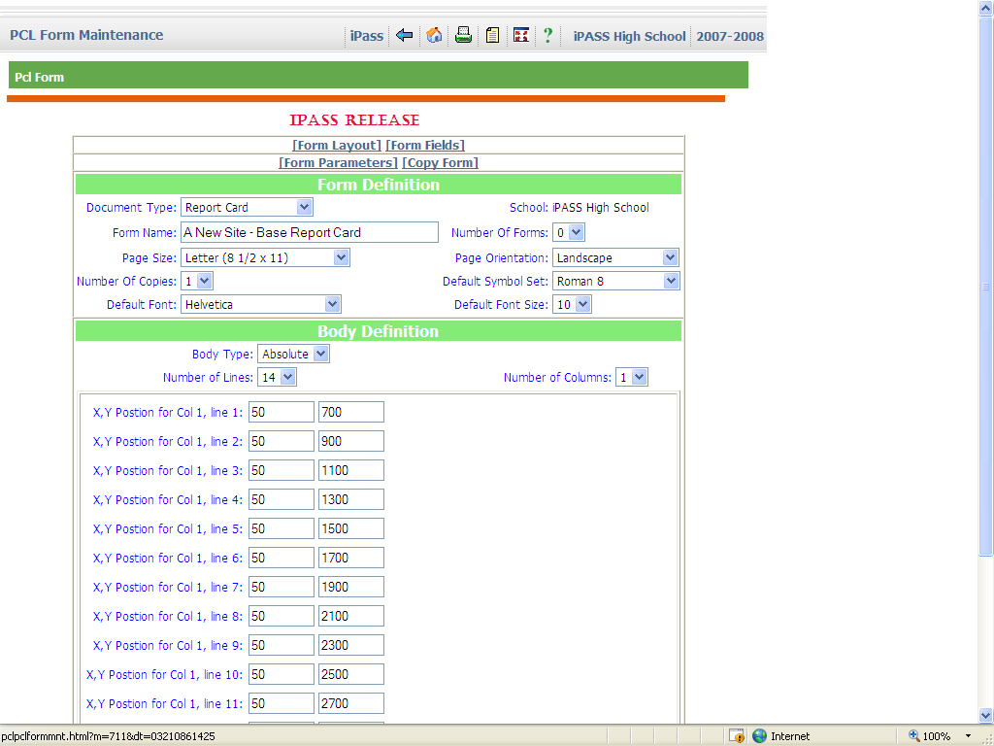

Form Definition

Document Type:
- Select the appropriate Type from the pull-down list. Form Fields are associated with one or more types and may not be available in all types.

Form Name:
- Enter the name of the form you are creating.

Page Size:
- Select the appropriate Page Size from the pull-down list.

Page Orientation:
- Select the appropriate Page Orientation from the pull-down list.

Number of Copies:
- Accept the default of one (1) to print a single copy of the form for each of the students selected.
- Select more than one (1) to get multiple copies of the form for each student selected. If, for example, you select two (2) copies, then two (2) copies will print back-to-back for each student. This option is often used when the school wants to send home two (2) copies of a Report Card or Progress Report and have one returned to the school with a signature, while the Parent/Guardian keeps a copy.
Note: This option has been added to the report program for Transcripts to make it easier to print multiple copies for a single student.

Default Symbol Set:
- Select the appropriate Symbol Set. This value can be changed for individual Text items or Fields. ISO 6:ASCII is the default, select ISO 8859/1 Latin 1 for Narrative Report Cards.

Default Font:
- Select the appropriate Default Font. This value can be changed for individual Text items or Fields. Century Schoolbook is the default. You may want to change the font depending on the available fonts in your printer.

Default Font Size:
- Select the appropriate Default Font. This value can be changed for individual Text items or Fields. (Suggestion: Use 12 for Progress Reports and use 10 for Report Cards and Transcripts which generally contain more text and data.)

NOTE: Changing any of the defaults will change all text items and fields, where the default was accepted and will alter your alignments and relationships with boxes, lines, other text items and other fields.

Body Definition

Body Type
- Select the appropriate Body Type. (Suggestion: Select “Absolute”).

Number of Lines:
- Select the number of data field items you would like on each page. This is usually the number of courses that will print on a page and should be set to the most common maximum for your students. If the number of courses for a specific student exceeds the “Number of Lines”, then a second page of the form will automatically be printed. Accept the default of one (1) for a Data Sheet and do not select any form fields in the Body section of the document.

Number of Columns:
- Select the number of columns of data fields (Course information) you would like on each page. The number of columns is usually one (1) for Report Cards and Progress Reports and two (2) for Transcripts.
- Select the default of one(1) for all other “Document Types”.

- Click to save your changes.

The new form is now listed with your other documents
- Select the form.

You now have the following additional options:

X, Y Position for each Column and each Line:
- Enter the appropriate X value (left-right) position for each column and line.
- Enter the appropriate Y value (up-down) position for each column and line.

Delete this entire form:
- Check the box and submit to delete this form. It cannot be retrieved after it has been deleted.

Form Layout:
- Click on Form Layout to access the page where you define the Boxes, Lines and Text values for the form.

Form Fields:
- Click on Form Fields to access the page where you define the data elements for the form.

Additional Parameters exists for Report Cards. Transcripts & Competency Reports

1a. Parameters for Report Cards:
- Click on Form Parameters to open a new screen of options for printing report cards.

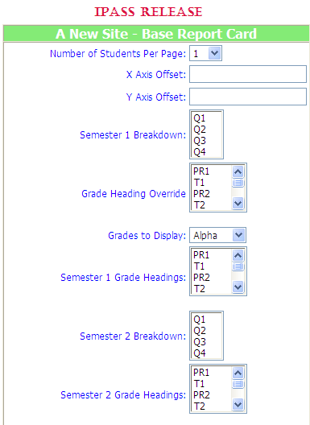

Custom Fields – Please ignore
Number of Students Per Page:
X Axis Offset: Y Axis Offset:

The following options allow you do define a Report Card Form which will print data for each semester, either on a single page or a separate page/form for each semester.

Semester 1 Breakdown:
- Highlight the Terms that makeup Semester 1.

Grade Heading Override:
Custom field. Please ignore.

Grades to Display:
- Accept the default value of Alpha to print only alpha grades on the report card. Alpha grades must be defined for your school, with the correct Display Order and with the correct minimum and maximum values for conversion.

Semester 1 Grade Headings:
- Highlight the grade headings that makeup Semester 1.

Semester 2 Breakdown:
- Highlight the Terms that makeup Semester 2.

Semester 2 Grade Headings:
- Highlight the grade headings that makeup Semester 2

Semester Breakdown Separation Height:
- Enter number of PCL units that will create the space separation between the Semester 1 data and the Semester 2 data when printing on a single page.

- Click to save your changes.

1b. Parameters for Transcripts:
- Click on Parameters to open a new screen of options for printing transcripts.

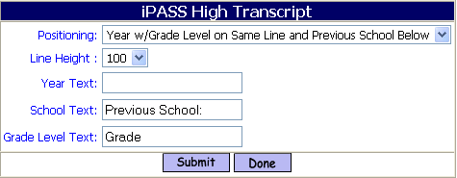

Positioning:
Use this option to define the data and relative locations of; the Academic Year, the Grade Level and the name of a Previous School on your Transcript. The Previous School is the school name that was entered when a Transcript History record was created manually for transfer courses. Your school name will also print, even when all of the records for a specific academic year are from your school. Currently, the groups of multiple records in the same academic year will print in alphabetical order of the school name. Using 2 lines for data is suggested for Transcripts which include term grades. One line of data may be sufficient for Transcripts which print final grades only for all years. Be sure to check the output of your data!

  - Select from the available combinations of locations of static data for each academic year.
The choices are:
Year w/Previous School on Same Line
Year w/Previous School on Line Below
Year w/Grade Level and Previous School on Same Line
Year w/Grade Level on Same Line
Year w/Grade Level on Same Line and Previous School Below
  - Leave this field blank and a separate academic year group will print for each different school name in the student’s record for that year without a reference to the school. (Not suggested)

Line Height:
  - Accept the default value of 0 (zero) if you have not defined above that data would be printed on the “Line Below”. Leaving this field zero when 2 lines have been defined will result in data overprinting other data.
  - Enter the number of PCL units that data on a second line, as defined above, should be placed below the first line. For a form of 10 or 12 point font, this number should be 100. (Approx. 600 PCL units = 1 inch).

Year Text:
  - Leave the field blank to print only the academic year without a label.
  - Enter any text that you want to print in front of the academic year in each group of data on the Transcript. A single space will automatically be inserted following any text that you define. Example: Enter Academic Year: to have your Transcript print Academic Year: 2004-2005.

School Text:
  - Leave the field blank to print only the school name without a label.
  - Enter any text that you want to print in front of the school name, for each school including yours in each group of data on the Transcript. A single space will automatically be inserted following any text that you define. Example: Enter School: to have your Transcript print School: iPASS High School. Suggestion: leave this field blank, it just adds length and little information.

Grade Level Text:
  - Leave the field blank to print only the grade level without a label.
  - Enter any text that you want to print in front of the grade level in each group of data on the Transcript, if you have chosen to print grade level in the options above. A single space will automatically be inserted following any text that you define. Example: Enter Grade: to have your Transcript print Grade: 10.

- Click to save your changes.

1c. Parameters for Competency Reports/Standards Based Report Cards:
- Click on Parameters to open a new screen of options for printing competency based report cards.

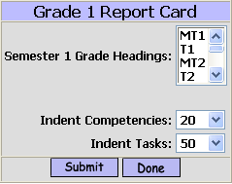

Grade Headings:
  - Accept the default of all Grade Headings listed to allow for the entry of scores and narrative comments for all Grade Headings.
  - Select/highlight only those Grade Headings which are appropriate for this form. Often upper elementary grades will report for all grade headings/terms and Kindergarten will only report starting at the half year.

Indent Competencies:
  - Enter the number PCL units to indent the Competency Name or Description. Suggested: 20. If you do not define an indent, then the name will print at the left edge of the box.

Indent Tasks:
  - Enter the number PCL units to indent the Task Description. Suggested: 50. If you do not define an indent, then the name will print at the left edge of the box.

Print Teacher Print Name at Caption of Comment:
  - Accept the default of No to not print a teacher’s “Print Name” print in the caption area of a comment.
  - Select Yes from the pull-down list to have the teacher’s “Print Name” print in the caption area of a comment. The teacher’s “Print Name” will print one space to the right of any caption that you have defined in the form, such as “Teacher:”.

- Click to save your changes.

1d. Parameters for Narratives and Standards Based Report Cards:
<Grading System> <Maintenance> <Narrative Parameters>. These parameters deal with Narrative Report Cards that would contain narrative comments for multiple terms and Standards Based Report Cards that could also contain narrative comments and not just the scoring of competencies.

These parameters define the dimensions of the Narrative boxes for each Report Card/Grade Level and for each term. This is to allow for different size comment boxes depending on the Term. A larger box for the first reporting period and smaller reporting box for the last reporting period of the year. The boxes may also vary by report card/grade level depending on the number of competencies being scored and how many pages you want the report going home to be.

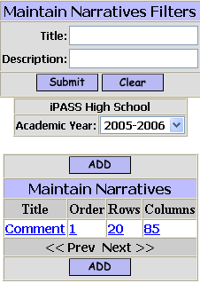

      - Click or Press Enter to submit your Search criteria.
      - Click to create additional Narrative Parameters.
      - Click on the Title, Order, Rows or Columns to modify an existing grade.

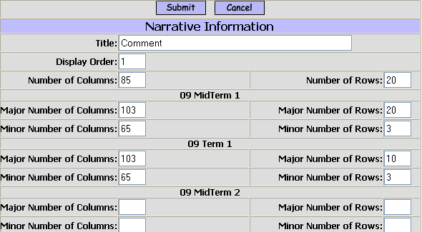

Generally, there is only one narrative box that could be re-configured in size for each Term or Grade Heading.
An example of when you might want a pair of narrative boxes would be to create a narrative that describes the curriculum of the course with a second the describing the student’s individual positives and negatives. In this case, the first box automatically copies to each student in the class and could be edited for individuals. The second narrative box is blank.

Title:
  - Enter the Title for the narrative box.

Display Order:
  - Enter 2 if you do not want to create a pair of narrative boxes so that the comment for the first student will not automatically copy to every other student in the class.

Major Number of Columns/Rows:
  - Enter the number of Columns and Rows to define the dimensions of the narrative boxes for Major courses.

Minor Number of Columns/Rows:
  - Enter the number of Columns and Rows to define the dimensions of the narrative boxes for Minor courses.

- Click to save your changes.

PCL Form Layout

Click “Form Layout” on the Form Definitions page to access this page.

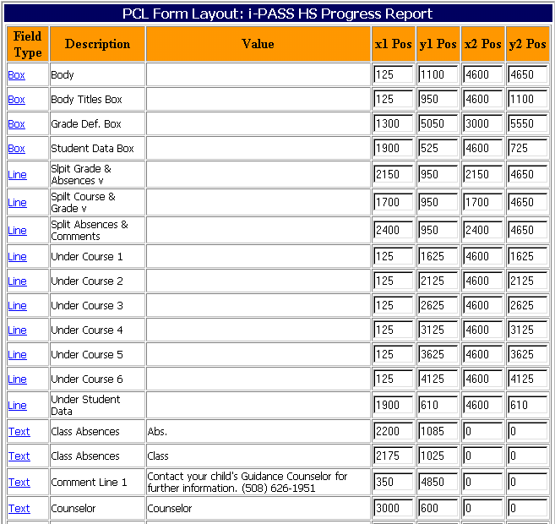

- Click to create a new Box, Line or Text field.

Form Layout Details

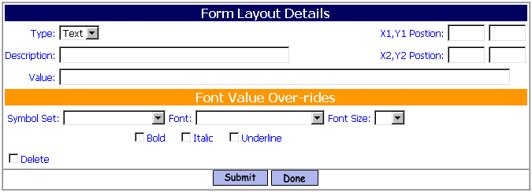

Type
- Select the appropriate Type. (Box, Line, Text)

Description:
- Enter a description that will identify the Box, Line or Text field that you are creating. This description will appear on the main page and not on the printed form.

Value:
- Enter a value for any Text field that you are creating. This “Value” will appear on the printed form.
- Leave the value blank for Boxes and Lines.

X1, Y1 Position:
- Enter the appropriate X1 (starting - left-right) position for this field.
- Enter the appropriate Y1 (starting - up-down) position for this field.

X2, Y2 Position:
- Enter the appropriate X2 (ending - left-right) position for this field.
- Enter the appropriate Y2 (ending - up-down) position for this field.

NOTE: 1) A Box requires that all four (4) positions are defined.
2) A Line requires that all four (4) positions are defined.
3) A Horizontal Line will have the same Y1 and Y2 position values.
4) A Vertical Line will have the same X1 and X2 position values.
5) A Text field is defined with only an X1 and Y1 position.
6) A Text field can be defined without a value, that can be defined or modified later,
such as defining multiple lines for comments on a Report Card, but leave
them blank if there is less to say, but reserving the positioning for future use.
(Sample documents of any type are available upon request.)

Form Value Over-rides

Symbol Set:
- Leave the field blank to accept the default Symbol Set defined on the Form Definition page.
- Select a different Symbol Set from the pull-down list.

Font:
- Leave the field blank to accept the default Font defined on the Form Definition page.
- Select a different Font from the pull-down list.

Font Size:
- Leave the field blank to accept the default Font Size defined on the Form Definition page.
- Select a different Font Size from the pull-down list. (Font sizes 6 and 8 are at the bottom of the list.)

Bold:
- Check this box to have the Text Value print BOLD. This option only affects Text type fields

Italic:
- Check this box to have the Text Value print in Italics. This option only affects Text type fields.

Underline:
- Check this box to have the Text Value print Underlined. This option only affects Text type fields.

Delete:
- Check this box to delete this field.

- Click to save your work.

A new screen will appear to Add more fields.

- Click DONE to return to the PCL Form Layout page.

- Click on the field type to Modify an existing field. You can change the positioning of any field on this page without going to the field directly.
- Check the box in the Delete column and Submit to permanently remove any field.

Form Fields

- Click “Form Fields” on the Form Definitions page to access this page.

This page is divided into three (3) sections – Header, Body and Footer. Each has its own set of available data elements that can be pulled from the student’s record.

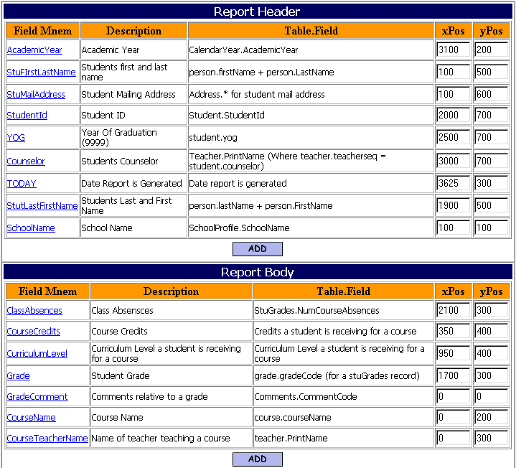

NOTE: The Footer Section is not shown in this example.

- Click at the bottom of the appropriate section to create a new Header Field, Body Field or Footer Field.

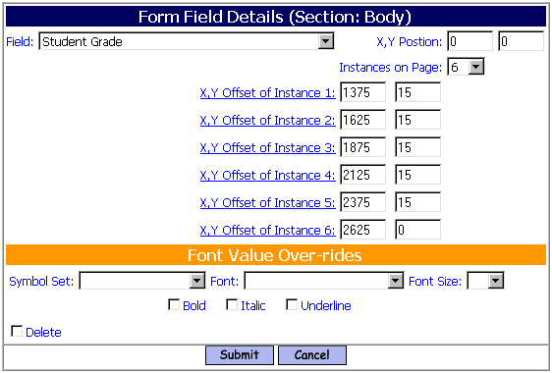
Field:
- Select the field you wish to add to the Header, Body or Footer section of the form.

X, Y Position:
- Enter the appropriate X (left-right) position for this field.
- Enter the appropriate Y (up-down) position for this field.

- Click to save your work.

Instances on Page:
It is possible that a field will appear more than once on a page. e.g. Multiple term grades on a Report Grade, multiple comments on a Report Card or Progress Report or multiple number of Absences, Tardies, Dismissals for each term.
The definition of the field will have an X and Y position of zero (0). Positioning will be defined for each instance of the field.

- Select the number of instances of this field that will appear on the form.

Once you submit this field, re-select it to define the positioning of the several instances of the field.

Some data fields also have dependent data fields. e.g. Earned Credits are dependant upon a Final (Passing) Grade.
Click on the Grade instance of the Final Grade and add the “Earned Credits” field and its positioning.

NOTE: The position of fields in the Body are based on the starting position, in one or more columns, of each record as defined on the “Form Definition” page. The X and Y values are relative to those starting positions.

Form Value Over-rides

Symbol Set:
- Leave the field blank to accept the default Symbol Set defined on the Form Definition page.
- Select a different Symbol Set from the pull-down list.

Font:
- Leave the field blank to accept the default Font defined on the Form Definition page.
- Select a different Font from the pull-down list.

Font Size:
- Leave the field blank to accept the default Font Size defined on the Form Definition page.
- Select a different Font Size from the pull-down list. (Font sizes 6 and 8 are at the bottom of the list.)

Bold:
- Check this box to have the data print BOLD.

Italic:
- Check this box to have the data print in Italics.

Underline:
- Check this box to have the data print Underlined.

- Click to save your work.

NOTE: Data elements in either the Body or Footer may be placed on the page within the other area, even if they are not available as data elements to select within that section. e.g. Attendance data can be created in the Footer and then defined with positions that fall in the Header (upper portion) of the form.

Suggestions:
  - Print an appropriate Grid Page from <System Configuration> <PCL Reports> <Grid Page> on a transparency page to overlay, align and determine position.
  - Copy an existing form and make modifications.
(Contact IMG to get sample documents to use a templates.)
  - Make a copy of an existing form before you start making modifications.
  - When creating a new form, do all the typing first, then do the positioning. Define the fields, descriptions, fonts, etc. when creating them, but define the positioning on the main page.
  - Cluster lines and Text, based on being in the Header, Body or Footer or other groupings.
  - When using a form with more than nine (9) courses, number the Courses 01, 02, 03, etc.
  - Print working copies often to check your work.
L. Term Start/End Dates
<Scheduling System> <Maintenance> <Academic Year Settings>
Check your term Start/End Dates to see that they are correct. For Report Cards and Progress Reports, these dates are referenced for printing accurate attendance numbers.

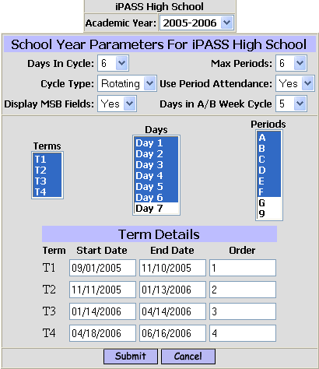

Check the data for accuracy. Make necessary adjustments based on Calendar changes such as Snow Days.

M. System Configuration
<System Configuration> <Parameter Maintenance> <Application = Grading> <Parameter Group = Configuration>. There are several parameters listed here which control aspects of Grade entry which you may want to adjust. These are District settings which will affect other schools within your District that are doing grading.

Check Effort/Conduct/Comment codes in Honor Roll:
The calculate Honor Roll program checks to see if parameters for Qualifying, Disqualifying or Ignoring Comments, Conduct Codes or Effort Codes have been defined and should be considered when determining Honor Roll or Ineligibility.
- Enter Yes to have the calculate Honor Roll program consider these parameters.
- Enter No to have the calculate Honor Roll program ignore these parameters

Class Grades Paging (Next or Current):
Define the default action when grades are being entered for a class that has more students than will print on a single display page.
- Enter Next to get a list of the students on the next page after submitting the grades for the students on the first page.
- Enter Current to have the first page list of students displayed/refreshed after submitting their grades. You would then use the <Next Page> option at the bottom of the list to get the second page list of students.
There is a system parameter which will increase the number of students who appear on an entry list. Contact img support for assistance.

Course 1 Grade Heading Only:
This parameter determines if only 1 (open) Grade Heading column is available for grade entry within <Add/Modify Course Grades> or will all open Grade Headings be available for grade entry.
- Enter Yes to display only 1 (open) Grade Heading column for grade entry.
- Enter No to display All (open) Grade Heading columns for grade entry.

Helpful Hints!
Enter Yes, if only some of your teachers will be entering grades for more than 1 grading. It may be easier to determine who has not entered grades for a specific grade column, then determine which teachers have entered grades in the wrong column.

Display Enrolled Status:
Which Enrollment statuses will be listed in the pull-down list.
Please contact i mg support if you think this parameter should be modified.

Display Grades:
This parameter determines if previous grade columns will be displayed along with the current (open) grade heading(s).
- Enter True to display the Grade Heading and grades for all previous Grade Headings.
- Enter False to display only the current (open) Grade Heading(s).

GPA List 100: and GPA List 4: Print grade
These are custom fields, please ignore them.

Student Grades Confirm Box:
- Enter Yes to have the Confirm Box displayed which says “Are you sure you want to update? OK / Cancel” after submitting records in <Add/Modify Student Grades> .
- Enter No to not display this box and submit the data without the extra check.

Teacher Grades Confirm Box:
- Enter Yes to have the Confirm Box displayed which says “Are you sure you want to update? OK / Cancel” after submitting records in <Add/Modify Course Grades> .
- Enter No to not display this box and submit the data without the extra check.

These next two (2) parameters will define the Failing and Passing grades used for Pass/Fail course when a Final Average is calculated using <Calculate Horizontal Averages>. For courses defined in <Course Details> as Pass/Fail, the program does not look at the Horizontal Averaging Rules except to determine which grades to consider. For Pass/Fail courses, if any one (1) of the grades being considered is a Failing grade, based on this parameter, then that grade will be the Final Grade for the student and they will fail the course.
Pass/Fail Failing Grade:
- Enter the grade code which is considered to be Failing for a Pass/Fail course.
Pass/Fail Passing Grade:
- Enter the grade code which is considered to be Passing for a Pass/Fail course.

Passing Grade:
This is the same parameter which is defined in <Grading System> <Maintenance> <Transcripts Parameters>. This is the code which will print on the student’s Transcript when the “Minimum Passing Grade” field is included in the form.
- Enter your minimum passing grade code.

Print Grade:
This is a custom field, please ignore it

** Separate area of <Parameter Maintenance>-
Number of Students per Page for grade entry of a class list:
<System Configuration> <Parameter Maintenance> <Application = Team> <Parameter Group = Search>. “grdinputgradesclass.html Number of Rows”
- Enter the maximum number of students that would be displayed on a course list for grade entry.

Note: Remember these are District settings that will affect all schools doing grading.

Delete:
- Check this box to delete this field.

- Click to save your work.

N. Security -
<Security System>

Check your <User Types> in both Folder View and Tab View to insure that proper access is granted or denied for the Maintenance programs and System Configuration options.

Check your <Manage Users> to insure that proper access is granted or denied for Folders, Schools and Extra Security Options.

Check your <Assign Teacher Access> to insure that proper access is granted or denied for teachers and staff to enter Grades or Competencies for other teachers.

II. DATA ENTRY -

A. Report Cards & Progress Reports

1. iTeacher Entry of Grades -
<iTeacher> <Add/Modify Student Grades>
This screen allows teachers to enter grades for students scheduled into their classes only.

Note: Staff or substitures can also enter grades using this screen, if they have been given access through <Security System> <Assign Teacher> for a specific teacher or all teachers.

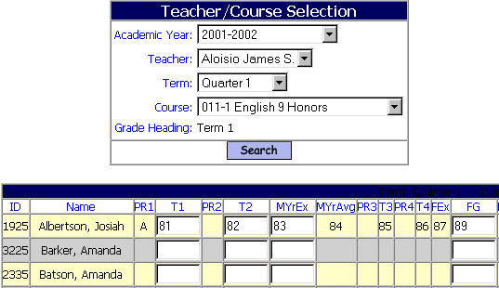

Academic Year:
  - Accept the default of the current Academic Year.

Teacher:
  - Accept the default of your name. For teachers that are properly setup as users, this will default to your name. Otherwise select the appropriate teacher from the drop down list.

Term:
  - Select the appropriate term for entering/editing grades.

Course:
  - Select the course/section that you wish to work with.

Grade Heading:
  - Select the appropriate Grade Heading that you wish to work with.

Please Note: The grade columns above (i.e. T1 = term one, T2 = term two, MyrEx = Mid Year Exam, FG = Final Grade) are open for teachers to enter grades. The ability to enter or edit grades on this screen is controlled by administration. Please consult with administration for details regarding your school’s policy on entry of grades.

Teachers will enter the appropriate data. Progress Reports may or may not include grades and/or course absences depending on your Grade Parameter settings. Your Grade Parameters also determine if Conduct Codes and/or Effort Codes are being entered and the number of Comments, if any.

If teachers are using the i pass Rankbook, then an additional column is displayed showing the term average to two decimal places and the Term Grade Heading column will be pre-filled with a rounded-off whole number, or an alpha grade if their rankbook parameters are defined to generate alpha grades. They may override the rounded-off average.

If they are using Period Attendance, then the number of course absences will also be pre-filled, but cannot be modified.

They can go back and change any grades while the Grade Heading is open.

2. Staff Entry of Grades
<Grading System> <Add/Modify Student Grades>

Note: Staff can enter grades and enter grades for previous year, if they have been given access through <Security System> <Manage Users> <Extra Security Options> for “Can enter grades for closed terms” and “Can Update Prior Year Grades”.

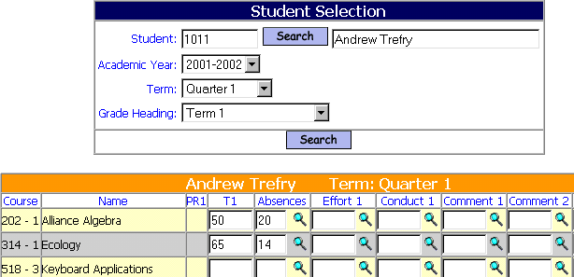

Student:
- Enter a student ID # and click , the student’s name be displayed.
- Chick to get a filtering screen to find a student.

Academic Year:
- Accept the default of the current Academic Year.
- Select a previous Academic Year.

Term:
- Accept the default of the current Term.
- Select a different Term from the pull-down list.

Grade Heading:
- Accept the default of Term 1.
- Select a different Term from the pull-down list.

Enter the appropriate data.

- Click to save your work.

3. Grades entered from another source
<Grading System> <Maintenance> <Grade Import>
This program is explained in detail in Section IV-E of this document. It is written to allow for the import of grades from other grade book software.

4. Rankbook
<iTeacher> <Rankbook>
This program is explained in detail in Section IV of this document.

B. Transcripts
Transcript records come from two (2) sources:
1) Records that have been entered in <Add/Modify Course Grades> or <Add/Modify Student Grades>, or
2) Records that have been entered in <Transcript History> either manually for Transfer and Summer School courses or through data conversion.

1. Transcript History -
<Grading System> <Transcript History>

Note: Transcript records that were entered in <Add/Modify Course Grades> or <Add/Modify Student Grades> are a part of the Transcript History. These records should not be changed in <Transcript History>. They should be changed using the Add/Modify program and will get re-posted/updated when a Report Card or Transcript is printed for the student.

Helpful Hints!
If your system has the ability to generate PDF reports, then you could “print” all report cards or transcripts to PDF to get the data updated after entering corrections or summer school records without wasting paper.

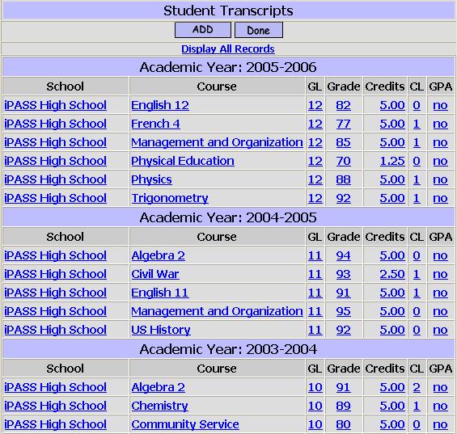

The student’s Transcript History screen lists the most recent academic year first and lists all courses, in alphabetical order by course name. The Transcript will print the courses in ID# order. If course ID#s have not been defined for transfer courses, then they will print on the Transcript in alphabetical order by course name.

Display All Records:
- Click on this hyperlink to display all grade records for the student. This will include Middle School records. You will also see records where the grade level assigned to the record is outside the grade level range of the school.

CL
This is the Curriculum Level of the course for this student.

GPA Yes/No
Yes, indicates that it is a course entered manually as a transfer course or summer school course or entered through data conversion and that it is included in GPA calculations.

- Click on any piece of data to open a new screen showing the specific detail for the record selected.
- Click to create a new record.

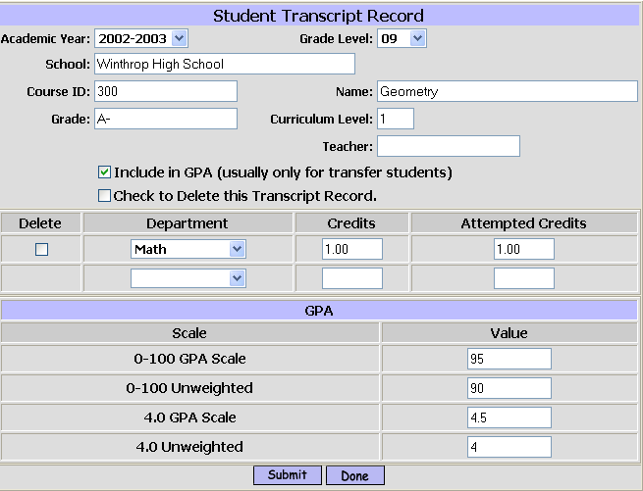

Academic Year:
- Select the Academic Year when the course was taken.

Grade Level:
- Select the Grade Level of the student when the course was taken.

School:
- Enter the name of the School where the course was taken. If you are adding multiple records for a student transferring into your school, the school name remains when you submit this record and proceed to enter another. This will give a consistent name for the school, at least for this student’s record. Be careful that a long school name does not overwrite data when printed.

Course ID:
- Enter an alpha-numeric ID for the course. Courses on the Transcript are printed in ID order. Suggestion: Enter only the first character or two that would represent the department in your schools course numbering scheme, so that transfer courses will print in the same (department) order as course taken at your school.
- Leave the field blank and courses will print on the Transcript in alphabetical order of course name.

Name:
- Enter the Name of the course. Again be careful of length.

Helpful Hints!
If the courses for your school are still all upper case, then re-type them in Upper/lower case to take up less room on Report Cards and Transcripts. The re-typing will take care of all updating for all Academic Years.

Grade
- Enter the Grade the student received for the course. The grade must be a grade used by your school, so a conversion may be needed.

Curriculum Level:
- Enter the Curriculum Level of the course based on your school’s curriculum levels.
- Leave the field blank or enter 0 if the course will not count toward GPA.

Teacher:
- Enter the name of the Teacher who taught the course.
- Leave the field blank.

Department:
- Select the Department that the course would be in from the list of departments for your school.
- Select Administration if the course does not match any of your school’s departments.

Credits:
- Enter the number of Credits the student earns toward graduation from your school. You many need to do a conversion if your credit system does not match that of the transfer school.
- Enter 0 if the course does not count toward graduation at our school or if the student failed the course.

Attempted Credits:
- Enter number of Accepted Credits if this course counts toward GPA. A conversion of credits to your system may be needed.

- Click to save your work.

After the course(s) have been entered, open the records again, if they count for GPA or need to be deleted. 2 new options will be available with check boxes.

Include in GPA:
- Check the box to have the course count toward GPA.

Check to Delete this Transcript Record:
- Check the box to delete the record.

- Click to save your work.

If you have checked the box for Include in GPA, then the Quality Point values for each of your GPA scales will be shown.

- Click a second time to save the Quality Point values.
- Click “Done” to save your work and select another record.
- Click to save your work and select another student or program.
2. GPA
Grade Point Averages (GPAs) are generally printed on student Transcripts. They can be included on i pass Transcripts as well, along with class rank and class size. The scale that prints is defined in your <Transcript Parameters>.

GPA, it’s components, how it is calculated, how it is stored and how it can be verified is covered in detail in Section IV-B of this document.

C. Competencies and Standards Based Report Cards
Competencies for Tech Schools, Middle Schools and Elementary Schools must be defined, as described earlier and the Competency Groups need to be assigned to course. Courses already exist for scheduling Tech Schools and Middle School, but generally not for Elementary Schools. A separate section for “Developing Standards Based Report Cards” is described in Section IV-C of this document.
The teacher entry of competency scores is the same for any type of school and is described below.
Entry of competency scores by a staff person is the same, provided they have been given <Assign Teacher Access – Competencies> for some or all teachers.

<iTeacher> <Add/Modify Competencies>
The Teacher’s name is pre-defined based on the teacher’ login.
The Academic Year and Term are also pre-defined.

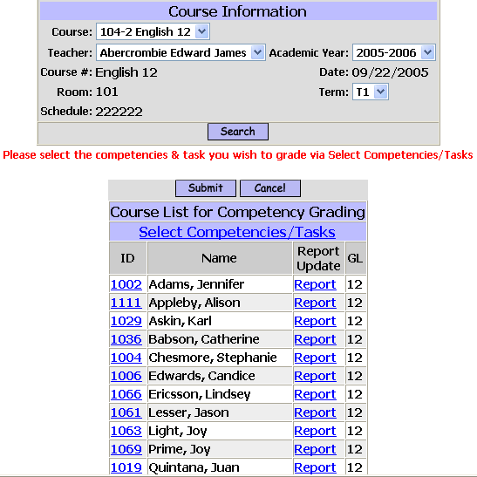

Course :
- Select the course that the wish to score competencies for from the pull-down list.

Teacher :
- Accept the default value of your name.
- Select another teacher from the pull-down list if you have access to enter competency scores for other teachers.

Academic Year:
- Accept the default of the current Academic Year.
- Select a previous Academic Year from the pull-down list.

The Course Name, Today’s Date, Room and Schedule of the course will be displayed.

- Click to get a class list.

You have two (2) options for entry of competency scores; by class list or by individual student.

Entry by Class List -

Select Competencies/Task:
- Click on this hyperlink to open a new screen where you can select the competencies and/or tasks that you wish to score.

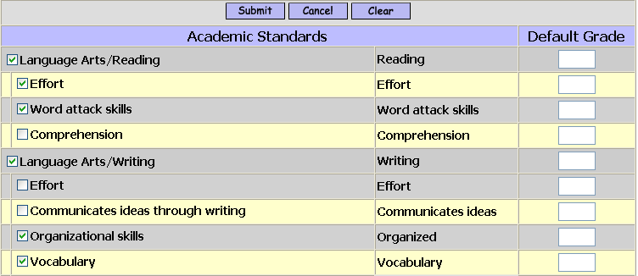

Competencies and Tasks:
- Check the competencies and tasks that you wish to score.

Default Grade:
- Enter a default grade for a competency or task to be assigned to every student in the class. Default grades can be overridden for individual students.
- Leave the default grade blank to assign grades individually.

- Click to get a class list with columns to score the selected competencies and/or tasks.

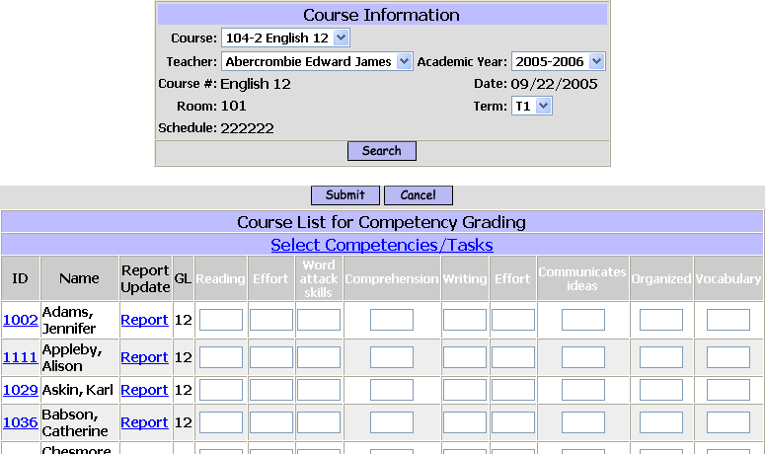

Scoring :
- Enter a score for each student, for each competency and/or task as appropriate.
- Leave the field blank if the student cannot be evaluated at this time.
- Accept a default score that has been defined.
- Modify the default grade as necessary.

- Click to save your work.

Entry by Individual Student -

Student ID:
- Click on the ID# of the student you wish to score.

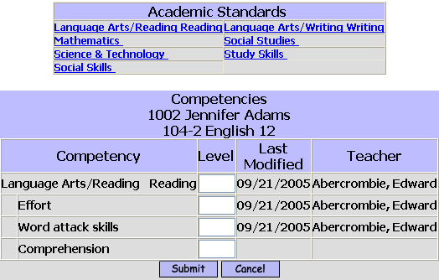

The first Competency and all of its Tasks are available for scoring.

Scoring :
- Enter scores for this student, for each competency and/or task as appropriate.
- Leave the field blank if the student cannot be evaluated at this time.
- Select a different set of Competencies and Tasks to score, if available.
- Select a different set of Competencies and Tasks to score, from a different Competency group, if available.

- Click to save your work.

D. Narratives and Standards Based Report Cards
Narrative can be Report Cards (one page per course) or Progress Reports (one page per course) or can be narratives that enhance a Standards Based Report Card for major and/or minor courses
Entry of narrative comments by a staff person is the same entry by a teacher, provided that they have been given <Assign Teacher Access – Competencies> for some or all teachers.

<iTeacher> <Add/Modify Competencies>
The Teacher’s name is pre-defined based on the teacher’s login.
The Academic Year and Term are also pre-defined.

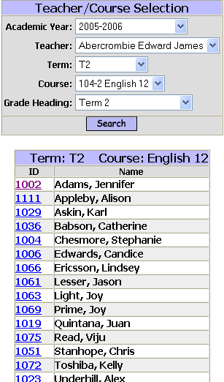

Course :
- Select the Course that the wish to enter narratives for from the pull-down list.

Grade Heading :
- Select the Grade Heading that the wish to enter narratives for from the pull-down list.

- Click on the ID# of the student you want to enter the narrative for.

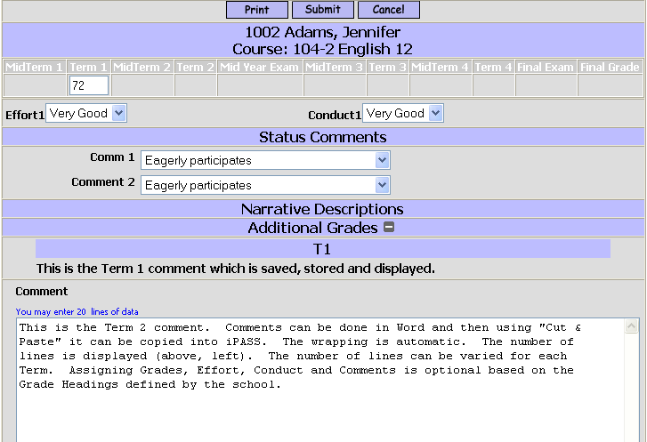

Text :
- Enter your text
- Copy in your text from another source.

- Click to save your work.

III. Reports -

A. Public Reports -
Reports that are sent or made available outside of the school are your #1 means of communication. These reports should be clear, informative, accurate and professional looking.
All of these reports are available in <Grading System> <Reports>.

1. Stock -
Report Cards, Progress Reports and Transcripts make the most impression, not just for content, but also for appearance. They can easily be enhanced by adding color, logos, and clearly displayed information.

Options available for i pass documents include special stock paper, pre-printed and logo printing.

2. Foreign Language Options for Report Cards & Progress Reports -
i pass currently has the following three (3) option for producing Report Cards and/or Progress Reports in languages other than English.

- Create a single PCL Report Card form and have the teachers select from the defined list of comments either the English comment or the Spanish comment (numbered or coded differently) from the list of available comments that would appropriate for the student and their parents.
- Create one or more separate Report Cards with the headings, labels, legends and school-wide comments in the appropriate language(s). Use the <Select Language> option and the appropriate form to print the correct Report Card.
- <In Development> Define each word, phase, title, label, course name, comment, etc. that you wish to convert in a <Translation> for whatever languages you want. The conversion for the output of the report in the proper language will be based on the Language of the first Guardian who “Lives With” the student and the Language of a Guardian/Contact who “Receives Mail”.

3. Distribution -
Report Cards, Progress Reports and Transcripts can be sent home with the students. They can be printed by Homeroom.

Helpful Hints!
If the you do not have regular homerooms, then use the <Assign Homerooms from Schedules> program to generate Report Cards or Progress Reports based on the students’ last class of the day to reduce the disruption that happens when they are distributed.

Reports can be printed with an address in the proper position for stuffing in window envelopes.

Report can be printed ready-to-mail using “Print To Mail” or similar software and stock.

Emailing reports is possible, if the proper pieces are in place. For example: Your computer systems mail-processor and having email addresses to send to.

4. Report Cards -
Used to: Communicate a student’s academic standing at the end of a marking period.
Filtering: Academic Year, Form, Student ID, Homeroom, Grade Level, Enrollment Status, Term, Counselor, SPED, Exclude Course Type, Selected Languages, Period, Day, Print Narrative, Output Device.
Sorting: Name, Grade Level, Homeroom, Zip Code.
Output: Defined in the PCL form and Report Card Parameters, which could include course level, multiple comments, effort and conduct codes, attendance, GPA, Honor Roll, signature line, and a school-wide message.

5. Progress Reports (PCL)-
Used to: Communicate a student’s progress, positive or negative, at any time, but usually at the mid-point of a marking period.
Filtering: Academic Year, Form, Student ID, Homeroom, Grade Level, Enrollment Status, Term, Counselor, Include Courses With No Comments, Print Grade, SPED, Exclude Course Type, Selected Languages, Output Device.
Sorting: Name, Grade Level, Homeroom, Zip Code.
Output: Defined in the PCL form, which could include attendance and grades.

6. Progress Reports (Generic) -
Used to: Communicate a student’s progress, positive or negative, at any time, but usually at the mid-point of a marking period.
Filtering: Academic Year, Student ID, Homeroom, Grade Level, Term, Counselor, Include Attendance, Include Courses With No Comments, Print Grade, SPED.
Sorting: Name, Grade Level, Homeroom, Zip Code
Output: This is a pre-defined report. The only options are those in the filtering.

7. Transcripts -
Used to: Officially provide career records of courses, grades and GPA information for Colleges and transfer schools. It can also become the student’s permanent record.
Filtering: Academic Year, Form, Student ID, Student Last Name, Grade Level, Enrollment Status, Include Current Courses, Number of Copies, Output Device, Homeroom.
Sorting: Name, Grade Level, Homeroom, Zip Code
Output: Defined in the PCL form and Transcript Parameters.

8. Permanent Record Labels -
Used to: Provide a label to be placed on Permanent Record Cards to record course, grade, GPA records for a single year.
Filtering: Academic Year, Name, Student ID, Grade Level, Enrollment Status, Convert Numeric to Alpha, Final Grade Only, Print Curriculum Level, Print GPA, Print Rank & Rank Out Of, Print Attendance, Label Style (AVRY5164 = 3 1/3” x 4”, AVRY5163 = 2” x4”, AVRY5395 = 2 1/3” x 3 3/8”)
Sorting: Name, Grade Level, Homeroom, Zip Code
Output: As defined by the filtering options.

9.Competency Reports – Tech Ed -
<Competency System> <Reports> <Competency Report>
Used to: Communicate a student’s academic standing at the end of a marking period.
Filtering: Group, Report Type (Competency & Task, Competency Only, Task Only), Include Inactive.
Sorting: <None>
Output: Scores and averages

10 Standards Based Report Cards -
<Competency System> <Reports> <Competency Report Card>
Used to: Communicate a student’s academic standing at the end of a marking period.
Filtering: Academic Year, Form, Student ID, Homeroom, Grade Level, Enrollment Status, Term, Grade Heading, Counselor, SPED, Selected Languages, Print Narrative, Output Device.
Sorting: Name, Grade Level, Homeroom, Zip Code
Output: Defined in the PCL form.

11. Narrative Report Cards -
Used to: Communicate a student’s academic standing at the end of a marking period using teacher entered text..
Filtering: Academic Year, Form, Student ID, Homeroom, Grade Level, Enrollment Status, Term, Counselor, SPED, Exclude Course Type, Selected Languages, Period, Day, Print Narrative
Sorting: Name, Grade Level, Homeroom, Zip Code
Output: Defined in the PCL form.

B. In-house Reports -
The following reports are available to assist you.

1. Calculate Earned Credits -
Used to: Communicate a student’s academic standing at the end of a marking period.
Filtering: Academic Year, Form, Student ID, Homeroom, Grade Level, Enrollment Status, Term, Counselor, SPED, Exclude Course Type, Selected Languages, Period, Day, Print Narrative
Sorting: Name, Grade Level, Homeroom, Zip Code
Output: Defined in the PCL form.

2. Credits by Grade Level -
Used to: Communicate a student’s academic standing at the end of a marking period.
Filtering: Academic Year, Form, Student ID, Homeroom, Grade Level, Enrollment Status, Term, Counselor, SPED, Exclude Course Type, Selected Languages, Period, Day, Print Narrative
Sorting: Name, Grade Level, Homeroom, Zip Code
Output: Defined in the PCL form.

3. E G Club -
Used to: Communicate a student’s academic standing at the end of a marking period.
Filtering: Academic Year, Form, Student ID, Homeroom, Grade Level, Enrollment Status, Term, Counselor, SPED, Exclude Course Type, Selected Languages, Period, Day, Print Narrative
Sorting: Name, Grade Level, Homeroom, Zip Code
Output: Defined in the PCL form.

4. GPA Rank -
Used to: Communicate a student’s academic standing at the end of a marking period.
Filtering: Academic Year, Form, Student ID, Homeroom, Grade Level, Enrollment Status, Term, Counselor, SPED, Exclude Course Type, Selected Languages, Period, Day, Print Narrative
Sorting: Name, Grade Level, Homeroom, Zip Code
Output: Defined in the PCL form.

5. Grade Verification -
Used to: Communicate a student’s academic standing at the end of a marking period.
Filtering: Academic Year, Form, Student ID, Homeroom, Grade Level, Enrollment Status, Term, Counselor, SPED, Exclude Course Type, Selected Languages, Period, Day, Print Narrative
Sorting: Name, Grade Level, Homeroom, Zip Code
Output: Defined in the PCL form.

6. Grades not Entered -
Used to: Communicate a student’s academic standing at the end of a marking period.
Filtering: Academic Year, Form, Student ID, Homeroom, Grade Level, Enrollment Status, Term, Counselor, SPED, Exclude Course Type, Selected Languages, Period, Day, Print Narrative
Sorting: Name, Grade Level, Homeroom, Zip Code
Output: Defined in the PCL form.

7. Grading Letters -
Used to: Communicate a student’s academic standing at the end of a marking period.
Filtering: Academic Year, Form, Student ID, Homeroom, Grade Level, Enrollment Status, Term, Counselor, SPED, Exclude Course Type, Selected Languages, Period, Day, Print Narrative
Sorting: Name, Grade Level, Homeroom, Zip Code
Output: Defined in the PCL form.

8. Honor Roll -
Used to: Communicate a student’s academic standing at the end of a marking period.
Filtering: Academic Year, Form, Student ID, Homeroom, Grade Level, Enrollment Status, Term, Counselor, SPED, Exclude Course Type, Selected Languages, Period, Day, Print Narrative
Sorting: Name, Grade Level, Homeroom, Zip Code
Output: Defined in the PCL form.

9. Ineligibility -
Used to: Communicate a student’s academic standing at the end of a marking period.
Filtering: Academic Year, Form, Student ID, Homeroom, Grade Level, Enrollment Status, Term, Counselor, SPED, Exclude Course Type, Selected Languages, Period, Day, Print Narrative
Sorting: Name, Grade Level, Homeroom, Zip Code
Output: Defined in the PCL form.

10. Pass/Fail List -
Used to: Communicate a student’s academic standing at the end of a marking period.
Filtering: Academic Year, Form, Student ID, Homeroom, Grade Level, Enrollment Status, Term, Counselor, SPED, Exclude Course Type, Selected Languages, Period, Day, Print Narrative
Sorting: Name, Grade Level, Homeroom, Zip Code
Output: Defined in the PCL form.
11. Student Comments -
Used to: Communicate a student’s academic standing at the end of a marking period.
Filtering: Academic Year, Form, Student ID, Homeroom, Grade Level, Enrollment Status, Term, Counselor, SPED, Exclude Course Type, Selected Languages, Period, Day, Print Narrative
Sorting: Name, Grade Level, Homeroom, Zip Code
Output: Defined in the PCL form.

12. Grade Distribution -
Used to: Communicate a student’s academic standing at the end of a marking period.
Filtering: Academic Year, Form, Student ID, Homeroom, Grade Level, Enrollment Status, Term, Counselor, SPED, Exclude Course Type, Selected Languages, Period, Day, Print Narrative
Sorting: Name, Grade Level, Homeroom, Zip Code
Output: Defined in the PCL form.

IV. Procedures -

A. i Teacher Rankbook -
The iTeacher Rankbook feature is specifically designed to provide teachers with an easy-to-use system for managing course assignments and related student scores. These scores are then used to produce grades for report cards.

The system is completely browser-based (Internet Explorer or Netscape), providing you with real-time access to your information, from anywhere, at anytime. See your iPASS System Administrator for additional information.

There is no need for you to create or import any course or student data, the system all ready knows what courses you are scheduled to instruct and which students are enrolled in your classes.

PLEASE NOTE - YOU MUST CREATE THE FOLLOWING TABLES BEFORE YOU CAN USE THE RANKBOOK.
- <Assignment Types>
- <Assignment Weights>
- <Grades Table>

<Rankbook Maintenance>
Rankbook Maintenance is used to set up Assignment Types, Assignment Weights and Grade Tables necessary to individualize your own Rankbook.

<Assignment Types>
This setup screen allows you to create assignment types (see examples). The system will allow you to create as many assignment types as necessary for you to properly categorize and weight assignments in each of your courses. Please note that the system will not allow you to delete an “assignment type” if it has already been associated with a course or student grade.
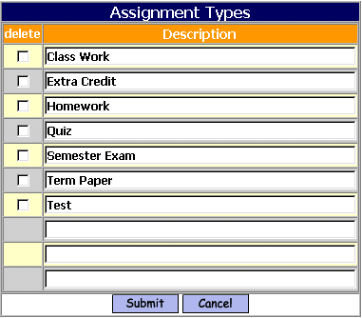

Steps to add/modify Assignment Types:

Step 1. Click on <Rankbook Maintenance> <Assignment Types>

Step 2. Create as many assignment types as necessary to achieve the various categories you require. You may add up to 3 types at a time, once you add 1, 2 or 3 types and click submit, 3 more boxes will appear for you to create additional types. Keep in mind that you may add to this list.
Step 3. Click to save your work

Deleting an Assignment Type
To delete an Assignment Type
- Check the box under Delete
- Click to delete the Assignment Type.

<Assignment Weights>
This screen allows you to define the parameters for weighting selected assignment types for a course. Be sure to select the appropriate academic year and course-section. The system will automatically provide you with a list of courses that you are scheduled (or have been scheduled) to teach for the selected academic year.

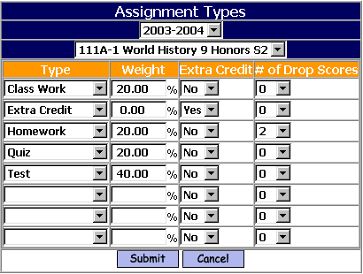

Academic Year:
  - Select the appropriate Academic Year from the pull-down list.

Course:
  - Select the course-section from the pull-down list that you wish to work with.

Type:
  - Select the appropriate Assignment Type from the pull-down list. You may add more assignment types by clicking <Rankbook Maintenance> <Assignment Types>.

Weight:
  - The weighting percentage of each assignment type for a specific course. This will determine how the average of all grades of this assignment type will be weighted in determining a term grade. Using the example above, all of the grades for homework assignments will be averaged, that average will makeup 20% of the students’ term grade. It is recommended that the total weights, of all of the assignment types for a course equals 100%, but not required.

Extra Credit:
  - If an <Assignment Type> is flagged as “Extra Credit=Yes”, then it will be averaged in the calculation of the term grade.

# of Drop Scores:
  - Select the number of lowest scores of each assignment type to be dropped and not included in the calculation of an average. The dropped scores will not be removed from your Rankbook, only ignored in any calculations.

Steps to add/modify Assignment Weights:

Step 1. Click on <Rankbook Maintenance> <Assignment Weights>

Step 2. Define as many assignment weights as necessary to achieve the various categories you require for each course. Keep in mind that you may add to this list.
Step 3. Click to save your work

<Grades Table>

This is a one-time setup screen that allows you to select the numeric and/or alphabetic grade codes that will be available to you when entering scores for students.

By default, you will notice that all grades are selected (highlighted). It is recommended that you click submit and accept all of the values, which will then populate your grades table. The system will use this table to validate against when you are entering grades for students. You will be able to add to this list.

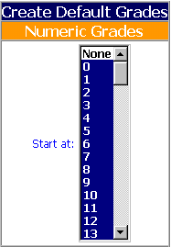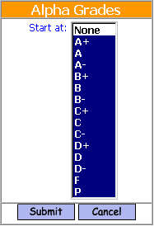

Steps to select/define Numeric/Alphabetic Grades Table:

Step 1. Click on <Rankbook Maintenance> <Grades Table>

Step 2. De-select any of the Numeric and/or Alphabetic grades that you do not wish to have available in your grades table. You will be able to add additional grade codes, once your grades table has been created.

Step 3. Click to save your work

Modifying Grades
After you have submitted the grade table(s) you want this screen allows you to add, modify or delete any grades from your grades table. Click on a specific grade to update the information. Click on the add button to create a new grade.

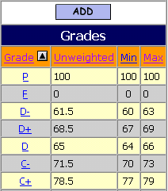

This screen allows you to modify any values for the selected grade or delete the grade. This screen will also be displayed if you choose to add a new grade.

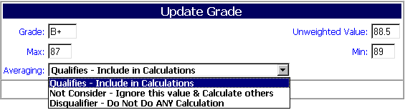

Grade:
  - This is the grade that can be entered for a student when scoring an assignment.

Unweighted Value:
  - This is the numeric value that will be used for averaging.
Max:
  - If you are averaging and want the results to be an alpha grade, then this is the maximum value to be used in the conversion.
Min:
  - If you are averaging and want the results to be an alpha grade, then this is the minimum value to be used in the conversion.
Averaging:
  - Select “Qualifies-Include in Calculations”
  - Select “Not Consider – Ignore this value & Calculate others”
  - Select “Disqualifier – Do Not Do Any Calculation”. No average will be calculated for either the assignment or the student if a grade with this setting is assigned to the student.
<Rankbook Configuration Parameters>
This screen allows you to customize the rankbook for the individual teacher.

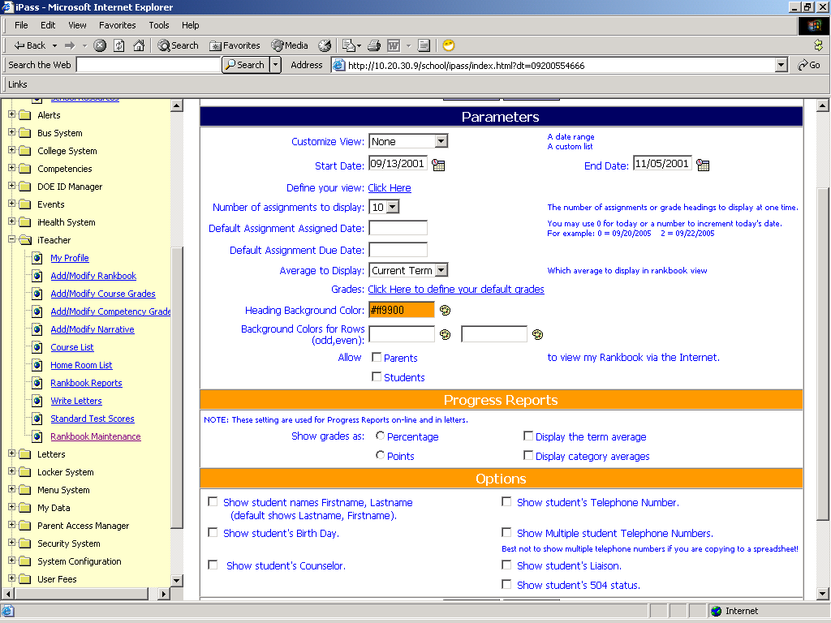

Customize View:
- Enter None, Date Range, Defined List or Current Term.

Start Date:
- Enter a Start Date for displaying Assignments

End Date:
- Enter an End Date for displaying Assignments

Custom View:
- Enter the number of Assignments/Grade Headings you wish to display when viewing and using your rankbook. This can be adjusted at any time.

Default Assignment Assigned Date:
- Use a date or assign a number to represent the number of days from “TODAY’S DATE”
i.e. Today = 09/15/2003 2= 09/17/2003

Default Assignment Due Date:

- Use a date or assign a number to represent the number of days from “TODAY’S DATE”
i.e. Today = 09/15/2003 2= 09/17/2003

Define Your View:

This link will bring you to a screen that allows you to customize the view of assignments that are displayed on your <Rankbook> screen.

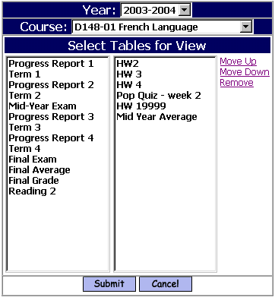
Steps to create a new Rankbook View:

Select Tables for View:
  - On the left hand side of the screen select (click) any of your assignments or any of the Grade Headings that may appear from your schools administration.
  - Once you have selected the assignments/grade heading to appear in your view, you may use the “Move Up”, “Move Down”, & “Remove” links to place them in the order that you want them to be displayed in your <Rankbook> view.
  - Click to save your view.

Helpful Hint!
The grade columns (Term 1, Term 2, etc. and ones with an *) are created and controlled by your school’s administration. Please consult with administration or your iPASS System Administrator for details regarding your school’s policy on entry of grades.

Grades:
This will take you to the Grades Tables in <Rankbook Maintenance>.

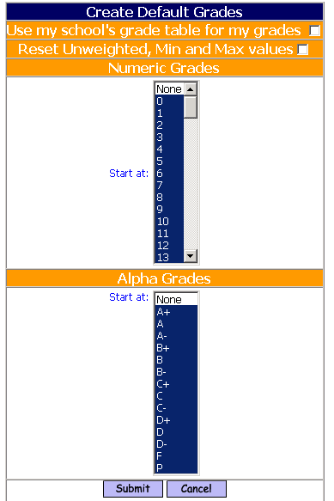

Use my school’s grade table for my grades:
- Click this box if you want your grade to be the same as the grade tables used in the school for Report Card grades.

Reset Unweighted, Min and Max values:
- Click this box if you are changing grades from your own to the schools so that the un-weighted, Min and Max values will be the same as the grade table used in the school for Report Card grades.

Numeric Grades

Start At:
- Select the Numeric grades you want available to you in your rankbook.

Alpha Grades

Start At:
- Select the Alpha grades you want available to you in your rankbook.

Heading Background Color:
- Click the image to select your color form a color palette.

Background Color For Rows Odd/Even:
- Click the image to select your color form a color palette for Odd rows
- Click the image to select your color form a color palette for Even rows.

Allow to view my Rankbook on the internet:
- Select if you want Parents and/or Students to view your rankbook through iParent. This only allows the Parent and/or Student to view their own assignments and related information.

Progress Reports

Show Grades as:
This allows you to set what will be shown on the Progress Reports that are run directly from your Rankbook.

- Select Percentage or Points
- Select Display the Term Average or Display Category Average

Options
These options can be controlled at the district level. Go to <Administration><Teacher Rankbook Parameters>. Options to allow teachers to select whether they want to have their rankbook include more student information as listed below. If the district does not set these options first, teachers will not see them.

Show Student names First Name, Last Name:
- Select this if you want to change the default from Last Name, First Name

Show student’s Birth Date:
- Select this if you want the student’s Birthday to display on your rankbook.

Show student’s counselor:
- Select this if you want the student’s Counselor to display on your rankbook.

Show Student’s Telephone Number:
- Select this if you want the student’s Telephone Number to display on your rankbook.

Show multiple student Telephone numbers:
- Select this if you want the student’s multiple Telephone Numbers to display on your rankbook.

Show student’s Liaison:
- Select this if you want the student’s Liaison form the Confidential Screen to display on your rankbook.

Show student’s 504 status:
- Select this if you want the student’s 504 status form the Confidential Screen to be on your rankbook.
NOTE: This will only show an * if the student has 504 selected as a status in DOE Special Education Status.

<Roll Assignments Forward>
This allows you to Copy your assignments from one year to the next year. Use the Select Assignment portion of the screen to find the assignments you want to copy forward.

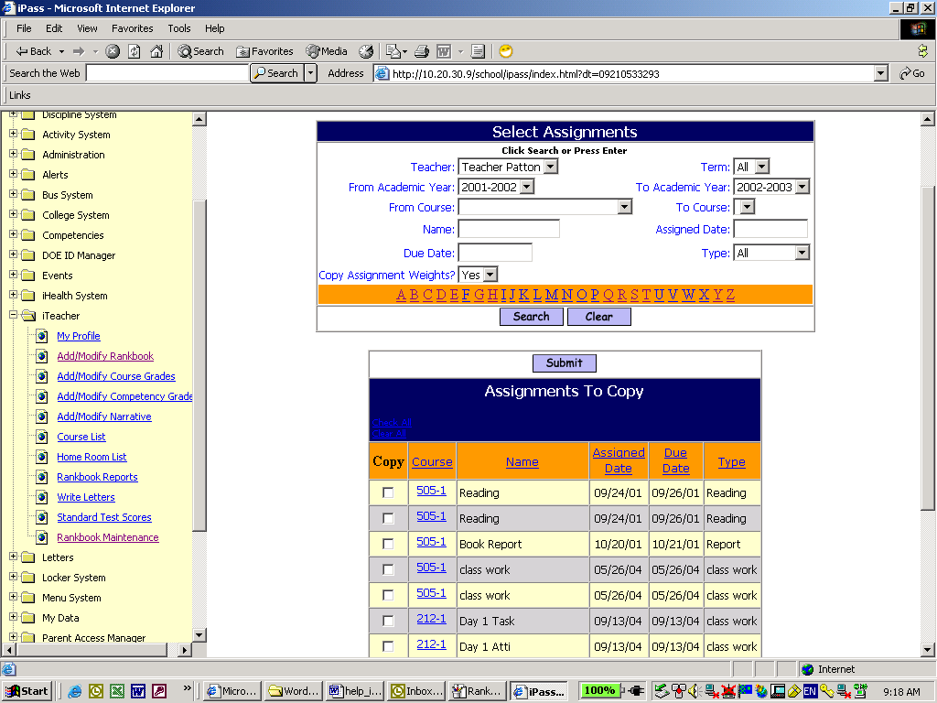

Teacher:
- Your Name should be here. If you have access to other people’s rankbook their name would be listed.

Term:
- Select a Term.

From Academic Year:
- Select an Academic Year to copy from.

To Academic Year:
- Select an Academic Year to copy to.

From Course:
- Select a course to copy from.

To Course:
- Select a course to copy to.

Name:
- Enter the name of an Assignment to copy.

Assigned Date:
- Enter the Assignment Date.

Due Date:
- Enter the Due Date.

Type:
- Select an Assignment Type.

Copy Assignment Weights:
- Select Yes to copy the weight.

Click to find your assignments that meet the criteria you set

Use the Assignments to Copy portion of the screen to select which assignments you want to copy.

- Click the box under copy next to the assignment(s) you want to copy.

Click to copy your assignments

<Add/Modify Rankbook>
This screen allows you to view, add, update, and manage grading information for students enrolled in courses that you are scheduled to instruct. Use the course search screen to find the course and section that you wish to work with. Upon selecting your course the system will return a screen that displays a class list of students that have been scheduled into this course-section by your school.

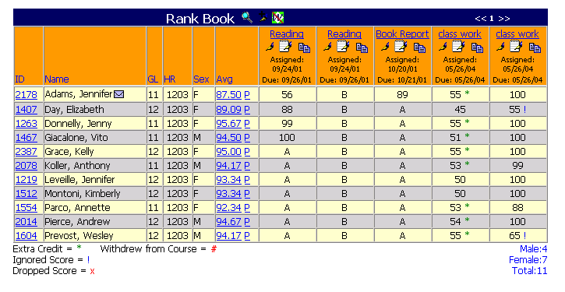

ID:
  - Clicking on the ID of the student will bring you to a series of additional tabs of information on each student. Generally, these tabs display attendance, grading, scheduling, and test data for each student. These view only tabs are controlled by your iPASS System Administrator.
Envelope:
  - The envelope image indicates that email communication is available with the guardian(s) of a particular student. Clicking on the envelope will open an e-mail form allowing teachers direct email communication with a specific guardian(s).

<<1 >>:
  - Clicking on the right arrow of this image allows you to scroll to the right to view additional assignments. Clicking on the left arrow will scroll you to the left.
<<>>
Avg:
  - Clicking on this and will show a student’s average broken down by category and term.

<<>>
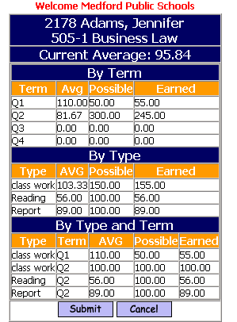

P:
  - Clicking on this will show a student’s Progress Report.
  - Clicking on this will show your Rankbook Parameters Configuration Screen.
  - Clicking on this you will allow you to add an assignment to this course.
  - Click on this and you can turn the view withdrawn students on and off.
  - Click on this and you will be able to modify your assignment.
  - Click on this and you will be able to grade an assignment.
  - Click on this and you will be able to copy the assignment to another course.

Extra Credit = * If it is extra credit the grade will have an asterisk (*) next to it.

Withdrew from Course = # If it is next to a student it will indicate they are withdrawn.

Ignored Score = ! If the score is to be ignored then this will be next to the score.

Dropped Score = x If the score is to be dropped you will see this next to the score.

<Add/Search Assignments>

This screen allows you to add, update, and search for assignments that you have already created. You can use any combination of the filtering options to help you refine your search. Once you have made your selections, click on the submit button and the system will display a list of assignments that meet your criteria. You can then use this screen to select an assignment, modify the assignment, enter scores for students, or to “copy” assignments from one course/section to another.

Click on the add button to create a new assignment.

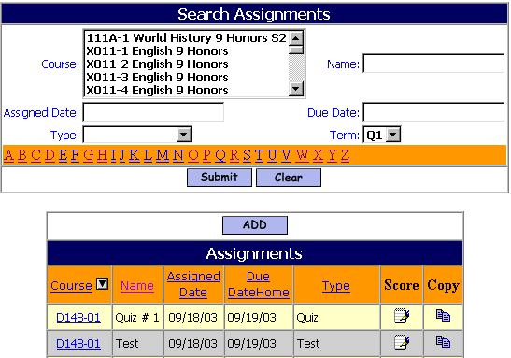

Course:
  - Click on a single course or hold the Control Key down and click multiple courses, then click submit and the system will display a list of assignments for the course(s).

Assigned Date:
  - Defaults to the current date, but can be changed by clicking on the date picker (calendar) image to the right of the date field. Leave the default of blank to see all dates.

Type:
  - Select an assignment type to search by, or leave the default of blank to see all types within your search.

Name:
  - Enter an assignment name or any part of the name (you may also click on any letter of the alphabet) and click submit to search.

Due Date:
  - Defaults to the current date, but can be changed by clicking on the date picker (calendar) image to the right of the date field. This is the day that the student is expected to have completed and turned-in the homework assignment.

Alphabet (a-z):
  - You may click on any letter of the alphabet and click submit to search.

Course:
  - You may click on the course column heading to sort. Clicking on the course-section number will allow you to update an assignment.
Score:
  - Clicking on the image will allow you to enter scores. When you are finished entering scores, be sure to click submit and save your changes.

Copy:
  - Clicking on the copy image will allow you to copy the entire assignment contents and apply them to another section or course. After clicking the copy image, the system will open the original assignment, simply select the course-section you wish to copy it to, and click submit to save your copy.

Note: You may click on any of the column headings to sort your assignments.

Helpful Hint!
You can cut and paste text from Microsoft Word or other text editors.

Example:
Cut & Paste - Cut data <control> <C> and Paste data <control> <V> - you can highlight data with your mouse by clicking your left mouse button and dragging until you have highlighted the data that you intend to cut and paste. Once you have highlighted your data press the <control> key and the <C> (letter C) key simultaneously, this will place the data in your clipboard and allow you to paste it using the <control> key and the <V> (letter V) keys simultaneously or by clicking your right mouse button and selecting the paste option.

<Add/Update>

This screen allows you to update Assignments.

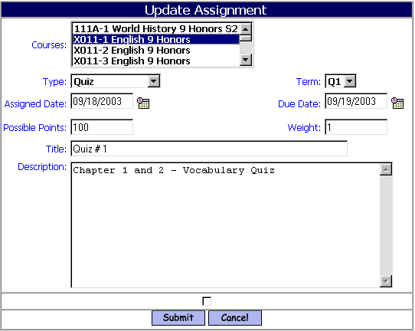

Course:
  - Click on a single course or hold the Control Key down and click multiple courses, then click submit and the system will display a list of assignments for the course(s).

Type:
  - Select the appropriate assignment type from the pull down list

Term:
  - Select the appropriate term/quarter for the assignment.

Assigned Date:
  - Defaults to the current date, but can be changed by clicking on the date picker (calendar) image to the right of the date field. Leave the default of blank to see all dates.

Due Date:
  - Defaults to the current date, but can be changed by clicking on the date picker (calendar) image to the right of the date field. This is the day that the student is expected to have completed and turned-in the homework assignment. It is also a search field used in the iParent System.

Possible Points:
  - If you are using a scoring base of points rather than percentages, then enter the maximum number of points that this assignment will be worth.
Weight:
  - If you are weighting this assignment for than others of the same assignment type, then enter a multiplier for this assignment.
Title:
  - Enter an assignment title or short name

Description:
  - Enter as much detail for the assignment as necessary.

Helpful Hint!
You can cut and paste text from Microsoft Word or other text editors.

Steps to Add/Update Assignments:

Step 1. Click on <Rankbook> <Add/Search Assignments>

Step 2. Select your course. Enter pertinent information and complete the assignment form.
Step 3. Click to save your work

<Rankbook>Reports
Rankbook reports are located under <iTeacher System><Reports-Rankbook>
Each report has a set up screen, which allows the user to set up criteria to filter on and criteria to Sort on.

Helpful Hint!
Most reports can be filtered by school. If you have access to more then one school, then you will have the ability to change the school you want to filter by and click on submit. Your default school will be shown in the drop down when you open the report tab. Once the submit button is clicked the report will be processed and sent to <My Data><My Reports> for you to view.

Selection Criteria: Selection options may be available under Enter Selection Criteria. Selections allow the user the ability to limit what information will be listed on the report. Examples; students in second grade only, courses taught by a single teacher or all special education students. If you do not make a selection in a drop down box, then all the criteria listed in that box will be included in the report.

If the option to select criteria by Student IDs is available, then type a list of student IDs separated by commas into the box to use this feature. If no students IDs are listed then all students will be included.

Hold down the shift key on your Keyboard to highlight the whole selection list or selections on the list in order. Use the Control Key on your Keyboard to highlight selections on the list when you need to skip selections.

Sorting: Sorting options may be available under Enter Selection Criteria. Sorting allows the user the ability to list the information in a certain order. Examples; list students by last name, courses by teacher’s last name, or list by courses in alphabetical order. Sorting options are restricted to the list provided.

To: This box allows you to enter an email address or several addresses of people you want to send the report to. List email address separated by commas.

CC list: This box allows you to enter an email address or several addresses of people you want to cc: a copy of the report to. List email addresses separated by commas.

Priority: This box allows you to set a priority level for the report processor. Priority options are limited to the list provided.

<Assignment Grade> Report
The Assignment Grade report provides a list of students with their ID, Overall Average, Assignment Scores, Assignment Averages, Assignment Standard Deviation, Assignment Minimum and Assignment Maximum.

Selection Criteria: Academic Year, School Term, Course, Assignments, Hide Name YES/NO.
Sorting: Student ID, Name, Grade Level, Random.
Sample Output:

Course - Algebra 1 College Prep - 212-1
Teacher – Teacher’s Name
Sorted By - Name
Date - 08/16/2004

 |  |  |  | 1 | 2 | 3
 |  |  |  | Book Report-10/20/01 | Reading-09/24/01 | Worksheet Number 7-1-11/23/01
 | Name | Student ID | Overall Average
1 | Albertson, Christina-Marie | 1925 | 90.00 | 97 | 85 | 88
* | Average : |  |  | 97.00 | 85.00 | 88.00
* | StdDev : |  |  | 0.00 | 0.00 | 0.00
* | Max : |  |  | 97 | 85 | 88
* | Min : |  |  | 97 | 85 | 88

<Assignments Due> Report
The Assignments Due report provides a list of students who have not turned in an assignment.
Selection Criteria: Academic Year, School Term, Teachers, Course, Assignments, List Assignments, How many missing, Hide Name YES/NO, Student ID, include Unscored Assignments.
Sample Output:

Course: | Business Law 505-1 | Teacher: | Teacher Patton
Sort By: |  | Date: | 09/21/2005
School Year: | 2001-2002 | Term: | Q1
 | Name | Student ID | Assignments Due | Assigned | Due Date
1 | Donnelly, Jenny | 1263 | Reading | 09/24/01 | 09/26/01
2 | Adams, Jennifer | 2178 | Reading | 09/24/01 | 09/26/01
2 | Students | owe | 2 | assignments.

<Progress Reports> Report
The Progress Report provides a Progress Report for one or all students in a course.
Selection Criteria: Academic Year, School Term, Teacher, Course, Student ID, Enrollment Status.
Sorting: Student ID, Name.
Sample Output:

Course: | Business Law 505-1 | Teacher: | Teacher Patton
Sort By: | ID | Date: | 09/21/2005

Student Progress Report
09/21/2005

Term Q1: Business Law 505-1
Jennifer Leveille | Laura Patton
Overall Grade: 93.34 % | iPASS High School

Category | Weight | Overall Grade
• class work | 100% | 100.00
• Reading | 100% | 90.00
• Report | 100% | 95.00

Date | Category | Assignment | Score | Grade
09/26 | Reading | Reading | 85.00/100 | 85.00
05/26 | class work | class work | 50.00/50 | 50.00

Teacher Letters
Letters can be generated by a teacher to be sent to parents regarding assignments from their rankbook. Letters can also be run to include a copy of a Progress Report for the student and a set of mailing Labels that correspond with the letters printed.

Go to <Letters System><Write Letters> to create a template.
Use these Data elements to enhance your letter template.

AssignmentsInc | List of Incomplete Assignments | Teacher
AssignmentsLow | List of Assignments with Low (Fail) Grad | Teacher
AssignmentsOwed | List of Assignments Owed | Teacher
StudentProgress | Progress Report | Teacher
Teacher Phone | Teacher At School Phone Number | Teacher
TeacherEmail | Teacher Email address | Teacher
TeacherName | Teacher Name First Last | Teacher

Example Template:
$TODAY$
$SchoolName$

Dear $GuardianName$:

Here is a summary of progress to date for $StudentNameFirst$:

$StudentProgress$

If you have any questions, or need additional information or would like assistance in helping your child complete this work, please contact me.
I may be reached via email at $TeacherEmail$ or by telephone at $Teacher Phone$.

Thank you,

$TeacherName$

Running a Teacher Letter:
Go to <Letter System><Print Letters><Parent Student Letters>
Selection Criteria: Letter, Academic Year, School Term, Student ID, Last Name, Course, Grade Lower Than, Teacher, Assignment Types, Progress Report, Include Unscored assignments, enrollment Status, Mailing Labels YES/NO.
Sorting: Name/ID, Homeroom/Name, Grade Level/Name, Course/Name, Town/name.
Sample Output:

09/21/2005
iPass High School
Dear Deb Nicastro:
Here is a summary of progress to date for Kristen:
Term Q1: Science Bridge 924-01
 | Laura Patton
Overall Grade: 78.80 % | iPass High School
Term Grade: 78.80 %

Category | Weight | Term Grade | Overall Grade
• Classwork | 10% | 88.00 | 88.00
• Homework | 20% | 70.00 | 70.00
• Test | 70% | 80.00 | 80.00

Date | Category | Assignment | Score | Grade
08/02 | Classwork | Schooning 1 | 0/100
08/02 | Classwork | Bridge too far | 88.00/100 | 88.00
08/02 | Homework | Bridge how big | 70.00/100 | 70.00
08/02 | Test | Test 1 | 80.00/100 | 80.00
08/28 | Classwork | Schonning 06-07 | 0/100
If you have any questions, or need additional information or would like assistance in helping your child complete this work, please contact me.
I may be reached via email at support@imgsoftware.com.
Thank you,
Mrs. Teacher

B. GPA -
This program is designed to calculate Grade Point Average and Class Rank for each academic year for all students in a given grade level.

Important Preparation for Calculating GPA

There are several pieces (items A through F) that must be in place and correctly defined in order to accurately calculate GPA

A. Courses - GPA/Class Rank and Curriculum Level fields must be properly defined in your courses <Scheduling System><Course Catalog><Course Details>.

GPA Rank: Select “Yes” if the course is to be used in your GPA calculations. Select “No” if the course should not be used in your GPA calculations.

Helpful Hint!
Physical Education courses are usually not included in GPA calculation

Curriculum Level: Enter any integer from 1 – 99. This number corresponds to grade scale value for specific grade as defined under <Grading System> <Grade Maintenance> <Grade Scale>.

B. Scale Codes & Grade Scales

Scale Codes: defined under <Grading System> <Grade Maintenance> <Scale Codes>.

Example: (generally schools define at least three grade scales)
1) 4.0 weighted scale
2) 0 -100 weighted scale
3) 0 -100 un-weighted scale

New! Define grade scale codes to be included for College GPA or school specific calculations.
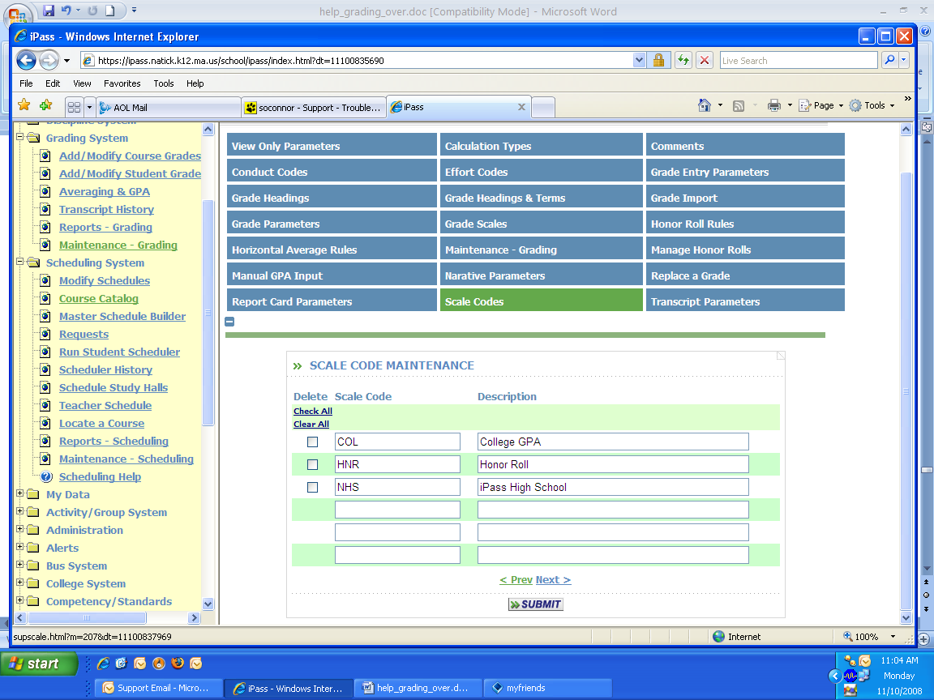

Grade Scales: defined under <Grading System> <Grade Maintenance> <Grade Scales>.
Create Grade Scales that will be applied to courses in the course catalog.

Schools that use a College GPA scale for printing on transcripts will list this as a scale in the course catalog. If a school wants to calculate a GPA for all courses, then a different scale code can applied to a particular course or courses. For example, a PE or Health course would be included in school Honor Roll calculations and GPA, but not on the College GPA reported on transcripts:

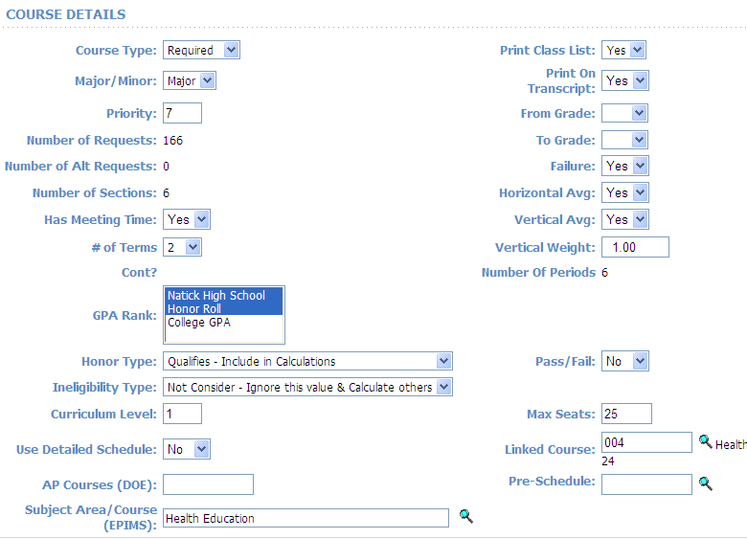

Helpful Hint!
You should assign a Scale Value for each Curriculum Level, Scale and Grade in your Grade Maintenance table that will be used in GPA calculations. If it is not defined then a Scale Value of “zero” will be applied when GPA is calculated.

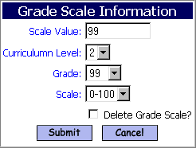

Figure 1.2

C. Grade Definitions

Grade Definitions: defined under <Grading System> <Grade Maintenance> <Grades - Maintenance>. With each grade you must define one of the following GPA identifiers; See figure 1.3

“Qualifies – Include in Calculations”
“Do Not Consider this Value & Calculate Other”
“Disqualifier – Do Not Do Any Calculation”

Helpful Hint!
If a student has a grade flagged as “Disqualifier – Do Not Do Any Calculation”
for a course, then no quality points or attempted credits will be calculated for that student.

If a student has a grade flagged as “Do Not Consider this Value & Calculate Other” for a course then no quality points or attempted credits will be calculated for that student’s grade.

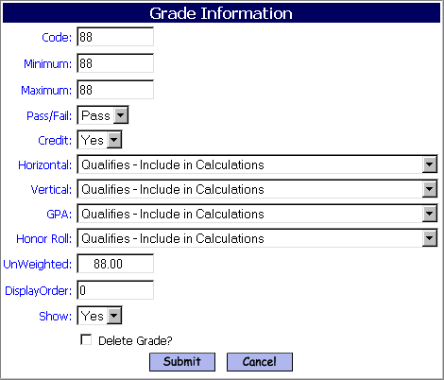

Figure 1.3

D. Horizontal Averages/Percentage (%) Rules

Horizontal Averages/Percentage (%) Rules are defined in the<Grading System> <Grade Maintenance> <Horizontal Average Rules>. They are used to determine the weight of each grade based on the Grade Heading it is in when you use iPASS to calculate averages or to calculate the GPA Quality Points and GPA Attempted Credits for each course to accumulate toward a YTD and Career GPA. You need to define a code that will be applied to each course-section that meets the criteria.

Example:
FY = Full Year Courses
S1 = Semester 1 Courses
T13 = Sections that meet Terms 1 & 3

Helpful Hints!
Check the boxes to identify the Terms when the sections meet. Assign a value to each Grade Heading that you wish to use in the Calculation of Horizontal Averages or GPA. The total must equal 100%.

You may change the values in this table before processing either an Average calculation or a GPA calculation if you want different weighting.

Horizontal Averages/Percentage (%) Rules need to be assigned to the course sections. This can be done individually in the Course Details or globally under <Scheduling System><Course Catalog><Assign Average Rules to Sections>.

If you use the Horizontal Averages/Percentage (%) Rules for both GPA and Averaging, then you may need to change the values to insure equity among term grades.

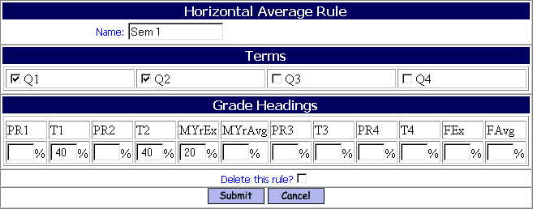

Figure 1.4

E. Transfer or Summer School Courses

Transfer or Summer School Courses must be entered in the students’ transcript record and properly defined if they are to be included in GPA calculations.

Student Transcript Record: Defined under <Grading System> <Student Transcripts>. Select the student and then click on the add button to create records for a Transfer course, Summer Course, etc. See figure 1.5

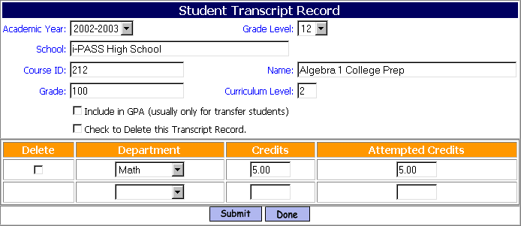

Figure 1.5

Academic Year: Select the appropriate Academic Year from the pull down list. This would be the academic year that the student took the course and was given a grade.

Helpful Hint!
When you are in add mode and entering course information for students, the software will remember and default to the academic year and school you have previously entered.

School: Enter the name of the School where the student was enrolled and received a grade for the course.

Course ID: Enter the identification number of the course.

Grade: Enter the grade that the student received for the course. This field accepts alpha or numeric values. The grade must be a value already defined in your grade definitions under <Grading System> <Grade Maintenance> <Grade Definitions>.

Grade Level: (required for GPA Calculation) - Enter the Grade Level of the student when they took the course.

Name: Enter the name of the course. This is the name that will display when printing Transcripts.

Curriculum Level: (required for GPA Calculation) - Enter the curriculum level of the course. Be sure that the curriculum level is properly translated to your school’s curriculum level definitions.

Include in GPA: (usually only for transfer students) - Click and place a check mark in this box if you want this course to be included in GPA calculations for this student. This option is not available while you are adding records, you must “Submit” and save your initial record and then go back and modify to adjust quality points (this extra step is by design in an attempt to protect the integrity of the data).

Helpful Hint!
Attempted Credits, Curriculum Level, Department, Grade and Academic Year need to be defined prior to using the “Include in GPA” option. Grade Scales and Grade Definitions should also be defined for all Academic Years. The program will then calculate the quality points for that course. The Quality Point Values may be adjusted if necessary. Remember you must “submit” to saves changes.

Check to Delete this Transcript Record: Click and place a check mark in this box if you want to “delete” this transcript record. You must “submit” to complete the process.

Helpful Hint!
Using this option will only delete transfer/summer school courses. This option will Not permanently delete a students grade record that has been entered by a teacher and is driven through the scheduling module.

Delete: Check this box to delete the credits assigned to the course

Department: Select the appropriate department from the pull down list.

Credits: Enter the credits received by the student for this course. Be sure that the credits are properly translated to your school’s credit criteria. You must adjust for credits earned in quarter, semester or full year courses.

Attempted Credits: (required for GPA Calculation) Enter the attempted credits received by the student for this course. Be sure that the credits are properly translated to your school’s credit criteria.

F. Calculating GPA – (running the program)

Calculating GPA: Locate the program under <Grading System> <Grade Maintenance> <Calculate GPA>. See figure 1.6

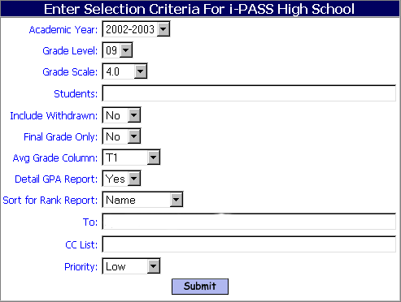
Figure 1.6

Select School: Select the school for which you are going to calculate GPA.

Academic Year: Select the appropriate academic year to calculate.

Grade Level: Select the appropriate grade level to use in the calculation as defined.

Helpful Hint!
You must select a grade level when calculating GPA (it cannot be left blank). The grade level is used to determine ranking. If you are running it in previous years then select the grade year you wish to run it in and assume the students’ grade level for that year.

Example:
A Student is currently in grade level 12 for the 2012-2013 academic year and you want to recalculate grade level 11 for the 2011-2012 academic year. You would run GPA for grade level 11 using academic the year of 2011-2012.

Grade Scale: Select the appropriate scale to use in the calculation as defined under <Grading System> <Grade Maintenance> <Grade Scales>.

Students: You may enter a single Student ID# or a string of ID #’s separated by commas (no spaces) in order to process a batch of students.

Helpful Hint!
Leave this field blank if you want to calculate GPA for all students in a selected grade level. Be sure to select the appropriate Grade Level value.

Include Withdrawn: All students will be included in the GPA calculation regardless of their enrollment status. If you select “Yes” when running the Class Ranking Report, the program will include students that were withdrawn during that academic year.

Final Grade Only: Select “Yes" if you only want to use courses that have a final grade and ignore courses that are not completed.

Average Grade Column: Select the Grade Heading Column that you want to use to calculate GPA. If a grade value exists then it alone will be used, otherwise the Horizontal Average Rules will count individual grades proportionally.

Helpful Hint!
Leave this field blank under most conditions. It is generally used when you want to calculate a GPA using a semester average that may include a mid-year exam rather than using only the individual term grades.

Detail GPA Report: Select “Yes” to automatically generate two reports (GPA Rank & GPA Report) that will be sent to you in <My Data> <My Reports>. The “GPA Report” can also be printed at anytime, and sorted differently, without re-calculating GPA under <Grade System> <Grading Reports> <GPA Rank>. See Figure 1.7

Helpful Hint!
If you are re-calculating GPA for prior years, then you must start with the earliest academic year that you need to re-calculate. You must also re-calculate all other academic years, in order, finishing with the current year.

Sort for Rank Report: Select a sorting option from the pull down list.

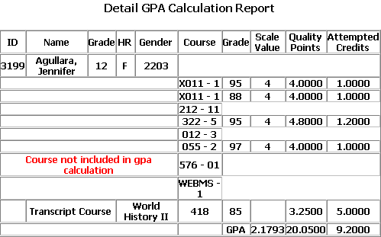
Figure 1.7

The GPA Formula

Quality Points divided by Attempted Credits = GPA

For Year-to-Date (YTD) GPA

The Final Grade for the course will be used, if available. Otherwise, each grade that has been assigned a percentage in the Horizontal Average/Percentage Rules will be used proportionally to determine the GPA Quality Points and GPA Attempted Credits for the course.

The Final Grade for the course or each of the individual grades stored for the selected term and all prior terms are converted to the GPA Grade Scale value. The GPA Grade Scale Value is multiplied by the Full Credit for the Course if it is a Final Grade. If it’s not a Final Grade, then each grade is multiplied by the Full Credit and then by the Percentage from the Horizontal Average/Percentage Rules to get the Quality Points for each grade.

Grade converted to GPA value X Credits X Horizontal % = Grade Quality Points

The Course Credits are multiplied by the Percentage from the Horizontal % Rules to get the Attempted GPA Credits for each grade.

Course Credits X Horizontal % = Grade Attempted Credits

The total of the Grade Quality Points for all course divided by the total of the Grade Attempted Credits for all courses gives you the YTD GPA.

Total Grade Quality Points / Total Grade Attempted Credits = YTD GPA

Year-to-Date GPA – Sample calculation using a simple 4.0 scale with the following values;

GPA Scale Value Courses Credits
  - 95 Full Year Courses 1.0 (1 credit)
  - 92 Semester Courses .5 (1/2 credit)
- 90 Quarter Courses .25 (1/4 credit)
3.4 84

Assuming the following percentages defined in Horizontal Averaging Rules and Grade Heading %

Course Description MT1 Q1 MT2 Q2 MidEx S1Avg MT3 Q3 MT4 Q4 FEx S2Avg FinGr
Full Year Courses 20% 20% 10% 20% 20% 10%
Semester One Courses 40% 40% 20%
Semester Two Courses 40% 40% 20%

Course Description MT1 Q1 MT2 Q2 MidEx S1Avg MT3 Q3 MT4 Q4 FEx S2Avg FinGr
Quarter Course 77 79 80
Semester Course 80 85
Full Year Course 90 95

Example:
Grade converted to GPA value x Credits x GH% = Quality point
80 = 3.0 x .25 x = .75
85 = 3.5 x .5 x .40 = .70
95 = 4.5 x 1.0 x .20 = .90

Total Quality Points 2.35

YTD GPA
Total Quality Points 2.35 = 3.615
Total Attempted Credits (.25x.20x.20) .65
C. Outline for Developing Standards Based Report Cards
The Standards Based Report Card pulls together multiple pieces of data in order to produce a final printed document. Each piece needs to be created and data needs to be entered and checked in order to produce a final document.
Standards Based Report Cards are printed from a network printer with a PCL driver. At least one such printer needs to be available at each school.

There are several steps that need to be completed in order to produce a final product.

1. Re-define Security Access.
Not all users will currently have access to the areas that they will need.
e.g. Scheduling, Grading, Competencies, for example.

2. Courses need to be created and scheduled.
(See “Scheduling Procedures” documentation for details)
Terms and Academic Year Settings need to be defined.
Courses need to be created, moved to the Academic Year/Course Details and defined. Be sure to include a Department assignment.
Courses can be defined with no meeting time; but would need term, room and teacher assignments.
A course will be needed for each combination of Competencies that a teacher will score.
e.g. A 4th Grade Reading Course will need to be created with a section for each teacher.
If the same teacher will be scoring more than one set of Competencies, then a single course can be created with multiple competencies.
e.g. In a self-contained classroom, the teacher is teaching all the core subjects, than a single course “Core Subject Gr. 6” can be created, again one section for each teacher, and the sets of competencies for Reading, Language Arts, Math, Science, etc. can all be associated with that course on the Course Details page.

3. Students need to be assigned to the proper courses.
(See “Scheduling Procedures” documentation for details)
The Mass Load Schedules and Requests program will do this based on students already being in Homerooms

4. Competencies need to be defined and assigned to the appropriated courses.
There are 3 levels within the Competency System. The Competency Group, Competencies and Tasks. Competencies and Tasks can be scored. Scoring of Competencies is optional.
e.g. Group = “Language Arts/Reading”
Competency = “Forming Initial Understanding”
Tasks = “Uses a variety of reading strategies”
“Understands key vocabulary in text”
“Reads with fluency and expression”
“Reads with understanding”

5. Grades need to be defined.
These are the grades or codes that a teacher will choose from to indicate the performance level of the student for each Task and/or Competency.
When defining a Competency Grade, the value needs to be an integer, which could then be used to average all task scores for an overall competency score.

6. Teachers will need to enter Scores for each Task and/or Competencies for each student.
From their class list <Add/Modify Competencies>, they click on the ID# of the student and enter the scores for that student.

7. IMG will create an initial form that you can then modify, if you wish.
Depending on the equipment you have available, the final document can be portrait or landscape, with color, duplex printed and include images.

Note: These procedures need to be repeated for each school.

D. Standard Tests -
The programs in this folder allow you to store and report on any Standard or Government test. These could include; SAT, Iowa, MEEPS, Ohio, Stanford 9, as well as State Curriculum Assessment Tests and District Assessment Tests.

1. Maintenance

a. Test Attributes –
<Standard Tests> <Maintenance> <Test Attributes>
Create Attributes for the Standard Tests that you wish to maintain.

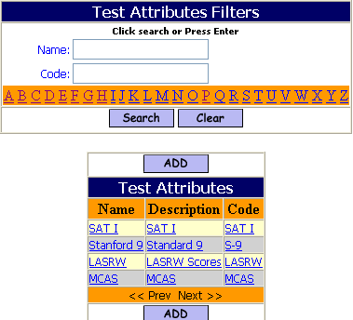

- Click to enter a new set of Test Attributes

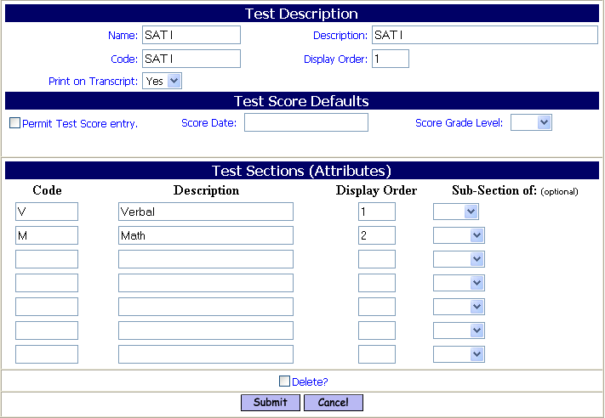

Test Score Description

Name:
- Enter the Name of the Test.

Description:
- Enter the Description of the Test.

Code:
- Enter the Code for the Test.

Display Order:
- Enter the Display Order for the Test.

Print on Transcript:
- Accept the default value of Yes to have the Test Name, Date and Score print on the student’s Transcript.
- Select No, to have the Test not appear on Transcripts.

Test Score Defaults
This section allows you to create default parameters.

Permit Test Score Entry:
- Check the box to allow for direct Test Score Entry by teachers from <iTeacher> (Enter Standard Test Scores).

Score Date:
- Enter a default Test Date, if needed.

Score Grade Level:
- Enter a default Grade Level, if needed.

Test Section Attributes

Test Attribute Code:
- Enter the Code for the Attribute.

Test Attribute Description:
- Enter the Description for the Attribute.

Test Attribute Display Order:
- Enter the Display Order for the Attribute.

Sub-Section of:
- Select the Section from the pull-down list that this attribute is a sub-section of.

- Click to save your work.

b. Score Parameters –
<Standard Tests> <Maintenance> <Score Parameters>
Create possible test scores for each test, by date.

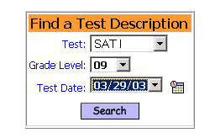
Test:
- Select a Test from the pull-down list existing Tests.

Grade Level:
- Select a Grade Level from the pull-down list.

Test Date:
- Enter a date
- Click on the calendar button to see a calendar.

- Click to access the selected test.

If a test exists for that grade and date then a screen will open to allow you to edit the following information, otherwise a screen will open to allow you to set the scoring information.

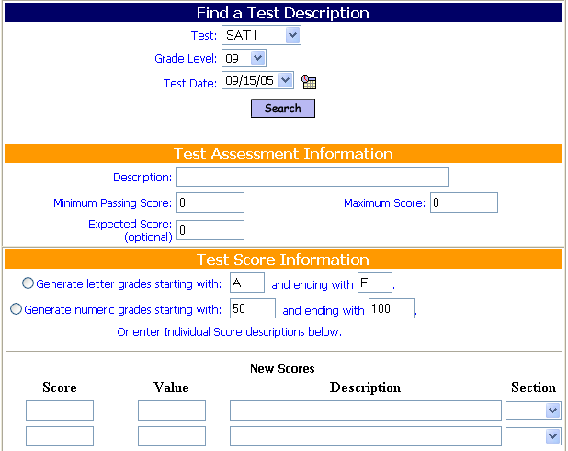

Test Assessment Information

Description:
- Enter a Description for the test.

Minimum Passing Score:
- Enter the lowest possible Passing score for this test.

Maximum Score:
- Enter the maximum score for this test.

Expected Score:
- Enter the expected score for this test.

Test Score Information
This section allows you to create possible scores in several ways.

Note: If a Test already exists in ipass, then this section will need to be defined in order to process new reports. The feature to copy scores from another test will help facilitate this process for all existing tests. Each test is unique by name, grade level and date.

Use one of the three (3) options below to automatically generate possible scores that can be used for this test and/or define new or additional scores.
- Click on the radio button if you wish you use one of the automatic generation options and accept the default range or define a different range.
- Do not accept one of the automatic generation and enter scores below.

Generate letter score starting with A and ending with F:
- Accept the default starting letter score of A.
- Enter a different starting letter score.
- Accept the default ending letter score of F.
- Enter a different ending letter score, which would alphabetically follow your starting letter.

Generate numeric score starting with 50 and ending with 100:
- Accept the default starting numeric score of 50.
- Enter a different starting numeric score.
- Accept the default ending numeric score of 100.
- Enter a different ending numeric score, which would be greater your starting numeric score.

Copy scores from the test dated (in the pull-down):
- Accept the default test date.
- Select a different test date from the pull-down list.

Enter Individual Score descriptions:
- Accept the default starting numeric score of 50.
- Enter a different starting numeric score.

Score:
- Enter a score.

Value:
- Enter a numeric value for this score, so that averages can be calculated.

Description:
- Enter a description.

Section:
- Select the test section that this score applies to.
- Leave the section field blank to have the score apply to all sections.

- Click to save your work.

2. Modify/Import Test Scores -

a. Modify/Delete Test Scores –
<Standard Tests> <Modify/Import Test Scores> <Modify/Delete Test Scores>
Create Attributes for the Standard Tests that you wish to maintain.
This program allows you to edit fields such as Grade Level or Test Date for all students, or for individual students who took the test that was imported.

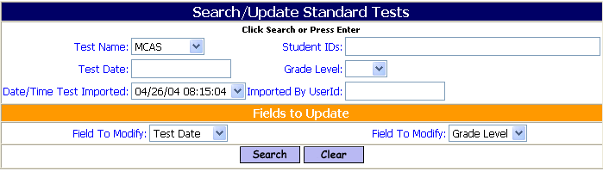

Test Name:
- Enter the Test Name.

Student ID:
- Enter a Student ID
- Enter a string of student IDs, separated by commas, no spaces.

Test Date:
- Enter a Test Date.

Grade Level:
- Select a Grade Level from the pull-down list.

Date/Time Test Imported:
- Select the Date/Time for a test which was imported from the pull-down list.

Imported By UserID:
- Enter the UserID of the person who imported the test.

Field to Modify:
Any field that can be modified for the Test Scores selected will be in the pull-down list. You can select up to two (2) Field to Modify.
- Select a Field to Modify from the pull-down list.

Field to Modify:
- Select a second Field to Modify from the pull-down list.

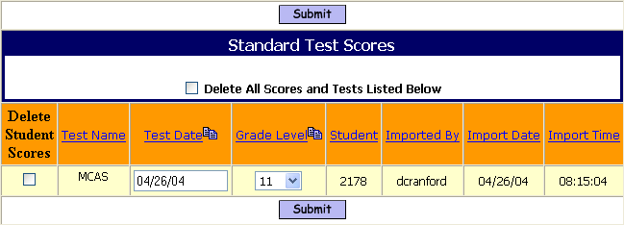

Mass Delete Option
Delete All Scores and Tests Listed Below
- Check the box to delete ALL record of this test.

Delete Student Scores:
- Check the box to delete this test record for the single student on this line.

Modify Selected Field (Example: Grade Level):
- Select a different (Grade Level) value from the pull-down list. Example: By default all of the students took the test as 10th graders and the selected student took the test as an 11th grader.

Modify Selected Field (Example: Test Date):
- Enter a different (Test Date) for the selected student.

- Click to save your work.

WARNING! Be sure that you are deleting or modifying the correct record!

b. Import Test Scores –
<Standard Tests> <Modify/Import Test Scores> <Import Test Scores>

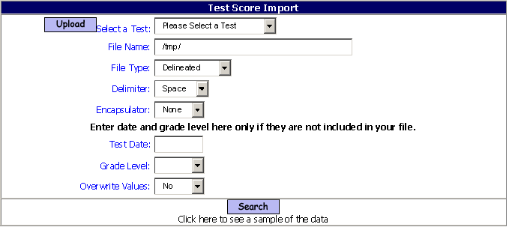

You must upload the file into a Temp Directory first.

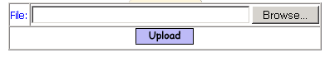

Browse:
- Click the Browse button to locate the file on your desktop or wherever you placed it.
- Click on the file to bring the filename into the file box.
- Click to load the file into the proper iPASS directory.

Select a Test:
- Select a Test from the pull-down list that corresponds to the data in the file.

Filename:
- Enter the Filename. It must be entered exactly how it was displayed when uploaded. The Filename is case sensitive.

File Type:
- Accept the default value of Delineated.

Delimiter:
- Accept the default delimiter of Space.
- Select None, “,” (comma) or “|” (pipe) as the field delimiter.

Encapsulator:
- Accept None, if the fields are not encapsulated.
- Select “ (the single quote) if the fields are encapsulated.

Test Date:
- Leave the field blank if a test date is included in the data to be imported.
- Enter a Test Date to load for all records.

Grade Level:
- Do not select a Grade Level, if the date to be imported contains a Grade Level.
- Select a Grade Level from the pull-down list to load for all records.

Overwrite Values:
- Accept the default value of No to not overwrite any existing data for this test.
- Select Yes from the pull-down list to overwrite any existing date for this test.

- Click to see a sample of the data in the file and to link the data to the fields in the file with the Test Attribute fields.

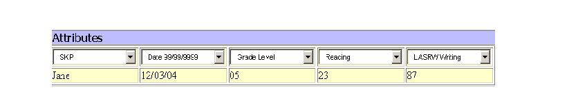

- Select the corresponding test attribute in the each pull-down list for each data element below it in the sample view of the import file.

- Click to import your test scores.

3. Reports – Standard Tests -
a. Missing Tests –
<Standard Tests> <Reports> <Missing Tests>
This report lists student’s who do not have any data regarding for a selected Test.

Filtering: Test, From Date, To Date, Grade Level, Homeroom, Enrollment Status.
Sorting: Name, Grade, Homeroom.
Output: Name, ID, Grade Level, Year of Graduation, Homeroom, Test Date.

Name | Student  ID | Grade  Level | YOG | Homeroom
Adams, Joseph | 10027 | 09 | 2016 | 1303
Baxter, Cambridge | 1831 | 11 | 2007 | 1209

b. Missing Scores –
<Standard Tests> <Reports> <Missing Scores>
This report lists student’s whose test scores are missing. from the Standard Test Maintenance menu option.

Filtering: Test, From Date, To Date, Grade Level, Homeroom, Enrollment Status.
Sorting: Name, Grade, Homeroom.
Output: Name, Student ID, Grade Level, Year of Graduation, Homeroom, Test Date.

Name | Student  ID | Grade  Level | YOG | Homeroom
Adams, Joseph | 10027 | 09 | 2016 | 1303
 | 12/08/04 | No Scores
 | Found: | 1 | Students

c. Low Test Scores –
<Standard Tests> <Reports> <Low Test Scores>
This report lists student’s whose test scores are lower then the Minimum Score entered in <Score Parameters> <Define Possible Scores

Filtering: Test Type, From Date, To Date, Student ID, Grade Level, Homeroom, Enrollment Status.
Sorting: Name, Grade, Homeroom.
Output: Name, ID, Year of Graduation, Homeroom, Threshold score, test scores.

SAT I |  |  |  | 1 | 2 | 3 | 4 | 5
 |  |  |  | 06/30/04 | 12/21/04 | 06/30/04 | 12/21/04 | 06/30/04
Name | Student  ID | YOG | HR | Math | Math | Science | Science | Verbal
 |  |  |  | Threshold: 500.00 | Threshold: 500.00 | Threshold: 500.00 | Threshold: 500.00 | Threshold: 500.00
Adams, Joseph | 10027 | 2016 | 1303 | 346 | 123 | 134 | 123 | 111

d. Test Scores –
<Standard Tests> <Reports> <Test Scores>
This report lists student’s whose test scores.

Filtering: Test Type, From/To Date, ID, Grade Level, Homeroom, Enrollment Status.
Sorting: Name, Grade, and Homeroom.
Output: Name, Student ID, Year of Graduation, Homeroom, test scores.

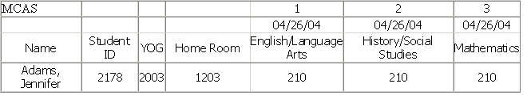

D. Other -
<Grading System> <Maintenance>
These are additional procedures which may help you manage your grading data.

1. Manage Honor Roll
Use this program to remove a student from Honor Roll/Ineligibility or change their level for the current Academic Year only.

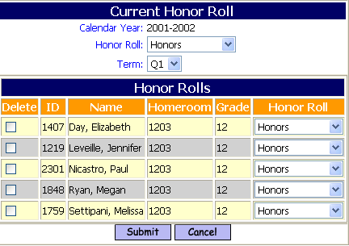

Honor Roll:
- Select the Honor Roll Level you wish to modify from the pull-down list.

Term:
- Select the Term you want from the pull-down list.

A list of students who qualified for the Honor Roll Level and Term selected will be displayed.

Delete:
- Check the box to delete the student from the Honor Roll.

Honor Roll:
- Select a different Honor Roll Level from the pull-down list to place the student on.
You can move a student up or down to a different level, but you cannot add a student to an Honor Level using this program.

- Click to save your work.

2. Manual GPA Input
Use this program to Add, Modify or Delete GPA data.
Data can be loaded into these data fields by conversion, but it is strongly recommended that GPA be determined based on Transcript History being converted.
Data for multiple years could be placed in a single YTD Academic Year record and duplicated in the Career record.

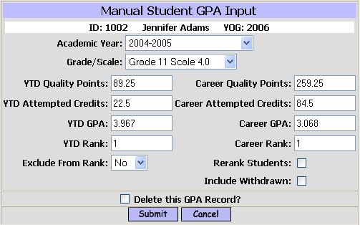

After selecting the student –

Academic Year:
- Select the Academic Year you want.

Grade /Scale:
- Select the Grade Level and Scale from the pull-down list that you want.
The Grade/Scale must already exist. It is created when GPA is calculated.

YTD Quality Points:
- Enter the total number of Quality Points that the student has for this Academic Year.

YTD Attempted Credits:
- Enter the total number of Attempted Credits that the student has for the Year.

YTD GPA:
- Enter the student’s YTD Grade Point Average.

YTD Rank:
- Enter the student’s YTD Rank in Class.

Career Quality Points:
- Enter the total number of Quality Points that the student has for their career including the YTD data that has just been entered.

Career Attempted Credits:
- Enter the total number of Career Attempted Credits that the student has.

Career GPA:
- Enter the student’s Career Grade Point Average.

Career Rank:
- Enter the student’s Career Rank in Class.

Exclude From Rank:
- Select the default value of No to have the student included in ranking
- Select Yes to have the student Not Ranked now or in the future. The student will still get a GPA, but will not be ranked.

Rerank Students:
- Check the box to calculate a ranking for this student and all others for the Grade/Scale selected.

Include Withdrawn Students:
- Check the box to include Withdrawn students in the re-ranking process.

Delete this GPA Record:
- Check the box to remove this record.

- Click to save your work.

3.Replace a Grade
Use this program to replace a grade code with another.

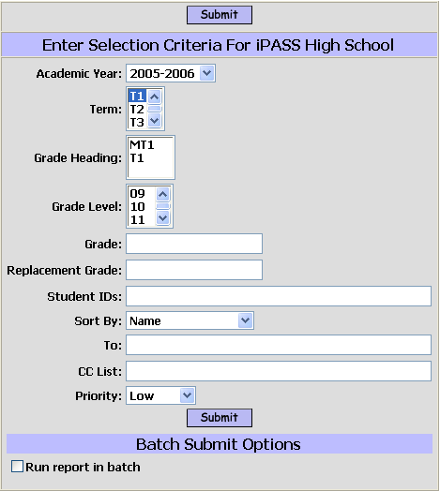

Academic Year:
- Select the Academic Year you want.
Term:
- Select the Term that you want from the pull-down list.
Grade Headings:
Grade Headings for the Term selected will be displayed.
- Select/Highlight the Grade Heading to search for the grade being replaced.
Grade Level:
- Accept the default of all grade levels.
- Select/Highlight one or more Grade Levels to include.
Grade:
- Enter the Grade code to be replaced. (Example: Inc)
The field cannot be left blank.
Replacement Grade:
- Enter the Replacement Grade.
Student ID:
- Leave the field blank to not filter for individual students.
- Enter one or more ID# for students whose grade needs to be replaced.

- Click to save your work.

You will get a report of the students affected with their original grade and their replacement grade.

4. Grade Import -
Use this program to import grades from another Rankbook software. You will need to know the formatting and layout of the file being exported from the other software. This process will need to be repeated for at least each teacher, if not each course, depending on the export file and if you have a means of combining files from multiple teachers.
The file(s) being loaded need to Uploaded into ipass first. You can use the File Upload program in <DOE ID Manager> to browse and upload the file.

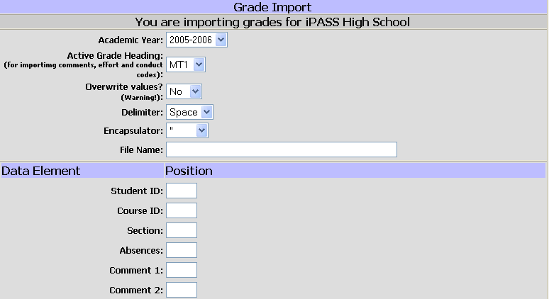

Academic Year:
- Select the Academic Year you want.

Active Grade Heading:
- Select the Grade Heading that you are loading grades into.

Overwrite values?:
- Accept the default value of No to not overwrite values that may already exist.

Delimiter:
- Accept the default delimiter of Space.
- Select “,” (comma) or “|” (pipe) as the field delimiter.

Encapsulator:
- Accept “ (the single quote) if the fields are encapsulated.
- Select None, if the fields are not encapsulated.

Filename:
- Enter the filename being loaded. The filename is case-sensitive.

Data Element/Position:
- Enter the number of the position in the file that corresponds to the data element being loaded.

