BMI Charts

Go to iHealth>Add/Modify Student>Select a Student and click on the BMI Chart tab at the top of the screen.

The chart will appear as seen below:

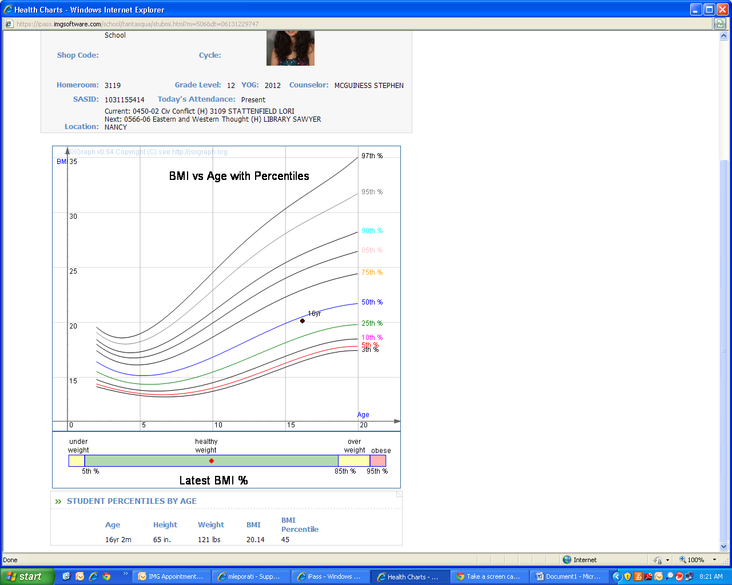

The chart can be printed using the Print icon at the top of the screen.

The chart can also be included in the Letter System.

BMI Letters
The Letter System contains a sample letter, ***BMI Letter*** that is representative of a typical letter sent home to parents regarding their child’s BMI calculation based on the most recent physical. Letters will be generated for selected default school.

Go to iHealth>Reports-Health>Health Letters

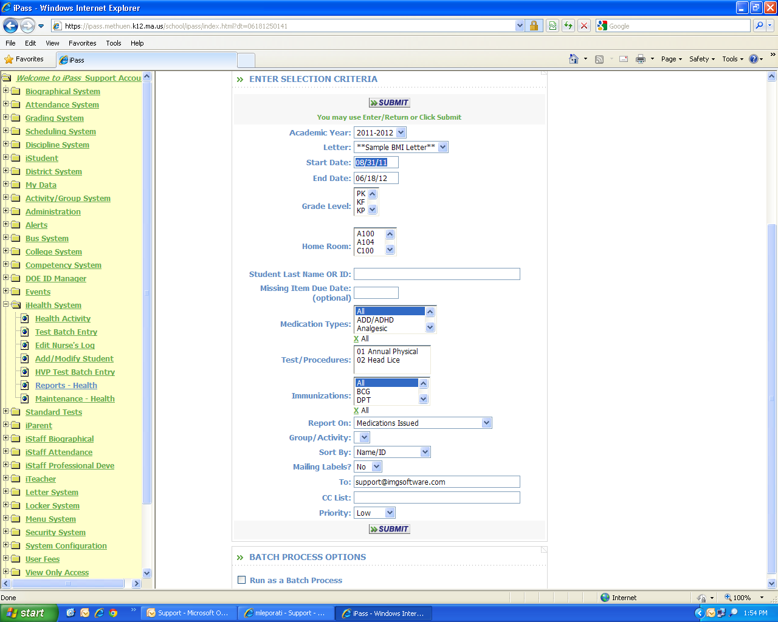

Academic Year Defaults to current academic year
Letter Select BMI Letter from drop-down menu
Start Date/End Date Defaults to start and end dates in iPass calendar
Grade Level Highlight grade level(s) desired
Homeroom Highlight homeroom(s) desired
Student Last Name or ID Enter student last name(s) or ID(s) entering a comma between multiple names or ID’s

Missing Item Due Date Leave Blank for BMI Letters
Test or Procedure Leave Blank for BMI Letters
Report On Use drop-down menu to select BMI
Group/Activity Highlight group or activity desired
Sort By Use the drop-down menu to select sorting output desired
Mailing Labels Use the drop-down menu to select yes or no

Click on to begin the report.

Go to My Reports to view letters in PDF format. Letter will be two pages; page one contains the actual letter, page two contains the BMI chart. If Mailing Labels>Yes was selected there will be an additional report generated in rtf (Word) format to print labels.

iParent View BMI

Schools may opt to include View BMI Charts in iParent. Please contact your iPass database administrator to configure this view for your school.

