INFORMATION MARKETING GROUP, INC.

ANNUAL CONFERENCE MAY 3, 2013

**REQUISITION CONTROL BALANCE (NEW FUNCTIONALITY):**

Information Marketing Group, Inc. has implemented new functionality in the Requisition/Purchase Order Processing System.

This functionality through a series of parameter maintenance settings allows the end user at each line of entry on a requisition to view the total budget available to them for encumbering funds for purchases.

For discussion purposes we will assume that the Expenditure Chart of Accounts contains a segment code that identifies or is related to a particular department. The system is designed in a two-step security approach. First we will set the segment code that corresponds to the department in the iFIPS Parameter Maintenance. This will then designate the segment code in the Chart of Accounts upon which the total unencumbered balance will be calculated.

The above setting in addition to the users account access rights will provide an available balance from which the user can create, get approved, and post PO’s. If a particular account is overdrawn but the control balance is greater than zero then the user will be allowed to enter the encumbrance up to the available control balance.

This new functionality provides for additional leeway for those organizations that allow their individual departments to encumber to the bottom line of that departments appropriation, while at the same securing access to restricted accounts.

**PROCESS FOR REQUISITIONS AND PURCHASE ORDERS:**

From your Purchase Order/Requisition menu choose Requisitions or Purchase Order depending on your access rights and procedures for processing these documents. At the top of the list of requisitions or orders click on the http://10.20.30.19/images/btn_add.gif icon under the title “Requisition List”

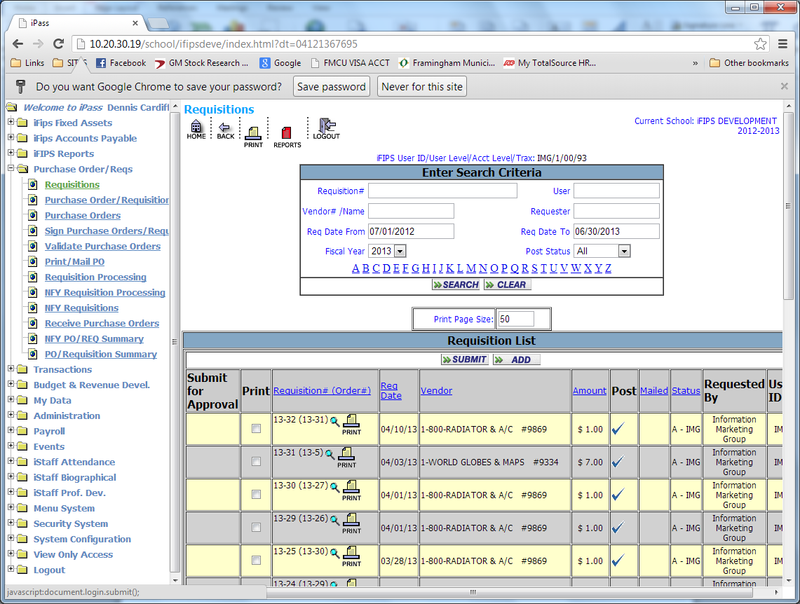

This action will open the requisition/order template below. Note that the requisition/order lines now contain a new field titled Control Balance. (See the template below.)

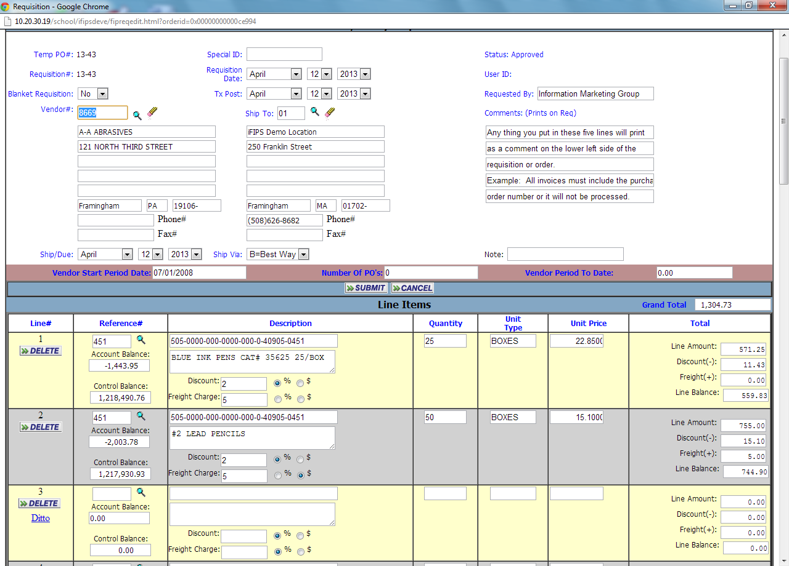

If you are utilizing the same account number on the next line you can hit the ditto button this will populate all of the account information from the previous line automatically updating the available “Account Balance” and the available “Control Balance” saving several entry steps.

The Control Balance is calculated based on a combination of the segment code of the account so designated as the “control segment” and the account restrictions assigned to user via “Restrict Account Access” in security settings.

This functionality will effectually allow the user to overdraw any account they have access to that may contain a zero or negative balance up to the available control balance calculated on each line. If the “CONTROL BALANCE” reaches zero

or displays negative the entire Requisition/Purchas Order will be automatically backed out and disappear.

**SET UP**:

The system administrator or IMG will need to set the background parameter settings to establish the segment code of the account that will be used in calculating the control balance. There is also an override setting, when set to yes allows any level one (1) user will be allow to override the control balance.

In addition, each user will need to be assigned to their particular accounts for this segment code.

Use of segment code that is defined as a department or location code may include payroll accounts that the end users can be restricted from accessing. If restricted the “Control Balance” will not calculate these account balances in the total available “Control Balance”.