Massachusetts EPIMS Teacher Evaluations

**Enter Individual Evaluation information**

iStaff Biographical>Add Modify Staff. Search for a teacher by Last name, Employee ID, MEPID, Department, Building, Job Type and working status. Click on the teacher name to open the Profile screen. Click on the DOE Evaluations tab and complete the fields necessary for teacher evaluations reporting, SR28-SR34.

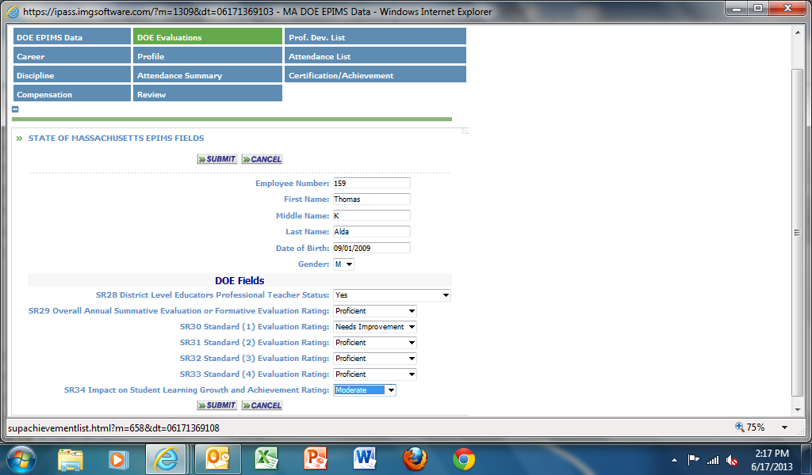

Select the appropriate item from each drop down menu for SR28 to SR32.

Click on  to record changes.

**Batch Entry for SR28-SR34**

iStaff Biographical>Procedures – iStaff. Click on the tab for Batch Data Entry. Filter employees by Employee ID (up to 10 ID numbers separated by commas may be entered) State ID/MEPID, Last Name (up to 10 last names separated by commas), Building or Department.

In the Fields to Update section, select the SR28-SR34 items in each drop down menu.

Click on  to display employees and fields

.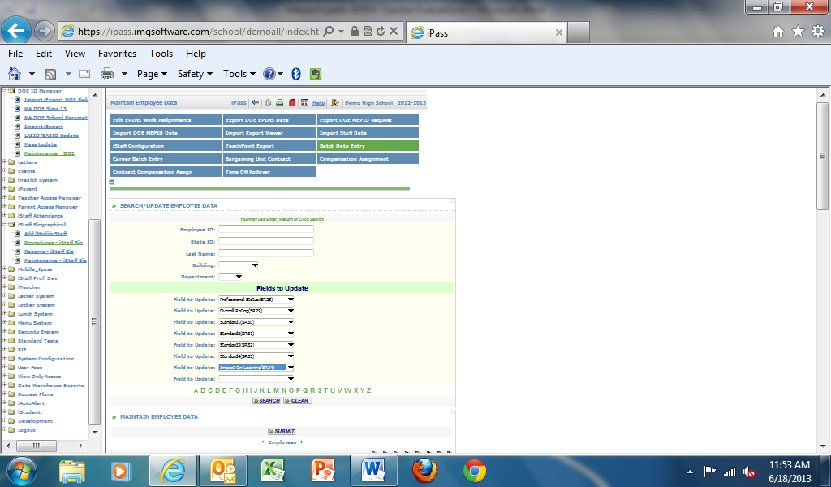

The fields will display as shown:

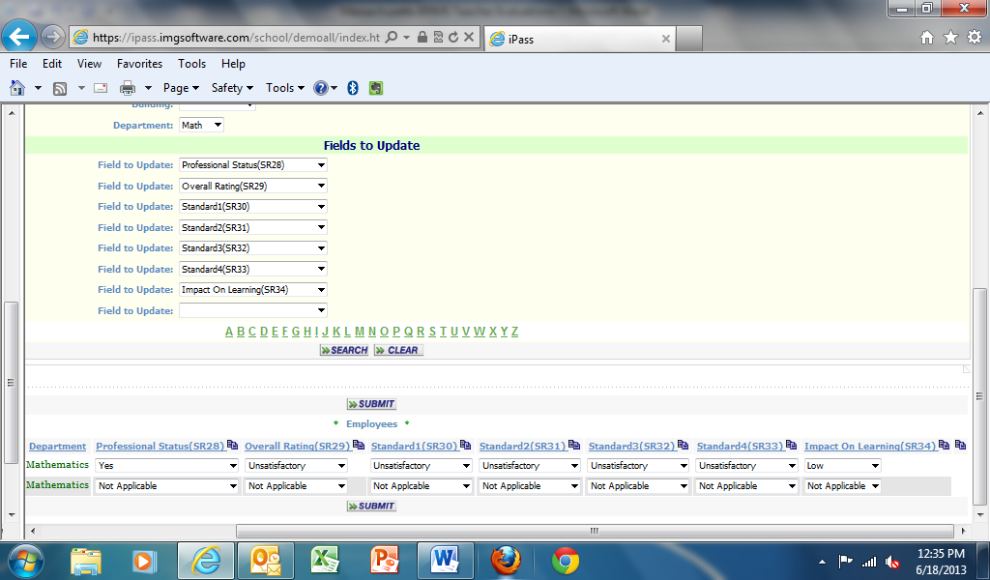

Select data from drop-down menus in each category. Use the Copy  function to copy the data selection in each field from the first employee to all other employees. For example, select Not Applicable for the first employee and copy down to other employees.

To export the EPIMS data, go to iStaff Biographical>iStaff Procedures and click on the tab Export MA DOE EPIMS. The data for SR28 to SR34 will be included in the Staff Roster file.