INFORMATION MARKETING GROUP, INC.

PROCEDURES FOR POSTING PAYROLL TO THE APPROPRIATIONS ACCOUNTS

LOGIN TO iPAY:

On the payroll menu click on the option “Payroll Files” then click on the tab “BUDGET INTERFACE” The GENERATE BUDGET FILE will be highlighted in blue. In the boxes below you will select the year and then the payroll period in the list of the file that you are generating and mouse click submit. This process will generate the file for that period.

See below

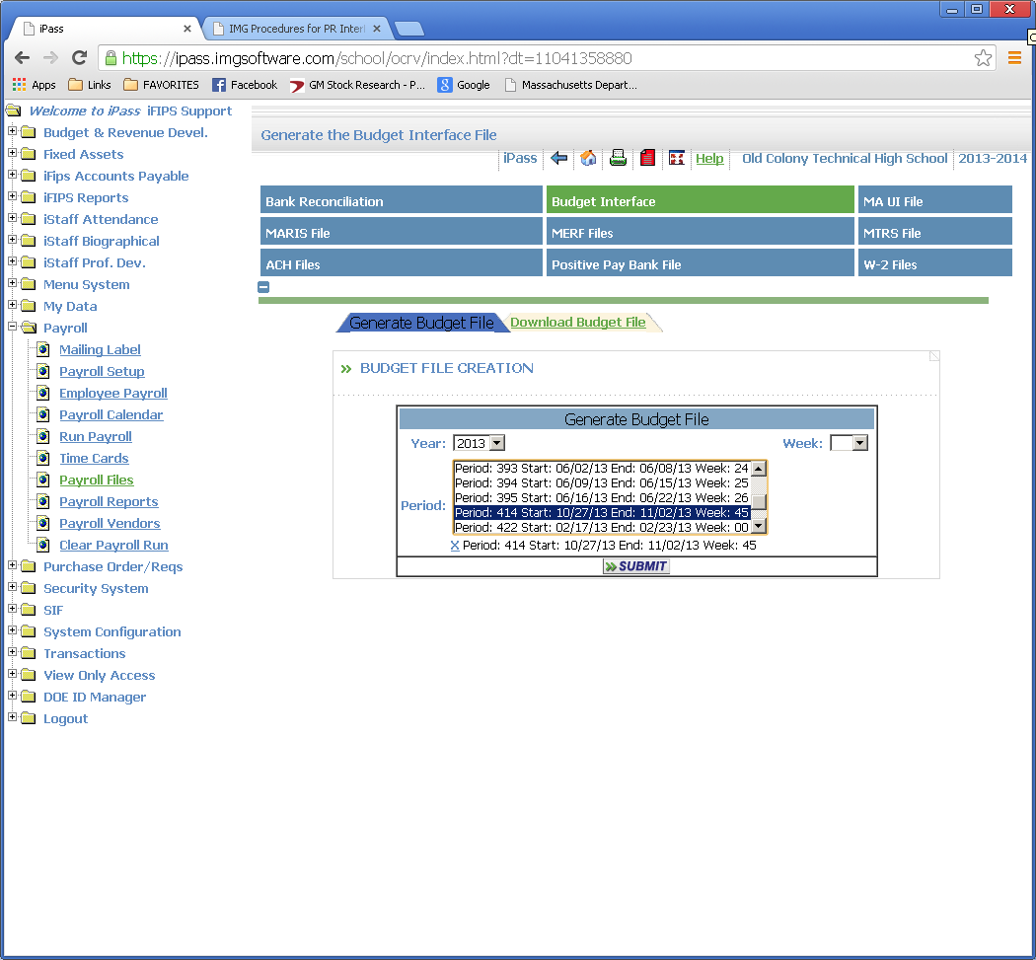

Now you must click on the “Download Budget File” Tab and a list of files will display as you see below.

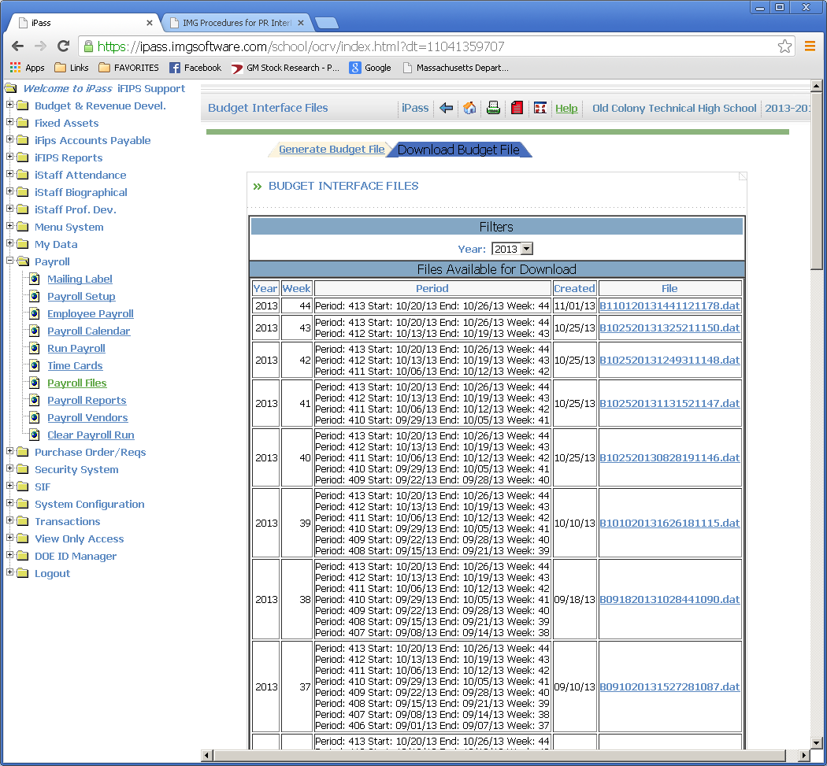

The system will assign a large file number you will see in the column labeled “File”. Double click that file and open it. Once opened you will want to click the option at the to gray bar “File” and

save as a text document to a location that you can easily access for upload to your financial system.

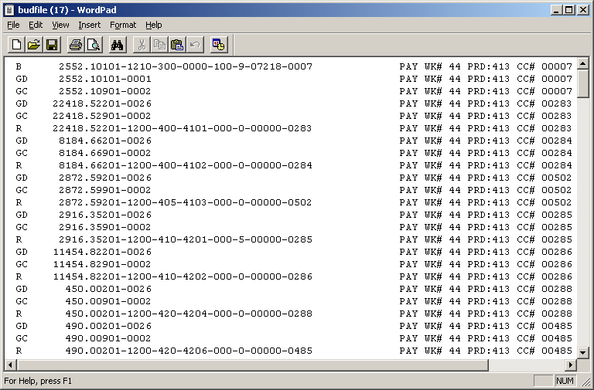

For example the file received for pay period 10/31/2013 was opened and saved as payinter413-44 and saved as a text document so the saved file will have a name of payinter413-44.txt. Next weeks file should be named payinter414-45 and so on.

It is important to note the exact name and spelling of your file as the entry of the file name in the upload process is case sensitive.

Once you have named and saved your document to the location of your choice on your computer you will need to login to iFIPS and choose the “iFIPS Transactioins” option on the menu, then choose “FILE UPLOAD” This will open the following screen:

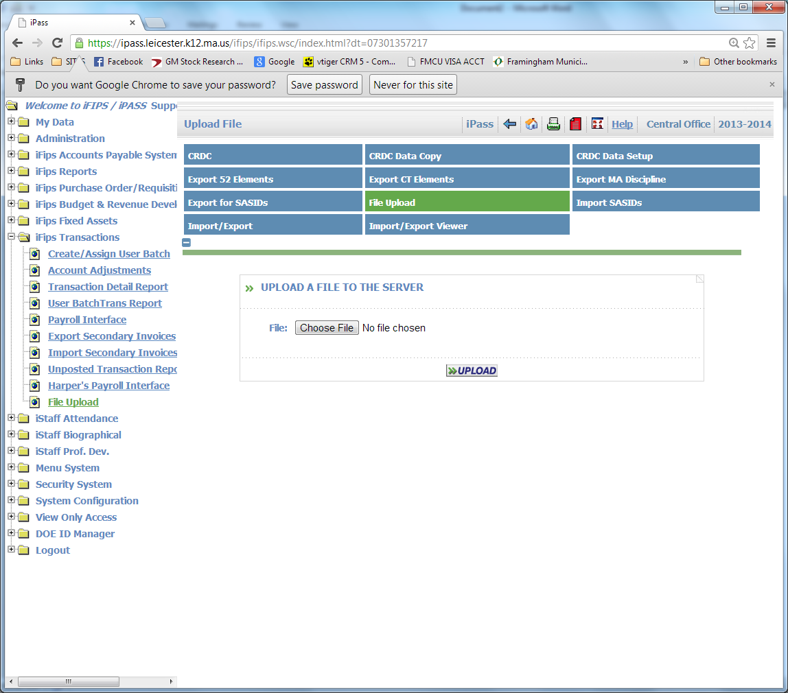

Click on the icon “Choose File” this will open a search screen where you can go to locate the file you “Saved as”.

Click on the file and it will appear in the “Choose File” window, then click upload and you will get a message “Process Complete” Click ok

Now go to the menu option “Harper’s Payroll Interface and the following screen will open:

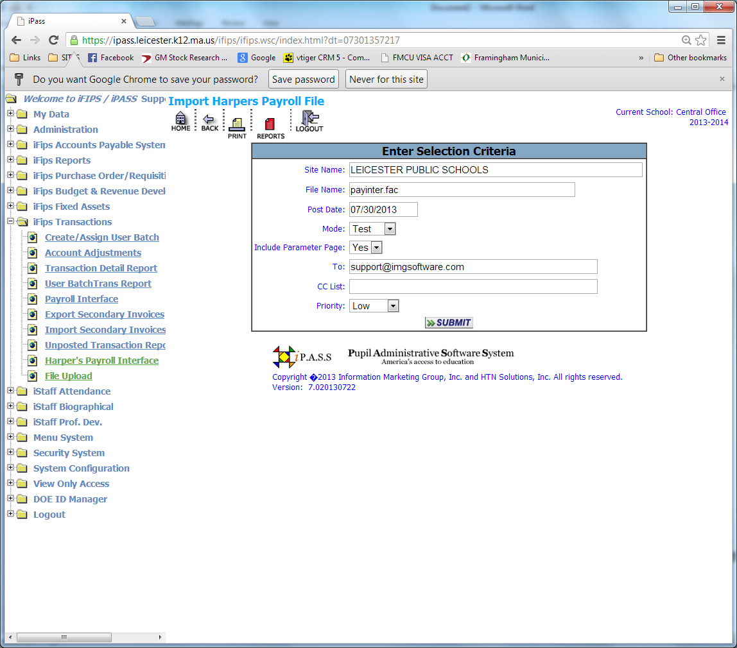

At this point you will need to enter the file name just as you saved it in the “File Name” field

Example: payinter413-44.txt.

You will need to change the post date to the date you wish to affect the accounts you are posting to. The first interface used a post date that was in the file of 10/31/2013.

Always use Test mode for the first submission as this will provide you with a review report before you hit the accounts and will print any error messages that may occur.

Once you have reviewed the test report you will need to repeat the steps above and in the “Mode” Field pull down and change to “Update” and submit again.

The expenditure transactions have been created and if your organization utilizes the automatic liquidation feature then the Liquidation transaction would be created as well. All general ledger transactions are created seamlessly in the background.