iParent Overview

iParent Overview 1
Set Up User Type 1
Customization of the Login Page 1
Add Message to the Login Page 2
Set up Other Text Messages 2
Set up Email Message 5
Set up Parameter Maintenance 7
Email 7
Pamregister.html 8
Guardian Approval 9
Guardian Maintenance 11
iParent Configuration 13
District 13
By School 14

Set Up User Type

Go to <Security System><User Types>
Look for a User Type named Parent. If there is not one create one.

Click on the button.

Scroll down to My Data

Check off Change Password

Scroll to Parent Access Manager Check off any of these selections for Parents to view.

View Homework
View Biographical
View Attendance
View Grades
View Schedule
View Discipline

Click the button.

Customization of the Login Page

Go to <System Configuration><Text Messages>

Create a message named System Login Bottom and select HTML Page Template under description.

Click the button.

Copy and Paste this into the box.

<table border="0" cellspacing="0" cellpadding="0" align="center">
<tr>
<td CLASS="DATA" align="center"><a href="pamregister.html">Click here
to apply for<br>on-line access to your child</a>
</td>
</tr>
</table>

Click the button.

Under the login box on the login screen you will now see Click here to apply for on-line access to your child

Add Message to the Login Page

Go to <System Configuration><HTML File Maintenance>

- Enter SYS in the file name field and click

- Open syslogin.html

- Add System Login to the Bottom Messages on that page

Click the button.

Set up Other Text Messages

Go to <System Configuration><Text Messages>

Create a message named Parent Registration select HTML Page Template under description.

Click the button.

Copy and Paste this into the box:

<table border="1" cellspacing="0" cellpadding="0" bgcolor="#ffffcc" width="100%" align="center">

<tr bgcolor="#bdbdff">
<td align="Center" CLASS="HEAD">
Application for On-line Access to Your Child's Records
</td>
</tr>
<tr>
<td>
<table width="100%" border="0" cellspacing="2">
<tr>
<td CLASS="DATA">
<font color="red">This application is for parents and/or legal guardians of students enrolled in this School System only. If you are here in error, please cancel (back button). Any and all other attempts to gain access to this system is forbidden and considered unlawful.</font>

</td>

</tr>
<tr height="10">
<td>

</td>

</tr>
<tr>
<td CLASS="DATA">Please fill out and submit the registration form below:
<ul>
<li>All fields indicated with an asterisk are required.</li>
<li>You must enter your own username and password. The school does not maintain this information, so if you forget either or both, you must contact your child’s school to have it reset. This is done to maintain a high level of security. Your password is your property and your responsibility.</li>
<li>Please understand that the application process does not instantly provide you with on-line access. You will receive an e-mail from the school regarding the status of your application. The school may require additional information and/or that a parent/guardian visit the school in person prior to final approval.</li>
</ul>

</td>

</tr>
<tr>
<td CLASS="DATA" ALIGN="CENTER">
Your comments, questions, and concerns are welcome support@yourschool.com <mailto:support@yourschool.com>
</td>
</tr>
</table>
</td>
</tr>
</table>

Edit the Text at the bottom to display the email you want comment, questions and concerns sent to for your district.

Your comments, questions, and concerns are welcome support@yourschool.com <mailto:support@yourschool.com>

Click the button.

Create a message named Registration Approval select Email Template under description.

Click the button.

Type the message you would like sent to parents once their Registration has been approved.

Example:

Your registration for the Parent Access System has been approved.

Click the button.

Create a message named Registration Confirmation select HTML Page Template under description.

Click the button.

Copy and Paste this into the box.

<center>
<table border="0" width = "80%">
<tr>
<td>
Thank you for registering<br>
We will process your request as soon as possible.
</td>
</tr>
</table>
</center>

Click the button.

Create a message named Registration Denial select Email Template under description.

Click the button.

Type the message you would like sent to parents once their Registration has been approved.

Example:

Your registration for the Parent Access System has been denied due to insufficient or inaccurate information. Please contact your child’s school or contact (Put in an Email Address).

Click the button.

Create a message named Registration Request select Email Template under description.

Click the button.

Type the message you would like sent to parents once their Registration has been approved.

Example:

Thank you for registering for the Parent Access System. Our administrator will get back to you shortly.

Click the button.

Set up Email Message

Go to <System Configuration><Email Messages>

Set up 3 Email messages
Parent/Guardian Registration Request
Parent/Guardian Registration Approval
Parent/Guardian Registration Denied

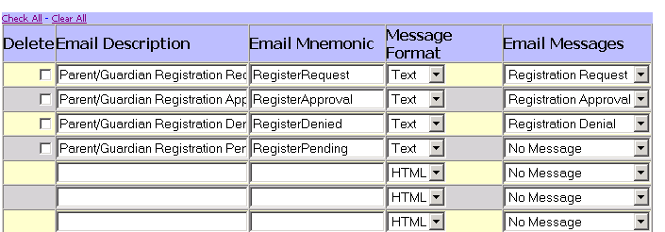

Parent/Guardian Registration Request

Email Description
- Enter Parent/Guardian Registration Request

Email Mnemonic
- Enter Registration Request

Message Format
- Select Text

Email Message
- Select Registration Request

Parent/Guardian Registration Approval

Email Description
- Enter Parent/Guardian Registration Approval

Email Mnemonic
- Enter Registration Approval

Message Format
- Select Text

Email Message
- Select Registration Approval
Parent/Guardian Registration Denied

Email Description
- Enter Parent/Guardian Registration Denied

Email Mnemonic
- Enter Registration Denied

Message Format
- Select Text

Email Message
- Select Registration Denied

Set up Parameter Maintenance
Changes made to the Parameter Maintenance affect the entire system. Please ensure that you know what changes you are making and document those changes.

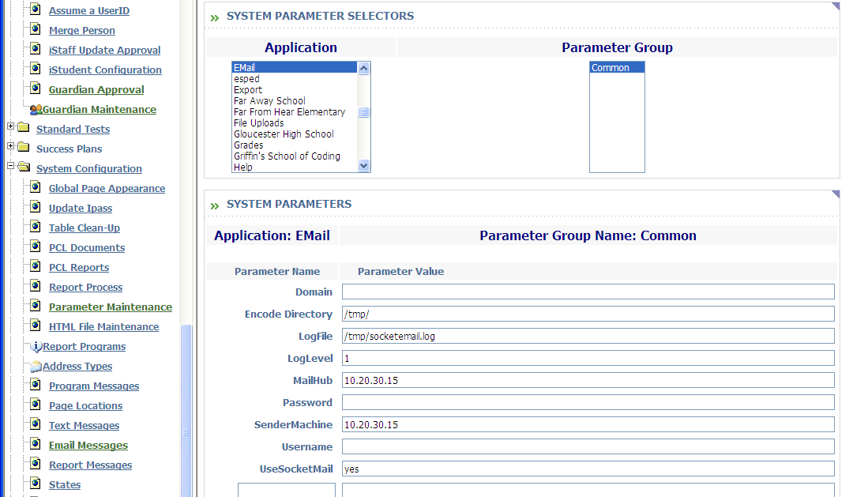

Go to <System Configuration><Parameter Maintenance>

Under Application select Email.

Under Parameter Group Select Common.

Email

Common
Email is sent by default to operate on a Unix machine using sendmail. Other environments that allow socket connections may be setup.
Encode Directory:

This is the directory where the email messages and attachments are encoded.
- Enter /tmp

LogFile:

The log file contains all of the email transactions that take place and should be cleared periodically.
- Enter /tmp/socketemail.log

LogLevel:

This sets the level of the log file.
- Enter 2

MailHub:

If you are using socket connections, the mail hub (where the SMPT client is located) must allow other machines (Sender Machine) to send form it.
- Enter the mail sever address

SenderMachine:
This is the machine that will be making the socket connection to the mail hub via an API. Port 25 is the port that is required to be open in order to send the system mail command.
- Enter the sending machine address

Pamregister.html

Default
The registration process for guardians is controlled through the pamregister.html webpage. This allows you to determine which fields you require guardians to enter in the application for access:

Address Type:

This indicates which address to use during the guardian approval process.
- Enter HOME

Approved:

This is a setting for approved.
- Enter 3

Confirm Page:

This sets up what is used on the confirm page.
- Enter Our administration staff will contact you when your ID is available.

Display SSN:

Social Security number can be made required by the school administrator through a logical.
- Enter YES or NO

Guardian Menu Access:

This is a setting to indicate the sequence number for the menu access.
- Enter 2

Guardian User Type:

This is a setting to indicate the sequence number for the User Type of Parent.
- Enter 3

Send Administrator Email:

This specifies whether or not the system administrator receives an email when a potential user registers.
- Enter YES or NO

State:

This is the state that the parents will be applying from.
- Enter the state abbreviation

Guardian Approval

Go to <Security System><Guardian Approval>

The Guardian Approval menu option allows you the ability to Approve or Disapprove Parent applications to receive access to the iParent system.

- Click on the applicant’s name.

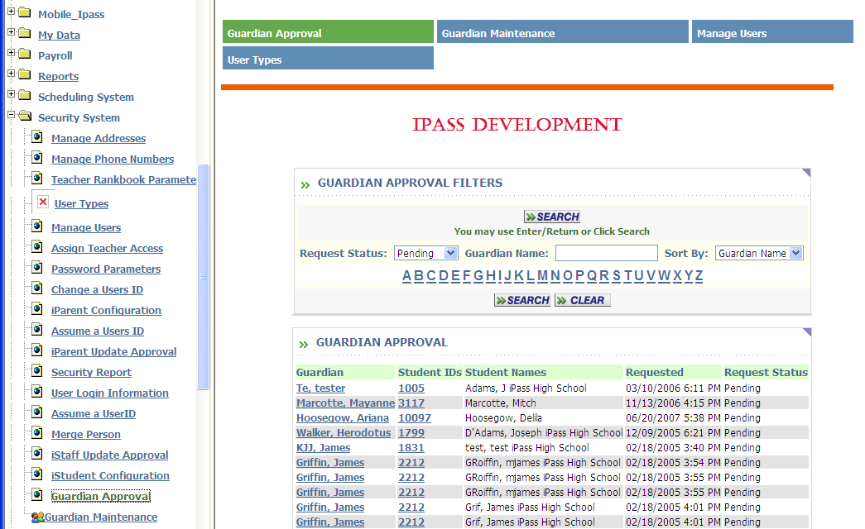

This screen is used to Approve, Deny, Delete and mark as Pending any iParent Applications that have been submitted. The RED indicates where there is a discrepancy between the data in the Database and the date entered by the parent at time of registration.

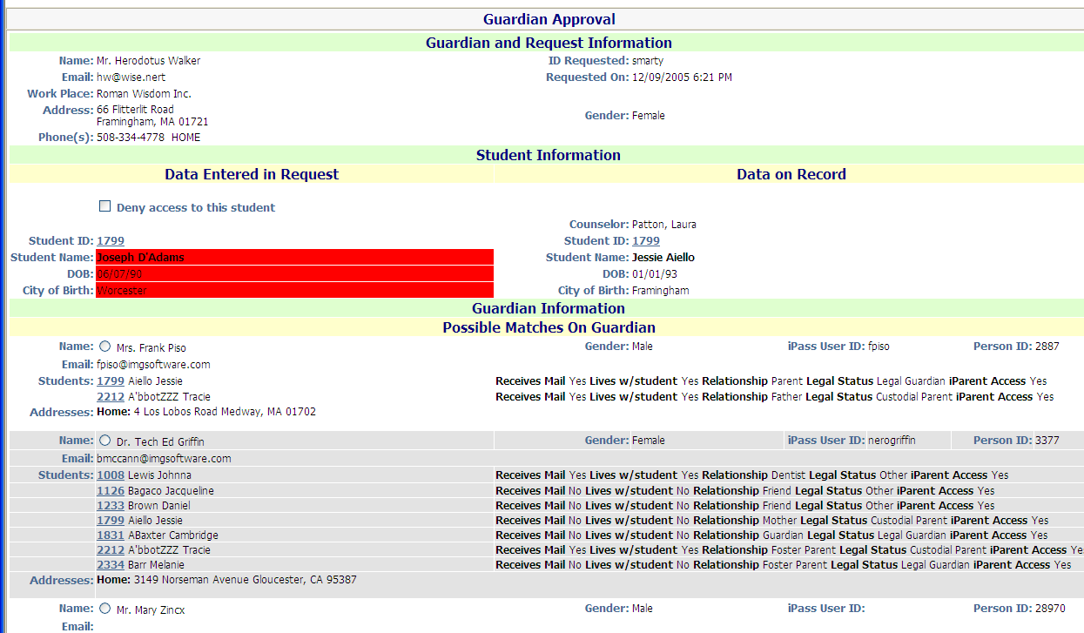

The student information will be displayed as well as any Guardians in the database that match the information.

- Click the radio button next to the guardian.

- Click Clear to clear a radio button.

- Click Approve to approve the application.

- Click Deny to deny the application.

- Click Pending to mark the application as pending.

- Click Delete to delete the application.

The bottom part of the screen allows you to Create a new Guardian record for the parent if does not already exists.

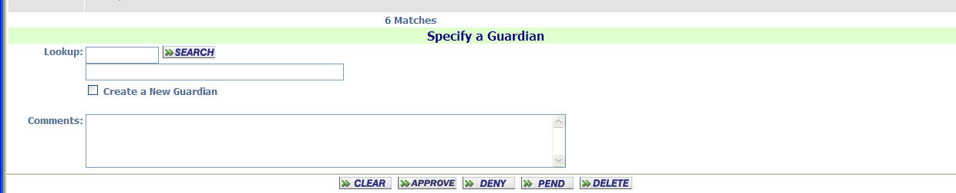

- Click Search to lookup the Guardian if no accurate match was displayed above.

- Click on the radio button “Create a New Guardian” to create a new guardian record for this Guardian if one does not exists.

- Add any comments you wish to the comment box.

- Click Clear to clear a radio button.

- Click Approve to approve the application.

- Click Deny to deny the application.

- Click Pending to mark the application as pending.

- Click Delete to delete the application.

Guardian Maintenance

Go to <Security System><Guardian Maintenance>
This menu option allows you the ability to manage all Guardian Records.

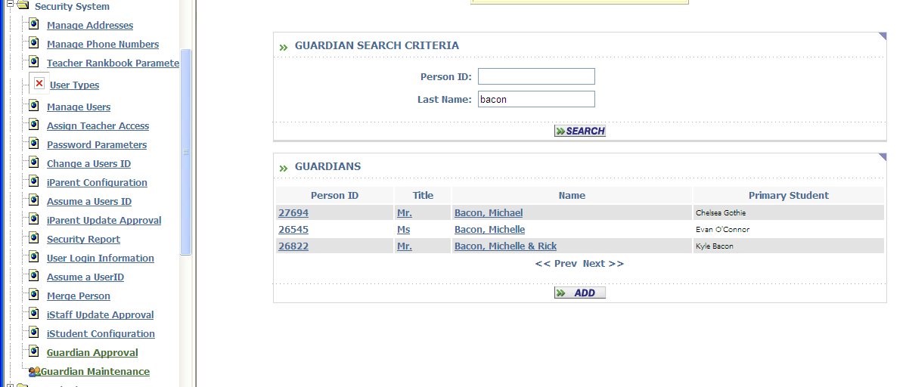

- Enter the Last Name of the Guardian you would like to search for.

- Click on Search

- Click on the name or ID number of the Guardian you wish to view.

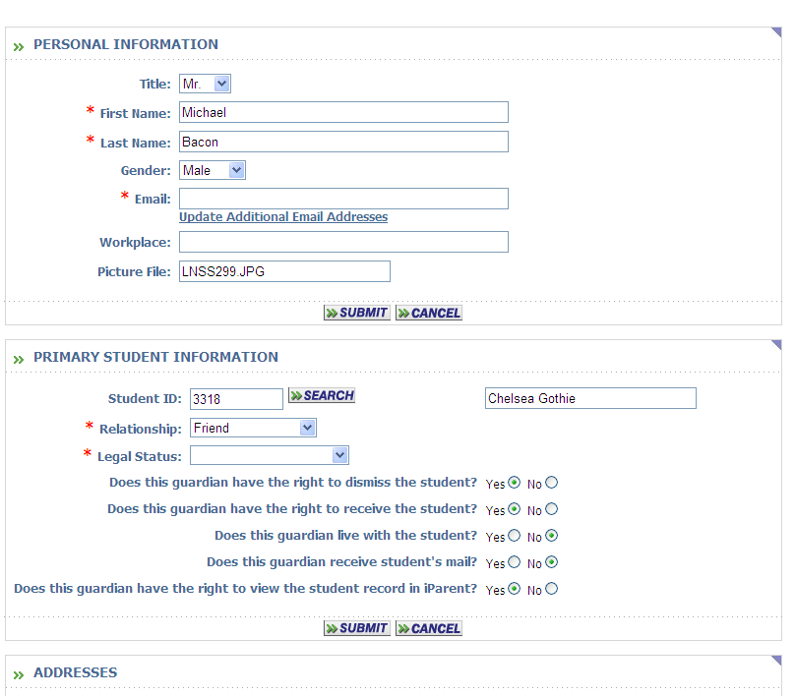

- Enter the information for the Guardian

- Click the Search button to locate the student you wish to associate this Guardian to.

- Click the button.

iParent Configuration

This menu option allows you the ability to set the configurations needed for Access, Grading and Scheduling information in iParent.

District
You can set a District configuration that allows certain Guardians to access iParent information.

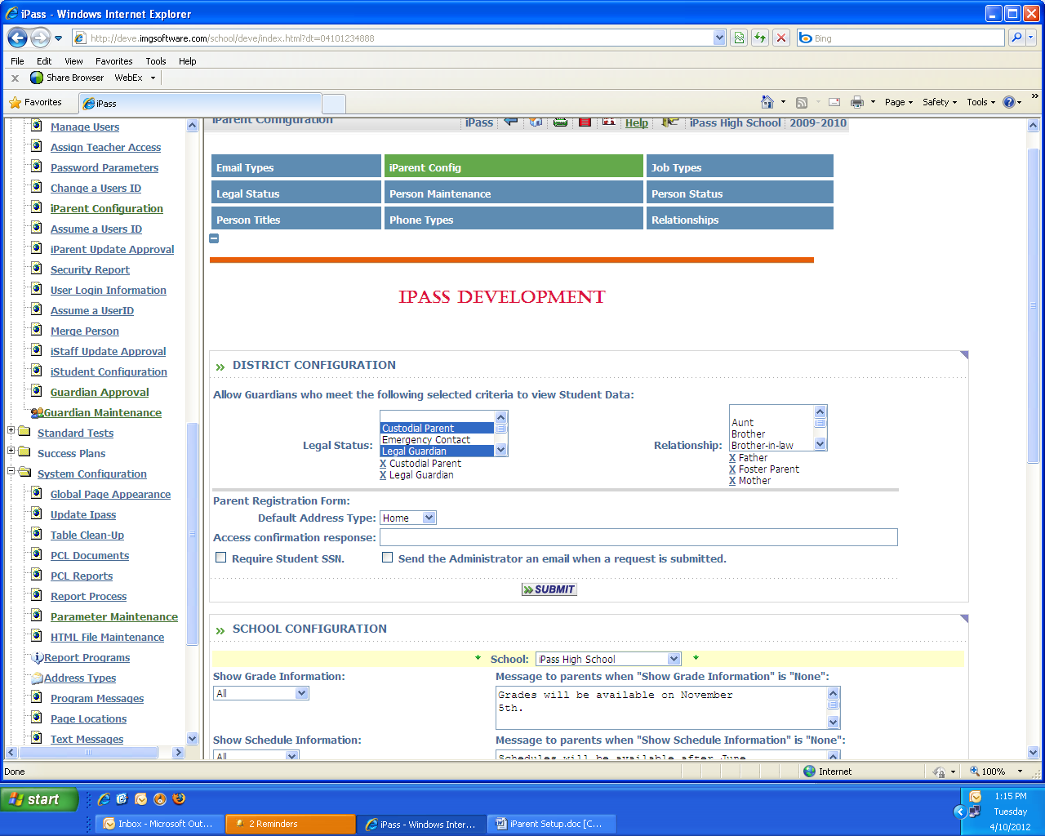

Allow access to student’s data to Guardians who are the following:

Legal Status:
- Select one or more of the Legal Status to gain access to iParent information
- Use the Ctrl key and mouse clicks to multi select

Relationship:
- Select one or more of the Relationships to gain access to iParent information
- Use the Ctrl key and mouse clicks to multi select

By School
You can set a configuration for each School regarding what Grading or Scheduling information can be viewed.

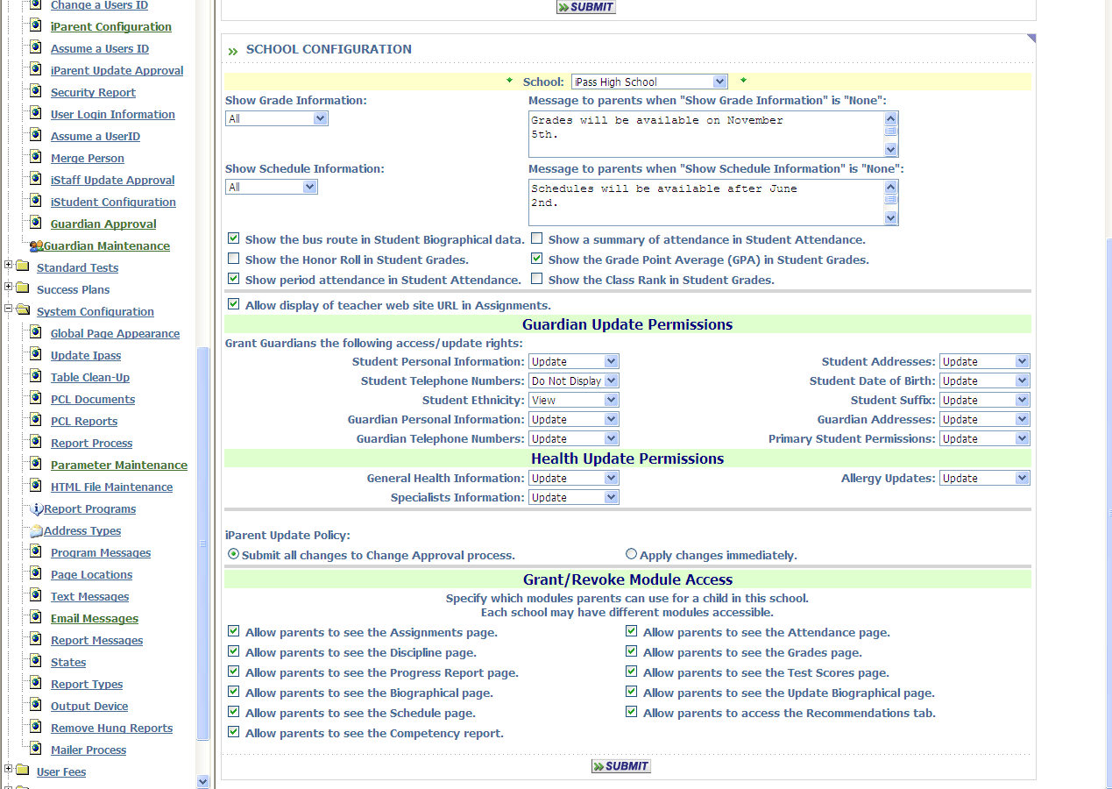

School:
- Select the school from the drop-down menu

Show Grade Information:
- Select from the drop down

All – Shows all grades

Prior – Only shows Prior Academic Year Grades

Current – Only shows Current Academic Year Grades

Current & Prior – Shows Current and Prior Grades

None – Will show no Grade information

Message to Parents when “Show Grade Information”
- Enter a message to be displayed when the Grading information is not available due to the selection made above in Show Grade Information

Example: Grades are not available at this time. Please check back on Friday after 2pm.

Important Note! When grading is open for teachers, it should be set to NONE for parents. Once grading is complete and report cards are published, set Grading back to Current or Current & Prior or All.

Show Schedule Information:
- Select from the drop down

All – Shows all Schedules

Prior – Only shows Prior Schedules

Current – Only shows Current Schedules

Current & Prior – Shows Current and Prior Schedules

None – Will show no Schedule information

Message to Parents when “Show Schedule Information”
- Enter a message to be displayed when the Scheduling information is not available due to the selection made above in Show Scheduling Information

Example: Scheduling is not available at this time.

Important Note! When the scheduling process is in progress for the following academic year, schedule information should be set to Current. Once your database has been rolled to the next year, remember that the schedules now become Current in the new academic year and should be set to Prior until they are complete.

Click to record the information.

