**Q. How do I add new codes to iPASS for Discipline Report to DOE fields?**

**A.** For the 2014-2015 School Safety and Discipline Report (SSDR) the DOE has added a few discipline codes and discontinued others. Your school district should review the new codes and add them if you will need them. Discontinued codes may be re-labeled, but should not be deleted.

***New –* Disciplinary Action Taken Code**

**6 – Emergency Removal** (not more than 3 days, inclusive of the day or removal)

|  |  |
| --- | --- |
| **Disciplinary Action Taken Codes**-Column H | **DAT_DESC** |
| 1 | In-school suspension (1 day – either partial or full - or more) |
| 2 | Out-of-school suspension (1 day – either partial or full - or more) |
| 3 | Expulsion |
| 4 | Removed by an impartial hearing officer to an alternative setting (only valid if Program Status = 2. SWD) |
| 5 | Removed by school personnel to an alternative setting (only valid if Program Status = 2. SWD) |
| 6 | Emergency Removal (not more than 3 days, inclusive of the day or removal) |

To add this code to your list of **Consequence** options:

* Go to Discipline System > Maintenance Discipline > Consequences
* Scroll to the bottom of the list to the first line of empty fields.
* Enter a Code, Descriptions, State Code (6), Type, and Unit (Days)
* Submit

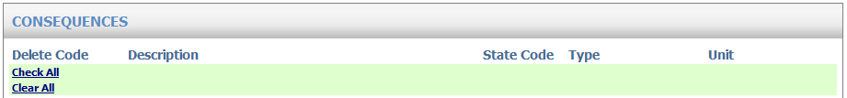



***New –* Educational Services Codes**

**6 – Distance learning, 7 – Saturday School, 8 – Other (Specify)**

|  |  |
| --- | --- |
| **Ed Serv Codes**-Column O | **AE_DESC** |
| 1 | Home Tutoring |
| 2 | In-district education services (specify in AEX) |
| 3 | Out-of-district education services (specify in AEX) |
| 4-5 | Discontinued codes |
| 6 | Distance learning |
| 7 | Saturday School |
| 8 | Other (specify in AEX) |

If your district will offer any of these new options you need to add the codes to your list of **Alternative Education Type** options.

To add these codes:

* Go to Biographical System > Biographical Maintenance > User Defined Fields
* Select Table = StuDiscipline (Search)
* Click on **Alternate Education Type**
* In the Values field: Add a comma after the last value (ie. 5) and add 6,7,8
* In the Labels field: Add a comma after the last entry (ie. 5 Work/community service setting…) and then enter new labels (ie. 6 Distance learning) separated by commas and no space. You can add “Discontinued” after codes 4-5 but you should not remove or delete them (ie. 4 Discontinued).

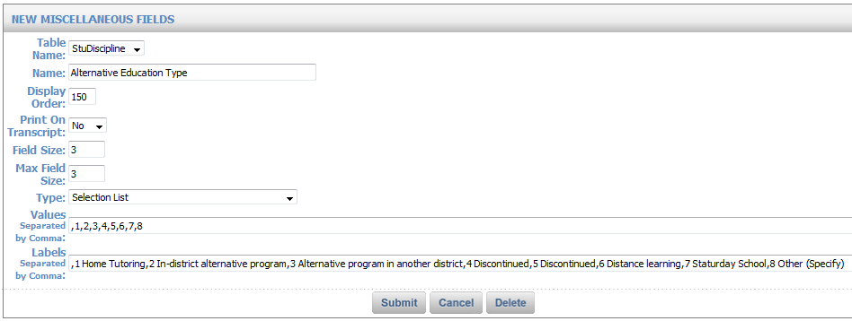

***New –* No Educational Services Code**

**5 – Refused services, 6 – Did not respond to offer of services, 7 – Other (Specify)**

|  |  |
| --- | --- |
| **No Ed Serv Codes**-Column P | **NAE_DESC** |
| 1 | Moved / transferred |
| 2-4 | Discontinued codes |
| 5 | Refused services |
| 6 | Did not respond to the offer of services |
| 7 | Other (specify in AEX) |

These new codes need to be added to your list of **Alternative Education Not Provided** options.

To add these codes:

* Go to Biographical System > Biographical Maintenance > User Defined Fields
* Select Table = StuDiscipline (Search)
* Click on **Alternate Education Not Provided**
* In the Values field: Add a comma after the last value and add 5,6,7
* In the Labels field: Add a comma after the last entry and then enter new labels (ie. 5 Refused services) separated by commas and no space. You can add “Discontinued” after codes 2-4 but you should not remove or delete them (ie. 2 Discontinued).

