
iPASS

DOE Reporting

DOE Reporting Table of Contents

UPDATE a SASID 1
SASID Export 1
SASID Import 3
To View the SASID Import ERRORS 4
DOE ID Manager 6
MASS Update 6
DOE Parameters 7
DOE Fields 8
DOE Labels 8
DOE Import Export 8
DOE Defaults 10
Export 52 Element SIMS file 11
Biographical Maintenance 12
<DOE Specific> Tabs 12
<Career & Technical Program> Tab 12
<Limited English Proficiency> Tab 12
<Country Codes>Tab 13
<Entry Withdrawal Codes>Tab 14
<Tech Ed (Shop Codes) > Tab 15
<Language Codes>Tab 16
<Town Codes>Tab 17
MA DOE Screen 18
AP Course Numbers 18
Term Codes not defined error 18
Entry Withdrawal Codes and DOE012 19

UPDATE a SASID

You can Add or Modify a SASID for an individual student.

Go to <DOE ID Manager><LASID/SASID Update>

- Select the student you want to update by clicking on their name.

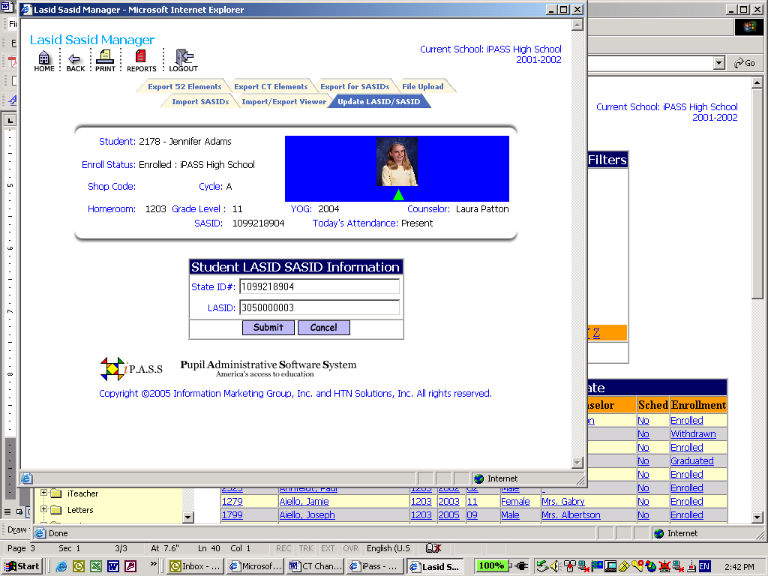

State ID #: This will show the SASID number assigned by the state. Add or Modify the state number here.

LASID: This field is not used in Connecticut and it could display the iPASS ID, a random number or be blank.

Click the button to save your changes

SASID Export

Go to <DOE ID Manager><SASID Export>

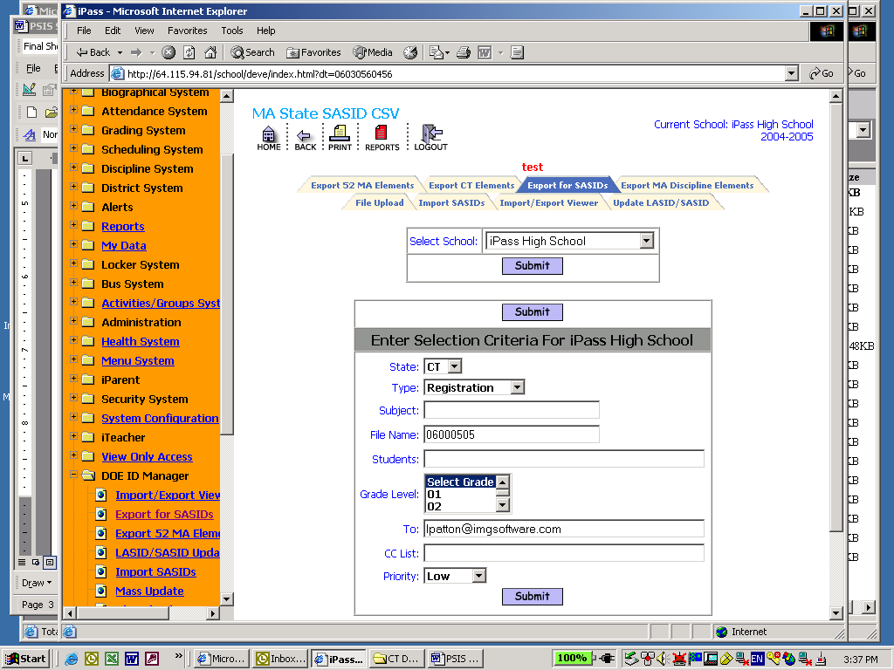

State: Select the state abbreviation

Type: Select Registration

Subject: Enter a subject to help identify the file over time

File Name: Enter a file name to help identify the file over time

Students: Enter student ID numbers separated by a comma. If you want all students then leave this field blank.

Grade Level: Select a Grade level. If you want all grades then leave this field set to Select Grade.

To: This box allows you to enter an email address or several addresses of people you want to send the report to. List email address separated by semi-colons.

CC list: This box allows you to enter an email address or several addresses of people you want to cc: a copy of the report to. List email addresses separated by semi-colons.

Priority: This box allows you to set a priority level for the report processor. Priority options are limited to the list provided.

Click the button to export your SASIDs

SASID Import

In order to Import the SASIDs in to i PASS you must first upload the file that you received from the DOE PSIS site.

Go to <DOE ID Manager><File Upload>

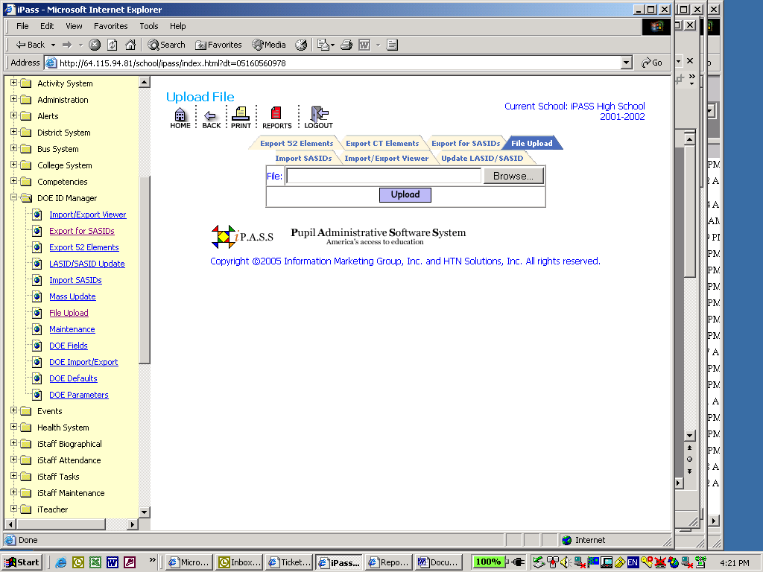
- Click on the Browse Button
- Find the file on your hard drive
- Click Open
- Click the button to upload the file into iPASS

Go to <DOE ID Manager><Import SASIDs>

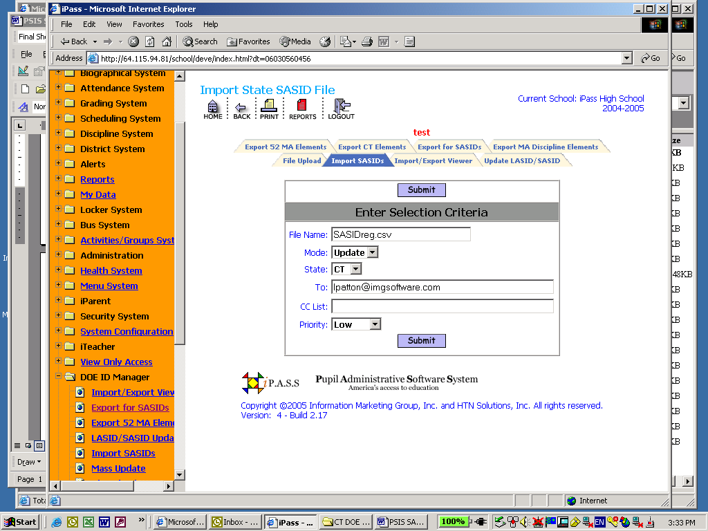

File Name:
- Enter the file name including the file extension. This field is case sensitive, so enter the name exactly how it was saved as.

Mode:
- Select Test mode to see if there are any errors

- Select Update to run the SASID import to populate the database

State:
- Select the state abbreviation

To: This box allows you to enter an email address or several addresses of people you want to send the report to. List email address separated by semi-colons.

CC list: This box allows you to enter an email address or several addresses of people you want to cc: a copy of the report to. List email addresses separated by semi-colons.

Priority: This box allows you to set a priority level for the report processor. Priority options are limited to the list provided.

Click the button to import your SASIDs and update the database

To View the SASID Import ERRORS

Go to <DOE ID Manager><Import/Export Viewer>

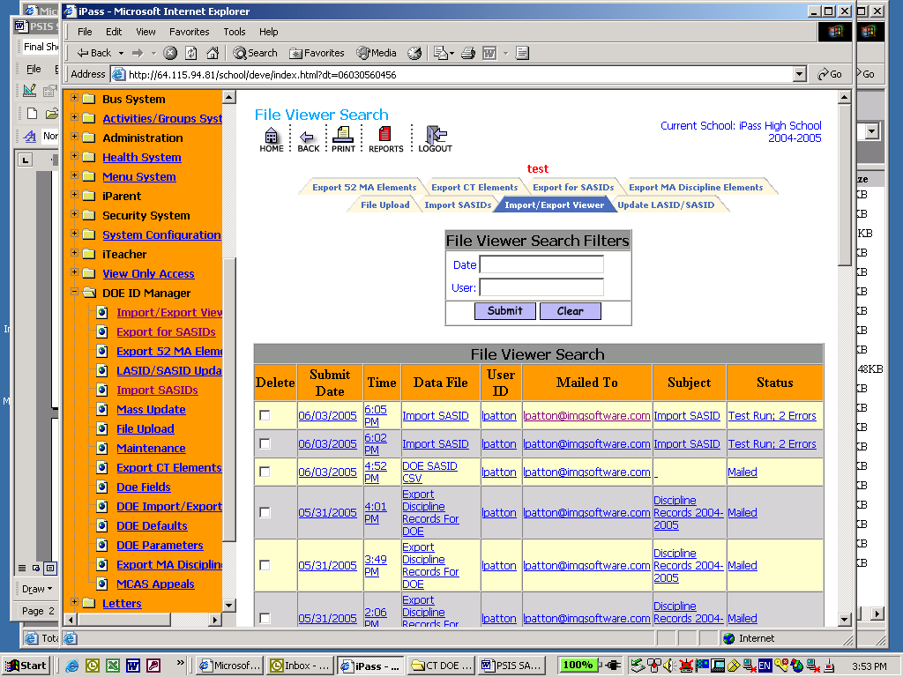

Delete: Click this box to put a check mark in it. Then click the submit button to delete the file from the viewer.

Submit Date: This will indicate the date you submitted the import to be processed

Time: This will indicate the time you submitted the import to be processed

Data File: This will be the name of the import file

User ID: This indicates the user ID of who submitted the import to be processed

Mailed To: This indicates who was emailed the results of the import

Subject: This will show the subject you entered on the Export SASID screen.

Status: This will indicate the status of the import. Test Run: With Errors, Test Run Successful, Updated: With Errors or Updated: Successful.

Click on the file name (Blue Underlined Link) under Data File

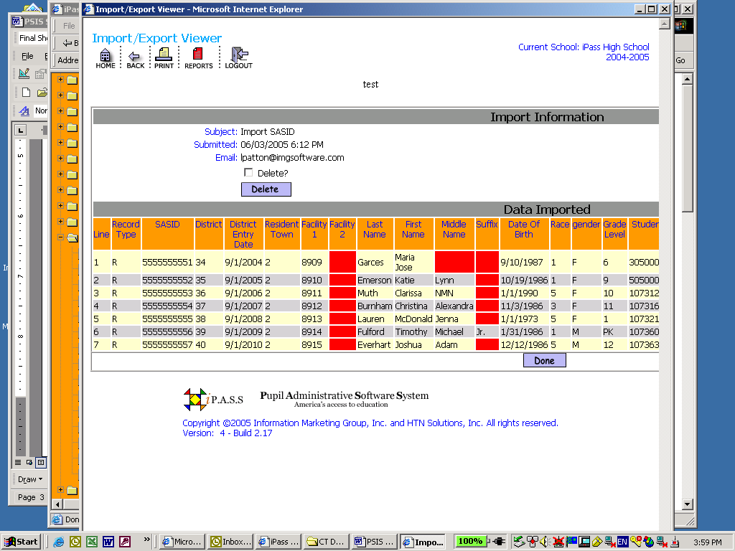

Delete: Click this box to place a check mark in it. Click the Delete button to delete the file.

Data Exported: This lists the data that was exported. The RED BOX indicates a blank data field.

Done: Click the Done button to close the viewer window

DOE ID Manager

MASS Update

This screen allows you the ability to do a global find and replace for DOE field data. The following DOE fields can be mass updated:

Race:
Reporting Reason:
Enrollment Status:
Enrollment Reason:
Town Of Residence:
Low Income Status:
Title 1 Participation:
LEP – Students Recently Arriving in US:
Emergency Immigration Education Program Status:
Country Of Origin:
1st Native Language:
Limited English Proficiency:
English Language Learners Programs Status:
Alternative Education:
Title 1 Choice Program:
Discontinued DOE029:
Discontinued DOE030:
DOE031:Technical Competency Attainment:
Post Graduate Plan:
Sped Placement All Ages 3-21:
Career & Technical Education:
DOE036 Special Education - Nature of Primary Disability:
DOE037 Graduated MA Core Curriculum:
DOE038 Special Education - Level of Need :
DOE039 Discontinued:
DOE040 Special Education - IEP Goals Reason for exit from special education:
DOE041 Discontinued:
DOE042 Career/Tech - Special Populations:
DOE043 Career/Tech - Chapter 74 Program Participation:
DOE044 Career/Tech - Non Chapter 74 Program Participation:

This screen is divided into two parts Filter Criteria and Update Criteria.

*Use the Enrollment field to filter the enrollment status you want *

Set the filter Criteria. Which students do you want to update? You can filter on Student ID, Last Name, Homeroom, Grade Level, Gender or by a code set in one of the fields.

Example: Filter on Races of 02- Black will find all students who are Black and enrolled in the database.

Set the Update Criteria. What data do you want to update? You can update any of the fields under this section. Pick the code that you want given to the students.

*Update one field at a time*

To update all Enrolled Students in the database to the same Skip the filter criteria and just fill in the Code in the field you want to update.

DOE Parameters
The DOE Parameters screen is where you link the Out of School Suspensions, In School Suspensions and Truancy to the codes used. This link tells iPass what Discipline Codes to use when calculating the Suspensions and what Attendance codes to use to calculate the Truancy days.
Use the Control key or Apple key and mouse click to select all the codes that correspond to the code displayed.

Also on this screen is the Test Wiz Parameters. Select all the departments that you want to Export. The Test Wiz select will export up to 4 courses and teachers per student for each department selected here.

To run the Test Wiz export go to <DOE ID Manager><Export 52 Elements> on this screen select YES in the Test Wiz field. The Export will be a 52 element SIMS file with the Course and Teacher information for up to 4 courses the student is scheduled for in each department. This file can be imported into Test Wiz.

DOE Fields
This is where the DOE fields DOE028, DOE031, DOE036-DOE052 are stored.

Click on the field name to open the edit screen.

Set the Code, Description and State code needed.

Use the delete box and submit button to delete any unwanted codes.

On this screen you can also set the default values you want assigned to any new student added to the database.

* You cannot delete a code that has been given to any student in the database, Withdrawn or Enrolled*

DOE Labels
This screen is where the field labels for the MADOE Screen are stored. Changing a label here will change the name listed on all the screens where these field are displayed.

DOE Import Export
This screen is used to Import DOE SPED data from your Special Education Database (eSPED, Eutactics).

In order to Import a SPED file into iPASS you must first upload the file.

Go to <DOE ID Manager><File Upload>

- Click on the Browse Button
- Find the file on your hard drive
- Click Open
- Click the button to upload the file into iPASS

Go to <DOE ID Manager><Import/Export>

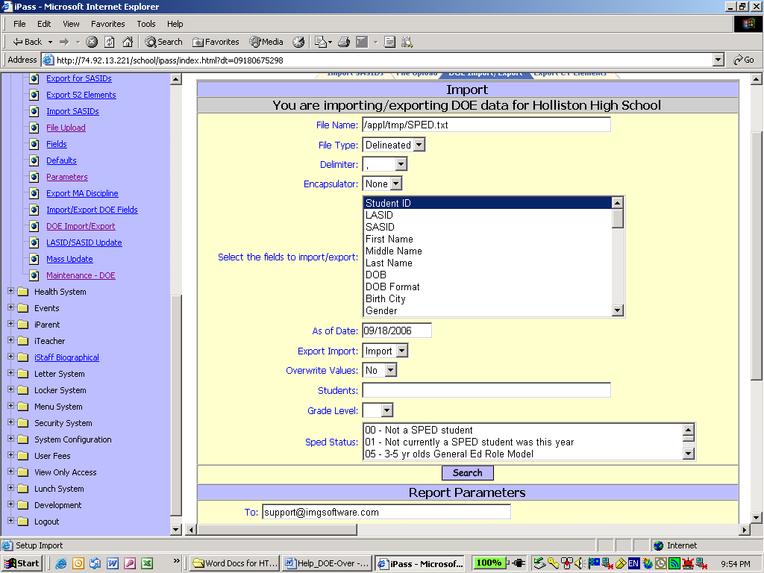

Add the File Name use /appl/tmp/Filename.ext this field is case sensitive and you must add the file name exactly how it was saved.

Select Delineated for File Type

Enter a comma or other delimiter for Delimiter. This indicates how each field is separated.

Enter None or “ for Encapsulator. This is how the text fields are surrounded.
Use the Control Key or Apple Key and mouse clicks to select the fields for Select the fields to Import/Export. You will need the Student ID, SASID or LASID to link on. Also select all SPED fields that are in the Text File you uploaded.

Select import for Export Import.

Click Search

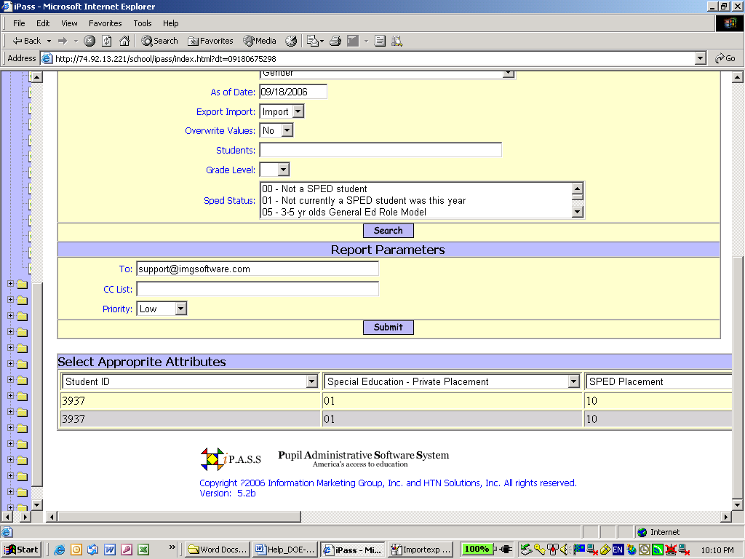

After you click search the field attributes and sample data will be displayed.

Link the Attribute to the sample data and click submit

A report will go to <My Data><My Reports> showing what data was imported for each student.

DOE Defaults
On this screen can set the default values you want assigned to any new student added to the database for the following field:

Low Income Status:
Title 1 Participation:
LEP – Students Recently Arriving in US:
Emergency Immigration Education Program Status:
Country Of Origin:
Primary Language:
Limited English Proficiency:
English Language Learners Programs Status:
Discontinued Use 500 For All Students:
Discontinued Use 500 For All Students:
Discontinued Use 500 For All Students:
Discontinued Use 500 For All Students:
Discontinued Use 500 For All Students:
Post Graduate Plan:
SPED Placement All Ages 3-21:
Career Tech Ed

Export 52 Element SIMS file

The 52 element exports are done by school.

Select a school and click submit

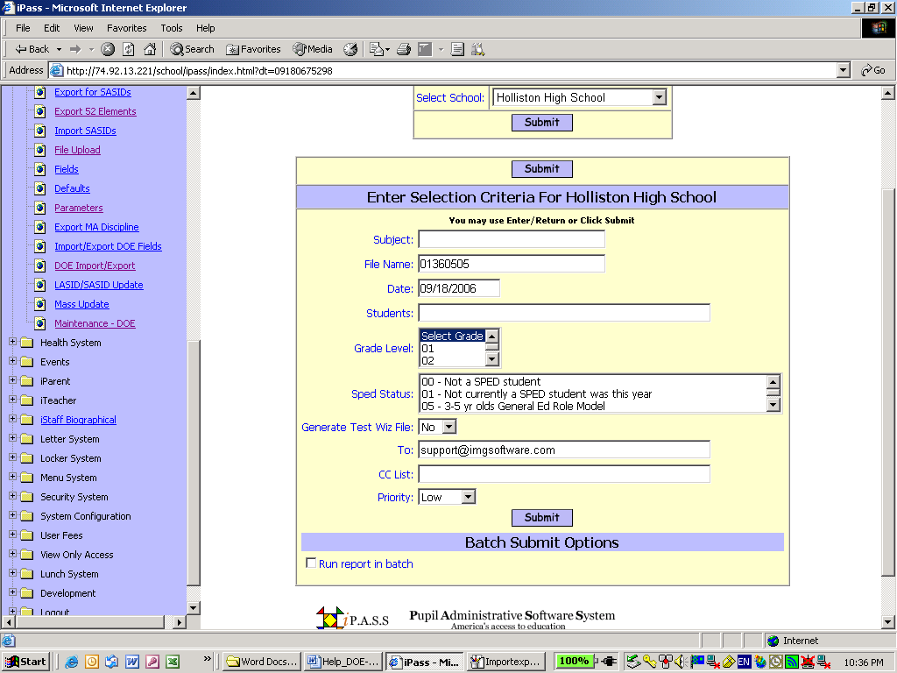

Enter a Subject, File Name and Cut off Date

If you want to make a file of just certain students then Add Student IDs under Students.

If you want to make a file for a certain Grade level then use the Control Key or Apple Key and Mouse click the grade levels you want to include in Grade Level.

If you want to make a file for a certain SPED Status then use the Control Key or Apple Key and Mouse click the SPED status you want to include in SPED Status.

If you want to make a file for Test Wiz select YES under Generate Test Wiz File.

*You must set the Test Wiz parameters in DOE Parameters First*

Click Submit

The file will be in the Import/Export Viewer for you to view and the file will go to <My Data><My reports>.

*See the Import/Export viewer section of this document for details*.

Right Click on the file name under CSV and save the Target as a CSV file to your hard drive.

This file will need to be uploaded to the DOE security Portal.

Biographical Maintenance

<DOE Specific> Tabs

Each of the DOE data Elements that need drop down menus will have a corresponding Tab. These Tabs are used to add and modify the codes used in the drop down menus.

<LEP – Students Recently Arriving in US> Tab

<Title 1> Tab

<Post Graduate Plans> Tab

<SPED Placement All Ages 3-21> Tab

<Not used at this time> Tab

<Compensatory Education> Tab

<Enrollment Reason> Tab

<Enrollment Status Codes> Tab

<Career & Technical Program> Tab

<Limited English Proficiency> Tab

<Ethnic Codes> Tab

<Immigrant Codes> Tab

<Language Codes> Tab

<Low Income> Tab

<English Language Learner Program> Tab

<Reporting Reasons> Tab

<Alternative Education> Tab

Delete:
- Check this box to delete an item.

* You cannot delete a code that has been given to any student in the database, Withdrawn or Enrolled*

Code:
- Create an Alphanumeric code for each item.

Description:
- Enter a description for each item.

State:
- This is the code that will be sent to the DOE in the Data Transmissions.

Clear All and Check All:
- Use these options to check all delete boxes or Clear all checks form the delete boxes.

Prev and Next:
- Use these options to move to the Next Screen for this table or move to the Previous screen for this table.

Submit:
- Click the button to submit additions or changes to the table.

<Country Codes>Tab

Delete:
- Check this box to delete an item.

Code:
- Create an Alphanumeric code for each item.

Description:
- Enter a description for each item.

Clear All and Check All:
- Use these options to check all delete boxes or Clear all checks form the delete boxes.

Prev and Next:
- Use these options to move to the Next Screen for this table or move to the Previous screen for this table.

Submit:
- Click the button to submit additions or changes to the table.

<Entry Withdrawal Codes>Tab
This table is used to create the entry/withdrawal codes used on the enrollment records.

Delete:
- Check this box to delete an item.

Code:
- Create an Alphanumeric code for each item.

Description:
- Enter a description for each item.

Enrollment Status:
- Enter the corresponding Enrollment Status for each item.

Clear All and Check All:
- Use these options to check all delete boxes or Clear all checks form the delete boxes.

Prev and Next:
- Use these options to move to the Next Screen for this table or move to the Previous screen for this table.

Submit:
- Click the button to submit additions or changes to the table.

<Tech Ed (Shop Codes) > Tab
This table is used for the Shop Code field on the <Career and Tech Ed> Tab.

Delete:
- Check this box to delete an item.

Tech Ed Code:
- Enter the Tech Ed Code for each item.

Description:
- Enter a description for each item.

Chapter 74:
- Select YES or NO for each item.

Cip No:
- Enter the Cip code for each item.

Non Trade Type:
- Enter the Non Trade Type for each item.

Sec Tech Voc:
- Select YES or NO for each item.

Clear All and Check All:
- Use these options to check all delete boxes or Clear all checks form the delete boxes.

Prev and Next:
- Use these options to move to the Next Screen for this table or move to the Previous screen for this table.

Submit:
- Click the button to submit additions or changes to the table.

<Language Codes>Tab

Delete:
- Check this box to delete an item.

Code:
- Create an Alphanumeric code for each item.

Description:
- Enter a description for each item.

Clear All and Check All:
- Use these options to check all delete boxes or Clear all checks form the delete boxes.

Prev and Next:
- Use these options to move to the Next Screen for this table or move to the Previous screen for this table.

Submit:
- Click the button to submit additions or changes to the table.

<Town Codes>Tab
This table is used to create Town of Residence Codes when entering the Town name.

Delete:
- Check this box to delete an item.

Code:
- Create an Alphanumeric code for each item.

City:
- Enter the City Name.

State:
- Enter the State Name.

Zip:
- Enter the Zip Code.

State Town Code:
- This is the code that will be sent to the DOE in the Data Transmissions.

Clear All and Check All:
- Use these options to check all delete boxes or Clear all checks form the delete boxes.

Prev and Next:
- Use these options to move to the Next Screen for this table or move to the Previous screen for this table.

Submit:
- Click the button to submit additions or changes to the table.

MA DOE Screen

The MA DOE Screen will give you a quick view of all fields that are in the DOE 52 Element SIMS file.

Report to DOE – This is a YES/NO field that will allow you to set if the student needs to be in the DOE SIMS report.

DOE011, DOE012, DOE013 and School ID - These fields are view only on this screen. To make changes to these fields you must adjust the most current enrollment Record. <Biographical System><Add/Modify Student Biographical><Enrollment>.

Race and Ethnicity - You can make changes to the Race and Ethnicity on this screen; however, it is much easier to pick the Race using the Confidential Screen. <Biographical System><Add/Modify Student Biographical><Confidential>.

Picking Race on the Confidential Tab – Pick up to 5 races and select Hispanic or Latino if needed. iPass will calculate the correct code to send to the DOE for you.

AP Course Numbers

To Add/Modify AP course numbers go to <Scheduling System><Course catalog><Course Details> click on the course number.

Add the AP code under DOE STATE CODE

Term Codes not defined error

When you create the DOE 52 elements SIMS file you may see this error message in the file or in the DOE Import/Export viewer.

To fix this error go to <Scheduling System><Maintenance-Scheduling><Academic Year Settings>. Set the correct dates for each term.

Entry Withdrawal Codes and DOE012

These two fields will be linked in the Enrollment records in a future Build of iPass. For now you must select a code for each field. There is not a one to one corresponding code in DOE012 for each Entry/Withdrawal code. In the future this link is made behind the scenes and will find the correct code to use. For now just find the Entry/Withdrawal code and DOE012 codes that best fit the student’s situation.

Submitting Summer Transferred, Dropped Out and Graduated Students.

Create withdrawal records for students who have Transferred, Dropped Out or Graduated over the summer.
- Enter a Withdrawal record for a date that falls after the last day of school and before the first day of school next year. Summer Dates Only
- Select the proper Entry/Withdrawal and DOE012 Enrolled Status Codes that reflect the reason why they left your district.
Following these steps will assure that these students are included in the October 1 SIMS submission with 555 in Attendance and 555 days in Membership.
When creating the October 1 submission there is a field on the <Create 52 Element Export> screen. Here you multi select all the withdrawal codes needed to be included in the file.
Example: Transferred, Dropped Out, And Graduated.
Due to DOE requirements, the SIMS 52 element file will reflect the 2006-2007 Grade Levels and 555 in Attendance and Membership for the summer Transferred, Dropped Out and Graduated Students.

