
College System

College System Table of Contents

College System 1
Find a College 1
Print Mailing Labels 1
Reports – College 1
Appl Summary Report 1
College Address Report 2
College Analysis 2
College Appl Count 2
Contact Report 3
Applicant Report 3
Student College Status 3
Maintenance – College 4
<Applicant Status> 4
<Application type> 4
Assign Colleges to a student 4

College System
The college system tracks which colleges students have Applied to, been Accepted at and Planning on Attending.

Find a College

This is the College table which is loaded by IMG. Colleges can be added, modified and deleted using the Find a College menu.

The following information is kept in this table:

- College Name
- College Type
- College Address
- College Contact Person
- College Phone Numbers

Print Mailing Labels

- Click on the Print mailing Labels Link at the bottom of each college screen

- On the next screen you can select the numbers of labels you need for that college

Reports – College

Appl Summary Report

The Appl Summary Report provides the total number of students who have applied and attending.

Selection Criteria: YOG

Sample Output:

College Total Applied Attending

Boston University 3 2 1

Total: 3 2 1

College Address Report

The College address Report provides a list of colleges and their address.

Selection Criteria: Show colleges with applicant only: YES/NO

Sample Output:

College Address1 Address2 City State Zip

AAL NURSING SCHOLARSHIP'S COLL 123 SPONSORED SCHOL SERV PO BOX 6731 PRINCETON NJ 08541

ACADEMY COLLEGE SUITE 200 3050 METRO DRIVE MINNEAPOLIS MN 55425

College Analysis

The College Analysis Report provides information regarding how many students have applied and been accepted to each college based on their Academic rating and extra Curricula Activity.

Selection Criteria: Student ID, Last Name, Homeroom, YOG, Application type

Sample Output:

Acad Rat Extra Cu
College Attdg Most Dem Very Dem Demandin Exceptio Outstand Very Goo Average
AAKERS BUSINESS COLL 3 2 3 0 0 2 0 2 0 1
AAL NURSING SCHOLARS 0 1 1 0 0 1 0 1 0 0

College Appl Count

The College Appl Report provides information regarding the number of students who have Applied, been accepted and are attending.

Selection Criteria: Academic Year, Grade Level, Homeroom, Display Students, page Break on School type.

Sample Output:

School Applied Accepted Attending
Boston University 3 1 1

Contact Report

The Contact Report provides information regarding the contacts listed for the college.

Selection Criteria: Show colleges with applicant only: YES/NO

Sample Output:
College Last Name First Name Sex Phone Ext.

AAL NURSING SCHOLARSHIP'S COLL Smith Jane F 999-999-9000 101

Applicant Report

The Application Report provides information regarding students GPA, and test scores based on what college they have applied to.

Selection Criteria: Student ID, Last Name, YOG, Application type, Test 1, Test 2, Test 3, Hide Student Names YES/NO, Group activity.

Sample Output:
College Name
Student Name ID GPA GRD 2 Ba Iowa Wri MCAS Eng Type PGStatus Accd Attg

AAKERS BUSINESS COLL, ,
ABaxter, Cambridge 1831 3.25 7 88 ED Wait List No Yes
Abbot, Tracie 2212 5 EA Wait List
Aberle, Christa 1973 Wait List

Student College Status

The Student College Status report provides information regarding what students have applied to each school and what their application status is.

Selection Criteria: Student ID, Last Name, YOG, Status, Show Attending Only, Show accepted only, Mailing Labels YES/NO, Group/activity.

Sample Output:
College Name

AAKERS BUSINESS COLL, ,
ABaxter, Cambridge 1831 3.25 ED Wait Lis No Yes
Adams , Jennifer 3199 1.7 EA Wait Lis Yes Yes
Asaro, Joseph 1868 0 Wait Lis Yes Yes

Maintenance – College

<Applicant Status>

The status of the application

- Add a Code

- Add a Description

Suggestions: Waiting List, Processing, Rejected, Accepted, Pre interview, Post interview, Early Acceptance.

<Application type>

The type of application the student is submitting to the college.

- Add a Code

- Add a Description

Suggestions: Early Action, Early decision, Regular Application.

Assign Colleges to a student

Go to <Biographical System><Add/Modify Student><College App> Tab.

- Enter in a choice number

- Enter in the first 3 letters of the name of the college
Enter 3 letters and choices appear to select above.

The Drop down box will fill in automatically with any choice that begins with those 3 letters

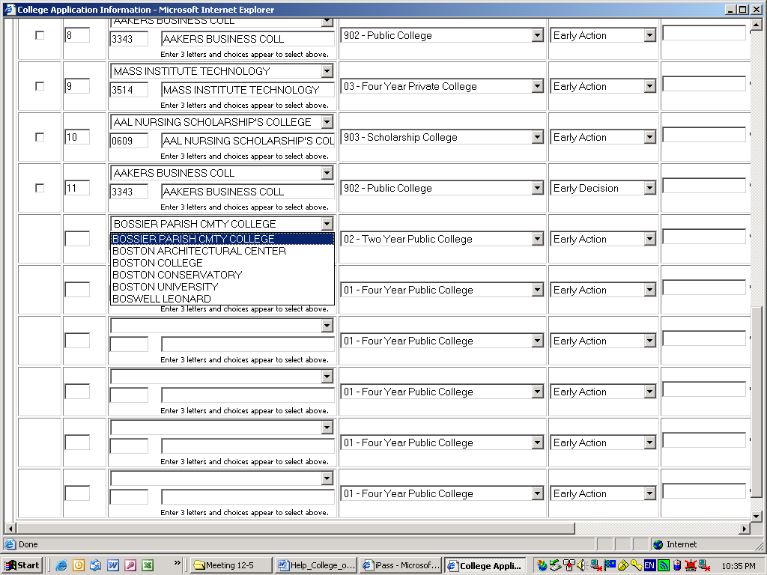

- The Post Grad Plans will fill in automatically based on your college selection.
*Note - This Post Grad plans are NOT the one sent to the DOE. The one sent to the DOE is the one at the top of the screen and must be filled in to report MA DOE33 in the end of year SIMS transmission based upon the student’s choice of college to attend.

- Select an Application Type

- Enter the Date Transcript Sent

- Enter an Applicant Status

- Select YES/NO for Accepted

- Select YES/NO for Attend

- Click the button.

