Letter System Table of Contents

Letters 1
Create/Modify Letters 1
<Write Letters> 1
Letter Examples 2
Helpful HTML Language 4
Delete a Letter 4
Print Letters 5
<Attendance Letters> 5
<Discipline Letters> 7
<Generic Letters> 9
<College Letters> 10
Letter Maintenance 11
<Letter Types> 12
<Letter Data> 12
Letter Data Table 12

Letters

This module allows you to set up and generate your Attendance Letters, Discipline Letters, College Letters and Generic Letters. Consistent with all i PASS modules, there is a set of maintenance tables that drive the system and they must be setup and defined by the school and/or school district.

Please be aware that all tab and Menu descriptions in the i PASS environment are customizable and may vary from the tab or menu descriptions displayed in this documentation. Please see your local i PASS super user or contact IMG support for further clarification.

The Letter System has 2 menu options:

Create/Modify Letters
Print Letters

(See Figure 1)
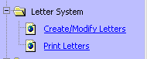
Figure 1

Create/Modify Letters

This menu option allows you to set up Attendance letters, Discipline Letters, Generic Letters and College Letters.

<Write Letters>

Description
- Type in the name for this Letter.

Letter
- This is where you type in the information you want on the letter.

- Start typing the paragraphs you want in the letter. To add data fields see Data Elements below.

Type
- Select the type

Data Elements
- Click on the elements you want to have included in your letter to highlight it.

- Click on the Data Element again and it will appear in your letter where you curser was last.

- Click to save the letter.

- Click to leave this screen.

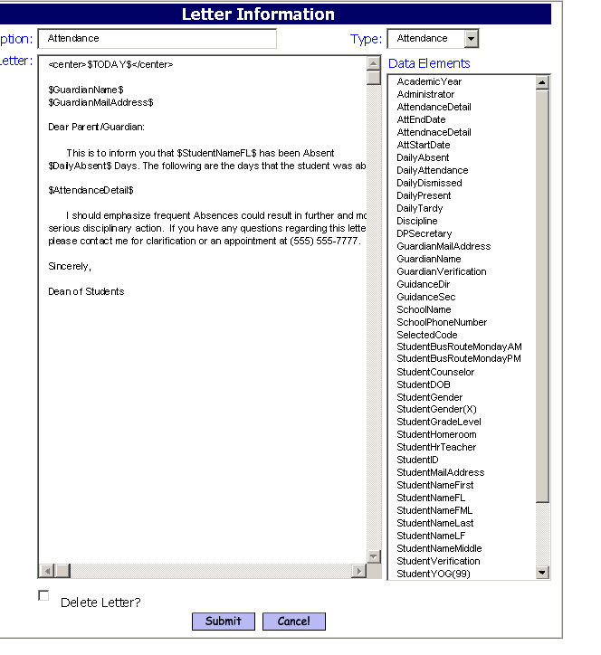
Figure 2

Letter Examples

Attendance Example

$TODAY$

$GuardianName$
$GuardianMailAddress$

Dear Parent/Guardian:

This is to inform you that $StudentNameFL$ has been Absent $DailyAbsent$ days. The following are the days that the student was absent.

$ AttendanceDetail $

I should emphasize that frequent Absences could result in further and more serious disciplinary action. If you have any questions regarding this letter, please contact me for clarification or an appointment at (555) 555-6666.

Sincerely,
$Administrator$

Discipline Example

$TODAY$

$StudentNameFL$

$GuardianName$
$GuardianMailAddress$

Dear Parent/Guardian:

This is to inform you that your son/daughter has been issued the following disciplinary action:

$Discipline$

I should emphasize subsequent infractions could result in further and more serious disciplinary action. If you have any questions regarding this letter, please contact me for clarification or an appointment at (555) 555-6666.

Sincerely,
$Administrator$

Generic Example

$StudentID$ $StudentNameFML$

A physical examination report is required and due within ______ days of school enrollment. A physical exam performed within one year prior to enrollment is acceptable.

Our records indicate that $StudentNameFirst$ is not compliant with this requirement.

Please contact the School Nurse at the $SchoolName$ immediately, so that we may assist you in meeting this policy.

Thank you for your attention to this matter.

Sincerely,

School Nurse

College Example

<center><b>Mid-Year Report Form Class of 2005</b></center>

<font size="4">
Name: <b>$StudentNameFML$</b>

Social Security Number: <b>$StudentSSN$</b>

College/University: <b>$CollegeName$</b>

Attached to this form is a first semester grade report. In addition to grades for the first half of the year, this report includes an additional written statement outlining any changes and additions to the student's academic and extra curricular activities that have occurred since the letter of recommendation.

Six Semester Cumulative GPA Scale: <b>$CGPA11thGradeScale4$</b>

Seventh Semester Cumulative GPA Scale: <b>$CGPACurrentScale4$</b>

If you have any questions, feel free to contact this office.

Signature:

Date:

Name
Position
Phone: 555-555-6666
FAX: 555-555-5555
</font>

Helpful HTML Language
You can use HTML Language to enhance your letters. The following are examples of HTML tags.

Center
Everything between <center> and </center> is centered in the letter.

Spaces
&nbsp; This adds one space.
&nbsp;&nbsp;&nbsp; This adds 3 spaces.

Boldface
Everything between <B> and </B> is boldfaced.

Italics
Everything between <I> and </I> is italicized.

Underline
Everything between <U> and </U> is underlined

Font Size
Everything between <font size="8"> and </font> is font size 8

Delete a Letter

If you need to delete a letter, simple open the letter. Go to the bottom of the letter and click
on the Delete Letter box to place an X in it.
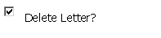
- Click to delete the letter.

Print Letters

This menu option allows you to print out the letters. The Letters are sent to <My Data><My Reports>. The first page will show the parameters you choose when printing the letter. You will also get a list of all students that a letter was generated for. The next page will be a letter for the first student with each of the other students printing on their own page.

Letters can also be printed from the <Reports> menu option in each of the respective areas. (Reports-Biographical, Reports-Attendance, Reports-Discipline, and reports-College)

<Attendance Letters>
This screen allows you to make filtering and sorting selections to print Attendance letters for a targeted group of students.

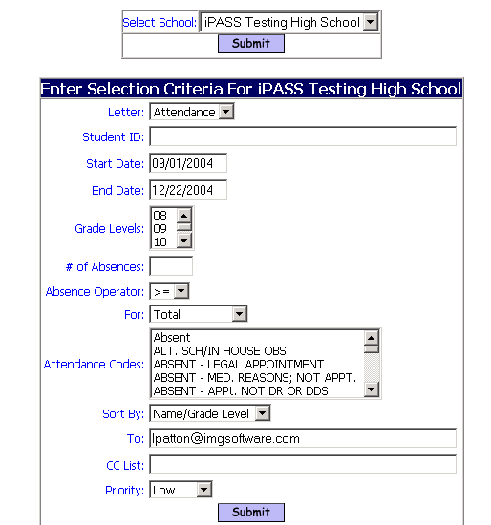

Figure 3

Select School
- Select the School

- Click to submit the selection

Letter
- Select the letter you want to run. You will only see letters that are designated as Attendance Type.

Student ID
- Enter a student ID number or a string of Student ID numbers separated by a comma.

Start Date
- This is the start date for the attendance. Using 09/01/2004 will give you all attendance that occurred since 09/01/2004.

End Date
- This is the end date for the attendance. Using 09/30/2004 will give you all attendance that occurred up until 09/30/2004.

Helpful Hint!

Using the above example Start Date 09/01/2004 and End Date 09/30/2004 you will get all attendance that happened between and included on both those dates.

Grade Level
- Select a grade level.

# of Absences
- Enter the number of Absences.

Absence Operator
- Enter the operator you want.

- < Less Than

- <= Less Than or Equal to

- > Greater Than

- >= Greater Than or Equal to

- = Equal to

- <> Does not Equal

For
- Select Total for all Attendance codes chosen. Examples: Absent, Tardy, Dismissed, Tardy/Dismissed, Truant and Field Trip.

- Select For Each Code for

Attendance Codes
- Select the Attendance Code(s) you want included. You must select at least one Attendance Code. Examples: Absent, Tardy, Dismissed, Tardy/Dismissed, Truant and Field Trip.

Sort By
- You can sort by the following
    - Name/Grade Level
    - Grade Level/Name
    - Homeroom/Name

To
- This box allows you to enter an email address or several addresses of people you want to send the report to. List email address separated by commas.

CC List
- This box allows you to enter an email address or several addresses of people you want to cc a copy of the report to. List email address separated by commas.

Priority
- This box allows you to set a priority level for the report processor. Priority options are limited to the list provided.

- Click to run the Letter.

<Discipline Letters>
This screen allows you to make filtering and sorting selections to print Discipline letters for a targeted group of students.

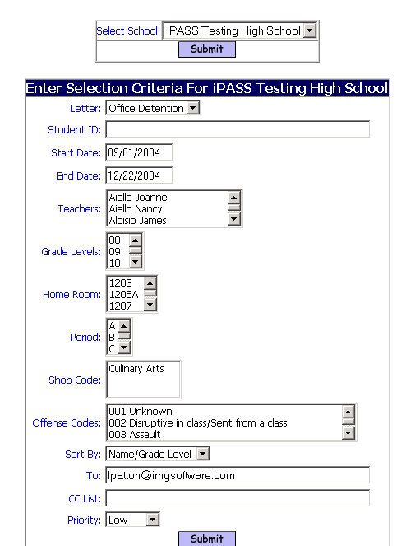

Figure 4

Select School
- Select the School

- Click to submit the selection

Letter
- Select the letter you want to run. You will only see letters that are designated as Discipline Type.

Student ID
- Enter a student ID number or a string of Student ID numbers separated by a comma.

Start Date
- This is the start date for the Discipline Records. Using 09/01/2004 will give you all Discipline Records that occurred since 09/01/2004.

End Date
- This is the end date for the Discipline Records. Using 09/30/2004 will give you all Discipline Records that occurred up until 09/30/2004.

Helpful Hint!

Using the above example Start Date 09/01/2004 and End Date 09/30/2004 you will get all Discipline Records that happened between and included on both those dates.

Teacher
- Select the Teacher(s). These are Teachers listed in the Report By field on the Discipline record.

Grade Level
- Select the Grade Levels. Do not highlight any Grade Levels to include all.

Homeroom
- Select the Homerooms. Do not highlight any Homeroom to include all.

Period
- Select the Periods. Do not highlight any Period to include all.

Shop Code
- Select the Shop Codes. Do not highlight any Shop Code to include all.

Offence Code
- Select the Offence Codes. Do not highlight any Offence Codes to include all.

Sort By
- You can sort by the following
    - Name/Grade Level
    - Grade Level/Name
    - Homeroom/Name

To
- This box allows you to enter an email address or several addresses of people you want to send the report to. List email address separated by commas.

CC List
- This box allows you to enter an email address or several addresses of people you want to cc a copy of the report to. List email address separated by commas.

Priority
- This box allows you to set a priority level for the report processor. Priority options are limited to the list provided.

- Click to run the Letter.

<Generic Letters>
This screen allows you to make filtering and sorting selections to print Generic letters for a targeted group of students.

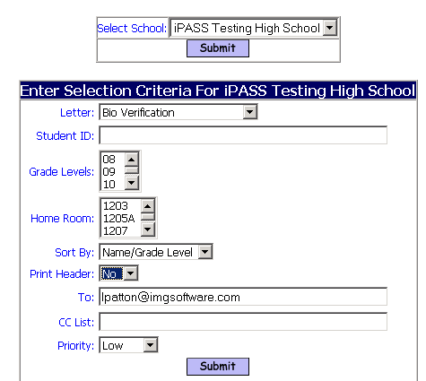

Figure 5

Select School
- Select the School

- Click to submit the selection

Letter
- Select the letter you want to run. You will only see letters that are designated as Discipline Type.

Student ID
- Enter a student ID number or a string of Student ID numbers separated by a comma.

Grade Level
- Select the Grade Levels. Do not highlight any Grade Levels to include all.

Homeroom
- Select the Homerooms. Do not highlight any Homerooms to include all.

Sort By
- You can sort by the following
    - Name/Grade Level
    - Grade Level/Name
    - Homeroom/Name

Print Header
- Selecting Yes will print the Letter Parameters on the first page.

- Selecting No will NOT print the Letter Parameters on the first page.

To
- This box allows you to enter an email address or several addresses of people you want to send the report to. List email address separated by commas.

CC List
- This box allows you to enter an email address or several addresses of people you want to cc a copy of the report to. List email address separated by commas.

Priority
- This box allows you to set a priority level for the report processor. Priority options are limited to the list provided.

- Click to run the Letter.

Helpful Hints!
Examples of Generic Letters: Welcome Letter, Honor Roll Congratulations, Class Field Trip, Graduation Events, and Procedures and Policies.

<College Letters>

This screen allows you to make filtering and sorting selections to print College letters for a targeted group of students.
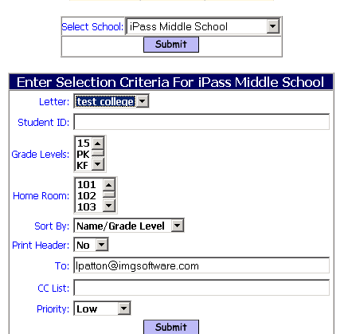

Figure 6

Select School
- Select the School

- Click to submit the selection

Letter
- Select the letter you want to run. You will only see letters that are designated as College Type.

Student ID
- Enter a student ID number or a string of Student ID numbers separated by a comma.

Grade Level
- Select the Grade Levels. Do not highlight any Grade Levels to include all.

Homeroom
- Select the Homerooms. Do not highlight any Homerooms to include all.

Sort By
- You can sort by the following
    - Name/Grade Level
    - Grade Level/Name
    - Homeroom/Name

Print Header
- Selecting Yes will print the Letter Parameters on the first page.

- Selecting No will NOT print the Letter Parameters on the first page.

To
- This box allows you to enter an email address or several addresses of people you want to send the report to. List email address separated by commas.

CC List
- This box allows you to enter an email address or several addresses of people you want to cc a copy of the report to. List email address separated by commas.

Priority
- This box allows you to set a priority level for the report processor. Priority options are limited to the list provided.

- Click to run the Letter.

Letter Maintenance

Letter Maintenance is not done in the Letter System. <Letter Types> and <Letter Data> are two tab options used to maintain Letters they can be found in <System Tables & Types >.

- Go to <System Configuration><System Tables & Types>.

<Letter Types>

There are four Letter types used presently.

- Attendance

- Discipline

- Generic

- College

NOTE: Do Not Add New Letter Types! Letter Types are specific to the programming involved and must be created only by IMG.

<Letter Data>
The letter data is maintained by IMG. Here is a list of current Data Elements and their descriptions that can be used in Letters. The following is a table of all Letter Data elements and their description.

Letter Data Table

Description | Data Field
Academic Year | AcademicYear
Administrator | Administrator
Table of Dates for Each Attendance Code Chosen | AttendanceDetail
Attendance End Date | AttEndDate
Attendance Start Date | AttStartDate
Student’s 11th Grade Career GPA | CGPA11thGrade
Scale used for 11th Grade Career GPA | CGPA11thGradeScale4
Student’s Career GPA | CGPACurrent
Scale used for Career GPA | CGPACurrentScale4
College Name | CollegeName
Daily Absence Count | DailyAbsent
Table of Student Attendance Information | DailyAttendance
Daily Dismissed Count | DailyDismissed
Daily Present Count | DailyPresent
Daily Tardy Count | DailyTardy
Table of Discipline Incidents | Discipline
DP Secretary | DPSecretary
Guardian Mail Address | GuardianMailAddress
Guardian Name | GuardianName
Each Guardian of Student and their address and phone numbers | GuardianVerification
Guidance Director | GuidanceDir
Guidance Secretary | GuidanceSec
School Name | SchoolName
Phone Number of the School | SchoolPhoneNumber
Count for individulally selected code greater than 0 | SelectedCode
Social Security | Social Security
Student Bus Route Monday AM | StudentBusRouteMondayAM
Student Bus Route Monday PM | StudentBusRouteMondayPM
Student Counselor | StudentCounselor
Student Date of Birth | StudentDOB
Gender - Male or Female | StudentGender
Gender - M or F | StudentGender(X)
Student Grade Level | StudentGradeLevel
Student Homeroom | StudentHomeroom
Home Room Teacher Name | StudentHrTeacher
Student ID | StudentID
Student Mail Address | StudentMailAddress
Student First Name | StudentNameFirst
Student Name First Last | StudentNameFL
Student Name First Middle Last | StudentNameFML
Student Last Name | StudentNameLast
Student Name Last First | StudentNameLF
Student Middle Name | StudentNameMiddle
Name Addresses phone numbers | StudentVerification
Student Year of Graduation 99 Format | StudentYOG(99)
Student Year of Graduation 9999 Format | StudentYOG(9999)
Technical Director | TechDirector
Today | TODAY
User Fee Assigned | UserFee
Amount of User Fee Due | UserFeeAmountDue
Date User Fee is Due | UserFeeDueDate

