SASID Table of Contents

SASID Import 1
To View the SASID Import ERRORS 3
SASID Export 4
UPDATE a SASID 6

SASID Import

In order to Import the SASIDs in to i PASS you must first upload the file that you received from the DOE PSIS site.

Go to <DOE ID Manager><File Upload>

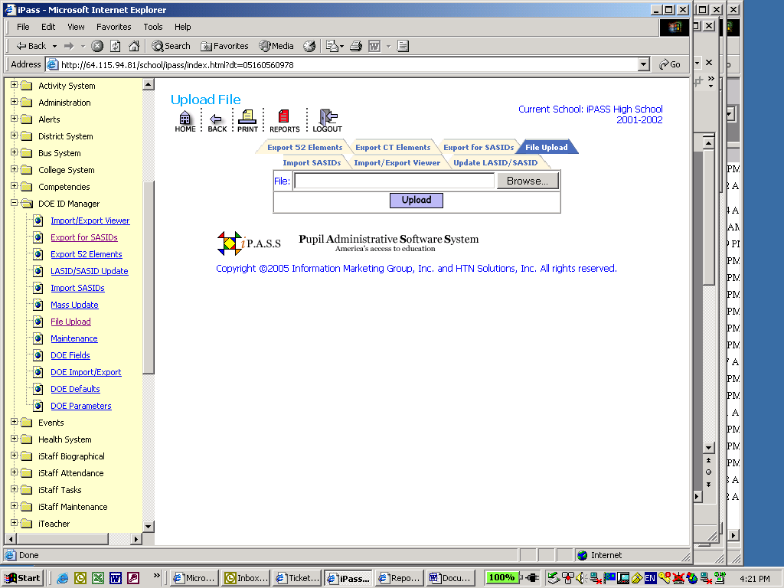
- Click on the Browse Button
- Find the file on your hard drive
- Click Open
- Click the button to upload the file into iPASS

Go to <DOE ID Manager><Import SASIDs>

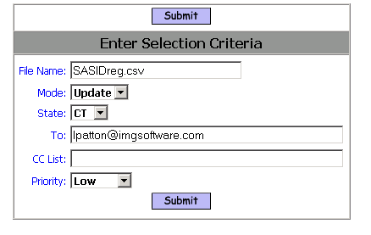

File Name:
- Enter the file name including the file extension. This field is case sensitive, so enter the name exactly how it was saved as.

Mode:
- Select Test mode to see if there are any errors

- Select Update to run the SASID import to populate the database

State:
- Select the state abbreviation

To: This box allows you to enter an email address or several addresses of people you want to send the report to. List email address separated by semi-colons.

CC list: This box allows you to enter an email address or several addresses of people you want to cc: a copy of the report to. List email addresses separated by semi-colons.

Priority: This box allows you to set a priority level for the report processor. Priority options are limited to the list provided.

Click the button to import your SASIDs and update the database

To View the SASID Import ERRORS

Go to <DOE ID Manager><Import/Export Viewer>

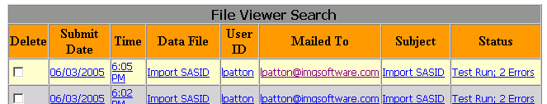

Delete: Click this box to put a check mark in it. Then click the submit button to delete the file from the viewer.

Submit Date: This will indicate the date you submitted the import to be processed

Time: This will indicate the time you submitted the import to be processed

Data File: This will be the name of the import file

User ID: This indicates the user ID of who submitted the import to be processed

Mailed To: This indicates who was emailed the results of the import

Subject: This will show the subject you entered on the Export SASID screen.

Status: This will indicate the status of the import. Test Run: With Errors, Test Run Successful, Updated: With Errors or Updated: Successful.

Click on the file name (Blue Underlined Link) under Data File

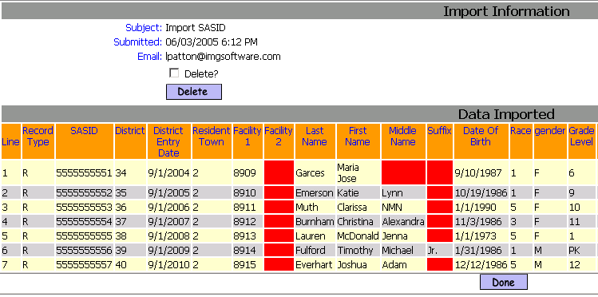

Delete: Click this box to place a check mark in it. Click the Delete button to delete the file.

Data Exported: This lists the data that was exported. The RED BOX indicates a blank data field.

Done: Click the Done button to close the viewer window

SASID Export

Go to <DOE ID Manager><SASID Export>

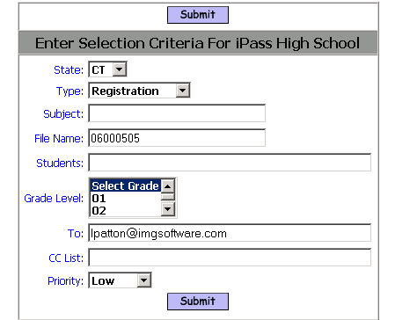

State: Select the state abbreviation

Type: Select Registration

Subject: Enter a subject to help identify the file over time

File Name: Enter a file name to help identify the file over time

Students: Enter student ID numbers separated by a comma. If you want all students then leave this field blank.

Grade Level: Select a Grade level. If you want all grades then leave this field set to Select Grade.

To: This box allows you to enter an email address or several addresses of people you want to send the report to. List email address separated by semi-colons.

CC list: This box allows you to enter an email address or several addresses of people you want to cc: a copy of the report to. List email addresses separated by semi-colons.

Priority: This box allows you to set a priority level for the report processor. Priority options are limited to the list provided.

Click the button to export your SASIDs

UPDATE a SASID

You can Add or Modify a SASID for an individual student.

Go to <DOE ID Manager><LASID/SASID Update>

- Select the student you want to update by clicking on their name.

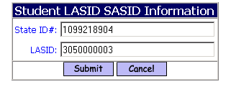

State ID #: This will show the SASID number assigned by the state. Add or Modify the state number here.

LASID: This field is not used in Connecticut and it could display the iPASS ID, a random number or be blank.

Click the button to save your changes

