Table of Contents

Standard Tests 1
Test Maintenance 1
<Test Attributes> Tab 1
<Score Parameters> Tab 4
Modify/Import Test Scores 8
<Import Test Scores> Tab 8
<Modify/Delete Test Scores> Tab 9
Reports – Standard Tests 11
<Missing Tests> Tab 11
<Missing Scores> Tab 12
<Low Test Scores> Tab 13
<Test Scores> Tab 13
iTeacher 14
<Standard Tests>Tab 14

Standard Tests
The Standard Test programs allow you to store test scores and report on scores from any Standard or Government test.

Tests could include; SAT, Iowa, MEEPS, Ohio, Stanford 9, as well as any State Curriculum Assessment Tests and District Assessment Tests.

Test Maintenance
Use this menu option to add/modify Test attributes and to set Score Parameters.

<Test Attributes> Tab
<Standard Tests> <Maintenance> <Test Attributes>
Create Attributes for the Standard Tests that you wish to maintain.

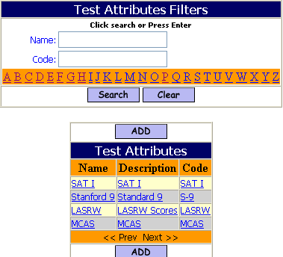

- Click to enter a new set of Test Attributes

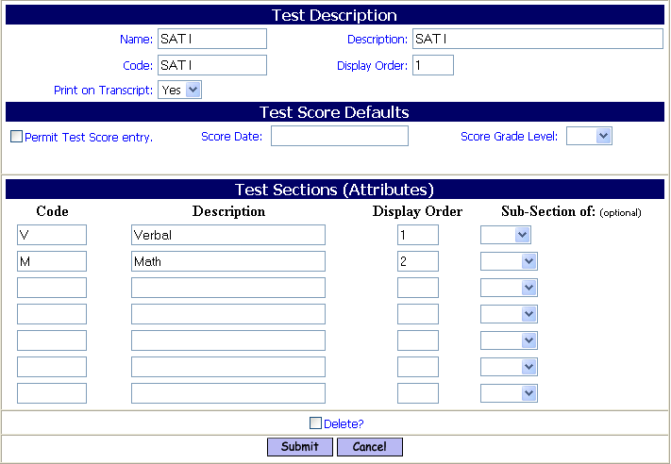

Test Description

Name:
- Enter the Name of the Test.

Description:
- Enter the Description of the Test.

Code:
- Enter the Code for the Test.

Display Order:
- Enter the Display Order for the Test.

Print on Transcript:
- Accept the default value of Yes to have the Test Name, Date and Score print on the student’s Transcript.
- Select No, to have the Test not appear on Transcripts.

Test Score Defaults
This section allows you to permit teachers to enter test scores for a specific test date and grade level. Note that test scores may be entered for one test and grade level at a time, system-wide.

Permit Test Score Entry:
- Check the box to allow for direct Test Score Entry by teachers from <iTeacher> (Enter Standard Test Scores).

Score Date:
- Enter a default Test Date. A date must be provided in order for teachers to enter scores for the desired test date

Score Grade Level:
- Enter a default Grade Level. A grade level must be provided in order for teachers to enter scores for the desired test date and gradel level.

Test Section Attributes
This section allows you to define the sections of this test. The expectation is that a score should be entered for each section defined.
Optionally, you can specify that a section has sub-sections. Enter the main sections first, submit the form, and then enter the sub-sections. (Note that reports do not follow the parent-child relationship at this time.)

Test Attribute Code:
- Enter the Code for the Attribute.

Test Attribute Description:
- Enter the Description for the Attribute.

Test Attribute Display Order:
- Enter the Display Order for the Attribute.

Sub-Section of:
- Select the Section from the pull-down list that this attribute is a sub-section of.

- Click to save your work.

<Score Parameters> Tab
This section allows you to specify the scoring parameters for this instance of the test. A test instance is defined by a test date and grade level.

You can set a minimum passing score, to be used by the Low Test Scores report to identify students whose scores fall below a threshold.

<Standard Tests> <Maintenance> <Score Parameters>
Create possible test scores for each test, by date.

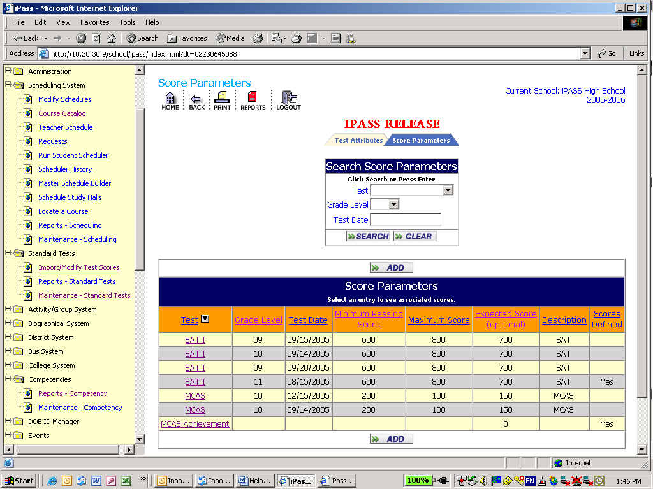

Search Score Parameters

Test:
- Select a Test from the pull-down list of existing Tests.

Grade Level:
- Select a Grade Level from the pull-down list.

Test Date:
- Enter a date

- Click to access the selected test.

Score Parameters

Test:
- This displays the test name. The test name is a link that will take you to a screen where you can set the score information.

Grade Level:
- This displays the Grade Level assigned to the test.

Test Date:
- This displays the Test Date assigned to the test.

Minimum Passing Score:
- This displays the Minimum Passing Score assigned to the test.

Maximum Score:
- This displays the Maximum Passing Score assigned to the test. (Defined but not used currently.)

Expected Score:
- This displays the Expected Score assigned to the test. (Defined but not used currently.)

Description:
- This displays the description assigned to the test.

Scores Defined:
- This displays a Yes if Scores have been defined and a No if they have not.

The test name is a link that will take you to a screen where you can set the score information.

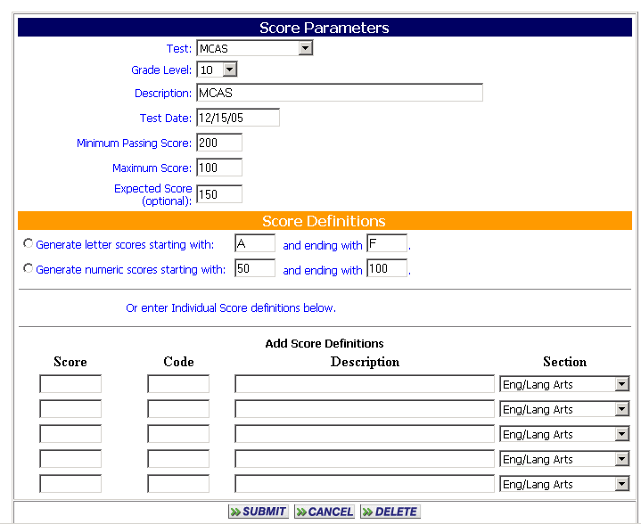

Score Parameters

Test:
- Use the drop down selections to change which test these scores describe..

Grade Level:
- Use the drop down selections to assign a different grade level to this test instance

Description:
- Enter a Description for this test instance.

Minimum Passing Score:
- Enter the lowest possible Passing score for this test.

Maximum Score:
- Enter the maximum score for this test.

Expected Score:
- (Optional) Enter the expected score for this test.

Score Definition

This section enables you to create possible scores for this test instance in several ways.

Note: If a similar Test already exists in ipass, then this section will need to be defined for this instance of the test in order to report on the scores for this instance. The feature to copy scores from another test will help facilitate score creation for new test instances. Each test is unique by name, grade level and date.

Use one of the three (3) options below to automatically generate possible scores for this test and/or to define new or additional scores.

- Click on the radio button if you wish you use one of the automatic generation options and accept the default range or define a different range.
- Do not accept one of the automatic generation and enter scores manually below.

Generate letter score starting with A and ending with F:
- Accept the default starting letter score of A.
- Enter a different starting letter score.
- Accept the default ending letter score of F.
- Enter a different ending letter score, which would alphabetically follow the starting letter.

Generate numeric score starting with 50 and ending with 100:
- Accept the default starting numeric score of 50.
- Enter a different starting numeric score.
- Accept the default ending numeric score of 100.
- Enter a different ending numeric score, which would be greater than the starting numeric score.

Copy scores from an exiting test by date (in the pull-down):
- Accept the default test date.
- Select a different test date from the pull-down list.

Enter Individual Score descriptions:
- Accept the default starting numeric score of 50.
- Enter a different starting numeric score.

Score:
- Enter a score.
Value:
- Enter a numeric value for this score, so that averages can be calculated.
Description:
- Enter a description.
Section:
- Select the test section that this score applies to.
- Leave the section field blank to have the score apply to all sections.

- Click to save your work.

Modify/Import Test Scores
Use this menu option to import scores from a file, or to update scores which were imported previously.

<Import Test Scores> Tab

<Standard Tests> <Modify/Import Test Scores> <Import Test Scores>

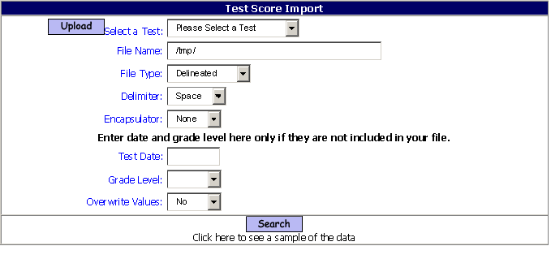

You must upload the file into a Temp Directory first. This copies the score file from your PC up to the iPass server system.

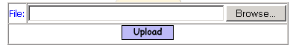

Browse:
- Click the Browse button to locate the file on your desktop or wherever you placed it.
- Click on the file to bring the filename into the file box.

- Click to load the file into the proper iPASS directory.

Select a Test:
- Select a Test from the pull-down list that corresponds to the data in the file.

Filename:
- Enter the Filename. It must be entered exactly how it was displayed when uploaded. The Filename is case sensitive.

File Type:
- Accept the default value of Delineated.

Delimiter:
- Accept the default delimiter of Space.
- Select None, “,” (comma) or “|” (pipe) as the field delimiter.

Encapsulator:
- Accept None, if the fields are not encapsulated.
- Select “ (the single quote) if the fields are encapsulated.

Test Date:
- Leave the field blank if a test date is included in the data to be imported.
- Enter a Test Date to load for all records.

Grade Level:
- Do not select a Grade Level, if the date to be imported contains a Grade Level.
- Select a Grade Level from the pull-down list to load for all records.

Overwrite Values:
- Accept the default value of No to not overwrite any existing data for this test.
- Select Yes from the pull-down list to overwrite any existing date for this test.

- Click to see a sample of the data in the file and to link the data to the fields in the file with the Test Attribute fields.

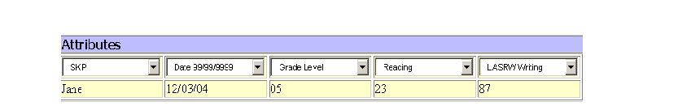

- Select the corresponding test attribute in the each pull-down list for each data element below it in the sample view of the import file.

- Click to import your test scores.

<Modify/Delete Test Scores> Tab
<Standard Tests> <Modify/Import Test Scores> <Modify/Delete Test Scores>
Create Attributes for the Standard Tests that you wish to maintain.
This program allows you to edit fields such as Grade Level or Test Date for all students, or for individual students who took the test that was imported.

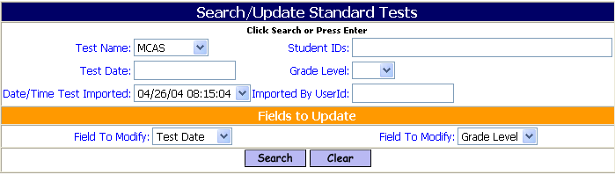

Test Name:
- Enter the Test Name.

Student ID:
- Enter a Student ID
- Enter a string of student IDs, separated by commas, no spaces.

Test Date:
- Enter a Test Date.

Grade Level:
- Select a Grade Level from the pull-down list.

Date/Time Test Imported:
- Select the Date/Time for a test which was imported from the pull-down list.

Imported By UserID:
- Enter the UserID of the person who imported the test.

Field to Modify:
Any field that can be modified for the Test Scores selected will be in the pull-down list. You can select up to two (2) Field to Modify.
- Select a Field to Modify from the pull-down list.

Field to Modify:
- Select a second Field to Modify from the pull-down list.

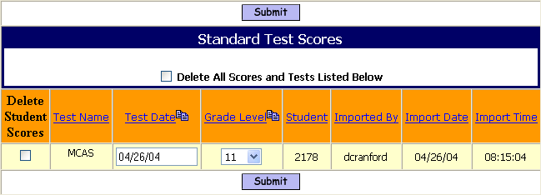

Mass Delete Option

Delete All Scores and Tests Listed Below
- Check the box to delete ALL record of this test.

Delete Student Scores:
- Check the box to delete this test record for the single student on this line.

Modify Selected Field (Example: Grade Level):
- Select a different (Grade Level) value from the pull-down list. Example: By default all of the students took the test as 10th graders and the selected student took the test as an 11th grader.

Modify Selected Field (Example: Test Date):
- Enter a different (Test Date) for the selected student.

- Click to save your work.

WARNING! Be sure that you are deleting or modifying the correct record!

Reports – Standard Tests

<Missing Tests> Tab
<Standard Tests> <Reports> <Missing Tests>
This report lists students who do not have any data regarding a selected test.

Filtering: Test, From Date, To Date, Grade Level, Homeroom, Enrollment Status.
Sorting: Name, Grade, Homeroom.
Output: Name, ID, Grade Level, Year of Graduation, Homeroom, Test Date.

Name | Student  ID | Grade  Level | YOG | Homeroom
Adams, Joseph | 10027 | 09 | 2016 | 1303
Baxter, Cambridge | 1831 | 11 | 2007 | 1209

<Missing Scores> Tab

<Standard Tests> <Reports> <Missing Scores>
This report lists students who have empty of missing test scores for a selected test.

Filtering: Test, From Date, To Date, Grade Level, Homeroom, Enrollment Status.
Sorting: Name, Grade, Homeroom.
Output: Name, Student ID, Grade Level, Year of Graduation, Homeroom, Test Date.

Name | Student  ID | Grade  Level | YOG | Homeroom
Adams, Joseph | 10027 | 09 | 2016 | 1303
 | 12/08/04 | No Scores
 | Found: | 1 | Students

<Low Test Scores> Tab

<Standard Tests> <Reports> <Low Test Scores>
This report lists students whose test scores are lower then the Minimum Score entered in <Score Parameters> <Define Possible Scores> for a selected test.

Filtering: Test Type, From Date, To Date, Student ID, Grade Level, Homeroom, Enrollment Status.
Sorting: Name, Grade, Homeroom.
Output: Name, ID, Year of Graduation, Homeroom, Threshold score, test scores.

SAT I |  |  |  | 1 | 2 | 3 | 4 | 5
 |  |  |  | 06/30/04 | 12/21/04 | 06/30/04 | 12/21/04 | 06/30/04
Name | Student  ID | YOG | HR | Math | Math | Science | Science | Verbal
 |  |  |  | Threshold: 500.00 | Threshold: 500.00 | Threshold: 500.00 | Threshold: 500.00 | Threshold: 500.00
Adams, Joseph | 10027 | 2016 | 1303 | 346 | 123 | 134 | 123 | 111

<Test Scores> Tab

<Standard Tests> <Reports> <Test Scores>
This report lists students’ test scores for a given test.

Filtering: Test Type, From/To Date, ID, Grade Level, Homeroom, Enrollment Status.
Sorting: Name, Grade, and Homeroom.
Output: Name, Student ID, Year of Graduation, Homeroom, test scores.

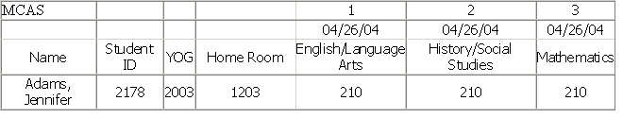

iTeacher

There is a menu selection named <Standard Test Scores> that can be placed in the iTeacher folder. This menu option allows teachers to view or add test scores to selected tests by course. By default, scores are made available for a teacher to view. The Add option is enabled in the <Standard Test><Maintenance Standard Test><Test Attributes> Screen, Test Score Defaults section.

Standard Test Scores

- Search for students by course.
- Select a test using the Choose a test: drop down selections.

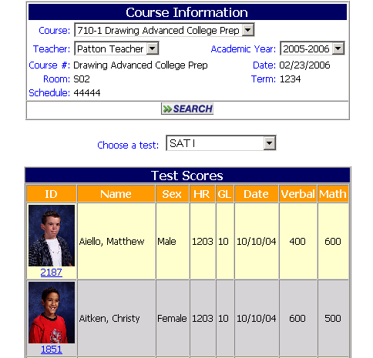

This screen shows student scores in a view only mode.

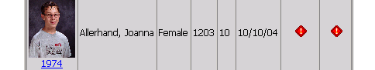

The indicates that there are no scores for this student for the test selected.

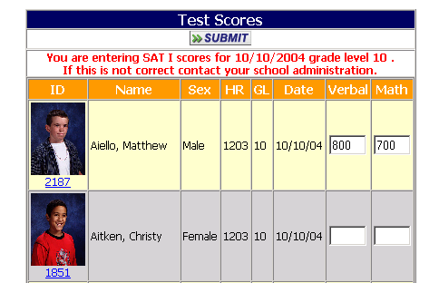

This screen shows student scores in the Add Score mode.

